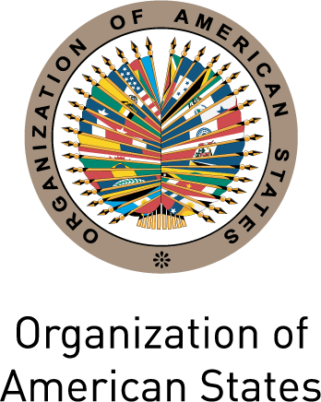
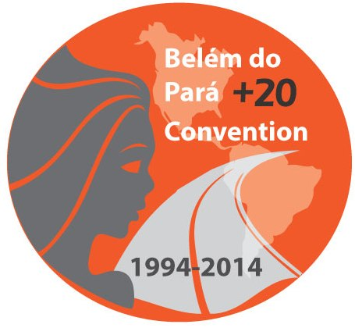
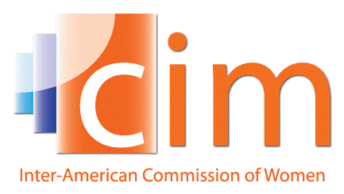

INTER-AMERICAN COMMISSION OF WOMEN

EXECUTIVE COMMITTEE 2013-2015 OEA/Ser.L/II.5.32
FOURTH REGULAR SESSION CIM/CD/doc.19/14
Mexico City October 1st 2014
October 24th 2014 Original: Spanish

ORGANIZATION OF WORK
input.doc

(Draft)

8:00-8:10 Inauguration:
      - Alejandra Mora Mora, President and Principal Delegate of Costa Rica to the CIM

8:10-8:20 Adoption of the agenda
(Item 1 of the Agenda, CIM/CD/doc.18/14)
Adoption of the organization of work
(Item 2 of the Agenda, CIM/CD/doc.19 /14)

8:20-9:15 Report of the President and the Executive Secretary of the CIM and Budget execution through September 30th 2014
(Item 3 of the Agenda CIM/CD/doc.20/14)

9:15-10:30 Integrated System of Indicators for Women’s Human Rights
(Item 4 of the Agenda)
- Belkys Mones, CIM Senior Specialist

10:30-10:45 Other matters
(Item 5 of the Agenda)

10:45-11:00 Adoption of agreements

