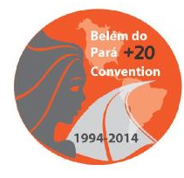
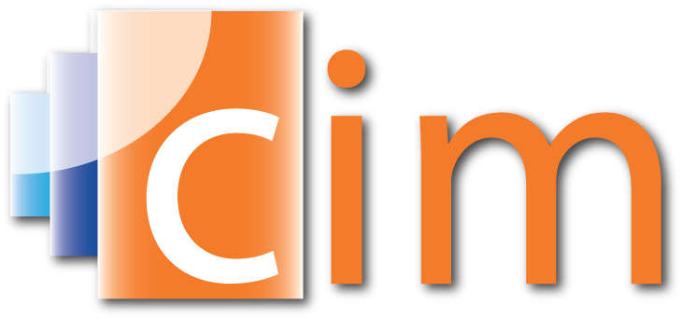
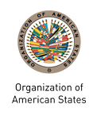

INTER-AMERICAN COMMISSION OF WOMEN

EXECUTIVE COMMITTEE 2013-2015 OEA/Ser.L/II.5.32
FOURTH REGULAR MEETING CIM/CD/INF.1/14
October 24, 2014 1 October 2014
Mexico City, Mexico Original: Spanish

Note for the Chair of the Working Group on the Strategic Vision of the OAS

Incorporating Gender and Diversity Awareness into the Work of the OAS

- Introduction

With the adoption in 2000 of the Inter-American Program on the Promotion of Women’s Human Rights and Gender Equity and Equality (IAP), the member states entered into a solemn commitment to “formulate public policies, strategies, and proposals to promote women’s human rights and gender equality in all spheres of public and private life, considering their diversity and their life cycles.”

They also charged the OAS General Secretariat with the task of “systematically integrating a gender perspective in all organs, organizations, and entities of the inter-American system.” With this, the Inter-American Commission of Women (CIM) and other relevant entities have a compelling mandate to work with the Organization as a whole to ensure the institutionalization of a perspective of gender, diversity, and rights throughout the OAS’s work.

The member states have annually reaffirmed their commitment to the full implementation of the IAP at the OAS General Assembly; they have also done so through the Summits of the Americas process and, at the same time, there has been a significant increase in the priority given to this topic in the Permanent Council’s deliberations. Since 2010, and chiefly with the support of the government of Canada, the OAS has made significant progress in its capacity to analyze gender issues, as well as in incorporating a gender approach in the Organization’s projects. That progress has had a demonstrable impact on the perception of the OAS as an organization that places a priority on the rights of women and gender equality.

- Background

As part of the measures to follow up on the IAP, including the mandates to ensure that “a gender perspective is consistently mainstreamed into the preparation and application of international instruments, mechanisms, and procedures within the framework of the OAS, and particularly on the agendas of ministerial-level meetings” and to “provide all organs, agencies, and entities of the OAS system with the necessary training to incorporate the gender perspective into their work and to prepare suitable tools for attaining this program’s main objectives, tapping, where applicable, the experience of other international organizations, cooperation agencies, and member states,” in May 2001, the Secretary General entered into an agreement with the Government of Canada for implementing the “Project on Gender Mainstreaming in the OAS,” which was coordinated by the OAS and the CIM. In the first phase (2002-2003) of this project, training was given to 200 officers of the General Secretariat (GS/OAS), with particular attention given to those responsible for the execution of programs and policies.

In the second phase, from 2005 to 2006, seven workshops for specific areas were held and a further 125 officers were trained. In this phase, tools were provided in response to specific needs in several areas of the GS/OAS. In addition, a gender integration manual for staff members was designed, containing tools for gender analyses.

Within the ministerial meetings and in compliance with the IAP’s mandate to integrate a gender perspective in the preparation and implementation of international instruments, mechanisms, and procedures, in particular the agendas of ministerial-level meetings, the CIM developed the SEPIA initiative (“Follow-up of the IAP”) which, between 2001 and 2004, enabled it to present recommendations to the ministerial meetings in the areas of labor (SEPIA I, 2001), justice (SEPIA II, 2002), education (SEPIA III, 2003), and science and technology (SEPIA IV, 2004) and to develop lines of action for implementing them, in conjunction with the ministerial mechanisms and in collaboration with civil society, government experts, other entities of the OAS, and specialized organizations.

By means of Executive Order No. 05-11 rev. 1 of January 12, 2006, the OAS Project Evaluation Committee (CEP), the Secretariat of which comes under the Department of Planning and Evaluation (DPE), was instructed to assess the relevance and importance of the projects underway and of the proposed projects in consideration of the attention they paid to crosscutting issues, including gender. This measure, as a concrete example of political will, has been essential in the later work of the CIM and the DPE in preparing specific tools and strengthening the capacity of the OAS’s personnel in responding to this mandate.

In 2008, as part of the OAS/CIDA First Cooperation Plan (2009-2011), the project “Integration of Gender Analysis and Gender Equity and Equality as Crosscutting Topics and Objectives in All OAS Programs” was carried out, representing the third phase of the OAS Gender Program. The project’s components were:

- Preparation of a study on staff needs for training and awareness-raising about gender and rights.
- Onsite training through gender workshops for personnel from the Department of Human Resources; for potential facilitators; three specialized sessions on the topics of competitiveness, civil registry and electoral observation, and trafficking in human lives; and a workshop for all the personnel of the Inter-American Children’s Institute.
- On the basis of those workshops, the preparation, by the CIM with the support of FLACSO, of the Guide for the Incorporation of Gender Awareness in OAS Policies, Programs, and Projects (2011) and the preparation, by the DPE in collaboration with the CIM, of the Handbook on Mainstreaming Gender Equality into the OAS Project Cycle (2011) (available to all OAS staff over the intranet).
- Online training through the course “Gender Equality and Rights-based Approach to Policies, Programs and Projects,” which was originally offered to OAS staff and was later opened to participants from around the region, including representatives of the permanent missions to the OAS.
- The creation of an OAS Gender Community, where the participants in the OAS online course continue to interact – exchanging information, experiences, best practices, and lessons learned – using an online platform hosted by the Educational Portal of the Americas.

In parallel to these processes and with the aim of strengthening the monitoring and evaluation of the efforts to integrate gender in the OAS, the CIM identified a series of ten indicators and prepared a questionnaire, which since 2010 has been distributed to all the departments, committees, and other entities of the Organization, including its offices in the member states. The answers given to that questionnaire are the principal source of information for the annual preparation of the Report of the Secretary General on the Implementation of the IAP. Beginning in 2010, when the baseline was set in accordance with the identified indicators, the successive reports have enabled the measurement and evaluation of the progress made with integrating gender into the different entities of the OAS. The annual reports on the implementation of the IAP are available on the web pages of the CIM and the Permanent Council.

- Current Situation

The DPE and the CEP are persevering with their efforts to integrate gender awareness into all the Organization’s projects that use specific funds, with the technical assistance of the CIM in reviewing project profiles and project implementation progress reports, in cases involving specific donors, as part of the evaluation process. To strengthen this work, what is needed is a closer focus on the results of each of the projects, particularly their impact in terms of gender awareness and the rights of women. While it is essential, this effort covers only a part of the Organization’s work, and its other activities are not subject to this rigorous process of evaluation and accountability as regards the integration of gender awareness.

The nine-week-long online course “Gender Equality and Rights-based Approach to Policies, Programs and Projects,” which has been successfully completed, as of its third edition, by 40 individuals from the GS/OAS and more than 105 from around the region, is shortly to begin its fifth round and it will continue to be offered both internally and externally, between two and three times a year, as long as there are participants interested in taking it. With the resources obtained through this course, and based on a methodology that has been validated in the region with the national women’s mechanisms and labor ministries, the CIM hopes to prepare another online course on Strategic Planning with Awareness of Gender, Diversity, and Rights.

The DPE, with the support of the CIM and in collaboration with the OAS Department of Information and Technology Services (DOITS), has developed an innovative tool designed to follow up on the Organization’s gender-sensitive mandates and programmed goals, using indicators that show the level to which a gender perspective has been integrated, together with the resources allocated to those mandates and goals. Results-based management requires following up on the commitments assumed by the Organization: in other words, determining the extent to which the mandates have been attained through specific results, with deadlines, goals, objectives, and indicators established to monitor progress. This interactive database offers a unique opportunity to address gender mainstreaming in the OAS on the basis of the organizational mandates, programmed goals, and resources allocated for its implementation.

This tool, which is currently undergoing internal validation and will be discussed with the member states in the near future, represents a qualitative leap forward in the Organization’s ability to analyze its progress with integrating gender in the work of the OAS and assists in clearly indicating the areas that require greater effort and technical assistance.

- Future Priorities

Over the past four years there has been a substantive change in the priority given to gender awareness and the rights of women in the OAS’s work: the General Assembly is currently adopting more resolutions that recognize the additional obstacles in their full participation in political, economic, and social life that women may encounter; the ministerials and other meetings are addressing gender awareness, diversity, and human rights more frequently in their work; and the Organization is beginning to identify and disseminate concrete results through its efforts, which strengthen the position of the OAS as an organization that responds to the demands made by the region’s women and men.

That work, however, could be strengthened with the following specific actions:

- Strengthening the integration of gender awareness in projects and programs, as well as in the capacity of the staff to incorporate gender mainstreaming in their work.
- The institutionalization of the integration of gender awareness in the work of the Organization that takes place explicitly in its ministerial meetings, in its policies, in its reports, and in the processes whereby it communicates and disseminates information. Accordingly, the CIM is working on a draft OAS Institutional Policy for Gender and Diversity, which seeks to replicate and bolster the progress made to date in other technical areas and to address the internal management of the Organization with an approach based on gender, diversity, and human rights.
- Increased production by the CIM and the DPE, depending on the availability of resources, of technical tools and practices to support both the OAS staff and the member states in integrating the gender, diversity, and human rights approach in areas of work other than the specific projects.
- The inclusion of diversity awareness in those processes to complement gender awareness, taking into account such other factors as ethnic origin, age, physical ability, geographical location, sexual orientation, etc.
- Greater focus on results-based management, on evaluating the progress made and the obstacles that remain, and on accountability for results based on the commitments that the Organization has acquired on those topics.
- The allocation of sufficient resources from the OAS Regular Fund to support those efforts. Besides a limited amount of funding from the Regular Fund, to date much of the gender integration work has been carried out primarily with specific funds or with ICR. Although they are essential, those funds are insufficient and, because of their precarious nature, they endanger the sustainability of the progress made in this area. The institutionalization of gender, diversity, and human rights awareness in the work of the OAS will be attained only when it is an institutional priority with the funding necessary to ensure its full accomplishment.
input.doc

