CHAPTER II
SYSTEM OF INDIVIDUAL PETITIONS AND CASES

Introduction

- This chapter reflects the work done by the Inter-American Commission on Human Rights in 2018 in connection with its system of petitions, cases and precautionary measures.

- Section B includes information about measures implemented to reduce the procedural backlog and about progress made during the year in pursuit of Strategic Objective 1 of the IACHR Strategic Plan 2017-2021. In keeping with that Plan the IACHR has also revised its statistics as well as the methodology used to keep track of matters pending before the IACHR, in order to make more information available, as is reflected in Section C, which presents statistics relating to petitions, cases, and precautionary measures.

- Section D, for its part, includes all the reports by which the Commission adopted decisions on cases (admissibility, inadmissibility, merits, friendly settlement, or archive) during the period covered by this report. That section contains a total of 143 published reports that include 118 reports on admissibility; 15 reports on inadmissibility; 6 reports on friendly settlement; and 4 reports on merits published. It also contains a list of 152 petitions and cases archived by the IACHR.

- Section E contains a summary of the decisions on precautionary measures granted or expanded by the IACHR in 2018 under Article 25 of its Rules of Procedure, as well as links to each one. That section refers to the resolutions adopted on precautionary measures in 2018, the processing time for those requests, as well as working meetings and hearings held. These resolutions set forth the parameters used by the IACHR to determine if the requirements as to urgency, seriousness and irreparability are met in each case.

- Section F provides a breakdown of the activities of the Commission before the Inter-American Court of Human Rights in connection with the following treaty-based and statutory mandates: (i) submission of contentious cases; (ii) requests for provisional measures; (iii) appearance and participation in public and private hearings; (v) presentation of written comments on state briefs in cases under monitoring of compliance with judgment; and (vi) presentation of written comments on state briefs on implementation of provisional measures.

- Section G includes an analysis of the implementation of recommendations issued by the IACHR in published merits reports and friendly settlement agreements it has approved. In that section the IACHR describes the actions taken during the year in relation to the methodology for follow-up on recommendations and friendly settlement agreements. It also contains information on activities carried out during the follow-up process in 2018 and highlights significant outcomes.

Procedural Backlog

- The IACHR has a unique mechanism for protecting human rights in the region: the system of petitions and cases and friendly settlements. By lodging petitions with the Inter-American Commission, those who have suffered human rights violations can obtain justice and reparation measures. To the extent that this mechanism operates effectively, individuals whose human rights have been violated will have access to an instrument for settling their claims that will not only benefit them in their specific cases, but will also offer significant capacity to transform structural situations of human rights violations as a result of IACHR recommendations, or as a result of friendly settlements ratified by the Commission. The system is an essential tool to ensure justice and reparations, fight impunity, and achieve structural reforms in law, policy, and practice.

- Nevertheless, one of the main historical challenges the IACHR faces is to reduce the backlog in the system of petitions and cases, inasmuch as this affects the possibilities of providing a timely response to individuals who turn to the inter-American system to report violations of their human rights. The procedural backlog has many causes, chief among which is the continually increasing number of petitions that the IACHR receives.

- In 2017 the IACHR adopted a series of measures as part of the plan of action of the “Special Procedural Delay Reduction Program” contained in its Strategic Plan, which were published in press releases and its 2017 Annual Report. In February 2018 the IACHR set up a working group—comprising four members of the Commission and the Executive Secretary—to support the process of reducing the procedural backlog. In the second stage of measures adopted as part of the plan of action and building on the efforts led by the working group, the IACHR took a series of additional steps.

- Notable among the measures implemented in the second stage was the establishment of a task force to reduce the procedural backlog at the initial review stage, which will be temporarily under the direct supervision of the office of the Executive Secretary. The Commission also reassigned its most experienced professionals in the petitions and cases system to the admissibility and merits sections in order to focus efforts on shrinking the procedural backlog at those stages. Their portfolios increased greatly in 2018 owing to the increased number of assessments at the initial review stage and the application of Resolution 1/16. The commission also expanded the pilot plan on adoption of reports in series to include the admissibility stage, having been introduced initially for the merits stage. It also decided to continue to move forward with the simplification of reports on admissibility and merits and the joinder of petitions and cases in which the parties and facts are the same or follow similar patterns. As regards its archive policy, the IACHR decided to change the inactivity threshold for parties from four to three years for sending archive notices. It also decided to archive cases at the merits stage for failure to submit additional observations on merits, in accordance with the scenarios envisaged at Article 42.1 (a) and (b) of its Rules of Procedure.

- On the strength of those measures and others adopted in previous years, in 2018 the IACHR made unprecedented strides in relieving its procedural backlog as well as in terms of developing new standards in the individual petitions and cases system. In 2018, the IACHR also made progress in expediting the initial review process for petitions, increasing by 18.2% the number of decisions to open cases for processing, as well as adopting 176 reports on admissibility and merits, its highest ever rate of output. In qualitative terms, in the merits reports it adopted this year, the Commission advanced and consolidated its jurisprudence on a large variety of topics, as well as issuing opinions for the first time in the individual cases system on subject matters not previously addressed. Notable among that subject matter were prejudice-based violence against LGBTI individuals, discrimination by reason of sexual orientation in the civil service and the workplace, right to health and medical confidentiality, legal capacity of persons with disabilities, institutionalization in psychiatric facilities, duties of regulation, supervision, and oversight of business activities, and violence and sexual harassment against girls in educational environments.

- The IACHR also gave significant impetus to the use of the friendly settlement mechanism by releasing an updated edition of its report Impact of the Friendly Settlement Procedure and the implementation of 106 reparation measures. The Commission also observed the publication of 6 friendly settlement agreements and the total compliance with 6 friendly settlement agreements that had been previously published. In 2018 the IACHR received a total of 1,618 requests for precautionary measures, which was the highest number of such requests that it has received in one year and 50% more than the previous year. Of that total, 90% were evaluated in the light of the requirements contained in Article 25 the Rules of Procedure. The Commission granted 120 precautionary measures in 2018, which was at once its highest number in one year, and the highest percentage of precautionary measures adopted (7.2 percent) relative to the number received since the amendment of its Rules of Procedure in 2013. Due to the serious situation of risk in which the applicants were,The Commission also granted a significant number of precautionary measures without requesting information in advance from the State, in accordance with the exception envisaged at Article 25.5 of its Rules of Procedure. At the same time, the Rapid and Integrated Response Coordination Unit (SACROI) set up in response to the human rights crisis in Nicaragua, evaluated around 400 requests for precautionary measures.

- Although all these steps do not go far enough to redress the years of procedural backlog completely, they are key steps that reflect the commitment of the IACHR to the individual petitions and cases system. In addition, the initiatives and the results achieved demonstrate a real and concrete possibility of implementing more and better measures to provide a timely response for individuals who turn to the inter-American system.

Statistics

- This section includes statistical information in order to provide an overview of the different activities of the Inter-American Commission on Human Rights.

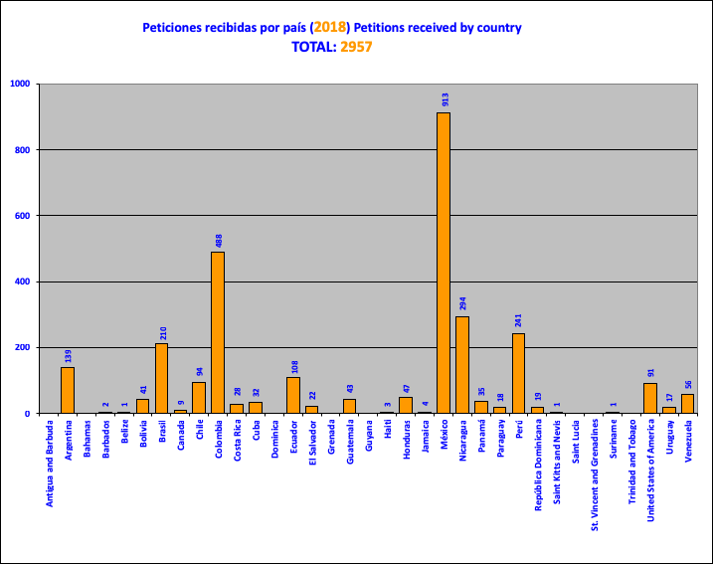

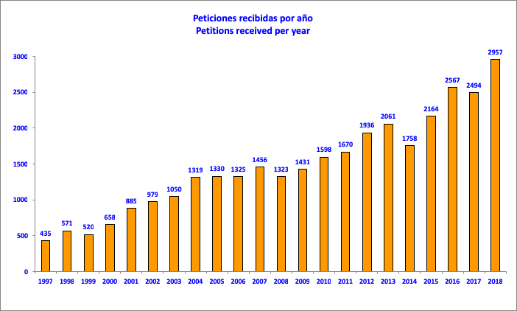

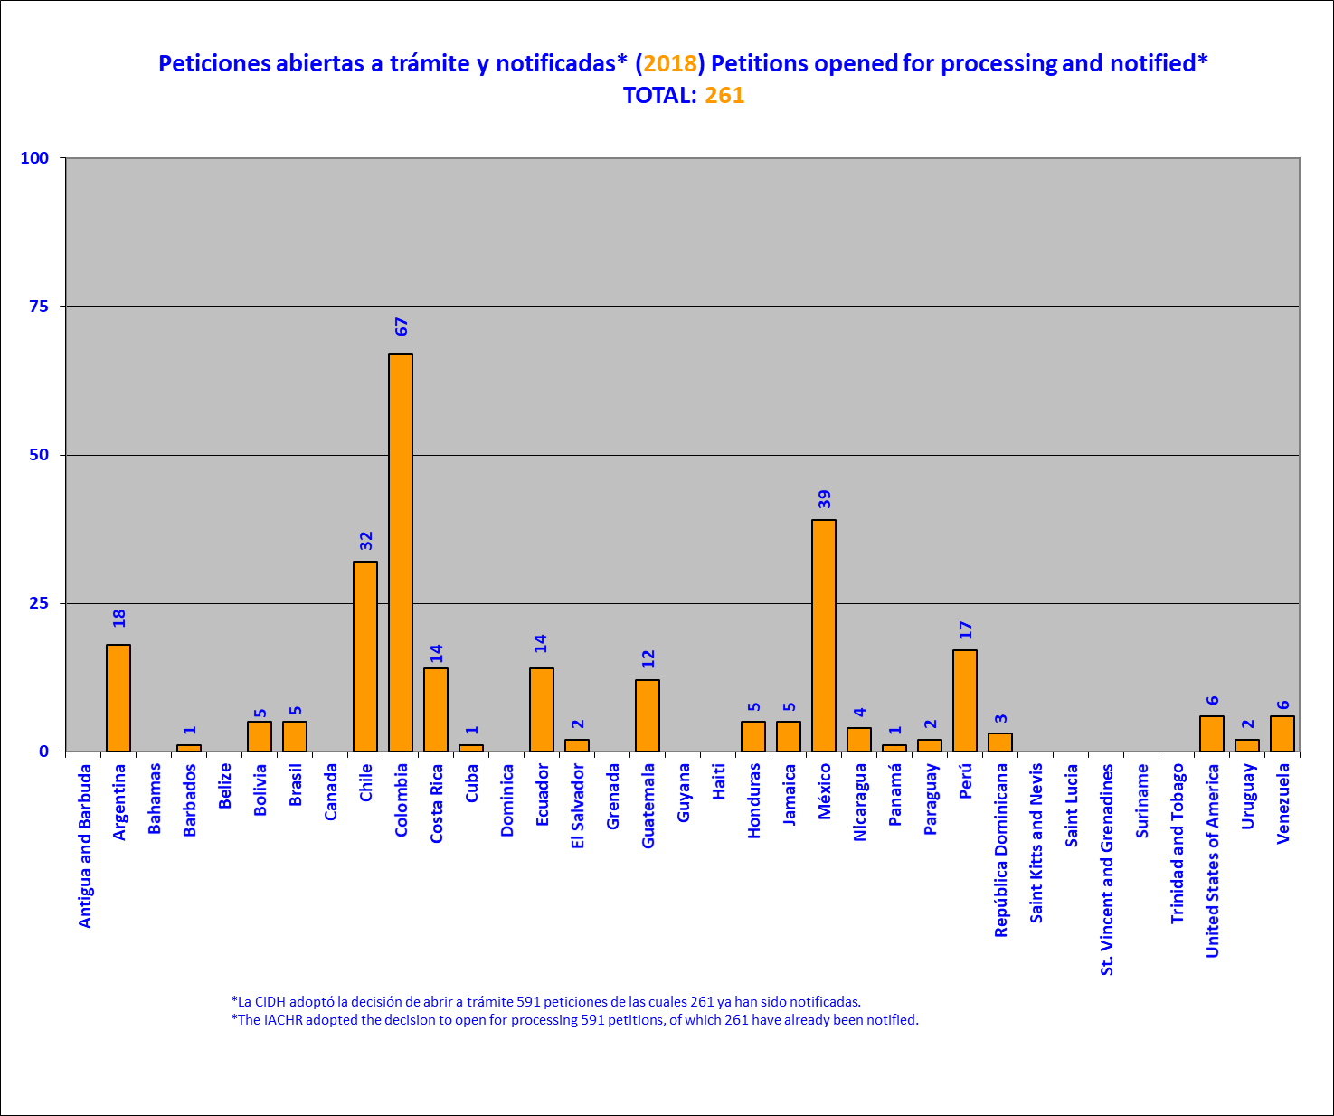

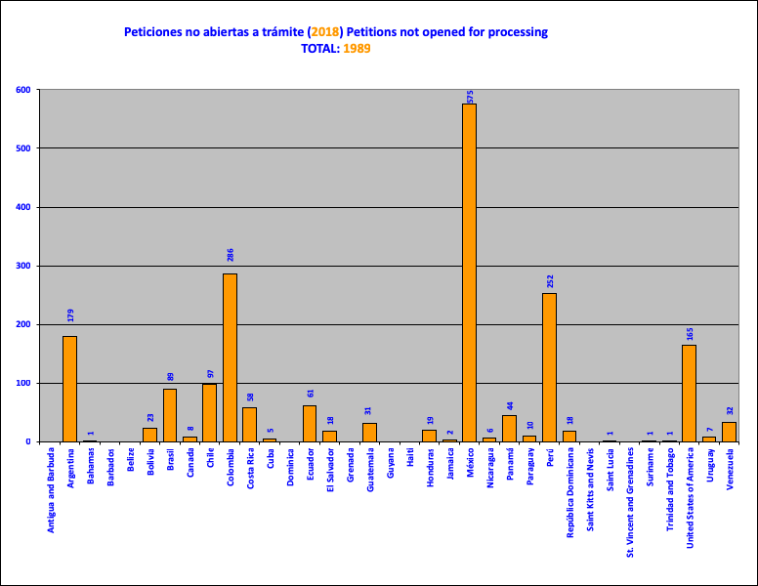

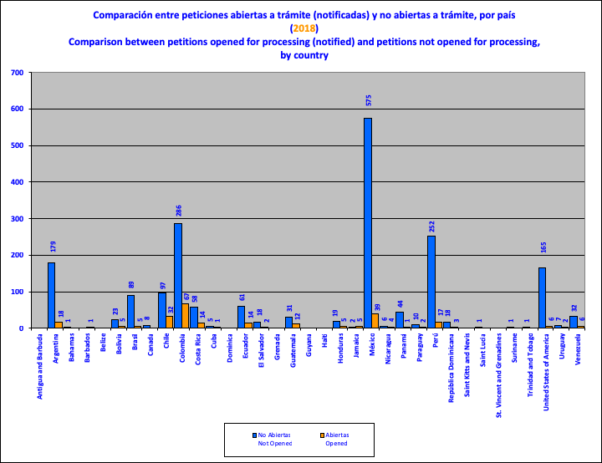

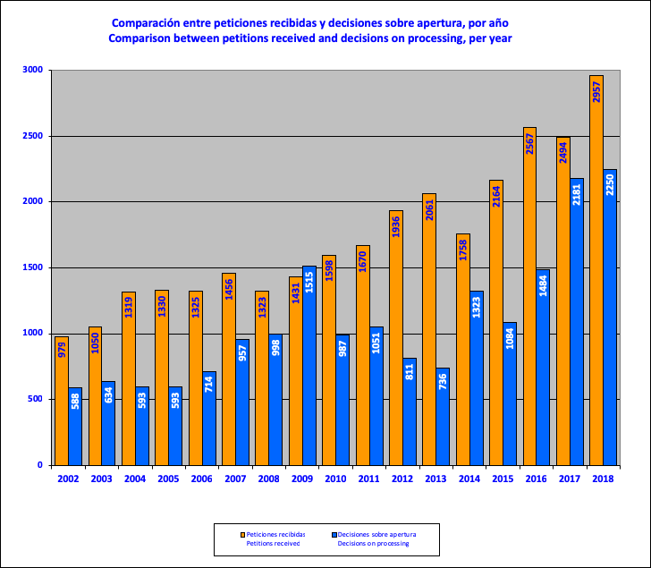

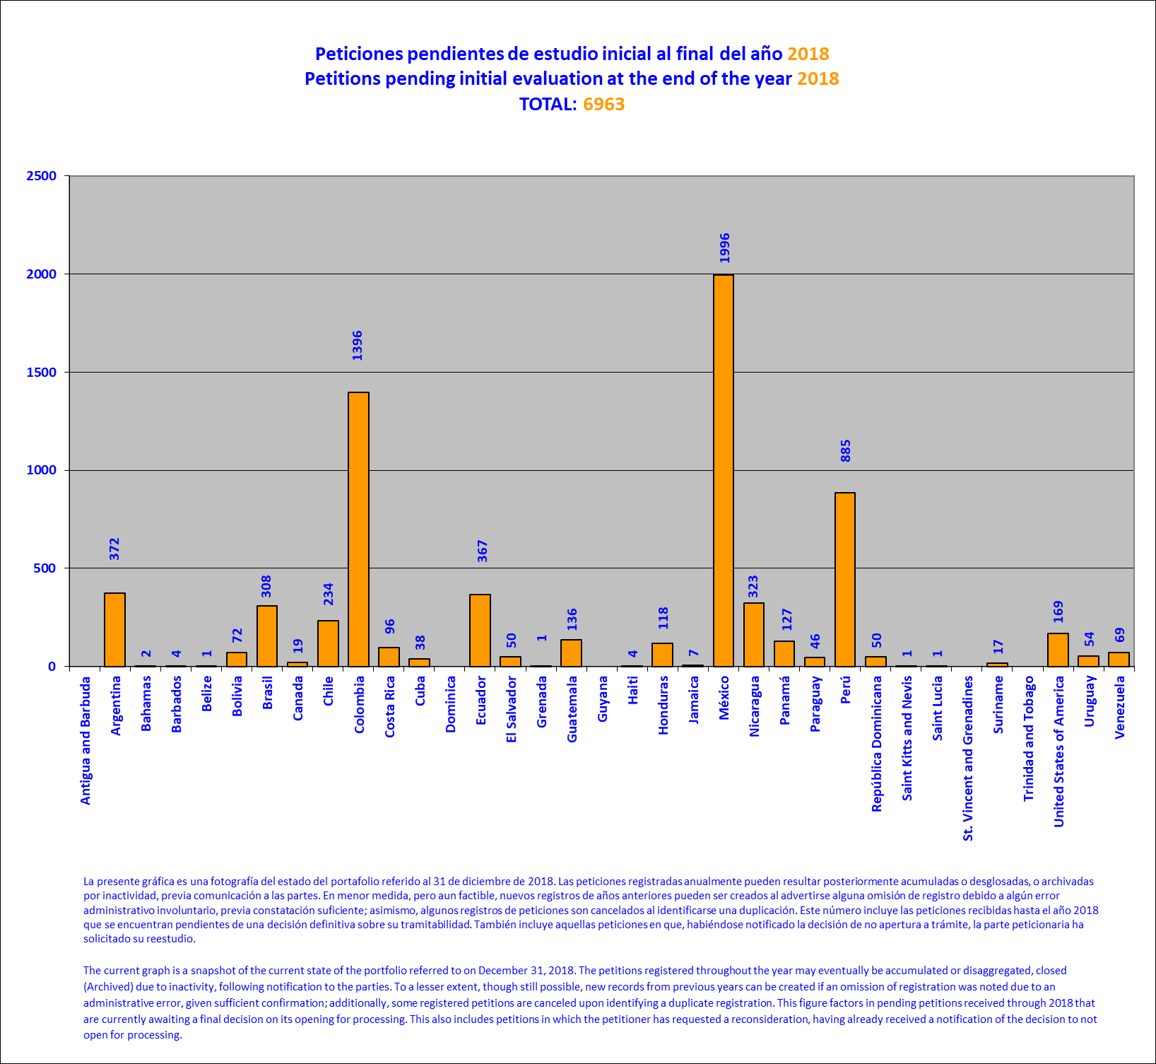
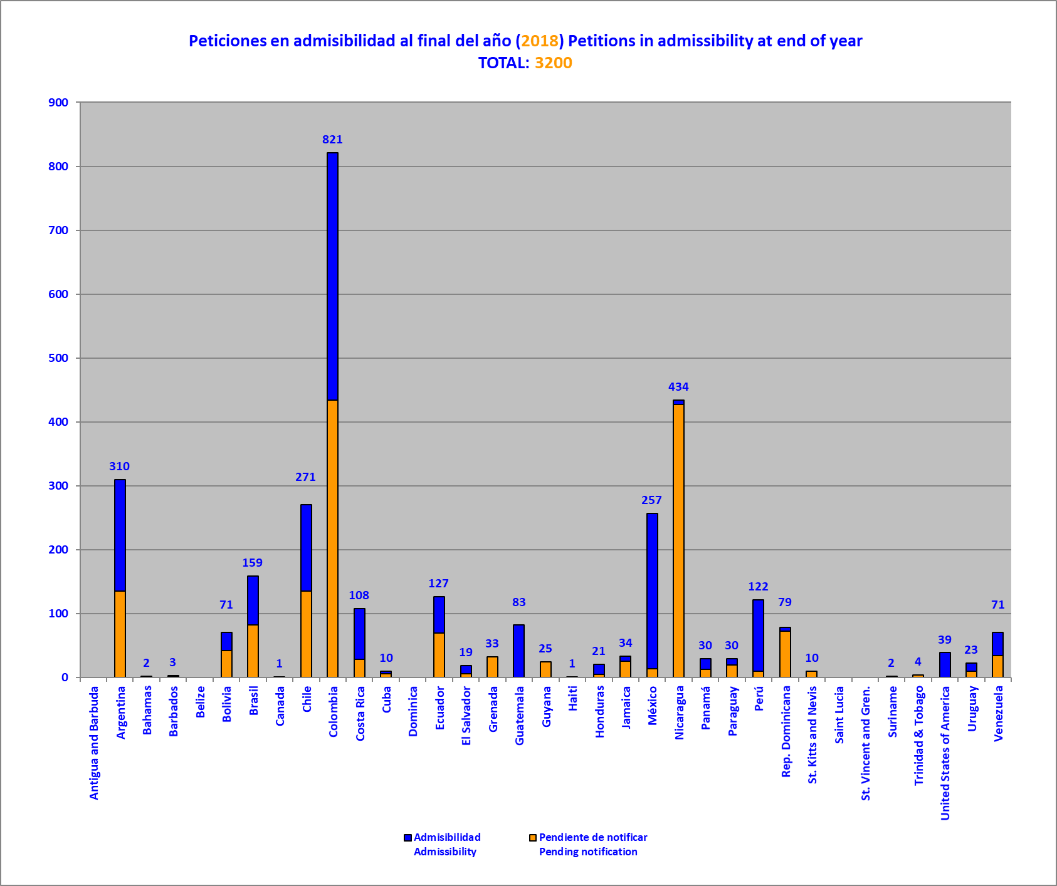

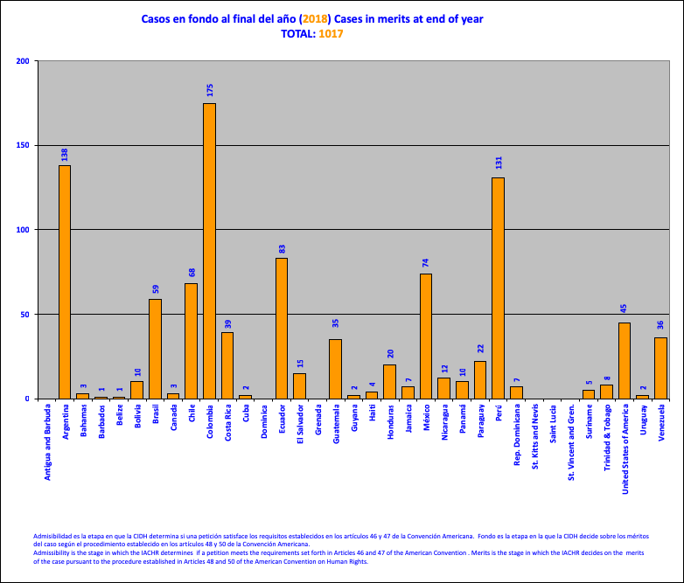

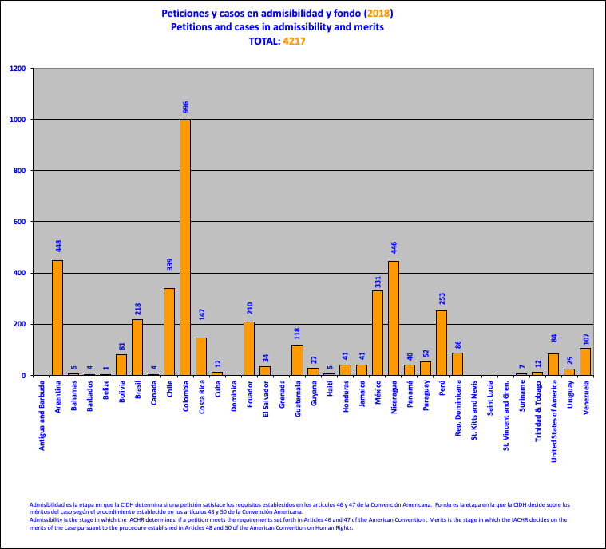

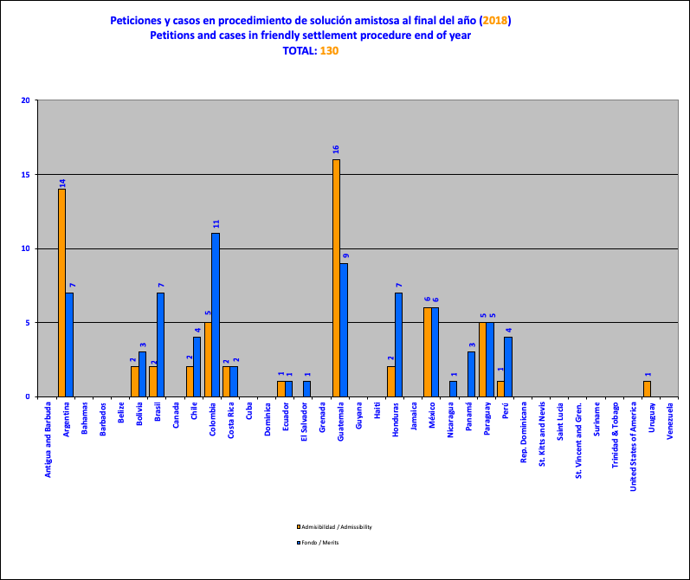

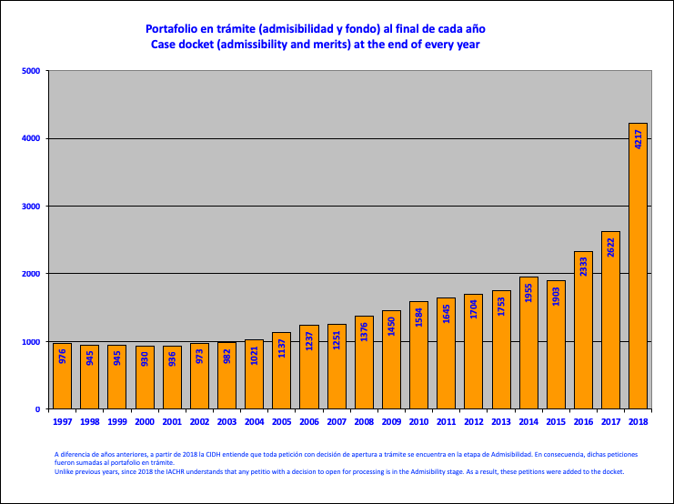

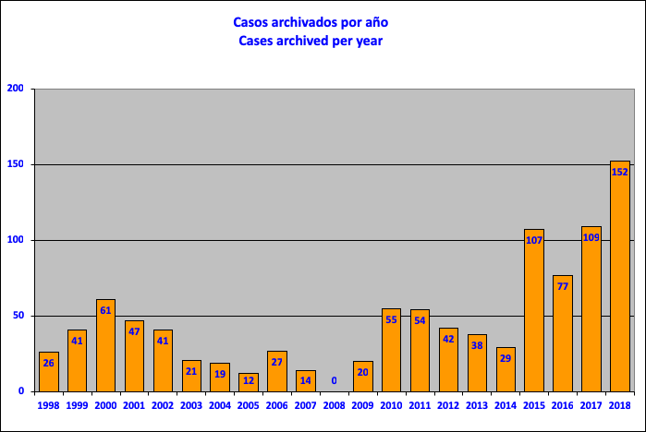

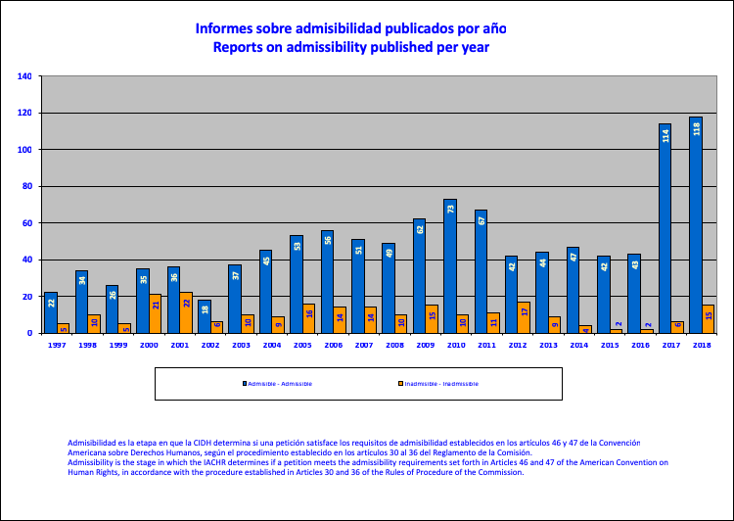

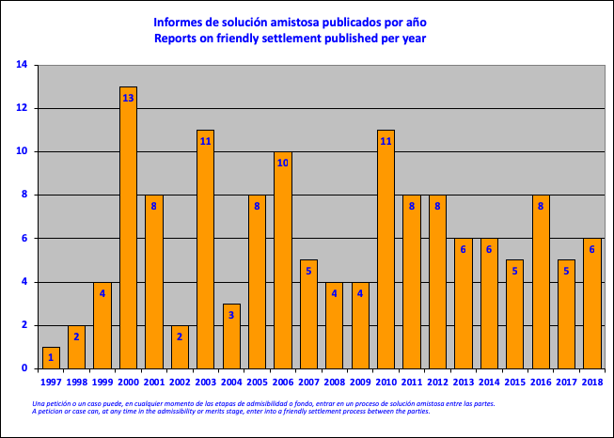

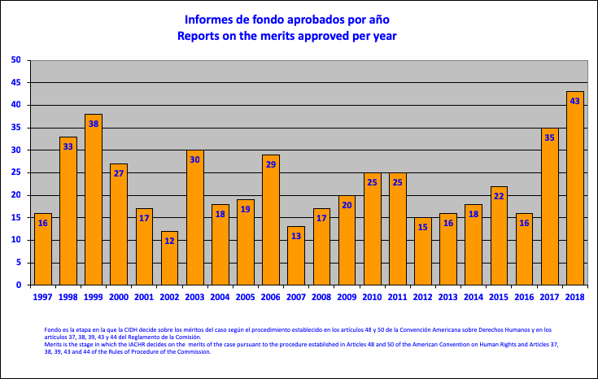

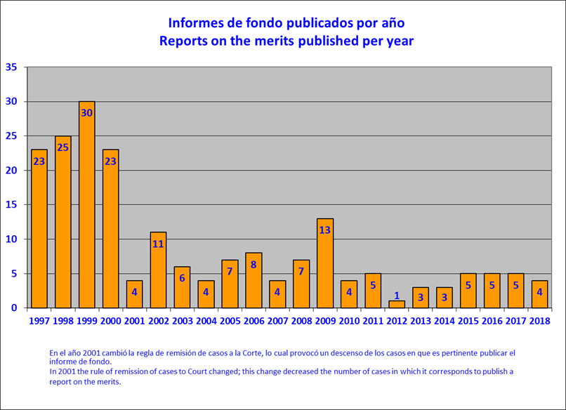

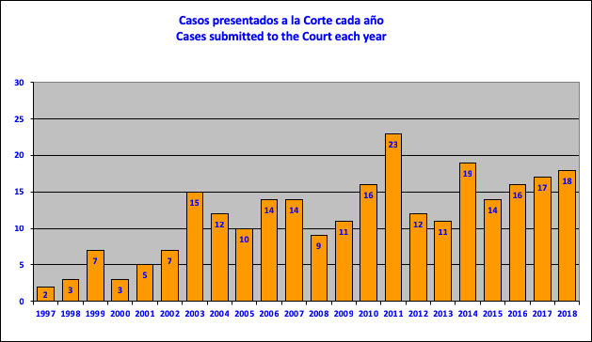

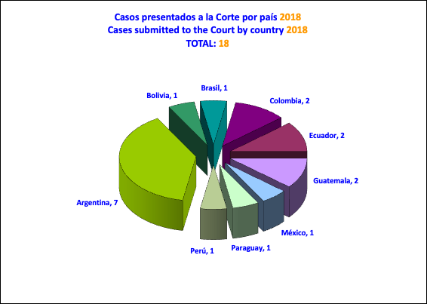

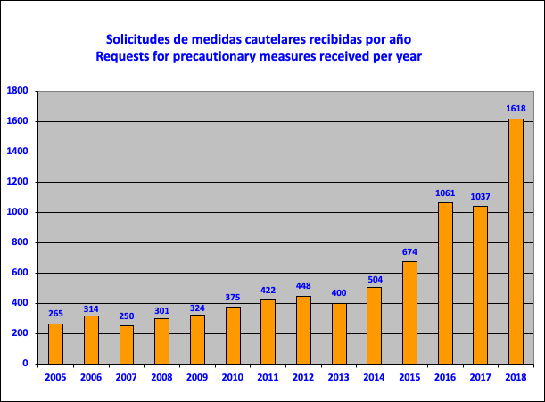

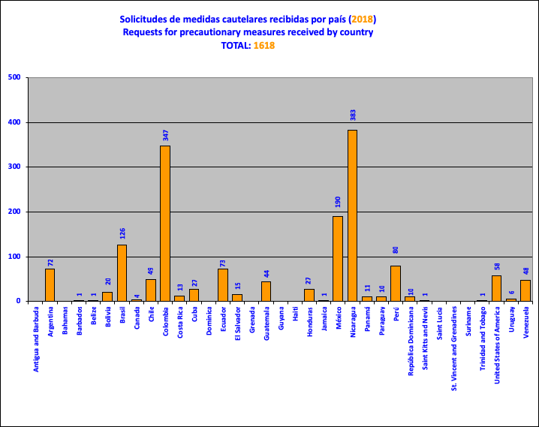

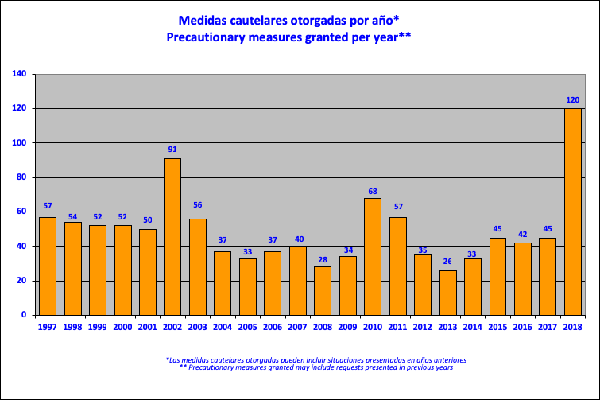

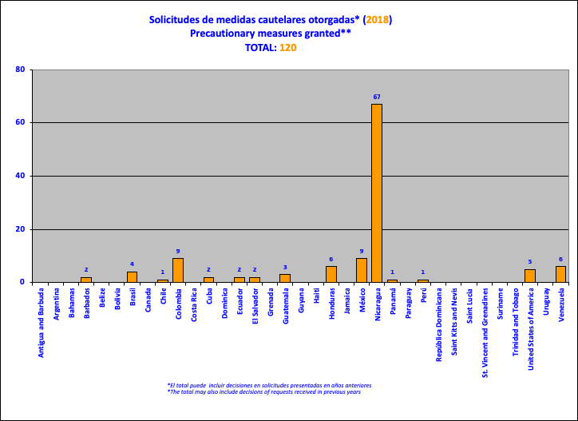

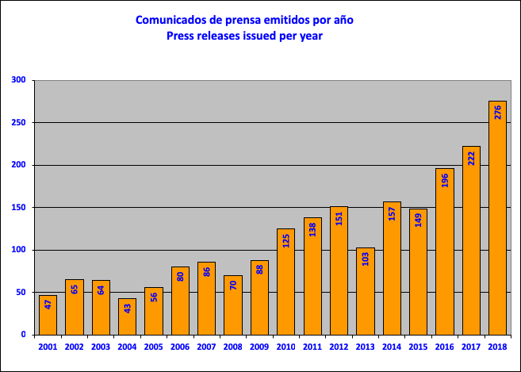
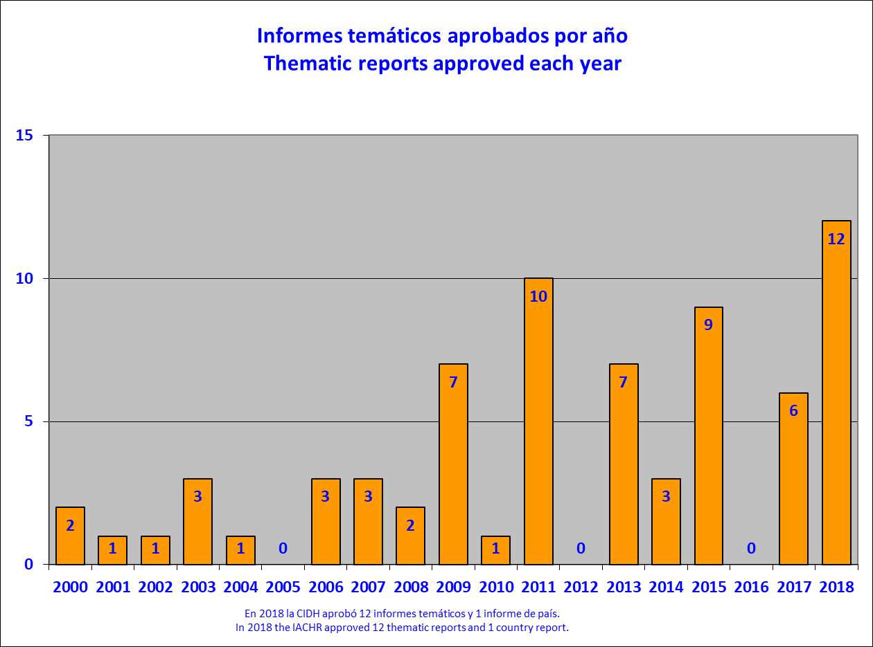

Decisions on admissibility, inadmissibility, the merits, friendly settlements, and archiving

- This section contains a total of 143 reports that include 118 reports on admissibility; 15 reports on inadmissibility; 5 reports on friendly settlement; and 4 reports on the merits published. It also contains a list of 152 petitions and cases archived by the IACHR.

Reports on admissibility

- Report No. 1/18, Petition 137-07, Mirta Elizabeth Canelo Castaño and family(Argentina)
- Report No. 2/18, Petition 656-08, Emilio Peón and family (Argentina)
- Report No. 3/18, Petition 1173-08, Diego Fabián Montesino (Argentina)
- Report No. 31/18, Petition 163-08, José Luis González and José Alberto Ramírez (Argentina)
- Report No. 32/18, Petition 355-08, Alberto Miguel Andrada and Jorge Osvaldo Álvarez (Argentina)
- Report No. 33/18, Petition 377-08, Amanda Graciela Encaje (Argentina)
- Report No. 34/18, Petition 1018-07, Guillermo Juan Tiscornia y Familia (Argentina)
- Report No. 132/18, Petition1225-12, Octavio Romero and Gabriel Gerbach (Argentina)
- Report No. 4/18, Petition 1519-08, Juan Carlos Encinas Mariaca and family (Bolivia)
- Report No. 5/18, Petition 1520-08, Carlos Quispe Quispe and family (Bolivia)
- Report No. 6/18, Petition 1172-09, Mario Francisco Tadic Astorga et al. (Bolivia)
- Report No. 145/18, Petition 1523-12, Eduardo Collen Laite et al. (Brazil)
- Report No. 163/18, Petition 1116-07, Paulo Igor do Nascimento Pinto et al.(Brazil)
- Report No. 186/18, Petition 683-08, Sidney da Silva et al. (Brazil)
- Report No. 35/18, Petition 31-07, Yasmín Eriksen Fernández Acuña (Chile)
- Report No. 36/18, Petition 837-07, Mapuche Huilliche “Pepiukelen” Indigenous Community (Chile)
- Report No. 37/18, Petition 1571-07, Patricio Germán García (Chile)
- Report No. 59/18, Petition 871-08, Tatiana Marisa Barría Mardones and B.B.A.B. (Chile)
- Report No. 91/18, Petition 574-07, Giorgio Vera Fernández (Chile)
- Report No. 134/18, Petition 1820-12, Margarita Elena López Beuzengerg and sons (Chile)
- Report No. 170/18, Petition 766-08, Julia Filomena Pérez Campana and Julio Fidel Flores Pérez (Chile)
- Report No. 38/18, Petition 140-09 (Colombia) - María G. and family (Colombia)
- Report No. 39/18, Petition 196-07, José Ricardo Parra Hurtado, Félix Alberto Páez Suárez and relatives (Colombia)
- Report No. 40/18, Petition 607-07, Nelson Enrique Giraldo Ramírez and family (Colombia)
- Report No. 41/18, Petition 644-08, Regina Betancur de Liska (Colombia)
- Report No. 42/18, Petition 663-07, Families Displaced from the Hacienda Bellacruz (Colombia)
- Report No. 43/18, Petition 705-07, Neri Luz Martínez Padilla and daughters (Colombia)
- Report No. 44/18, Petition 840-07, Pijiguay Massacre (Colombia)
- Report No. 45/18, Petition 1494-07, John Jairo Restrepo (Colombia)
- Report No. 46/18, Petition 1638-12, Raiza Isabel Salazar (Colombia)
- Report No. 74/18, Petition 1271-08, Patricia Rodríguez Rodríguez et al. (Colombia)
- Report No. 75/18, Petition 442-07, José Humberto Gómez Herrera et al. (Colombia)
- Report No. 76/18, Petition 1453-08, Yaneth Valderrama and family(Colombia)
- Report No. 81/18, Petition 190-07, Edgar José Sánchez Duarte and family (Colombia)
- Report No. 82/18, Petition 551-07, Alcides Espinosa Ospino et al. (Colombia)
- Report No. 86/8, Petition 550-07: Luz Dary Roncancio Torres et al. and P-1357-08: Olga Lucía Ceballos Ramos (Colombia)
- Report No. 89/18, Petition 1110-07, Juan Simón Cantillo Raigoa, Keyla Sandrith Cantillo Vides and family (Colombia)
- Report No. 96/18, Petition 1293-07, Benedesmo Palacios Mosquera (Colombia)
- Report No. 97/18, Petition 1071-07, Naudin José Fajardo Martínez et al. (Masacre Los Kativos Farm) (Colombia)
- Report No. 103/18, Petition 703-07, Workers of SINTRAISA, SINTRAISAGEN and SINTRACHIVOR (Colombia)
- Report No. 104/18, Petition 221-08, Delis Palacio Herrón et al. (Masacre de Bojayá) (Colombia)
- Report No. 125/18 , Petition 556-07, Leopoldo José Antonio Porto Lagonterie (Colombia)
- Report No. 126/18, Petition 872-08, Luis Mariano Pertuz Lara and family (Colombia)
- Report No. 127/18, Petition 1500-07, Juan Camilo Vega Pérez and family (Colombia)
- Report No. 129/18, Petition 1256-07, Cornelio Antonio Isaza Arango et al. (Massacre of the El Retiro sawmill (Colombia)
- Report No. 131/18, Petition 537-09, Ana Isabel Florez Thera et al. (Colombia)
- Report No. 162/18, Petition 1472-08, Martha Lucia Klinger Rodríguez and family (Colombia)
- Report No. 164/18, Petition 1448-08, Levis Elcener Centeno Cuero and family (Colombia)
- Report No. 165/18, Petition 995-07, Julián Alberto Toro Ortiz and family (Colombia)
- Report No. 171/18, Petition 926-08, Acosta Romero and family (Colombia)
- Report No. 174/18, Petition 1597-07, Hernando Alfredo López Gil (Colombia)
- Report No. 180/18, Petition 1616-07, A.G.A and relatives (Colombia)
- Report No. 47/18, Petition 975-07, Jasper McDonald Hamilton (Costa Rica)
- Report No. 175/18, Petition 571-08, Pompilio Campos Bonilla (Costar Rica)
- Report No. 7/18, Petition 310-08, Rogelio Miguel Ortiz Romero (Ecuador)
- Report No. 8/18, Petition 799-07, Servio Feliciano Peña Jiménez and Ramón Adalberto Zamora Zamora (Ecuador)
- Report No. 48/18, Petition 148-07, María Isabel Morán Bajaña (Ecuador)
- Report No. 49/18, Petition 1542-07, Juan Espinosa Romero (Ecuador)
- Report No. 140/18, Petition 1607-07, Carlos Julio Rodríguez Lasso (Ecuador)
- Report No. 168/18, Petition 101-07, Guillermo Noboa Molina (Ecuador)
- Report No. 185/18, Petition 967-10, G.C.A.M and son (Ecuador)
- Report No. 95/18, Petition 545-08, María Cristina Sagastizado, Carlos Roberto Rivera Sagastizado and Óscar Alexander Rivera Sagastizado (El Salvador)
- Report No. 177/18, Petition 1433-08, Mario Antonio Turcios Flores and family (El Salvador)
- Report No. 9/18, Petition 184-08, T.L. y Bernadette Taylor Lockett (United States)
- Report No. 173/18, Petition 1312-10, Nelson Mendoza (United States)
- Report No. 181/18, Petition 300-09, Ronald Bullock (United States)
- Report No. 190/18, Petition 468-08, Jesús Rodríguez Barrón (United States)
- Report No. 192/18, Petition 1506-08, Oswaldo Marcelo y otros (United States)
- Report No. 10/18, Petition 427-08, Comunidades Indígenas Maya Achí (Guatemala)
- Report No. 50/18, Petition 931-07, Edgar Alfredo Valdez López (Guatemala)
- Report No. 51/18, Petition 1779-12, Pueblos indígenas Maya Kaqchikuel de Sumpango, Sacatepéquez, Maya Achí de San Miguel Chicaj, Baja Verapaz, Maya Mam de Cajolá, Quetzaltenango, and Maya de Todos Santos de Cuchumatán, Huehuetenango (Guatemala)
- Report No. 72/18, Petition 1131-08, Moisés de Jesús Hernández Pinto and family (Guatemala)
- Report No. 161/18, Petition 14-08, Ana Patricia Pérez Jacobo de Rabbe (Guatemala)
- Report No. 172/18, Petition 1540-07, Hugo Aroldo Aguilar Barrios and family (Guatemala)
- Report No. 178/18, Petition 1522-08, Héctor René Reyes Pérez and family (Guatemala)
- Report No. 83/18, Petition 455-03, José Antonio Gutiérrez Navas et al. (Honduras)
- Report No. 84/18, Petition 2362-12, Leonela Zelaya (Honduras)
- Report No. 80/18, Petition 1850-11, Gareth Henry, Simone Carline Edwards and relatives (Jamaica)
- Report No. 11/18, Petition 134-07, Nicolás Tamez Ramírez (Mexico)
- Report No. 12/18, Petition 178-10, 48 Workers killed in the explosion at the Pasta de Conchos mine and their family members (Mexico)
- Report No. 13/18, Petition 345-08, Ángel García Casimiro (Mexico)
- Report No. 14/18, Petition 1057-07, Thelmo Reyes Palacios (Mexico)
- Report No. 15/18, Petition 1083-07, Héctor Galindo Gochicoa and family (Mexico)
- Report No. 52/18, Petition 253-10, Alejandro Fernando Aguilera Mendieta y otros (Mexico)
- Report No. 53/18, Petition 1348-08, Antonio López Cantú (Mexico)
- Report No. 73/18, Petition 1350-07, José Antonio Pérez Pérez (Mexico)
- Report No. 77/18, Petition 727-09, Fernando Tovar Rodríguez (Mexico)
- Report No. 79/18, Petition 1019-08, Armando Martínez Salgado and family (Mexico)
- Report No. 87/18, Petition 26-08, Gary Jay Calow (Mexico)
- Report No. 94/18, Petition 1402-10, Nadia Alejandra Muciño Márquez y familia (Mexico)
- Report No. 98/18, Petition 1345-07, Roque López Mendoza (Mexico)
- Report No. 99/18, Petition 1809-10, Elidia Sánchez Rodríguez y otros (Mexico)
- Report No. 166/18, Petition 1315-12, Efrén Cortes Chávez et al. (Masacre de El Charco) (Mexico)
- Report No. 102/18, Petition 1720-11, Ana Margarita Vijil Guardián (Nicaragua)
- Report No. 179/18, Petition 1360-11, Fabio Gadea Mantilla (Nicaragua)
- Report No. 88/18, Petition 1077-07, Panama Canal workers (Panama)
- Report No. 124/18, Petition 178-11, Ana Matilde Gómez Ruiloba (Panama)
- Report No. 90/18, Petition 1104-07, Amélia Alencar Bezerra de Menezes y Luis Heleno de Menezes and Souza (Paraguay)
- Report No. 139/18, Petition 359-14, Martín Almada and family (Paraguay)
- Report No. 16/18, Petition 884-07, Victoria Piedad Palacios Tejada de Saavedra (Peru)
- Report No. 17/18, Petition 1291-07, Edwin Javier Rivera Martínez (Peru)
- Report No. 54/18, Petition 64-08, Lita Natalia Sánchez Castillo (Peru)
- Report No. 55/18, Petition 354-08, Carlos Alberto Moyano Dietrich (Peru)
- Report No. 56/18, Petition 835-08, Blanca Imelda Arriaga Céspedes (Peru)
- Report No. 57/18, Petition 969-07, Karen Mañuca Quiroz Cabanillas (Peru)
- Report No. 58/18, Petition 1434-08, Rómulo Rubén Palma Rodríguez (Peru)
- Report No. 78/18, Petition 1025-07, Gregorio Cunto Guillén y otros (Peru)
- Report No. 101/18, Petition 476-07, Arturo Castillo Chirinos (Peru)
- Report No. 105/18, Petition 1278-07, Delmiro Carrasco Garcia (Peru)
- Report No. 128/18, Petition 435-07, Antonio Lucio Lozano Moreno (Peru)
- Report No. 142/18, Petition 239-08, Members of the National Association of Retired and Discharged Officials of the Judiciary (Peru)
- Report No. 143/18, Petition 940-08, Luis Américo Ayala González (Peru)
- Report No. 169/18, Petition 1044-07, Chuchón Castillo et al. (Peru)
- Report No. 176/18, Petition 1040-08, José Luis Altamirano Salvador (Peru)
- Report no. 182/18, Petition 9-07, Giovanna Marilú Anaya Nalvarte and family (Peru)
- Report No. 191/18, Petition 1405-08, Miguel Ángel Gómez Rodríguez (Peru)
- Report No. 100/18, Petition 770-08, Oscar Freddy Piastre Núñez (Uruguay)
- Report No. 188/18, Petition 894-08, Carlos Eduardo Giménez Colmenarez (Venezuela)

Reports on inadmissibility

- Report No. 135/18, Petition 1045-07, Enrique Alberto Elías Waiman (Argentina)
- Report No. 184/18, Petition 1304-07, Juan Carlos Aguilera Maldonado and Ricardo Federico Cortez Acosta (Argentina)
- Report No. 187/18, Petition 1255-08, Walter Esteban Ojeda (Argentina)
- Report No. 183/18, Petition 1493-09, María Vidalia Queba de Prieto (Colombia)
- Report No. 133/18, Petition 953-08, Jaime Ligator Feldman (Costa Rica)
- Report No. 18/18, Petition 1148-08, Mario Eugenio López Velasco (Ecuador)
- Report No. 144/18, Petition 1606-07, Jean Jocelyn Merilien (United States)
- Report No. 181/18, Petition 206-09, Juan Ayala (United States)
- Report No. 19/18, Petition 139-07, Juan Lome Rodríguez (Mexico)
- Report No. 20/18, Petition 1360-07, Julio Erasmo Tejada Pozo (Peru)
- Report No. 85/18, Petition 124-07, Miguel Alberto Salas Sánchez (Peru)
- Report No. 136/18, Petition 859-07, Manuel Jesús Aybar Marca (Peru)
- Report No. 137/18, Petition 1154-08, Leonardo López Amancio a (Peru)
- Report No. 141/18, Petition 350-08, Maximiliano Torres Quispe (Peru)
- Report No. 189/18, Petition 359-07, Vicente Rodolfo Walde Jauregui (Peru)

Reports on friendly settlements

  - Report No. 138/18, Petition 687-11, Gabriela Blas Blas and daughter C.B.B. (Chile)
  - Report No. 92/18, Case 12.941, Nicolasa and relatives (Colombia)
  - Report No. 93/18, Petition 799-06, Isidoro León Ramírez, Pompilio de Jesús Cardona Escobar, Luis Fernando Velásquez Londoño et al. (Colombia)
  - Report No. 167/18, Case 12.957, Luis Bolívar Hernández Peñaherrera (Ecuador)
  - Report No. 130/18, Case 12.699, Pedro Antonio Centurión (Paraguay)
  - Report No. 123/18, Petition 1516-08, Juan Figueroa Acosta (Peru)

Reports on the merits published

  - Report No. 122/18, Case 11.656, Marta Lucía Álvarez Giraldo (Colombia)
  - Report No. 92/18, Case 12.127, Vladimiro Roca Antunez et al. (Cuba)
  - Report No. 93/18, Case 12.958, Russell Bucklew (United States)
  - Report No. 121/18, Case 10.573, José Isabel Salas Galindo et al. (United States)

Archival decisions

- Pursuant to Articles 41 and 42 of the IACHR Rules of Procedure and Article 48(1)(b) of the American Convention, the IACHR archived the petitions and cases listed below due to the withdrawal of the petition or a lack of procedural activity from the petitioner of at least four years. Before archiving these matters, the Commission sent a notice to the petitioners’ addresses and confirmed that the petitioner did not respond, despite having been given sufficient time to do so.

N° | State | Number | Name
1 | Antigua & Barbuda | P-1022-07 | Alistair Greene and Jannis Reynolds-Greene
2 | Argentina | 12.010 | Children of the Paynemil Community, Mapuche Community, Neuquen Province
3 | Argentina | P-185-01 | Eduardo Fermín Elicabe
4 | Argentina | P-4415-02 | Alfredo Alfonso Magni
5 | Argentina | P-4420-02 | Claudio Rodolfo Jacod Piguela
6 | Argentina | P-181-03 | Yolanda Bustos de Olguin
7 | Argentina | P-662-03 | Héctor Eduardo Antonio
8 | Argentina | P-790-03 | Salvador Luis Gangi
9 | Argentina | P-286-05 | Benigno Enrique Videla, Vilma Francisca Loza, Rosana Beatriz Mattarollo and Alberto Pedro Saboulard
10 | Argentina | P-548-05 | Mirtha Haydee Sotomayor Méndez
11 | Argentina | P-613-05 | Luis Cosme Lezcano, Beatriz Fernández, Blanca Elisa Diaz de Delli Compagni, Alejandro Hosszu, Elvira Rosa Frenegal, Regina García de Anselmi, Mercedes Burgueño, Josefa Nélida Luján, Fulgencio Francisco Núñez, and others
12 | Argentina | P-956-05 | Luis Alberto Benitez Benitez
13 | Argentina | P-618-06 | Alan Daniel and Elián Andrés Pellegrino
14 | Argentina | P-785-06 | Juan Pedro Moreno
15 | Argentina | P-458-07 | Mario Di Nucci and Lucas Di Nucci
16 | Argentina | P-844-07 | Alicia Clara Larrea
17 | Argentina | P-1086-07 | Horacio Gustavo Espindola
18 | Argentina | P-1226-07 | Jorge Ismael Portillo
19 | Argentina | P-1367-07 | Fabiana Mariela Avallar and her children, Luciano and Florencia Manfredini
20 | Argentina | P-1370-07 | Hernán Federico Cantaro
21 | Argentina | P-457-08 | David Alberto Hayes and others
22 | Argentina | P-664-08 | Gerardo Zenobi
23 | Argentina | P-906-08 | María Eugenia Cirilo
24 | Argentina | P-1107-08 | Hugo Hector Palacio
25 | Argentina | P-442-09 | José Miguel Zorrilla
26 | Argentina | P-566-09 | Nilda Basilia Dure
27 | Argentina | 13.060* | Residents of Units 8 and 9 of the Building Complex 'Barrio Ejercito de los Andes' or 'Fuerte Apache'
28 | Argentina | 13.066 | Vida Mirta Levinzon
29 | Argentina | P-1098-03 | Mario Andrés Ayarde
30 | Bolivia | 12.938 | Javier Villanueva Martino
31 | Brazil | P-1277-07 | Flavio Mendes de Morais
32 | Brazil | P-1411-07 | Francisco de Sousa Geraldo
33 | Brazil | P-1608-07 | Débora Monteiro Silva
34 | Brazil | P-565-08 | Adilson de Freitas Vicente e outros
35 | Brazil | P-1247-08 | Nilson Saldanha
36 | Brazil | 12.858 | Marcio Manoel Fraga
37 | Brazil | 12.008 | Favela Vigario Geral
38 | Canada | P-1187-12 | Juan Manuel Sánchez Valdés
39 | Chile | P-574-03 | Mauricio Hernán Rojas Trincado
40 | Chile | P-936-06 | Silvana Goncalves Bravo
41 | Chile | P-1379-06 | Juan Patricio Negron Larre, Martín Humberto Hernández Vasquez, Miguel Retamal Maureira, Omar Barraza Diaz, Darío Ibañez Diaz, Ercides Martínez Mercado, Azucena Briones Soto, Ricardo Martínez Palma, Julio Aranguiz Romero, Gustavo Gonzalez Araya e Higinio Alfonso Espergue Cordoba
42 | Chile | P-1396-06 | Juan Bernardo Salinas Arce, Enrique Fernando Terán Pérez, Juan Enrique Robles Castro, Hernán Wilfredo Bravo Reyes and Oscar Nelson Robles Castro
43 | Chile | P-174-07 | Jose Ruden Neun and 82 indigenous Williche
44 | Chile | P-747-07 | Daniel Morales Salazar
45 | Chile | P-762-07 | María Zunilda Nauto Legue and 82 indigenous Williche of the Weketruamo community
46 | Chile | P-772-07 | Agrupacion No 3 Victims of Asbestos, Toxic Raw Materials and similar substances
47 | Chile | P-1305-08 | Fernando Olivares Mori
48 | Chile | P-1314-08 | Pedro Ángel Barrientos Riquelme
49 | Chile | P-551-09 | Carlos Patricio Millacura Yuduman
50 | Chile | P-561-09 | Alejandro Enrique Oro Quinteros
51 | Chile | P-827-09 | Yassim Ildefonso Acevedo Muñoz
52 | Chile | P-1209-09 | Reyna Limaco Espillco
53 | Chile | 12.409 | Luis Correa Bulo, Juan Luis Correa Bulo
54 | Colombia | 11.143 | María Mercedes Méndez de García, William Ocampo Ospina, Rosa Peña de Rodíguez, Pedro Angulo, Ernesto Serrato, Wilson Pardo
55 | Colombia | P-450-05 | Amalia Isabel Almarales Jiménez and others
56 | Colombia | P-1445-05 | Audes Esther Navarro Romero and others
57 | Colombia | P-94-06 | Geiner Ortiz Jiménez and others
58 | Colombia | P-290-06 | César Augusto López Leal
59 | Colombia | P-476-06 | Omar Castaño López and others
60 | Colombia | P-1246-06 | Renato Fabián Pardo Donado, José Jesús Gonzáles y José Domingo Onate, Renato Fabián Pardo Donado, José de Jesús Gonzalez and José Domingo Onate Benjume
61 | Colombia | P-595-07 | Alcibiades Orozco Orozco
62 | Colombia | P-1023-07 | Javier Saldarriaga Isaza
63 | Colombia | P-1379-07 | Walter Azuaga Nasser
64 | Colombia | P-1640-09 | Samuel Navia Moreno, Jhon Carlos Nocua Rueda, Samuel Navia Moreno, Jhon Carlos Nocua Rueda and Jhon Carlos Nocua Rueda
65 | Colombia | P-1590-07 | Carlos Alberto Duarte Angarita
66 | Colombia | P-328-08 | Pedro Luis Duque Duque
67 | Colombia | P-474-08 | William Antonio Rentería Córdoba and Francisco Antonio Chalá Moreno
68 | Colombia | P-510-08 | María Piedad Henao Arango and children
69 | Colombia | P-619-08 | Reinaldo Forero Murillo
70 | Colombia | P-1558-08 | José Gregorio Liberato Olaya
71 | Colombia | P-723-10 | Wilmar Albeiro Trujillo Vallejo and family
72 | Colombia | 13.023 | Jhonny Silva Aranguren
73 | Costa Rica | P-787-04 | Pablo Mendoza García, José Daniel Martínez Díaz
74 | Costa Rica | P-791-04 | Enrique Fallas Smith
75 | Costa Rica | P-851-04 | José Marcos Cedillos Cedillo
76 | Costa Rica | P-889-04 | Jorge Siles Garro
77 | Costa Rica | P-1009-04 | René Perlas Amador
78 | Costa Rica | P-1176-04 | Engels Salas Cáceres
79 | Costa Rica | P-1116-06 | Guglielmo Pedroni Masari
80 | Costa Rica | P-404-07 | Alberto Cabezas Villalobos
81 | Costa Rica | P-480-07 | Víctor Manuel Vargas Meneses
82 | Cuba | P-824-07 | Luis Guerra Juvier
83 | Ecuador | P-178-04 | Lilly, Deborah, Mónika, Sonia Mucarsel Gil
84 | Ecuador | P-901-07 | Luis Alberto Sabando Veliz
85 | Ecuador | P-102-10 | Leonardo Marcovix Pita García
86 | Ecuador | 12.715 | Wellington Geovanny Peñafiel Parraga
87 | Ecuador | 13.005 | Lider Efrén, José Raúl Jiménez Jiménez, Miguel Ángel, Manuel Antonio, Anter Oliver Jiménez Jiménez and others
88 | El Salvador | P-285-06 | Francisco Antonio Chávez Abarca
89 | El Salvador | 12.845 | René Mauricio Artiga Navarro, Antonio López Maldonado, Santiago Bermúdez, Carlos Alberto Ramírez, and others
90 | United States | P-295-05 | Kori Lynn Hansler
91 | United States | P-1207-05 | John Melvin Alexander et al.
92 | United States | P-744-06 | Tariq Aziz
93 | United States | P-1431-08 | Paul Pierre
94 | United States | P-161-09 | Antonio Zaldaña Ventura
95 | United States | P-806-09 | Talmedge L. Hayes
96 | United States | P-439-16 | Zenayda Del Carmen Sorto
97 | United States | 12.755 | Mossville Environmental Action Now and Mossville residents, Lorraine Cole, Sally Comeaux, Ollie Mae Hadnot, Dorothy Felix, Edgar Mouton, Jr., Diane Prince
98 | United States | 13.222 | Melissa L., Jesús L., and Yolanda L.R. (Undocumented Workers)
99 | Guatemala | P-950-04 | Jorge Mario Orozco Leal
100 | Guatemala | P-707-06 | Nicole Castillo Alejos
101 | Guatemala | P-1362-07 | Gerson Estuardo Reyes Gómez and Jeremías Fuentes López
102 | Guatemala | P-264-08 | Jorge Arturo Mazate Paz, Jorge Arturo Mazate Paz, Carlos Amilcar González Diaz y Audelio Diaz González
103 | Guatemala | P-265-08 | Moisés Esteban Santizo Ola, Waldemar Hidalgo Marroquín y Jaime Raúl Quezada Corzo
104 | Guatemala | P-266-08 | Carlos Enrique Chun Choc, Carlos Enrique Chun Choc, Gustavo Adolfo Carranza Castañeda y Ramiro Geovanni Padilla Marroquín
105 | Guatemala | P-273-08 | Antonio Israel Jiménez Godínez, Santos Hernández Torres, Miguel Ángel López Caló, Antonio Israel Jiménez Godínez, Santos Hernández Torres, Miguel Ángel López Caló, Adolfo Rodas Hernández y Dimas Samayoa García
106 | Guatemala | P-996-08 | Edgar Rudilio Ordoñez Martínez
107 | Guatemala | 13.329 | Elizabeth Vásquez Pérez de Orellana, Erick Alonso Orellana Ortega, Kelvin Alonso Orella Vásquez, Erick Esteban Ubaldo Orellana Vásquez
108 | Guatemala | 11.544 | Juan Humberto Ramos Cifuentes, Cecilio Jax
109 | Guatemala | 11.554 | Sergio Miguel Fuentes Chávez
110 | Guatemala | 12.020 | Juan José Mendez y otro
111 | Guatemala | 12.199 | Marcos Fidel Quisquinay
112 | Guatemala | 12.344 | Mario Federico Azmitia and others
113 | Haiti | P-1092-09 | A.B. et Rose Martha St Fleur
114 | Haiti | P-440-11 | G.S.
115 | Haiti | 12.566 | Jimmy Charles
116 | Honduras | P-642-06 | Oscar Kafati Kafati
117 | Honduras | P-177-08 | Roberto Isauro Becerra Lanza
118 | Jamaica | P-899-09 | Peter Rowe
119 | Mexico | P-4336-02 | Bernardo Ramos Reyes, David Montaño Concha, Dulce María Cruz Vázquez, Efrén A. Priego and others (workers of Petróleos Mexicanos)
120 | Mexico | P-509-03 | Guillermo Vélez Mendoza
121 | Mexico | P-1016-03 | Edmundo Ramírez Rodríguez
122 | Mexico | P-1226-04 | Retired, 41 Pensioners, Retired and Readjusted of Ingenio Independencia, Veracruz
123 | Mexico | P-89-06 | Mario Ernesto Villanueva Madrid
124 | Mexico | P-1326-06 | Alberto Sada Martínez
125 | Mexico | P-7-07 | Eustacio Aleman Zendejas and Juan Manuel Alvarado Sáenz
126 | Mexico | P-642-07 | Juan Francisco Pinales Hernández
127 | Mexico | P-1486-07 | Rómulo García Valerio
128 | Mexico | P-25-08 | Yordy Games Olivier
129 | Mexico | P-133-08 | Miguel Gutiérrez Reyes
130 | Mexico | P-197-08 | Elyahu Matalón
131 | Nicaragua | 12.628 | Wilmer Antonio González Rojas
132 | Peru | 12.121 | Asociacion del Personal Afecto al Sistema de Pensiones De Electroperu S. A.
133 | Peru | 12.262 | Genaro Delgado Parker
134 | Peru | P-824-98 | Martín Sinecio Nizama Carrión
135 | Peru | P-854-03 | Clara Cristina Lecca Vergara, Maura Celi Palomino, Oscar Abraham Malca Romero, Gloria Villavicencio de Minaya, and others
136 | Peru | P-966-03 | Felipe Sattler Zanatti
137 | Peru | P-224-05 | Javier Edgardo Zúñiga Talavera, Mauro Mori Moreno, Juan Manuel Orihuela Carhuancho and others
138 | Peru | P-488-07 | Mary Rosa King Jiménez, Carmela San Román Palavicini de Rodríguez, Jacqueline Noelia Soto Díaz, Augusto José Banda Quintana, Luis Gallegos Estrada, Gabriela Miluska Mendoza Pacherre and others
139 | Peru | P-829-07 | Nelson Saúl Manrique Gálvez
140 | Peru | P-1552-07 | Eduardo Gallardo Castro
141 | Peru | P-103-08 | Daniel Raul Lorenzzi Goycochea
142 | Peru | P-1278-08 | Antonio Guillermo Castro Arroyo
143 | Peru | P-765-10 | Juan Sebastián Pérez Carro and Pablo Pérez Carro
144 | Peru | 12.096 | Agustín Larios Verástigue
145 | Peru | 12.826 | Félix José Arce Apaza y Luis Enrique Quispe Vega
146 | Peru | 12.825 | Carlos Braulio Arana Franco
147 | Peru | 11.756 | Leonor La Rosa Bustamante, Peru
148 | Trinidad & Tobago | P-382-09 | Ronald Tiwarie
149 | Venezuela | P-709-01 | Pablo López Ulacio
150 | Venezuela | P-826-02 | Jesús Salvador Velásquez Torres
151 | Venezuela | P-763-05 | Juan Carlos Sánchez Ramos
152 | Venezuela | P-1112-05 | Henrique Capriles Radonski

Precautionary measures

- The precautionary measures mechanism is recognized in Article 25 of the IACHR Rules of Procedure. Under the Rules of Procedure, in serious or urgent situations the Commission may, on its own initiative or at the request of a party, request that a State adopt precautionary measures to prevent irreparable harm to persons or to the subject matter of a proceeding related to a pending petition or case. Such measures may be of a collective nature in order to prevent irreparable harm to persons or groups of persons. In this regard, the number of precautionary measures granted does not reflect the number of persons protected by their adoption. Moreover, the Rules of Procedure establish that the granting of such measures and their adoption by the State shall not constitute a prejudgment on the violation of the rights protected by the American Convention on Human Rights or other applicable instruments.

- This year the IACHR received a total of 1,618 requests for precautionary measures (the highest in its history) and managed to make a legal assessment of 90 percent of them in the light of the requirements contained in Article 25 of the Rules of Procedure. That amount was 50 percent higher than the previous year and more than double the number received in 2015. The Commission granted 120 precautionary measures in 2018, which was at once its highest number in one year, and the highest percentage of precautionary measures adopted (7.2 percent) relative to the number received since the amendment of its Rules of Procedure in 2013.

- Owing to the seriousness of the risk in which several requesters of precautionary measures found themselves, in 2018 the Commission granted a significant number of precautionary measures without first requesting information from the State, in accordance with the exception provided in Article 25.5 of the Rules of Procedure. In fact, the majority of precautionary measures granted this year (58 percent) were done so without a prior request for information to the State. In accordance with its Rules of Procedure, the Commission has analyzed the propriety of keeping the measures in effect.

- With the onset of the human rights crisis in Nicaragua, the IACHR installed a Rapid and Integrated Response Coordination Unit (SACROI) which evaluated around 400 requests for precautionary measures received in accordance with Article 25 of the Rules of Procedure. It is also worth noting that this year the Commission received a large number of requests for precautionary measures during on-site visits from applicants in highly vulnerable situations, which led to an increase in the use of technology to allow greater flexibility of access for applicants to provide an account of the risks they face submitted in the form of audio or video recordings.

- At the same time, despite the fact that the focus of a thorough analysis to determine propriety of granting a precautionary measure may not only be time-related, but also qualitative, in 2018 the Commission succeeded in substantially reducing its response time to the requests for precautionary measures that it granted. In that regard, the number of precautionary measures that were granted in less than a month after being requested rose from just 11 percent in 2017 to 44 percent in 2018 and will.

- In order to ensure the effectiveness of the precautionary measures mechanism and help expedite decision-making, on May 10, 2018, the IACHR adopted Resolution 3/2018 “Strengthening of the processing of requests for precautionary measures”. The resolution provides greater transparency for matters or claims that historically have consistently been considered not eligible for review under the precautionary measures mechanism because their analysis would require an examination of the merits of the matter, which is the purview of the system of individual cases and petitions. The IACHR also decided not to continue processing applications for precautionary measures in which a request for information made to the applicant had met with a lengthy silence. The foregoing strengthens the initial review methodology for requests received, ensuring greater predictability with respect to the scope of the mechanism while encouraging decisions to be adopted on matters with greater signs of risk.

- In order to ensure a timely response for precautionary measures applicants and bearing in mind the exponential increase in requests, from 2018 the complement of staff working in the Precautionary and Provisional Measures Section underwent a substantial increase, with the result that there was a doubling of both legal and administrative staff compared with the number that existed at the end of 2016.

- The following section covers the resolutions adopted on precautionary measures in 2018, the processing time for those requests, as well as working meetings and hearings held.

Resolutions adopted
- What follows is an overview of the precautionary measures granted (86) out of a total of 120 requested, as well as those extended (1), followed up (1) and lifted (8) under Article 25 of the Rules of Procedure of the IACHR It is worth noting that since the amendments to the Rules of Procedure adopted by the Inter-American Commission in Resolution 1/2013 of August 1, 2013, each summarized request for precautionary measures includes a link to the relevant resolution. These resolutions set forth the parameters used by the IACHR in determining compliance with the requirements of urgency, seriousness and irreparableness on a case by case basis. Precautionary measures granted in 2018 may include requests presented in previous years.

Argentina
PM No. |  | Name of beneficiaries | State | Date | Decision
PM 564/17 |  | Santiago Maldonado | Argentina | January 13, 2018 | Lifted
Barbados
PM 1047/17 |  | Dwayne Omar Severin and Jabari Sensimania Nervais | Barbados | May 5, 2018 | Granted
PM 1046/17 |  | Clyde Anderson Grazette | Barbados | May 5, 2018 | Granted
Brazil
PM 767/18 |  | Mônica Tereza Azeredo Benício | Brazil | August 1, 2018 | Granted
PM 1262/18 |  | Jean Wyllys De Matos Santos | Brazil | November 20, 2018 | Granted
PM 1358/18 |  | Joana D´Arc Mendes | Brazil | December 7, 2018 | Granted
PM 1489/18 |  | Andre Luiz Moreira da Silva | Brazil | December 31, 2018 | Granted
Chile
PM 975/17 | Children and adolescents of the SENAME Playa Ancha |  | Chile | March 15, 2018 | Granted
Colombia
PM 885/17 | Luz Angela Niño Chacón |  | Colombia | February 2, 2018 | Granted
PM 140/14 | Afro-descendent communities and leaders in Jiguamiandó, Curvaradó, Pedeguita and Mancilla |  | Colombia | February 7, 2018 | Extended
PM 400/15 | Members of the Governing Board of the Alto Mira y Frontera Community Council |  | Colombia | March 11, 2018 | Granted
PM 310/18 | Javier Ortega Reyes, Paúl Rivas Bravo & Efraín Segarra Abril |  | Colombia | April 12, 2018 | Granted
PM 21/05 | Manuel Enrique Vega Sarmiento |  | Colombia | May 5, 2018 | Partially lifted
PM 210/17 | Leaders of the Patriotic March Political and Social Movement |  | Colombia | May 5, 2018 | Granted
PM 739/17 | Daniel Silva Orrego |  | Colombia | May 5, 2018 | Granted
PM 99/10 | Tránsito Jurado, María Eugenia González, and Members of the Corporación Sisma Mujer |  | Colombia | April 15, 2018 | Lifted
PM 395/18 | Authorities and members of the Siona (ZioBain) indigenous people’s reservations Gonzaya (Buenavista) and Po Piyuya (Santa Cruz de Piñuña Blanco) |  | Colombia | July 14, 2018 | Granted
PM 175/18 | Giomar Patricia Riveros Gaitán |  | Colombia | August 27, 2018 | Granted
PM 301/13 | Buenaventura Hoyos Hernandez |  | Colombia | September 27, 2018 | Lifted
PM 283/18 | T.S.G.T. |  | Colombia | November 5, 2018 | Granted
PM 204/17 | Jani Silva, Hugo Miramar and Saúl Luna |  | Colombia | December 3, 2018 | Granted
Costa Rica
PM 617/15 | Gomez Murillo and others |  | Costa Rica | May 5, 2018 | Lifted
Cuba
PM 39/18 | Eduardo Cardet Concepción |  | Cuba | February 24, 2018 | Granted
PM 954/16 | Jose Ernesto Morales |  | Cuba | March 18, 2018 | Granted
Ecuador
PM 309/18 | Javier Ortega Reyes, Paúl Rivas Bravo & Efraín Segarra Abril |  | Ecuador | April 12, 2018 | Granted
PM 309/18 | Javier Ortega Reyes, Paúl Rivas Bravo & Efraín Segarra Abril |  | Ecuador | July 17, 2018 | Follow-up
PM 807/18 | Yaku Pérez Guartambel |  | Ecuador | August 27, 2018 | Granted
PM 30/14 | Fernando García et al. |  | Ecuador | December 3, 2018 | Lifted
El Salvador
PM 917/17 | Douglas Arquímides Meléndez Ruiz and family |  | El Salvador | February 24, 2018 | Granted
PM 170/18 | Óscar Álvarez Rubio |  | El Salvador | May 3, 2018 | Granted
United States
PM 334/18 | Charles Don Flores |  | United States | May 5, 2018 | Granted
PM 505/18 | Vilma Aracely López Juc de Coc and others |  | United States | August 16, 2018 | Granted
PM 731/18 | Migrant Children affected by the “Zero Tolerance” Policy |  | United States | August 16, 2018 | Granted
PM 82/18 | Ramiro Ibarra Rubi |  | United States | October 1, 2018 | Granted
PM 1357/18 | Judge Rotenber Educational Center |  | United States | December 3, 2018 | Granted
Guatemala
PM 860/17 | Indigenous families of the Chaab´il Ch´och’ community |  | Guatemala | January 25, 2018 | Granted
PM 872/17 | Families who have been evicted and displaced from the Maya Q’eqchi’ community Nueva Semuy Chacchilla |  | Guatemala | February 10, 2018 | Granted
PM 44/18 | Families of the Maya Q’eqchi’ community La Cumbre Sa’kuxhá |  | Guatemala | June 18, 2018 | Granted
Honduras
PM 1018/17 | Joaquín Mejía Rivera |  | Honduras | January 28, 2018 | Granted
PM 14/18 | Ericka Yamileth Varela Pavón and family |  | Honduras | February 24, 2018 | Granted
PM 772/17 | Locals who consume water from the Mezapa River |  | Honduras | February 24, 2018 | Granted
PM 54/18 | Germán Chirinos Gutiérrez |  | Honduras | March 8, 2018 | Granted
PM 374/17 | V.S.S.F. and others |  | Honduras | March 9, 2018 | Granted
PM 972/18 | Semma Julissa Villanueva Barahona and others |  | Honduras | August 12, 2018 | Granted
Mexico
PM 685/16 | Lucila Bettina Cruz and others |  | Mexico | January 4, 2018 | Granted
PM 361/17 | Tsotsil indigenous persons displaced from the Puebla communal land and members of the Ku’untik Center for Human Rights |  | Mexico | February 24, 2018 | Granted
PM 77/12 | Alberto Patishtán Gómez |  | Mexico | February 24, 2018 | Lifted
PM 882/17 | Tsotsil indigenous communities in Chalchihuitán and Chenalhó |  | Mexico | February 24, 2018 | Granted
PM 201/18 | Raffaele Russo, Antonio Russo and Vincenzo Cimmino |  | Mexico | March 16, 2018 | Granted
PM 48/18 | “M” |  | Mexico | April 2, 2018 | Granted
PM 1014/17 | U.V.O. indigenous girl and her family |  | Mexico | May 5, 2018 | Granted
PM 454/18 | Marbeli Vivani González López and family members of Yaneth González López |  | Mexico | September 6, 2018 | Granted
PM 5/15 | José Moisés Sánchez |  | Mexico | September 27, 2018 | Lifted
PM 1165/18 | Sergio López Cantera |  | Mexico | October 18, 2018 | Granted
PM 1375/18 | Daniel Ramírez Contreras |  | Mexico | December 28, 2018 | Granted
Nicaragua
PM 884/17 | Elea Valles Aguilar and her children |  | Nicaragua | February 24, 2018 | Granted
PM 472/18 | Bosco René Bermúdez |  | Nicaragua | May 21, 2018 | Granted
PM 1365/-18 | Brandon José Cruz |  | Nicaragua | May 21, 2018 | Granted
PM 1339/18 | Fernanda Porto Carrero |  | Nicaragua | May 21, 2018 | Granted
PM 1340/18 | Fernando José Sánchez Zeledón |  | Nicaragua | May 21, 2018 | Granted
PM 1341/18 | Ángel Gabriel Rocha Amador |  | Nicaragua | May 21, 2018 | Granted
PM 1342/18 | Víctor Agustín Cuadras Andino |  | Nicaragua | May 21, 2018 | Granted
PM 1343/18 | Lesther Lenin Alemán Alfaro |  | Nicaragua | May 21, 2018 | Granted
PM 1344/18 | Iskra Guisselle Malespín Sevilla |  | Nicaragua | May 21, 2018 | Granted
PM 1345/18 | Judith Belen Mairena |  | Nicaragua | May 21, 2018 | Granted
PM 1346/18 | Mildred Gisselle Rayo Ramírez |  | Nicaragua | May 21, 2018 | Granted
PM 1351/18 | Madelaine Jerusalem Caracas Marín |  | Nicaragua | May 21, 2018 | Granted
PM 1347/18 | Manuel López Gutiérrez |  | Nicaragua | May 21, 2018 | Granted
PM 1348/18 | Kevin Rodrigo Espinoza Gutiérrez |  | Nicaragua | May 21, 2018 | Granted
PM 476/18 | J.A.M.R. and others |  | Nicaragua | May 21, 2018 | Granted
PM 748/18 | Gloria María Cajina Machado, Norman Bismarck Alméndarez Carballo, Miguel Ángel Parajon Aburto, Yader de los Ángeles Parajón Gutiérrez, and the children M. P. V. and B. A. P. V. |  | Nicaragua | May 21, 2018 | Granted
PM 1354/18 | Jonny Winston Lezama Sevilla and family |  | Nicaragua | May 21, 2018 | Granted
PM 1355/18 | Jeyris Geovany Soza Vilchez |  | Nicaragua | May 21, 2018 | Granted
PM 1364/18 | Child W.D.G |  | Nicaragua | May 21, 2018 | Granted
PM 403/18 | Danilo Antonio Martínez Rodríguez |  | Nicaragua | May 21, 2018 | Granted
PM 1356/18 | Héctor Josué Parajon Márquez, Ana Luz Paragón Márquez and family |  | Nicaragua | May 21, 2018 | Granted
PM 653/18 | Erika Socorro Sánchez Ucera |  | Nicaragua | May 21, 2018 | Granted
PM 499/18 | Silvio Báez Ortega |  | Nicaragua | May 29, 2018 | Granted
PM 660/18 | Edwin Heriberto Román Calderón and Álvaro Leiva Sánchez |  | Nicaragua | June 5, 2018 | Granted
PM 663/18 | José Alberto Idiáquez Guevara |  | Nicaragua | June 10, 2018 | Granted
PM 669/18 | Migueliuth Sandoval Cruz and the family of journalist Ángel Eduardo Gahona |  | Nicaragua | June 12, 2018 | Granted
PM 661/18 | Ricardo Adán Velásquez Robleto |  | Nicaragua | June 17, 2018 | Granted
PM 626/18 | Alex Iván Aguirre Mairena |  | Nicaragua | June 17, 2018 | Granted
PM 615/18 | Jasson Osnar Hernández |  | Nicaragua | June 17, 2018 | Granted
PM 562/18 | Edwin Antonio Jiménez Balladares |  | Nicaragua | June 17, 2018 | Granted
PM 776/18 | Isaac de Jesús Molina Rojas |  | Nicaragua | July 1, 2018 | Granted
PM 921/16 | Marco Antonio Carmona and others |  | Nicaragua | July 2, 2018 | Granted
PM 520/18 | Marco Antonio Carmona and others |  | Nicaragua | July 2, 2018 | Granted
PM 693/18 | Anibal Toruño Jirón and other members of the news outlet Radio Darío |  | Nicaragua | July 2, 2018 | Granted
PM 778/18 | Janeth Velasquez Lopez and family |  | Nicaragua | July 7, 2018 | Granted
PM 628/18 | Julio Cesar Espinoza Cardoza |  | Nicaragua | June 30, 2018 | Granted
PM 671/18 | Félix Alejandro Maradiaga Blandón |  | Nicaragua | July 9, 2018 | Granted
PM 836/18 | Edwin Manuel Acevedo Hernández, José Dolores Borge Porra and Manuel Hernández Vega |  | Nicaragua | July 9, 2018 | Granted
PM 840/18 | Rodrigo Alejandro Rodríguez Arguello et al. |  | Nicaragua | July 17, 2018 | Granted
PM 841/18 | V.S.Z.S. and family |  | Nicaragua | July 17, 2018 | Granted
PM 779/18 | Katherine Manuela Estrada Téllez et al. |  | Nicaragua | July 17, 2018 | Granted
PM 893/18 | Maria Nelly Rivas and family |  | Nicaragua | July 25, 2018 | Granted
PM 868/18 | Cristhian Rodrigo Fajardo Caballero |  | Nicaragua | July 25, 2018 | Granted
PM 819/18 | Yubrank Miguel Suazo Herrera et al. |  | Nicaragua | July 25, 2018 | Granted
PM 777/18 | Daniery Emanuel Rodríguez Espinoza |  | Nicaragua | July 25, 2018 | Granted
PM 850/18 | Yaritzha Juddyth Roustrán Mairena, Joselyn Andrea Urbina Corea, and Levis Josué Artola Rugama |  | Nicaragua | July 25, 2018 | Granted
PM 871/18 | Sandra Inés Ramos López |  | Nicaragua | July 25, 2018 | Granted
PM 918/18 | Participants in the National Dialogue in representation of the private sector in the Civic Alliance for Justice and Democracy |  | Nicaragua | August 3, 2018 | Granted
PM 847/18 | Adelaida Sánchez Mercado and family |  | Nicaragua | August 8, 2018 | Granted
PM 738/18 | Braulio José Abarca Aguilar |  | Nicaragua | August 8, 2018 | Granted
PM 737/18 | Meyling Johana Gutierrez Pérez and Glenda Maria Arteta Arauz |  | Nicaragua | August 8, 2018 | Granted
PM 736/18 | Haydée Isabel Castillo Flores |  | Nicaragua | August 8, 2018 | Granted
PM 981/18 | Daisy Reymunda George West, Juan Carlos Ocampo Zamora, Reverend Marvin Hodgson, and their families |  | Nicaragua | August 10, 2018 | Granted
PM 984/18 | Nahomy Doris Urbina Marcenaro ("Másha") and her family |  | Nicaragua | August 15, 2018 | Granted
PM 929/18 | Cristian Ernesto Medina Sandino and family |  | Nicaragua | August 23, 2018 | Granted
PM 1033/18 | Bismarck de Jesus Martinez Sanchez |  | Nicaragua | September 6, 2018 | Granted
PM 939/18 | Yerling Marina Aguilera Espinoza and Jéssica del Socorro Cisneros Poveda |  | Nicaragua | September 17, 2018 | Granted
PM 1067/18 | Ana Otilia Quirós Víquez and 14 other human rights defenders |  | Nicaragua | September 17, 2018 | Granted
PM 1130/18 | Monica Lopez Baltodano and family |  | Nicaragua | September 27, 2018 | Granted
PM 469/18 | Edwin José Carcache Dávila and his family |  | Nicaragua | September 27, 2018 | Granted
PM 1172/18 | Medardo Mairena and Lerner Fonseca |  | Nicaragua | October 15, 2018 | Granted
PM 1133/18 | Women deprived of their liberty at the penitentiary center "La Esperanza" |  | Nicaragua | November 11, 2018 | Granted
PM 873/18 | Miguel Mora Barberena, Leticia Gaitan Hernandez and their families |  | Nicaragua | December 13, 2018 | Granted
PM 1606/18 | Carlos Fernando Chamorro Barrios and others |  | Nicaragua | December 21, 2018 | Granted
PM 823/18 | Manuel Eduardo Tijerino |  | Nicaragua | December 28, 2018 | Granted
PM 1051/18 | Erick Juriel Murillo Pavón |  | Nicaragua | December 28, 2018 | Granted
PM 698/18 | Álvaro Lucio Montalván and his family |  | Nicaragua | December 29, 2018 | Granted
Panama
PM 490/18 | M.B.B.P. |  | Panama | October 15, 2018 | Granted
Peru
PM 81/18 | Náthaly Sara Salazar Ayala |  | Peru | April 8, 2018 | Granted
Venezuela
PM 1039/17 | Child patients of Nephrology Area of Hospital José Manuel de los Ríos |  | Venezuela | February 21, 2018 | Granted
PM 798/17 | Juan Carlos Murillo |  | Venezuela | June 8, 2018 | Granted
PM 862/18 | Luis Humberto de la Sotta Quiroga |  | Venezuela | October 3, 2018 | Granted
PM 145/18 | 43 HIV/AIDS patients |  | Venezuela | October 4, 2018 | Granted
PM 688/18 | Pedro Patricio Jaimes Criollo |  | Venezuela | October 4, 2018 | Granted
PM 1039/18 | Juan Carlos Requesens Martinez |  | Venezuela | October 11, 2018 | Granted

- What follows are summaries of the resolutions adopted in 2018, by country.

ARGENTINA

PM 546/16 - Santiago Maldonado, Argentina - (Lifted)

- On January 13, 2018, the IACHR decided to lift the precautionary measure granted on August 22, 2016, to Santiago Maldonado in Argentina. In resolution 32/2017 the Commission requested that Argentina adopt the necessary measures to determine the status and whereabouts of Santiago Maldonado, in order to protect his rights to life and personal integrity. As a result of his death, the Commission considered that the measures no longer had any purpose, so it decided to lift the precautionary measure.

BARBADOS

PM 1047/17 - Dwayne Omar Severin and Jabari Sensimania Nervais, Barbados

- On May 5, 2018, the IACHR moved to request the adoption of precautionary measures in favor of Dwayne Omar Severin and Jabari Sensimania Nervais in Barbados. The request for precautionary measures alleges that the proposed beneficiaries are prisoners at Her Majesty's Prisons in Dodds, St. Philip, after being convicted and sentenced to the obligatory imposition of the death penalty by hanging, and that they are currently on death row. After analyzing the legal and factual allegations, the IACHR considers that the information presented demonstrates, prima facie, that the beneficiaries are in a situation of serious and urgent risk. Consequently, in keeping with Article 25 of the IACHR’s Rules of Procedure, the Commission asked Barbados to refrain from applying the death penalty that has been imposed on Clyde Dwayne Omar Severin and Jabari Sensimania Nervais until the IACHR makes a decision on their petition; to adopt any measures necessary to preserve beneficiaries’ lives and personal integrity; and to come to an agreement with beneficiaries and their representatives regarding any measures that need to be taken.

PM 1046/17 - Clyde Anderson Grazette, Barbados

- On May 5, 2018, the IACHR moved to request the adoption of precautionary measures in favor of Anderson Grazette in Barbados. The request for precautionary measures alleges that the proposed beneficiary is a prisoner at Her Majesty's Prisons in Dodds, St. Philip, after being convicted and sentenced to the obligatory imposition of the death penalty by hanging, and that he is currently on death row. After analyzing the allegations of fact and law, the IACHR believes that the information that has been put forward proves, in principle, that the beneficiary is at grave risk. Consequently, in keeping with Article 25 of the IACHR’s Rules of Procedure, the Commission asked Barbados to refrain from applying the death penalty that has been imposed on Clyde Anderson Grazette until the IACHR makes a decision on his petition; to adopt any measures necessary to preserve the beneficiary’s life and personal integrity; and to come to an agreement with the beneficiary and his representatives regarding any measures that need to be taken.

BRAZIL

PM 767/18 - Mônica Tereza Azeredo Benício, Brazil

- On August 1, 2018, the IACHR decided to request that precautionary measures be adopted on behalf of Mônica Tereza Azeredo Benício in Brazil. The request for precautionary measures alleges that the proposed beneficiary is in a situation of risk after denouncing the murder on March 14, 2018, of the human rights defender Marielle Franco. Mônica Tereza Azeredo Benício was Marielle Franco’s partner and is continuing her work and legacy in defense of the rights of women, members of the LGBTI community, people of African descent, and young people in deprived areas. After analyzing the allegations of fact and law, the IACHR considers that the information presented demonstrates, prima facie, that the beneficiary is in a serious and urgent situation. Consequently, in accordance with Article 25 of the IACHR Rules of Procedure, the Commission requested Brazil to adopt the necessary measures to protect the rights to life and well-being of the beneficiary, as well as to ensure that she is able to continue her work as a human rights defender without being the target of threats, harassment, or acts of violence in the course of that work. The IACHR also requested that the measures to be adopted be agreed upon with the beneficiary and any potential representatives and that it report on the steps taken to investigate the facts that gave rise to the adoption of this precautionary measure.

PM 1262/18 – Jean Wyllys de Matos Santos and his family, Brazil

- On November 20, 2018, the IACHR decided to grant precautionary measures in favor of Jean Wyllys de Matos Santos and his family in Brazil. The request for precautionary measures alleges that Jean Wyllys is at risk after receiving a series of death threats based on his sexual orientation and his work in favor of the LGBTI community in Brazil. After assessing the legal and factual allegations, the IACHR considers that the information that has been submitted shows, in principle, that the beneficiary faces a situation of grave and urgent risk. Consequently, in keeping with Article 25 of the IACHR’s Rules of Procedure, the Commission asked the Brazilian State to take any measures necessary to protect the rights to life and personal integrity of Jean Wyllys de Matos Santos and his family; to come to an agreement with beneficiaries and their representatives regarding any measures that need to be taken; and to report on any actions taken to investigate the events that gave rise to the adoption of this precautionary measure, to prevent such events from happening again in the future.

PM 1358/18 - Joana D'Arc Mendes, Brazil

- On December 7, 2018, the IACHR decided to grant precautionary measures in favor of Joana D'Arc Mendes, in Brazil. The request for precautionary measures alleges that Joana D'Arc Mendes would be at risk after receiving a series of threats and harassment allegedly related to her work as a human rights defender and the search for justice in the case of her son, allegedly murdered by the police, as well as the complaints filed against militia groups. After analyzing the legal and factual allegations, the IACHR considers that the information presented demonstrates, prima facie, that the beneficiary is in a situation of serious and urgent risk. Consequently, in accordance with Article 25 of the IACHR's Rules of Procedure, the Commission requested Brazil to adopt the necessary measures to protect the right to life and personal integrity of Joana D'Arc Mendes; to agree on the measures to be adopted with the beneficiary and her representative; and to report on the actions taken to investigate the facts that gave rise to the adoption of this precautionary measure and thus avoid its repetition.

PM 1489/18 – Andre Luiz Moreira da Silva, Brazil

- On December 31, 2018, the IACHR decided to grant precautionary measures in favor of Andre Luiz Moreira da Silva in Brazil. The request for precautionary measures alleges that, on September 22, 2018, Andre Luiz Moreira da Silva, who worked as a Military Police officer in Rio de Janeiro, was in his car with his partner and two children when he was intercepted by armed persons. His family was released, but the attackers allegedly took Andre Luiz Moreira da Silva with them. In the morning of September 23, police officers from his department allegedly found the proposed beneficiary’s car, which had been burned. The request alleges that there is a context of violence by “militias” against police officers in the city of Rio de Janeiro, allegedly with the support of “corrupt police officers,” and that such groups committed the alleged deeds. The request notes that the proposed beneficiary’s whereabouts remain unknown and that the authorities have failed to report on any progress made by the investigation. After assessing the legal and factual allegations, the Commission considers that Andre Luiz Moreira da Silva faces a situation of grave and urgent risk, since his rights to life and personal integrity risk suffering irreparable damage. Consequently, in keeping with Article 25 of the IACHR’s Rules of Procedure, the Commission asked the Brazilian State to take any measures necessary to protect the rights to life and personal integrity of Andre Luiz Moreira da Silva and, in particular, to establish his whereabouts and fate; to come to an agreement with the beneficiary’s representative regarding any measures that need to be taken; and to report on any actions taken to investigate the alleged events that gave rise to the adoption of this precautionary measure, to prevent such events from happening again in the future.

CHILE

PM 975/17 - Children and adolescents held at the facility known as Centro de Reparación Especializada de Administración Directiva (CREAD) in Playa Ancha, Chile

- On March 15, 2018, the IACHR moved to request the adoption of precautionary measures in favor of children and adolescents held at the facility known as Centro de Reparación Especializada de Administración Directiva (CREAD) in Playa Ancha, Chile. The request for precautionary measures alleges that the proposed beneficiaries are at risk after being subjected to ill-treatment and torture, among other acts of violence. The Commission noted the actions taken by the State to address the situation at the CREAD in Playa Ancha, in a context that includes court decisions, a plan for improvements and the move to shut down the facility. The Commission observed that such measures are programmatic and, at present, do not allow the IACHR to establish whether they are suitable and effective to protect those children and adolescents from the risks they allegedly face. Consequently, in keeping with Article 25 of the IACHR’s Rules of Procedure, the Commission asked Chile to take any measures necessary to preserve the lives and personal integrity of the children and adolescents held at the CREAD in Playa Ancha, in compliance with international standards on the issue and with the best interests of those children and adolescents in mind; to adopt any measures necessary to ensure that the conditions in which children and adolescents are held reflect the applicable international standards, while the State takes effective action to promote, through individual plans, those children’s return to their families—whenever that is possible and compatible with the children’s best interests— or to identify alternative care that ensures better protection and reflects the specific protection needs derived from those beneficiaries’ status as children, again bearing in mind their best interests; to come to an agreement with beneficiaries and their representatives regarding any measures that need to be taken; and to report on any actions taken to investigate the alleged events that gave rise to the adoption of this precautionary measure, to prevent such events from happening again in the future.

COLOMBIA

PM 885/17 - Luz Angela Niño Chacón, Colombia

- On February 2, 2018, the IACHR moved to request the adoption of precautionary measures in favor of Luz Angela Niño Chacón in Colombia. The request for precautionary measures alleges that the proposed beneficiary, who has metastatic facial and skin cancer, is not receiving adequate medical treatment despite having court decisions in her favor, and notes that her health condition is critical. After analyzing the allegations of fact and law, the IACHR considers that the information presented demonstrates, prima facie, that the beneficiary is in a serious and urgent situation. Consequently, in keeping with Article 25 of the IACHR’s Rules of Procedure, the Commission asked Colombia to adopt any measures necessary to preserve the health, life and personal integrity of Angela Niño Chacón, by providing medical assistance suitable for her health problems, in accordance with applicable international standards; and to come to an agreement with the beneficiary and her representatives regarding any measures that need to be taken.

PM 140/14 - Afro-descendant communities and leaders in Jiguamiandó, Curvaradó, Pedeguita and Mancilla, Colombia EXTENSION

- On February 7, 2018, the IACHR moved to extend precautionary measures in favor of the residents of the Curvaradó, Jiguamiandó, Pedeguita and Mancilla Afro-descendant communities in Colombia, including the leaders of those communities. The request for an extension alleges that the proposed beneficiaries—community leaders and the entire communities of Jiguamiandó, Curvaradó, Pedeguita and Mancilla—are at risk after being subjected to acts of violence including threats and harassment. After analyzing the legal and factual allegations, the IACHR considers that the information presented demonstrates, prima facie, that the beneficiaries are in a situation of serious and urgent risk. Consequently, in keeping with Article 25 of the IACHR’s Rules of Procedure, the Commission decided to extend this precautionary measure and asked Colombia to take any measures necessary to preserve the lives and personal integrity of the people who live in the Afro-descendant communities of Curvaradó, Jiguamiandó, Pedeguita and Mancilla, including leaders Manuel Denis Blandón, Félix Alvarado, Erasmo Sierra, Benjamín Sierra, Rumualdo Salcedo, Melkín Romaña, Maria Ligia Chaverra, Argemiro Bailarín, Eustaquio Polo, Eleodoro Polo, Yomaira Gonzalez and James Ruíz; to take any measures necessary to enable beneficiaries who are leaders to do their work as human rights defenders without being subjected to threats, harassment and other acts of violence; and to come to an agreement with beneficiaries and their representatives regarding any measures that need to be taken.

PM 400/15 - Members of the Governing Board of the Alto Mira y Frontera Community Council, Colombia

- On March 11, 2018, the IACHR moved to request the adoption of precautionary measures in favor of members of the Governing Board of the Alto Mira y Frontera Community Council (CCAMF, by its Spanish acronym) in Colombia. The request for precautionary measures alleges that the proposed beneficiaries are at risk after being subjected to threats, harassment and intimidation by armed actors, based on their defense of their territory and on their voluntary substitution of illicit crops in the framework of the Peace Agreements. After analyzing the legal and factual allegations, the IACHR considers that the information presented demonstrates, prima facie, that the beneficiaries are in a situation of serious and urgent risk. Consequently, in keeping with Article 25 of the IACHR’s Rules of Procedure, the Commission asked Colombia to adopt any measures necessary to preserve the lives and personal integrity of members of the Governing Board of Alto Mira y Frontera Community Council; and to adopt culturally appropriate protection measures that enable members of the CCAMF Governing Board to be able to carry out their tasks following CCAMF’s own self-government rules, without being subjected to threats, harassment or any other acts of violence. Such measures should be combined with more thorough efforts by the country’s security forces and with the adoption of more comprehensive, coordinated measures that might include: ensuring the safe presence of members of the Board within CCAMF, enabling their safe passage, and strengthening communication mechanisms to respond to emergency situations. The Commission further asked Colombia to come to an agreement with beneficiaries and their representatives regarding any measures that need to be taken, and to report on any actions adopted to investigate the alleged events that gave rise to the adoption of this precautionary measure, in order to prevent such events from happening again in the future.

PMs 309/18 and 310/18 - Javier Ortega Reyes, Paúl Rivas Bravo and Efraín Segarra Abril, Colombia and Ecuador

- On April 12, 2018, the IACHR moved to request the adoption of precautionary measures in favor of Javier Ortega Reyes, Paúl Rivas Bravo and Efraín Segarra Abril, in Colombia and Ecuador. The request for precautionary measures alleges that the proposed beneficiaries, members of a journalistic team, were kidnapped by a splinter group of the Revolutionary Armed Forces of Colombia (FARC, by their Spanish acronym) on March 26, 2018, in the border area between the two countries, and notes that the country where beneficiaries are currently being held remains uncertain. After analyzing the legal and factual allegations, the IACHR considers that the information presented demonstrates, prima facie, that the beneficiaries are in a situation of serious and urgent risk. Consequently, in keeping with Article 25 of the IACHR’s Rules of Procedure, the Commission asked Colombia and Ecuador to take any measures necessary to preserve beneficiaries’ lives and personal integrity; to adopt any measures necessary for them to be able to do their journalistic work in the enjoyment of their freedom of expression, without being subjected to intimidation, threats and other acts of violence; and to report on any actions taken to investigate the alleged events that gave rise to the adoption of this precautionary measure.

MC 617-15 Gómez Murillo et al., Costa Rica - (Lifted)

- On May 5, 2018, the IACHR decided to lift the precautionary measure granted on January 29, 2016, to Gómez Murillo and others in Costa Rica. The Commission requested the State of Costa Rica to adopt the necessary measures to make the IVF technique immediately accessible to the couples identified in the resolution granting this precautionary measure; and to agree the measures to be adopted with the beneficiaries and their representatives. In its decision to grant precautionary measures, the IACHR took into consideration that the six beneficiary couples were victims in Report on Merits 12.798 adopted by the IACHR on January 29, 2015. In that report, among other recommendations, the IACHR requested the State of Costa Rica to “[l]ift the prohibition of in vitro fertilization in the country through the corresponding legal procedures” and to “[m]ake full reparations to the victims in the present case.” On August 4, 2016, the parties signed a friendly settlement agreement that was submitted to the Inter-American Court of Human Rights. In its judgment of November 29, 2016, the Court found that the parties had reached “a friendly settlement agreement that includes the acknowledgment by the State of the facts and human rights violations alleged by the representative and the Commission,” and therefore it considered it appropriate to ratify that agreement. Based on the foregoing, the State requested the IACHR to lift these precautionary measures. Given the change in circumstances and the lack of any information contradicting the state, the commission finds that it lacks sufficient evidence to determine that the requirements as to seriousness, urgency, and risk of irreparable harm that originally prompted the adoption of the precautionary measures continue to be met; therefore it is appropriate to lift them.

PM 210/17 - Leaders of the Patriotic March Political and Social Movement, Colombia

- On May 5, 2018, the IACHR moved to request the adoption of precautionary measures in favor of the 389 people regarded as “leaders” of the movement known as MAPA in Colombia. The request for precautionary measures alleges that they have been subjected to threats, harassment and other acts of violence over several years, mainly by illegal armed groups who allegedly persecute them for political reasons. The request for precautionary measures further highlights the alleged murders of 156 members of MAPA between 2011 and 2018. After analyzing the legal and factual allegations, the IACHR considers that the information presented demonstrates, prima facie, that the beneficiaries are in a situation of serious and urgent risk. Consequently, in keeping with Article 25 of the IACHR’s Rules of Procedure, the Commission asked Colombia to take any measures necessary to preserve beneficiaries’ lives and personal integrity; to come to an agreement with the beneficiaries and their representatives regarding any measures that need to be taken; and to report on any actions taken to investigate the alleged events that gave rise to the adoption of this precautionary measure, to prevent such events from happening again in the future.

PM 739/17 - Daniel Silva Orrego, Colombia

- On May 5, 2018, the IACHR moved to request the adoption of precautionary measures in favor of Daniel Silva Orrego in Colombia. The request for precautionary measures alleges that the proposed beneficiary is at risk as a result of his journalistic work, and argues that the scheme in place to protect him is ineffective and inadequate. After assessing the legal and factual allegations, the IACHR considers that the information that has been submitted shows, in principle, that the beneficiary faces a situation of grave and urgent risk. Consequently, in keeping with Article 25 of the IACHR’s Rules of Procedure, the Commission asked Colombia to adopt any measures necessary to preserve the beneficiary’s life and personal integrity. In particular, Colombia should ensure that protection measures in place are effective and adequate and reflect the applicable international standards; take any measures necessary for the beneficiary to be able to do his work as a journalist without being subjected to intimidation, threats and other acts of violence for doing such work; and to report on any actions taken to investigate the alleged events that gave rise to the adoption of this resolution—considering the context for their implementation—to prevent such events from happening again in the future.

PM 99/10 - Tránsito Jurado, María Eugenia González, and Members of the Corporación Sisma Mujer

- On April 8, 2010, the IACHR granted precautionary measures for Tránsito Jurado, María Eugenia González, her minor children, and the members of the Corporación Sisma Mujer, in Colombia. The Commission asked Colombia to adopt the necessary measures to guarantee the life and personal integrity of María Eugenia González, her minor children, Tránsito Jurado, and the members of the Corporación Sisma Mujer The Commission received information about steps taken to protect the beneficiaries and notes that the applicants said that the circumstances that led the measures to be granted have changed in the five years since they were adopted, and that as a result they did not consider it necessary for the measures to remain in effect. Both the representatives and the State have requested that the precautionary measures be lifted. At the same time, the Commission has no information to suggest that there is an ongoing situation of risk of irreparable harm to the rights of the beneficiaries such as to warrant keeping the measures in place. As the requirements as to seriousness, urgency, and risk of irreparable harm that originally prompted the adoption of the precautionary measures are no longer met, the Commission decided to lift them.

PM 395/18 - Authorities and members of the Siona (ZioBain) indigenous people’s reservations Gonzaya (Buenavista) and Po Piyuya (Santa Cruz de Piñuña Blanco), Colombia

- On July 14, 2018, the IACHR decided to grant precautionary measures in favor of the authorities and families of the Siona (ZioBain) indigenous people’s reservations Gonzaya (Buenavista) and Po Piyuya (Santa Cruz de Piñuña Blanco), in Colombia. The request for precautionary measures alleges that the proposed beneficiaries are being subjected—in their own territory—to threats, harassment and other acts of violence by armed attackers who seek to impose their will on that of indigenous authorities and to set rules that restrict the movement of the proposed beneficiaries. Similarly, the request for precautionary measures reports the presence of anti-personnel landmines and other explosive devices in the area, as well as the recruitment of young indigenous persons. The request also mentions the risks faced by certain Siona authorities and leaders. After analyzing the legal and factual allegations, the IACHR considers that the information presented demonstrates, prima facie, that the beneficiaries are in a situation of serious and urgent risk. Consequently, in keeping with Article 25 of the IACHR’s Rules of Procedure, the Commission asked Colombia to adopt any measures necessary to preserve the lives and personal integrity of Siona authorities and families in the Siona reservations Gonzaya and Po Piyuya; to adopt culturally appropriate protection measures so that they can live safely within their territory, without being subjected to threats, harassment or any other acts of violence (such measures should include, beyond the efforts of the security forces, enabling them to move safely to perform cultural or subsistence tasks, removing explosives present in their territory or disproving their existence, preventing the recruitment of young people and making it impossible, and strengthening communication mechanisms to respond to emergency situations); to adopt culturally appropriate measures to enable Siona authorities to fulfil their mandates safely and in accordance with their own rules and government system; to come to an agreement with beneficiaries and/or their representatives regarding any measures that need to be adopted, in keeping with the Siona people’s own decision-making mechanisms and self-government system; and to report on any actions adopted to investigate the alleged events that gave rise to this precautionary measure, in order to prevent them from happening again in the future.

MC 175/18—Giomar Patricia Riveros Gaitán, Colombia

- On September 27, 2018, the IACHR decided to request the adoption of precautionary measures in favor of Giomar Patricia Riveros Gaitán, in Colombia. The request for precautionary measures alleges that the beneficiary, a human rights defender and a representative of the National Committee of Victims, has been receiving threats in relation to her work. After analyzing the allegations of fact and law, the IACHR considers that the information presented demonstrates, prima facie, that the beneficiary is in a serious and urgent situation. Consequently, in accordance with Article 25 of the IACHR’s Rules of Procedure, the Commission requested that Colombia take the necessary steps toward guaranteeing the rights to life and personal integrity of Giomar Patricia Riveros Gaitán; that it guarantee that Giomar Patricia Riveros Gaitán can continue to go about her work as a human rights defender without suffering threats, harassment, or acts of violence in the course of doing so; that it determine the measures to be implemented in consultation with the beneficiary and her representatives; and that it report on the actions it takes to investigate the allegations that led to the adoption of this precautionary measure, so as to prevent them from being repeated.

PM 301/13 – Buenaventura Hoyos Hernández, Colombia

- On September 27, 2018, the IACHR decided to lift the precautionary measure granted on October 4, 2013, to Buenaventura Hoyos Hernández in Colombia. The Commission requested Colombia to adopt the necessary measures to determine the status and whereabouts of Buenaventura Hernández Hoyos, in order to protect his rights to life and personal integrity, and to report on the actions taken to investigate the alleged facts that led to the adoption of the precautionary measure. The commission has taken note of the various efforts made by the State to establish the beneficiary’s whereabouts and observes that there is no contradiction between the representatives and the State with regard to the fact that Buenaventura Hoyos Hernández has been at liberty since 2014. The Commission’s finds that the circumstances that led to the adoption of these precautionary measures have changed and it has received no information from the parties to suggest the existence of a situation of serious and urgent risk of irreparable harm to the beneficiary’s rights, as established at Article 25 of the Rules of Procedure. Accordingly, the Commission decided to lift the precautionary measures.

PM 283/18 - T.S.G.T., Colombia

- On November 5, 2018, the IACHR decided to grant precautionary measures in favor of the child T.S.G.T., in Colombia. His identity is kept confidential in view of the Commission’s practice of not revealing the identity of children and adolescents. The request filed by petitioners alleged that four-year-old T.S.G.T. suffers from the "Othara-West” and “Lennox-Gastaut” syndromes, incurable diseases with grave consequences. In particular, applicants claimed that the child is in a serious risk since the medical treatment he is receiving is not adequate. After analyzing the allegations in fact and in law, the IACHR considered that the information presented shows, prima facie, that the beneficiary is in a situation of seriousness and urgency, given that he might face an imminent and irreparable harm. Consequently, in accordance with Article 25 of the IACHR's Rules of Procedure, the Commission requested Colombia to adopt the necessary measures to safeguard the life, personal integrity and health of T.S.G.T. In particular, it considered it urgent that a medical board be immediately carried out in accordance with the indications of the beneficiary's treating physicians, and that the State guarantee access to adequate medical treatment following the assessment of the relevant experts. The IACHR also requested that the measures to be adopted be agreed with the beneficiary and his representatives.

PM 204-17 - Jani Silva, Hugo Miramar and Saúl Luna (Leaders of the Perla Amazónica Peasant Reserve Zone), Colombia

- On December 3, 2018, the IACHR decided to request the adoption of precautionary measures in favor of Jani Silva, Hugo Miramar, and Saúl Luna (Leaders of the Perla Amazónica Peasant Reserve Zone), in Colombia. The request for precautionary measures filed on March 23, 2017 alleged that the rights to life and personal integrity of 800 families in the Perla Amazónica Peasant Reserve Zone, located in Puerto Asís, Putumayo, were at risk due to alleged impact of extractive operations carried out in the "Platanillo Block," which allegedly overlaps the Reserve Zone. It also requested that the rights of Jani Silva (legal representative of the Perla Amazónica-ADISPA Association for Sustainable Integral Development of the Reserve Zone), Hugo Miramar (husband of Jani Silva), and Saúl Luna (prosecutor of ADISPA of the Reserve Zone), and of the inhabitants of the communities, hamlets and/or “veredas” of the Reserve Zone, be protected against the actions of illegal armed groups in the zone. After analyzing the factual and legal allegations of the parties, in light of the specific context in which they allegedly took place, the Commission considers that Jani Silva, Hugo Miramar and Saúl Luna are, in principle, in a situation of gravity and urgency, since their rights to life and personal integrity are at risk. Consequently, in accordance with article 25 of its Rules of Procedure, the Commission requests the State of Colombia to take the necessary measures to guarantee the rights to life and personal integrity of Jani Silva, Hugo Miramar and Saúl Luna. The Commission considers it pertinent that, in addition to the security forces deepening their efforts and coordination in the protection of the beneficiaries, they ensure that the measures to be implemented are culturally appropriate, taking into account that Jani Silva and Hugo Miramar are members of the same family, as well as the importance of guaranteeing the safe presence of the leaders within the Reserve Zone, given the role they play. The IACHR requested that the State agree on the measures to be implemented with the beneficiaries and their representatives and to report on the actions taken in order to investigate the alleged facts that led to the adoption of this resolution and thus avoid its repetition.

COSTA RICA

MC 617-15 Gómez Murillo et al., Costa Rica - (Lifted)

- On May 5, 2018, the IACHR decided to lift the precautionary measure granted on January 29, 2016, to Gómez Murillo and others in Costa Rica. The Commission requested the State of Costa Rica to adopt the necessary measures to make the IVF technique immediately accessible to the couples identified in the resolution granting this precautionary measure; and to agree the measures to be adopted with the beneficiaries and their representatives. In its decision to grant precautionary measures, the IACHR took into consideration that the six beneficiary couples were victims in Report on Merits 12.798 adopted by the IACHR on January 29, 2015. In that report, among other recommendations, the IACHR requested the State of Costa Rica to “[l]ift the prohibition of in vitro fertilization in the country through the corresponding legal procedures” and to “[m]ake full reparations to the victims in the present case.” On August 4, 2016, the parties signed a friendly settlement agreement that was submitted to the Inter-American Court of Human Rights. In its judgment of November 29, 2016, the Court found that the parties had reached “a friendly settlement agreement that includes the acknowledgment by the State of the facts and human rights violations alleged by the representative and the Commission,” and therefore it considered it appropriate to ratify that agreement. Based on the foregoing, the State requested the IACHR to lift these precautionary measures.

CUBA

PM 39/18 - Eduardo Cardet Concepción, Cuba

- On February 24, 2018, the IACHR moved to request the adoption of precautionary measures in favor of Eduardo Cardet Concepción in Cuba. The request for precautionary measures alleges that the proposed beneficiary, who is being deprived of his liberty at a maximum security prison, was recently attacked by other inmates and, despite the injuries he suffered, is not receiving adequate medical care. After assessing the legal and factual allegations, the IACHR considers that the information that has been submitted shows, in principle, that the beneficiary faces a situation of grave and urgent risk. Consequently, in keeping with Article 25 of the IACHR’s Rules of Procedure, the Commission asked Cuba to take any measures necessary to protect the life and personal integrity of Eduardo Cardet Concepción and to ensure he has access to adequate medical care to suit his needs; to come to an agreement with the beneficiary and his representatives regarding any measures that need to be taken; and to report on any actions taken to investigate the events that gave rise to the adoption of this precautionary measure, to prevent such events from happening again in the future.

PM 954/16 - José Ernesto Morales Estrada, Cuba

- On March 18, 2018, the IACHR moved to request the adoption of precautionary measures in favor of José Ernesto Morales Estrada in Cuba. The request for precautionary measures alleges that the beneficiary is at risk for his activities as a human rights defender. After analyzing the legal and factual allegations, the IACHR considers that the information presented demonstrates, prima facie, that the beneficiaries are in a situation of serious and urgent risk. Consequently, in keeping with Article 25 of the IACHR’s Rules of Procedure, the Commission asked Cuba to take any measures necessary to preserve the life and personal integrity of José Ernesto Morales Estrada and to enable him to do his work as a human rights defender and an independent lawyer without being subjected to harassment and other acts of violence for doing such work; to come to an agreement with the beneficiary and his representatives regarding any measures that need to be taken; and to report on any actions taken to investigate the alleged events that gave rise to the adoption of this precautionary measure, to prevent such events from happening again in the future.

ECUADOR

PMs 309/18 and 310/18 - Javier Ortega Reyes, Paúl Rivas Bravo and Efraín Segarra Abril, Colombia and Ecuador

- On April 12, 2018, the IACHR moved to request the adoption of precautionary measures in favor of Javier Ortega Reyes, Paúl Rivas Bravo and Efraín Segarra Abril, in Colombia and Ecuador. The request for precautionary measures alleges that the proposed beneficiaries, members of a journalistic team, were kidnapped by a splinter group of the Revolutionary Armed Forces of Colombia (FARC, by their Spanish acronym) on March 26, 2018, in the border area between the two countries, and notes that the country where beneficiaries are currently being held remains uncertain. After analyzing the legal and factual allegations, the IACHR considers that the information presented demonstrates, prima facie, that the beneficiaries are in a situation of serious and urgent risk. Consequently, in keeping with Article 25 of the IACHR’s Rules of Procedure, the Commission asked Colombia and Ecuador to take any measures necessary to preserve beneficiaries’ lives and personal integrity; to adopt any measures necessary for them to be able to do their journalistic work in the enjoyment of their freedom of expression, without being subjected to intimidation, threats and other acts of violence; and to report on any actions taken to investigate the alleged events that gave rise to the adoption of this precautionary measure.

MC 807/18—Yaku Pérez Guartambel, Ecuador

- On August 27, 2018, the IACHR decided to request the adoption of precautionary measures in favor of Yaku Pérez Guartambel, who identifies as a member of the Cañari indigenous group in Ecuador. The request alleges that the beneficiary is at risk due to his work as a defender of the rights of indigenous people and the environment, as his stance against the mining industry has been discredited by sectors that identify as being “pro-mining,” who have allegedly threatened him. After analyzing the allegations of fact and law, the IACHR considers that the information that has been put forward proves, in principle, that Yaku Pérez Guartambel is at grave risk. Consequently, in accordance with Article 25 of the IACHR’s Rules of Procedure, the Commission requested that Ecuador take the necessary steps toward guaranteeing the rights to life and personal integrity of the beneficiary; that it take all culturally appropriate steps necessary to guarantee that Yaku Pérez Guartambel can continue to go about his work as a human rights defender without suffering threats, harassment, or acts of violence in the course of doing so; that it determine the measures to be implemented in consultation with the beneficiary and his representatives; and that it report on the actions it takes to investigate the allegations that led to the adoption of this precautionary measure, so as to prevent them from being repeated.

PM 30/14 - Fernando Alcibíades Villavicencio Valencia and others, Ecuador - (Lifted)

- On December 3, 2018, the IACHR decided to lift the precautionary measure granted on March 24, 2014, for Fernando Alcibíades Villavicencio Valencia, Cléver Jiménez, and Carlos Eduardo Figueroa Figueroa in Ecuador. The request for precautionary measures was submitted in the context of individual petition P-107-14, which alleged violations of rights enshrined in the American Convention on Human Rights. The petitioners asked for precautionary measures “in order for the State to suspend the implementation of the cassation ruling issued against them on January 14, 2014, due to the grave and irreparable harm the process itself and the subsequent judgment would have on their rights to life, physical integrity, personal liberty, political rights, and freedom of expression.” The foregoing, after Cléver Jiménez and Fernando Alcibíades Villavicencio were sentenced, among other penalties, to 18 months imprisonment for “judicial libel” as a result of expressions contained in a complaint filed against the then-president of the Republic of Ecuador Rafael Correa, with the Office of the Attorney General. Carlos Eduardo Figueroa, for his part, was reportedly sentenced to six months in prison. The IACHR decided to grant the measure and requested the State of Ecuador to immediately suspend the effects of the January 14, 2014, decision issued by the Cassation Court of the National Court of Justice’s Specialized Chamber on Criminal, Military-Criminal, Police-Criminal, and Transit Matters, until the IACHR has ruled on individual petition P-107-14. 16. According to information provided by the State, in respect of which the representatives did not provide any additional information, the proceeding that led this precautionary measure to be granted is “closed.” At the same time, with regard to a related judicial decision in a civil proceeding, a judge ruled in 2017, that Mr. Villavicencio was not in a state of insolvency and ordered the restoration of his rights. Likewise, with regard to the situation of Carlos Figueroa, the Commission notes that the State said that there is no record of any judicial proceeding that disqualified him or otherwise restricted any of his rights, and it highlighted the fact that Mr. Figueroa was actually running as a candidate for the Council for Citizen Participation and Societal Oversight. With respect to Cléver Jiménez, neither of the parties provided any information about his current situation. In the light of these circumstances and given that the purpose of this precautionary measure known longer exists, inasmuch as the criminal proceeding that would have led to the deprivation of the beneficiaries’ liberty is closed, the Commission decided to lift this precautionary measure.

EL SALVADOR

PM 917/17 - Douglas Arquímides Meléndez Ruíz and family, El Salvador

- On February 24, 2018, the IACHR moved to request the adoption of precautionary measures in favor of Douglas Arquímides Meléndez Ruíz and his family in El Salvador. The request for precautionary measures alleges that the proposed beneficiary, El Salvador’s Attorney General, is receiving threats against his life and personal integrity as well as his family’s, for investigations and proceedings he is leading that target high-ranking politicians, former public officials, businesspeople, the security forces and various criminal groups. After analyzing the legal and factual allegations, the IACHR considers that the information presented demonstrates, prima facie, that the beneficiaries are in a situation of serious and urgent risk. Consequently, in keeping with Article 25 of the IACHR’s Rules of Procedure, the Commission asked El Salvador to take any measures necessary to preserve the lives and personal integrity of Douglas Arquímides Meléndez Ruíz and his family and to enable him to do his work as a El Salvador’s Attorney General independently, without being subjected to intimidation, threats and harassment; to come to an agreement with beneficiaries and their representatives regarding any measures that need to be taken; and to report on any actions taken to investigate the alleged events that gave rise to the adoption of this precautionary measure, to prevent such events from happening again in the future.

PM 170/18 - Óscar Álvarez Rubio, El Salvador

- On May 3, 2018, the IACHR moved to request the adoption of precautionary measures in favor of Óscar Álvarez Rubio in El Salvador. The request for precautionary measures alleges that the proposed beneficiary was deported from the United States when he became an adult and that his whereabouts are unknown since January 4, 2018, after several young men forced him out of his home. After assessing the legal and factual allegations, the IACHR considers that the information that has been submitted shows, in principle, that the beneficiary faces a situation of grave and urgent risk. Consequently, in keeping with Article 25 of the IACHR’s Rules of Procedure, the Commission asked El Salvador to take any measures necessary to protect the rights to life and personal integrity of Óscar Álvarez Rubio and, in particular, to establish his whereabouts and fate; and to report on any actions taken to investigate the alleged events that gave rise to the adoption of this precautionary measure.

UNITED STATES

PM 334/18 - Charles Don Flores, United States

- On May 5, 2018, the IACHR moved to request the adoption of precautionary measures in favor of Charles Don Flores in the United States. This precautionary measure was granted with both a custody dimension, regarding conditions of detention on death row and the potential application of the death penalty, and a precautionary dimension, since, if Flores is executed before the Commission has had the opportunity to assess his petition, its final decision would be ineffective: Flores’ execution would constitute concrete irreparable damage. After assessing the legal and factual allegations, the IACHR considers that the information that has been submitted shows, in principle, that the beneficiary faces a situation of grave and urgent risk. Consequently, in keeping with Article 25 of the IACHR’s Rules of Procedure, the Commission asked the United States to adopt any measures necessary to preserve Charles Don Flores’ life and personal integrity; to refrain from applying the death penalty until the Commission makes a decision on his petition; to ensure conditions of detention that reflect international standards; and to come to an agreement with the beneficiary and his representatives regarding any measures that need to be taken.

PM 505/18 - Vilma Aracely López Juc de Coc and others, United States of America

- On August 16, 2018, the IACHR decided to request the adoption of precautionary measures in favor of Vilma Aracely López Juc de Coc and her son S.V.C.L.; Antonio Bol Pauu and his son R.B.S.; María Andrés de la Cruz and her three children D.P.A., G.A.P.P. and D.M.P.A.; and Dagoberto A. Melchor Santacruz and his son K.A.M.A., in the United States of America. The request for precautionary measures alleges that the proposed beneficiaries were separated by the authorities once they were detained upon their irregular entry into U.S. territory at the border with Mexico, in Texas. The children were reportedly held under custody of the Department of Health and Human Service Office of Refugee Resettlement (ORR), while their parents were being detained at different facilities, facing administrative and judicial proceedings. After assessing the legal and factual allegations, the IACHR considers that the information that has been submitted shows, in principle, that the beneficiary faces a situation of grave and urgent risk. Consequently, in accordance with Article 25 of the IACHR's Rules of Procedure, the Commission requested the United States of America to adopt the necessary measures to safeguard the rights to family life, personal integrity and identity of the beneficiaries. Particularly, guaranteeing that such rights are safeguarded by means of the reunification of the above-mentioned families and the best in accordance with the best interest of the children. The IACHR also requested to adopt the necessary measures, while the reunification is carried out, to immediately guarantee an appropriate, free, and regular communication between the beneficiaries and their families, in accordance with their best interests. Moreover, with the aim of protecting their rights, provide medical and psychological assistance, among others that might be necessary such as consular assistance. Also, provide interpreting services when necessary so that the proposed beneficiaries know their rights and have a good understanding of their situation and destination. In case any of the proposed beneficiaries was deported separately from their children, adopt immediately the necessary measures in the framework of international cooperation to guarantee their reunification, taking into account the child’s best interest and the necessary support and care. In addition, to suspend any immigration proceeding that may result in the separation of the children from their parents, and to agree on the measures to be adopted with the beneficiaries and their representatives.

PM 731/18 – Migrant Children affected by the “Zero Tolerance” Policy, United States of America

- On August 16, 2018, the IACHR decided to request the adoption of precautionary measures in favor of the children that have been separated from their parents as a result of the “Zero Tolerance” policy, who are under the custody of the Office of Refugee Relocation, comprising 572 children on the date of the decision to grant the precautionary measure, according to official information of the State of the United States of America. The request for precautionary measures presented by the National Human Rights Institutions of Mexico, Colombia, Ecuador, Guatemala, El Salvador and Honduras alleges that the separation of children from their parents could cause irreparable harm to their rights, particularly in the context of the children’s best interest. After assessing the legal and factual allegations, the IACHR considers that the information that has been submitted shows, in principle, that the beneficiary faces a situation of grave and urgent risk. Consequently, in accordance with Article 25 of the IACHR's Rules of Procedure, the Commission requested the United States to adopt the necessary measures to guarantee the rights of the family, to humane treatment, and to identity of the proposed beneficiaries. In particular, to ensure protection of those rights by reuniting the children with their biological families and supporting their best interests as children. The IACHR also requested the United States to adopt the necessary measures, while the reunification is carried out, to immediately guarantee an appropriate, free, and regular communication between the beneficiaries and their families, in accordance with their best interests. Moreover, with the aim of protecting their rights, provide medical and psychological assistance, among others that might be necessary such as consular assistance. Also, provide interpreting services when necessary so that the proposed beneficiaries know their rights and have a good understanding of their situation and destination. In case any of the proposed beneficiaries was deported separately from their children, adopt immediately the necessary measures in the framework of international cooperation to guarantee their reunification, taking into account the child’s best interest and the necessary support and care. In addition, it requested the suspension of any immigration proceeding that might result in the separation of the children from their parents, and that any measures to be adopted be agreed upon with the beneficiaries and their representatives.

PM 82/18 - Ramiro Ibarra Rubi, United States

- On October 1, 2018, the IACHR decided to request the adoption of precautionary measures in favor of Ramiro Ibarra Rubi, in the United States. The request for precautionary measures alleges that the beneficiary of Mexican nationality is currently on death row after being sentenced to death for crimes committed in 1987. This request is linked to petition P-162-18, in which petitioners denounce violations of article I (right to life, liberty, and security of person), article II (right to equality before the law), article XVIII (right to justice), article XIX (right to nationality), article XXV (right to protection against arbitrary detention), and article XXVI (right to a fair trial) of the American Declaration of the Rights and Duties of Man. After assessing the legal and factual allegations, the IACHR considers that the information that has been submitted shows, in principle, that the beneficiary faces a situation of grave and urgent risk. Consequently, in accordance with Article 25 of the IACHR's Rules of Procedure, the Commission requested the United States to adopt the necessary measures to preserve the life and personal integrity of Ramiro Ibarra Rubí; to refrain from carrying out the death penalty imposed on him; to guarantee conditions of detention that are compatible with international standards; and to agree on the measures to be adopted with the beneficiary and his representatives.

PM 1357/18, Judge Rotenberg Educational Center, United States of America

- On December 3, 2018, the IACHR moved to request the adoption of precautionary measures in favor of all persons with disabilities at the Judge Rotenberg Educational Center in the United States of America. The request alleged that the proposed beneficiaries were at risk due to the use of the treatments they are allegedly being subjected to at the institution, which include the use of electric shocks and restraint techniques, despite the beneficiaries’ medical conditions. After assessing the legal and factual allegations, the IACHR considers that the information that has been submitted shows, in principle, that the beneficiary faces a situation of grave and urgent risk. Consequently, in accordance with Article 25 of the IACHR’s Rules of Procedure, the Commission requested that the United States of America take the necessary steps toward protecting the rights to life and personal integrity of the beneficiaries, particularly by guaranteeing the immediate termination of the use of any harmful measures, including that of electroconvulsive therapies in the circumstances described in this resolution; that it determine the measures to be adopted in consultation with the beneficiaries and their representatives; and that it take the necessary steps to investigate the events that gave rise to the adoption of this resolution and thus prevent them from being repeated.

GUATEMALA

PM 860/17 - Indigenous families of the Chaab´il Ch´och’ community, Guatemala

- On January 25, 2018, the IACHR moved to request the adoption of precautionary measures in favor of the indigenous families of the Chaab´il Ch´och’ community in Guatemala. The request for precautionary measures alleges that the community—formed by families who fled the internal armed conflict from various places in Alta Verapaz after being persecuted and deprived of their land—is at risk after being evicted on October 30, 2017 from an area known as Finca Santa Isabel, which Lisbal S.A. claims is its property. After analyzing the legal and factual allegations, the IACHR considers that the information presented demonstrates, prima facie, that the beneficiaries are in a situation of serious and urgent risk. Consequently, in keeping with Article 25 of the IACHR’s Rules of Procedure, the Commission asked Guatemala to take any measures necessary to protect the rights to life and personal integrity of indigenous families of the Chaab´il Ch´och’ community, through culturally appropriate measures aimed at improving conditions (regarding, among other things, sanitation, health and food, particularly for children, women and older persons); and to come to an agreement with beneficiaries and their representatives regarding any measures that need to be taken, considering the importance of safeguarding beneficiaries’ cultural identity as members of the Maya-Q’eqchi’ community.

PM 872/17 - Families who have been evicted and displaced from the Maya Q’eqchi’ community Nueva Semuy Chacchilla, Guatemala

- On February 10, 2018, the IACHR moved to request the adoption of precautionary measures in favor of the evicted and displaced families of the Maya Q’eqchi’ community Nueva Semuy Chacchilla in Guatemala. The request for precautionary measures alleges that the community is at risk after having been evicted on November 3, 2017. In particular, the people who filed the request noted that the community was living next to the estate Finca Trece Aguas, in a vulnerable situation and a “humanitarian emergency,” without access to services that are essential for its subsistence. Later, on November 20, 2017, the community was allegedly displaced following the death of one of its members and after being subjected to attacks by third parties, which made it vulnerable. After analyzing the legal and factual allegations, the IACHR considers that the information presented demonstrates, prima facie, that the beneficiaries are in a situation of serious and urgent risk. Consequently, in keeping with Article 25 of the IACHR’s Rules of Procedure, the Commission decided to extend this precautionary measure and asked Guatemala to take any measures necessary to protect the rights to life and personal integrity of indigenous families of the community Nueva Semuy Chacchilla, through culturally appropriate measures aimed at improving conditions (regarding, among other things, sanitation, medical services and food, particularly for children, women and older persons); to adopt culturally appropriate measures to protect the lives and personal integrity of members of those families and to prevent acts of violence by third parties; and to come to an agreement with the beneficiaries and their representatives regarding any measures that need to be taken, considering the importance of safeguarding beneficiaries’ cultural identity as members of the Maya Q’eqchi’ community.

PM 44/18 - Families of the Maya Q’eqchi’ community La Cumbre Sa’kuxhá, Guatemala

- On June 18, 2018, the IACHR moved to request the adoption of precautionary measures in favor of the families of the Maya Q’eqchi’ community La Cumbre Sa’kuxhá, in Guatemala. The request for precautionary measures alleges that the proposed beneficiaries are at risk after having been evicted on November 1, 2017 from an area they had been occupying, and finding themselves in a precarious situation because of the conditions of their current location, allegedly without access to basic services to ensure their survival. After analyzing the legal and factual allegations, the IACHR considers that the information presented demonstrates, prima facie, that the beneficiaries are in a situation of serious and urgent risk. Consequently, in keeping with Article 25 of the IACHR’s Rules of Procedure, the Commission asked Guatemala to take any measures necessary to protect the rights to life and personal integrity of indigenous families of the Maya Q’eqchi’ community La Cumbre Sa’kuxhá, through culturally appropriate measures aimed at improving conditions (regarding, among other things, accommodation, sanitation, health, food and access to drinking water, particularly for children, women and older persons); to adopt culturally appropriate measures to protect the lives and personal integrity of members of those families and to prevent acts of violence by third parties; to come to an agreement with the beneficiaries and their representatives regarding any measures that need to be taken, considering the importance of safeguarding beneficiaries’ cultural identity; and to report on any actions taken to investigate the events that gave rise to the adoption of this precautionary measure, to prevent such events from happening again in the future.

HONDURAS

PM 1018/17 - Joaquín Mejía Rivera and his family, Honduras

- On January 28, 2018, the IACHR moved to request the adoption of precautionary measures in favor of Joaquín Mejía Rivera and members of his family in Honduras. The request for precautionary measures alleges that the beneficiary runs a serious risk for his work as a human rights defender, especially after raising one of the most critical voices concerning the recent election process. Further, the authorities have allegedly denied him access to the National System to Protect Defenders although he had allegedly been subjected to threats and harassment, arguing that such violence was unrelated to his work as a defender. After assessing the legal and factual allegations, the IACHR considers that the information that has been submitted shows, in principle, that the beneficiary faces a situation of grave and urgent risk. Consequently, in keeping with Article 25 of the IACHR’s Rules of Procedure, the Commission asked Honduras to take any measures necessary to preserve the lives and personal integrity of Joaquín Mejía Rivera and members of his family; to take any measures necessary to ensure he can do his work as a human rights defender without being subjected to threats, harassment or any other acts of violence for doing such work; to come to an agreement with the beneficiary and his representatives regarding any measures that need to be taken; and to report on any actions taken to investigate the alleged events that gave rise to the adoption of this precautionary measure, to prevent such events from happening again in the future.

PM 14/18 - Ericka Yamileth Varela Pavón and her family, Honduras

- On February 24, 2018, the IACHR moved to request the adoption of precautionary measures in favor of Ericka Yamileth Varela Pavón and her family in Honduras. The request for precautionary measures alleges that the beneficiary and her family are at risk after receiving threats from armed persons who allegedly murdered her son and her mother. The beneficiary and her family are currently staying at a temporary shelter, with no protection measures. After assessing the legal and factual allegations, the IACHR considers that the information that has been submitted shows, in principle, that the beneficiary faces a situation of grave and urgent risk. Consequently, in keeping with Article 25 of the IACHR’s Rules of Procedure, the Commission asked Honduras to take any measures necessary to preserve the lives and personal integrity of Ericka Yamileth Varela Pavón and her family; to come to an agreement with beneficiaries and their representatives regarding any measures that need to be taken; and to report on any actions taken to investigate the alleged events that gave rise to the adoption of this precautionary measure, to prevent such events from happening again in the future.

PM 772/17 - Locals who consume water from the Mezapa River, Honduras

- On February 24, 2018, the IACHR moved to request the adoption of precautionary measures in favor of the Planes de Arena Blanca community, the Pajuiles Alto community, the Pajuiles Bajo community, the Las Metalias community and the Santa Rosa del Norte Mezapa community, in Honduras. The request for precautionary measures alleges that persons who consume water from the Mezapa River in those communities are at risk given high levels of pollution. After assessing the legal and factual allegations, the IACHR observed that the parties agreed that the water is unfit for human consumption, although they differed regarding the source of that pollution. Consequently, in keeping with Article 25 of the IACHR’s Rules of Procedure, the Commission asked Honduras to report on any measures taken to mitigate, reduce and eliminate the sources of danger identified in this procedure; to conduct any necessary medical diagnoses relevant for the population in the identified communities, in order to provide adequate medical care in accordance with the applicable international standards, and to ensure those people have access to drinking water that is suitable for human consumption and domestic use; to come to an agreement with beneficiaries and their representatives regarding any measures that need to be taken; and to report on any actions taken to investigate the events that gave rise to the adoption of this precautionary measure, to prevent such events from happening again in the future.

PM 54/18, Germán Chirinos Gutiérrez, Honduras

- On March 8, 2018, the IACHR moved to request the adoption of precautionary measures in favor of Germán Chirinos Gutiérrez in Honduras. As stated in the request, the beneficiary has been subjected to death threats, harassment, and acts of violence by unidentified subjects in retaliation for his work campaigning against specific mining projects. After assessing the legal and factual allegations, the IACHR considers that the information that has been submitted shows, in principle, that the beneficiary faces a situation of grave and urgent risk. Consequently, in accordance with Article 25 of the IACHR’s Rules of Procedure, the Commission requested that Honduras take the necessary steps toward protecting the rights to life and personal integrity of the beneficiary; that it take steps to guarantee that he can go about his work as a human rights defender without being subject to threats, harassment, or acts of violence in the course of doing so; that it determine the measures to be adopted in consultation with the beneficiary and his representatives; and that it report on the actions it takes to investigate the allegations that led to the adoption of this precautionary measure, so as to prevent them from being repeated.

PM 374/17 - V.S.S.F. and others, Honduras

- On March 9, 2018, the IACHR moved to request the adoption of precautionary measures in favor of the girl V.S.S.F., the boys G.A.S.F. and R.A.S.F. and their mother in Honduras. Her identity is being withheld in compliance with the IACHR practice of not disclosing the identity of children and adolescents. The request for precautionary measures alleges that the proposed beneficiaries are being threatened and harassed by members of maras and other gangs to get them to reveal their father’s whereabouts. The man is currently requesting asylum in Canada with his partner. After analyzing the legal and factual allegations, the IACHR considers that the information presented demonstrates, prima facie, that the beneficiaries are in a situation of serious and urgent risk. Consequently, in keeping with Article 25 of the IACHR’s Rules of Procedure, the Commission asked Honduras to take any measures necessary to protect the rights to life and personal integrity of the girl V.S.S.F., the boys G.A.S.F. and R.A.S.F. and their mother, bearing in mind the importance of protecting the children’s best interests; to come to an agreement with beneficiaries and their representatives regarding any measures that need to be taken; and to report on any actions taken to investigate the events that gave rise to the adoption of this precautionary measure, to prevent such events from happening again in the future.

MC 972/18 - Semma Julissa Villanueva Barahona, Honduras

- On August 12, 2018, the IACHR decided to request the adoption of precautionary measures in favor of Semma Julissa Villanueva Barahona, Gregoria América Gomez Ramírez, Dicciana Noreyda Ferrufino and Karla Vanessa Beltrán Cruz, and their families, in Honduras. The request for precautionary measures alleges that the proposed beneficiaries, who are presumed to be part of the team at the Directorate of Forensic Medicine of the Attorney General’s Office in Honduras, are allegedly targets of threats and harassment, as a result of a finding in the context of their work. After analyzing the legal and factual allegations, the IACHR considers that the information presented demonstrates, prima facie, that the beneficiaries are in a situation of serious and urgent risk. Consequently, in accordance with Article 25 of the IACHR's Rules of Procedure, the Commission requested Honduras to adopt the necessary measures to safeguard the life and personal integrity of the beneficiaries; to adopt the necessary measures to enable the beneficiaries to carry out their activities without being subjected to acts of intimidation, threats or other acts of violence; and to report on the actions taken to investigate the alleged facts that gave rise to the adoption of this precautionary measure.

MEXICO

PM 685/16 - Lucila Bettina Cruz and her family, Mexico

- On January 4, 2018, the IACHR moved to request the adoption of precautionary measures in favor of Lucila Bettina Cruz and her family in Mexico. The request for precautionary measures alleges that the beneficiary—a well-known defender of indigenous territories who belongs to the Juchitán Zapotec community in the state of Oaxaca and who is the coordinator of the group Articulating Indigenous Peoples in the Oaxaca Isthmus (APOYO, by its Spanish acronym) and of the Assembly of Indigenous Peoples in the Tehuantepec Isthmus for the Defense of Land and Territory (APIITDTT, by its Spanish acronym)—is at risk based on her actions in defense of indigenous peoples against the project known as Eólica del Sur. After analyzing the allegations of fact and law, the IACHR considers that the information presented demonstrates, prima facie, that the beneficiary is in a serious and urgent situation. Consequently, in keeping with Article 25 of the IACHR’s Rules of Procedure, the Commission asked Mexico to take any measures necessary to preserve the lives and personal integrity of Lucila Bettina Cruz and her family; to take any measures necessary to ensure that Lucila Bettina Cruz can do her work as a human rights defender without being subjected to threats, harassment or any other acts of violence for doing such work; and to come to an agreement with the beneficiary and her representatives regarding any measures that need to be taken.

PM 361/17 - Tsotsil indigenous persons displaced from the Puebla communal land and members of the Ku’untik Center for Human Rights, Mexico

- On February 24, 2018, the IACHR moved to request the adoption of precautionary measures in favor of Tsotsil indigenous persons displaced from the Puebla communal land in the city of San Cristóbal de Las Casas, Chiapas, and members of the Ku’untik Center for Human Rights, in Mexico. The request for precautionary measures alleges that the proposed beneficiaries are in grave danger after being subjected to a series of threats, harassment and other acts of violence perpetrated by a group of armed persons over territorial and political disputes, among others, and also given the precarious living conditions allegedly caused by their displacement. After assessing the legal and factual allegations, the IACHR considers that the information that has been submitted shows, in principle, that beneficiaries face a situation of grave and urgent risk. Consequently, in keeping with Article 25 of the IACHR’s Rules of Procedure, the Commission asked Mexico to adopt any measures necessary to preserve beneficiaries’ lives and personal integrity; to take any measures necessary to ensure that members of the Ku’untik Center for Human Rights can do their work as human rights defenders without being subjected to threats, harassment or any other acts of violence for doing that work; to come to an agreement with beneficiaries and their representatives regarding any measures that need to be taken; and to report on any actions taken to investigate the alleged events that gave rise to the adoption of this resolution, to prevent such events from happening again in the future.

PM 77/12 - Alberto Patishtán Gómez, Mexico - (Lifted)

- On February 24, 2018, the IACHR decided to lift the precautionary measure granted on May 24, 2012, to Alberto Patishtán Gómez in Mexico. The Commission requested Mexico to instruct the relevant authorities to conduct the medical exams that would make it possible to assess the beneficiary, who was deprived of his liberty and at serious risk of his alleged glaucoma worsening; and to provide him appropriate treatment. Since then, the State has offered Mr. Patishtán Gómez access to various forms of medical treatment and, according to the parties, he is not currently deprived of liberty. The Commission noted that although Mr. Patishtán needs to continue receiving medical treatment in order to preserve his health, his current situation is different from the one on which it adopted the precautionary measures. As the requirements as to seriousness, urgency, and risk of irreparable harm that originally prompted the adoption of the precautionary measures are no longer met, the Commission decided to lift them. The foregoing is without prejudice to the petitioners’ standing to submit a new request to the Commission should they consider that the rights of Mr. Alberto Patishtán Gómez are in a situation that meets the requirements set forth in Article 25 of the Rules of Procedure.

PM 882/17 - Tsotsil indigenous communities in Chalchihuitán and Chenalhó, Mexico

- On February 24, 2018, the IACHR moved to request the adoption of precautionary measures in favor of Tsotsil indigenous persons from the Cruzton, Tzomolto’n, Bojolochojo’n, Cruz Cacanam, Tulantic, Bejelto’n, Pom, Chenmut and Kanalumtic communities in Chalchihuitán, and from the Majompepentic community in Chenalhó, in Mexico. The request for precautionary measures alleges that the proposed beneficiaries are at risk after being subjected to assault, harassment and threats by armed persons, and given the impact that displacement from their communities of origin has had on their rights. The Commission noted the actions taken by the State to address this humanitarian issue. However, the IACHR observed that the proposed beneficiaries are returning to the area from which they were displaced through threats and other acts of violence, which even involved the use of firearms. Consequently, in keeping with Article 25 of the IACHR’s Rules of Procedure, the Commission asked Mexico to adopt any security measures necessary to preserve beneficiaries’ lives and personal integrity, specifically to ensure their safety and to prevent threats, intimidation and other acts of violence against them by third parties; to come to an agreement with beneficiaries and their representatives regarding any measures that need to be taken; and to report on any actions adopted to investigate the events that gave rise to the adoption of this precautionary measure, in order to prevent such events from happening again in the future.

PM 201/18 - Raffaele Russo, Antonio Russo and Vincenzo Cimmino, Mexico

- On March 16, 2018, the IACHR moved to request the adoption of precautionary measures in favor of Raffaele Russo, Antonio Russo and Vincenzo Cimmino in Mexico. The request for precautionary measures alleges that the proposed beneficiaries’ whereabouts and fate remain unknown since January 31, 2018, after they were allegedly arrested by local police officers and handed over to members of an organized crime gang. After analyzing the legal and factual allegations, the IACHR considers that the information presented demonstrates, prima facie, that the beneficiaries are in a situation of serious and urgent risk. Consequently, in keeping with Article 25 of the IACHR’s Rules of Procedure, the Commission asked Mexico to take any measures necessary to establish beneficiaries’ whereabouts and condition in order to protect their rights to life and personal integrity, ensuring effective searches by specialist mechanisms created for such searches; and to report on any actions taken to investigate the alleged events that gave rise to the adoption of this precautionary measure.

PM 48/18 - M, Mexico

- On April 2, 2018, the IACHR moved to request the adoption of precautionary measures in favor of the adolescent known as M in Mexico. His identity is being withheld in compliance with the IACHR practice of not disclosing the identity of children and adolescents. The request for precautionary measures alleges that the beneficiary was arrested by officers of the State, that his whereabouts were unknown for six days and that, after being located, he is at risk given the state of his mental health and his broader condition. After assessing the legal and factual allegations, the IACHR considers that the information that has been submitted shows, in principle, that the beneficiary faces a situation of grave and urgent risk. Consequently, in keeping with Article 25 of the IACHR’s Rules of Procedure, the Commission asked Mexico to take any measures necessary to preserve M’s life, personal integrity and health, taking into account his status as an adolescent and the need to protect his best interests; and to come to an agreement with the beneficiary and his representatives regarding any measures that need to be taken—particularly those concerning medical and psychological care—protecting his autonomy and the need to obtain Reportd consent from the beneficiary and his parents in order to implement any medical and psychological examinations and treatment that specialists deem necessary

PM 1014/17 - U.V.O. indigenous girl and her family, Mexico

- On May 5, 2018, the IACHR moved to request the adoption of precautionary measures in favor of the indigenous girl U.V.O. and her family (her father, mother, paternal grandfather, paternal grandmother and maternal uncle) in Mexico. Her identity is being withheld in compliance with the IACHR practice of not disclosing the identity of children and adolescents. The request for precautionary measures alleges that they are being subjected to threats, intimidation and informal accusations within their community for having reported the alleged rape of U.V.O., who suffers health problems as a consequence. After analyzing the legal and factual allegations, the IACHR considers that the information presented demonstrates, prima facie, that the beneficiaries are in a situation of serious and urgent risk. Consequently, in keeping with Article 25 of the IACHR’s Rules of Procedure, the Commission asked Mexico to take any measures necessary to preserve the life, personal integrity and health of the girl U.V.O., in compliance with international standards on the issue and with her best interests in mind, including identified members of her family; to adopt any culturally appropriate measures, with a gender perspective and her best interests in mind, to ensure she continues to benefit from and to have access to the medical and psychological care she needs; to adopt any culturally appropriate measures, with a gender perspective and her best interests in mind, to protect her right to education and to enable her to attend school in a safe environment; to adopt any community-based measures necessary, with a gender and cultural perspective, to allow the indigenous girl U.V.O. and her family to live safely in their community; to come to an agreement with the beneficiary and her representatives regarding any measures that need to be taken, considering the girl’s opinion and her best interests; and to report on any actions taken to investigate the alleged events that gave rise to the adoption of this precautionary measure, to prevent such events from happening again in the future.

MC 454/18—Marbeli Vivani González López and family members of Yaneth González López, Mexico

- On September 6, 2018, the IACHR decided to request the adoption of precautionary measures in favor of Marbeli Vivani González López and members of Yaneth González López’s family, in Mexico. The request reports that on March 26, 2018, Yaneth González López, the municipal treasurer of Constancia del Rosario, Oaxaca, was murdered. The deceased was actively involved in the Movimiento de Unificación de la Lucha Triqui [Movement for Triqui Unification and Struggle] (MULT), through which she worked on social impact projects in local communities and other communities in the Triqui region. She began receiving explicit death threats in 2016 from the then mayor over budget issues. The request alleges that the 11 people who are part of Yaneth González López’s immediate family have been in a situation of extreme risk since her murder due to their demands for explanations of the events. After analyzing the allegations of fact and law, the IACHR considers that the information that has been put forward proves, in principle, that Marbeli Vivani González López and the other members of Yaneth González López’s family are at grave risk. Consequently, in accordance with Article 25 of the IACHR’s Rules of Procedure, the Commission has requested that Nicaragua take the necessary steps toward guaranteeing the life and personal integrity of Marbeli Vivani González López and the other members of Yaneth González López’s family listed in the request; that it determine the measures to be implemented in consultation with the beneficiaries and their representatives; and that it report on the actions it takes to investigate the allegations that led to the adoption of this precautionary measure, so as to prevent them from being repeated.

PM 5/15 - Sergio López Cantera, Mexico

- On September 27, 2018, the IACHR decided to lift the precautionary measure granted on January 26, 2015, to José Moisés Sánchez in Mexico. The Commission requested Mexico in resolution 1/2015 to adopt the necessary measures to determine the status and whereabouts of José Moisés Sánchez Cerezo, in order to protect his rights to life and personal integrity, and to report on the actions taken to investigate the facts that led to the adoption of the precautionary measure. The Commission has noted the various efforts made by the State to establish the whereabouts of the beneficiary and finds that there is no disagreement between the representatives and the State with regard to the fact that the body found in late January 2015 was that of José Moisés Sánchez Cerezo. The Commission laments the death of José Moisés Sánchez Cerezo but given the change in circumstances considers that there is no longer any purpose to the measures and that the requirements set forth in Article 25 of the Rules of Procedure are no longer met. Accordingly, the Commission decided to lift the precautionary measures.

PM 1165/18 - Sergio López Cantera, Mexico

- On October 18, 2018, the IACHR decided to request the adoption of precautionary measures in favor of Sergio López Cantera, in Mexico. The request for precautionary measures alleges that the beneficiary, who is an environmental rights defender and director of Civil Protection in the municipality of Pochutla, Oaxaca, is in a serious risk situation since September 17, 2018 when he was kidnapped on a federal highway in the state of Oaxaca. After assessing the legal and factual allegations, the IACHR considers that the information that has been submitted shows, in principle, that the beneficiary faces a situation of grave and urgent risk. Consequently, in accordance with Article 25 of the IACHR's Rules of Procedure, the Commission requested Mexico to adopt the necessary measures to guarantee the life and personal integrity of Sergio López Cantera and, in particular, to determine his whereabouts or fate; and to report on the actions taken to investigate the alleged facts that gave rise to the adoption of this resolution and thus avoid its repetition.

PM 1375/18, Daniel Ramírez Contreras, Mexico

- On December 28, 2018, the IACHR moved to request the adoption of precautionary measures in favor of Daniel Ramírez Contreras and his immediate family, in Mexico. According to the request, Daniel Ramírez Contreras was allegedly kidnapped in May by an armed group involved in drug trafficking. After assessing the legal and factual allegations, the IACHR considers that the information that has been submitted shows, in principle, that the beneficiary faces a situation of grave and urgent risk. Consequently, in accordance with Article 25 of the IACHR’s Rules of Procedure, the Commission requested that Mexico take the necessary steps toward protecting the rights to life and personal integrity of Daniel Ramírez Contreras, specifically by establishing his whereabouts, and urged the state to ensure that an effective search is carried out through the specialist mechanisms it has established for these purposes; that it take the necessary steps to protect the right to life and personal integrity of Daniel Ramírez Contreras’s immediate family; that it determine the measures to be adopted in consultation with the beneficiaries and their representatives; and that it report on the actions it takes to investigate the allegations that led to the adoption of this resolution so as to prevent them from being repeated.

NICARAGUA

PM 884/17 - Elea Valles Aguilar and Family, Nicaragua

- On February 24, the IACHR decided to request that precautionary measures be adopted for Elea Valles Aguilar and her immediate family, in Nicaragua. The request for precautionary measures alleges that the proposed beneficiary is at risk because of the complaint regarding the alleged murder of her husband and two of her sons in the context of an operation carried out by the Army on November 12, 2017. After examining the pleadings of fact and law, the IACHR believes that the information submitted to it is prima facie evidence that the beneficiaries face a serious and urgent situation. Consequently, pursuant to Article 25 of the IACHR’s Rules of Procedure, the Commission asked Nicaragua to adopt the necessary measures to ensure the right to life and personal integrity of Elea Valles Aguilar and her immediate family; to coordinate the measures to be adopted in conjunction with the beneficiaries and their representatives; and to report on the steps taken by it to investigate the alleged facts giving rise to the adoption of this precautionary measure and thus prevent the repetition thereof.

PM 472/18, 1365/18, 1339/18, 1340/18, 1341/18, 1342/18, 1343/18, 1344/18, 1345/18, 1346/18, 1351/18, 1347/18, and 1348/18- Members of the Student Movement, Nicaragua

- On May 21, 2018, the IACHR decided to request that precautionary measures be adopted for the following individuals belonging to student movement: Bosco René Bermúdez; Brandon José Cruz; Fernanda Porto Carrero; Fernando José Sánchez Zeledón; Ángel Gabriel Rocha Amador; Víctor Agustín Cuadras Andino; Lesther Lenin Alemán Alfaro; Iskra Guisselle Malespín Sevilla; Judith Belen Mairena; Mildred Gisselle Rayo Ramírez; Madelaine Jerusalem Caracas Marín; Manuel López Gutiérrez and Kevin Rodrigo Espinoza Gutiérrez and their immediate families, in Nicaragua. The request for precautionary measures alleges that the beneficiaries are being subjected to threats, harassment and acts of violence in the context of the events that have been taking place in the country since April 18, 2018. After examining the pleadings of fact and law, the IACHR considers the information submitted to it to be prima facie evidence that the beneficiaries are facing a serious and urgent situation. Consequently, pursuant to Article 25 of the IACHR’s Rules of Procedure, the Commission asked Nicaragua to adopt the measures necessary to ensure the lives and personal integrity of the beneficiaries and their immediate families, by making sure that its agents respect the lives and personal integrity of the proposed beneficiaries in accordance with international human rights law standards, as well as protecting their rights from potential infringements at the hands of third parties; coordinate the measures to be adopted in conjunction with the beneficiaries and their representatives; and to report on the steps taken by it to investigate the alleged acts giving rise to the adoption of these precautionary measures.

PM 476/18, 748/18, 1354/18, 1355/18, 1364/18, 403/18, 1356/18, and 653/18 - J. A. M. R. et al, Nicaragua

- On May 21, 2018, the IACHR requested that precautionary measures be adopted for minor child J. A. M. R. and family members; Gloria María Cajina Machado, Norman Bismarck Alméndarez Carballo, Miguel Ángel Parajon Aburto and Yader de los Ángeles Parajón Gutiérrez and minor children M. P. V. and B. A. P. V.; Jonny Winston Lezama Sevilla and family; Jeyris Geovany Soza Vilchez; Minor child W.D.G; Danilo Antonio Martínez Rodríguez; Héctor Josué Parajon Márquez; Ana Luz Paragón Márquez and family; and Erika Socorro Sánchez Ucera, in Nicaragua. The request for precautionary measures alleges that the beneficiaries, who are family members of victims of violence, are being subjected to threats, harassment and acts of violence in the context of the events that have been taking place in the country since April 18, 2018. After examining the pleadings of fact and law, the IACHR considers the information submitted to it to be prima facie evidence that the beneficiaries are facing a serious and urgent situation. Consequently, pursuant to Article 25 of the IACHR’s Rules of Procedure, the Commission asks Nicaragua to adopt the measures necessary to ensure the lives and personal integrity of the beneficiaries, by making sure that its agents respect the lives and personal integrity of the beneficiaries in accordance with international human rights law standards, as well as by protecting their rights from potential infringements at the hands of third parties; coordinate the measures to be adopted in conjunction with the beneficiaries and their representatives; provide adequate medical care to Jeyris Geovany Soza Vilchez, as required by his particular pathological condition and in keeping with international standards on the subject matter; and to report on the actions taken by it to investigate the alleged acts giving rise to the adoption of this precautionary measure.

PM 499/18 - Silvio José Baez Ortega and Family, Nicaragua

- On May 29, 2018, the IACHR decided to request that precautionary measures be adopted for Silvio José Báez Ortega and his family members, in Nicaragua. The request for precautionary measures alleges that the beneficiary, a Nicaraguan bishop, is at risk due to threats and harassment in the context of his participation in the talks between different sectors of civil society and the government, through the mediation of the Nicaraguan Episcopal Conference, to reach a peaceful solution to the situation. After examining the pleadings of fact and law, the IACHR finds the information submitted to it to be prima facie evidence that the beneficiary is facing a serious and urgent situation. Consequently, pursuant to Article 25 of the IACHR’s Rules of Procedure, the Commission asked Nicaragua to adopt the necessary measures to ensure the lives and personal integrity of Silvio José Báez Ortega and his immediate family, by making sure that its agents respect the lives and personal integrity of the beneficiaries in accordance with international human rights standards, as well as by protecting their rights from potential infringements at the hands of third parties; coordinate the measures to be adopted in conjunction with the beneficiary and their representatives; and to report on the actions taken by it to investigate the alleged facts giving rise to the adoption of this precautionary measure.

PM 660/18 - Edwin Heriberto Román Calderón and Álvaro Leiva Sánchez, Nicaragua

- On June 5, 2018, the IACHR decided to request that precautionary measures be adopted for Edwin Heriberto Román Calderón and Álvaro Leiva Sánchez, in Nicaragua. The request for precautionary measures alleges that Edwin Heriberto Román Calderón, a priest from Masaya, and Álvaro Leiva Sánchez, the Secretary of the Nicaraguan Pro- Human Rights Association are at risk due to the violence, that took place in the city of Masaya on June 2 and the human rights defense and humanitarian assistance work in which they continue to engage to date. After examining the pleadings of fact and law, the IACHR considers the information submitted to it to be prima facie evidence that the beneficiaries are facing a serious and urgent situation. Consequently, pursuant to Article 25 of the IACHR’s Rules of Procedure, the Commission asked Nicaragua to adopt the necessary measures to ensure the lives and personal integrity of Edwin Heriberto Román Calderón and Álvaro Leiva Sánchez and their immediate family members, by making sure that its agents respect the lives and personal integrity of the beneficiaries in accordance with international human rights law standards, as well as by protecting their rights from potential infringements at the hands of third parties; coordinate the measures to be adopted in conjunction with the beneficiaries and their representatives; and to report on the actions taken by it to investigate the alleged facts giving rise to the adoption of this precautionary measure.

PM 663/18 - José Alberto Idiáquez Guevara, Nicaragua

- On June 10, 2018, the IACHR decided to request that precautionary measures be adopted for José Alberto Idiáquez Guevara, in Nicaragua. The request for precautionary measures alleges that the proposed beneficiary, a priest from Managua and the chancellor of the Central American University of Nicaragua (UCA), is at risk as a result of his work as university chancellor and his active participation in the National Dialogue Table, having played an adverse role and adopted a critical position against the government and, therefore, is being subjected to threats. After examining the pleadings of fact and law, the IACHR believes the information submitted to it to be prima facie evidence that the beneficiary is facing a serious and urgent situation. Consequently, pursuant to Article 25 of the IACHR’s Rules of Procedure, the Commission asked Nicaragua to adopt the necessary measures to ensure the lives and personal integrity of José Alberto Idiáquez Guevara and his immediate family; coordinate the measures to be adopted in conjunction with the beneficiary and his representative; and to report on the actions taken by it to investigate the alleged facts giving rise to the adoption of this precautionary measure.

PM 669/18 - Migueliuth Sandoval Cruz and family members of journalist Ángel Eduardo Gahona, Nicaragua

- On June 12, 2018, the IACHR decided to request that precautionary measures be adopted for Migueliuth Sandoval Cruz, widow of journalist Ángel Eduardo Gahona, and her family, in Nicaragua. The request for precautionary measures alleges that the proposed beneficiaries are at risk after the events of April 21, 2018, the date when journalist Ángel Eduardo Gahona was murdered as he was broadcasting live about the damages wreaked during the protests in Bluefields on the Southern Caribbean Coast, Nicaragua. After examining the pleadings of fact and law, the IACHR believes that the information submitted to it is prima facie evidence that the right to life and personal integrity of Migueliuth Sandoval Cruz and the family members of her husband identified by name in the request are facing a serious and urgent situation. Consequently, pursuant to Article 25 of the IACHR’s Rules of Procedure, the Commission asked Nicaragua to adopt the necessary measures to ensure the lives and personal integrity of Migueliuth Sandoval Cruz and the family members of journalist Angel Eduardo Gahona identified by name in the request; coordinate the measures to be adopted in conjunction with the beneficiaries and her representative; and to report on actions taken by it to investigate the alleged facts giving rise to the adoption of this precautionary measure.

PM 661/18, 626/18, 615/18 and 562/18, Ricardo Adán Velásquez Robleto et al, Nicaragua

- On June 17, 2018, the IACHR decided to request that precautionary measures be adopted for Ricardo Adán Velásquez Robleto, Alex Iván Aguirre Mairena, Jasson Osnar Hernández and Edwin Antonio Jiménez Balladares and their families, in Nicaragua. The request for precautionary measures alleges that the beneficiaries, who are all students, are at risk due to the alleged death threats, persecution and harassment to which they have been subjected in the current context of the State of Nicaragua. After examining the pleadings of fact and law, the IACHR believes that the information submitted to it is prima facie evidence that the beneficiaries are facing a serious and urgent situation. Consequently, pursuant to Article 25 of the IACHR’s Rules of Procedure, the Commission asked Nicaragua to adopt the necessary measures to ensure the lives and personal integrity of Ricardo Adán Velásquez Robleto, Alex Iván Aguirre Mairena, Jasson Osnar Hernández and Edwin Antonio Jiménez Balladares and their immediate families, by taking care that its agents respect their lives and personal integrity in accordance with international human rights law standards, as well as by protecting their rights from potential infringements at the hands of third parties; coordinate the measures to be adopted in conjunction with the beneficiaries and their representatives; and to report on the actions taken by it to investigate the alleged facts giving rise to the adoption of these precautionary measures.

PM 776/18 - Isaac de Jesús Molina Rojas, Nicaragua

- On July 1, 2018, the IACHR decided to request that precautionary measures be adopted for Isaac de Jesús Molina Rojas and Fabiola Mercedes Villafranca Gutiérrez, in Nicaragua. The request for precautionary measures contends that Isaac de Jesús Molina Rojas has been subjected to three alleged attempts on his life and, although two bullet shots hit him in the last attempt, he managed to survive the assault. After examining the pleadings of fact and law, the IACHR believes that the information submitted to it is prima facie evidence that the beneficiaries face a serious and urgent situation. Consequently, pursuant to Article 25 of the IACHR’s Rules of Procedure, the Commission asked Nicaragua to adopt the necessary measures to ensure the lives and personal integrity of Isaac de Jesús Molina Rojas and Fabiola Mercedes Villafranca Gutiérrez, by making sure that its agents respect their lives and personal integrity in accordance with international human rights standards, as well as by protecting their rights from potential infringements at the hands of third parties; adopt the necessary measures so he receives adequate medical treatment as required by his current state of health, in accordance with applicable international standards; coordinate the measures to be adopted in conjunction with the beneficiary and their representatives; and to report on the actions taken by it to investigate the alleged facts giving rise to the adoption of this precautionary measure.

PM 921/16 and 520/18 - Marco Antonio Carmona et al (human rights defenders), Nicaragua

- On July 2, 2018, the IACHR decided to request that precautionary measure be adopted for S, C and family, Marco Antonio Carmona and other members of the Comisión Permanente de Derechos Humanos (CPDH), in Nicaragua. The request for precautionary measures alleges that the proposed beneficiaries are human rights defenders and are being subjected to threats, harassment and acts of violence in the context of the events that have been taking place in the country since April 18, 2018. After examining the pleadings of face and law, the IACHR believes that the information submitted to it is prima facie evidence that the beneficiaries are facing a serious and urgent situation. Consequently, pursuant to Article 25 of the IACHR’s Rules of Procedure, the Commission asked Nicaragua to adopt the necessary measures to ensure the lives and personal integrity of the beneficiaries, by making sure that its agents respect their lives and personal integrity, as well as by protecting their rights from potential infringements at the hands of third parties; coordinate the measures to be adopted in conjunction with the beneficiaries and their representatives; and to report on the actions taken by it to investigate the alleged facts giving rise to the adoption of these precautionary measures.

PM 693/18 - Anibal Toruño Jirón and other workers of Radio “Darío,” Nicaragua

- On July 2, 2018, the IACHR decided to request that precautionary measures be adopted for the workers of Radio “Darío”, in Nicaragua. The request for precautionary measures alleges that the workers of Radio “Darío” are being subjected to threats, harassment and acts of violence in the context of the events that have been taking place in the country since April 18, 2018. After examining the pleadings of fact and law, the IACHR believes that the information submitted to it rises to the level of prima facie evidence that the beneficiaries are facing a serious and urgent situation. Consequently, pursuant to Article 25 of the IACHR Rules of Procedure, the Commission asked Nicaragua to adopt the necessary measures to ensure the lives and personal integrity of the workers of Radio “Darío,” by taking care that its agents respect their lives and personal integrity in accordance with international human rights law standards, as well as by protecting their rights from potential infringements at the hands of third parties; adopt the necessary measures to enable the proposed beneficiaries to practice their profession as journalists without being subjected to acts of intimidation, threats or other acts of violence in performance thereof, including any measures that may be necessary to provide protection to the facilities of the radio stations; coordinate the measures to be adopted in conjunction with the beneficiaries and their representatives; and to report on the actions taken to investigate the alleged facts giving rise to the adoption of this precautionary measure.

PM 778/18 Janeth Velásquez López and family, Nicaragua

- On July 7, 2018, the IACHR decided to request that precautionary measure be adopted for Janeth Velásquez López and her immediate family, in Nicaragua. The request for precautionary measures alleges that the beneficiaries are at risk after their house and business were set on fire on June 15, 2018 in the context of the events that have been taking place in the country since April 18 of that year. After examining the pleadings of fact and law, the IACHR believes that the information submitted to it rises to the level of prima facie evidence that the beneficiaries are facing a serious and urgent situation. Consequently, pursuant to Article 25 of the IACHR’s Rules of Procedure, the Commission asked Nicaragua to adopt the necessary measures to ensure the lives and personal integrity of the members of the Velásquez López family identified by name in the request, by making sure that its agents respect their lives and personal integrity, as well as by protecting their rights from potential infringement at the hands of third parties; adopt the necessary measures so that minor child MVL receives adequate medical treatment as required by her current state of health, in accordance with applicable international standards; coordinate the measures to be adopted in conjunction with the beneficiaries; and to report on the actions taken by it to investigate the alleged facts giving rise to adoption of this precautionary measures.

PM 628/18 - Julio César Espinoza Cardoza, Nicaragua

- On June 30, 2018, the IACHR decided to request that precautionary measure be adopted for Julio César Espinoza Cardoza, in Nicaragua. The request for precautionary measures alleges that the whereabouts of the beneficiary have been unknown since April 2, 2018, when he left his home to meet with a client and never returned. After examining the pleadings of fact and law, the IACHR believes that the information submitted to it constitutes prima facie evidence that the beneficiary is facing a serious and urgent situation. Consequently, pursuant to Article 25 of the IACHR’s Rules of Procedure, the Commission asked Nicaragua to adopt the necessary measures to protect the right to life and personal integrity of Julio César Espinoza Cardoza and, in particular, to determine his whereabouts or fate; and to report on the actions taken by it to investigate the alleged facts giving rise to the adoption of this precautionary measure.

PM 671/18 - Félix Alejandro Maradiaga Blandón, Nicaragua

- On July 9, 2018, the IACHR decided to request that precautionary measures be adopted for Félix Alejandro Maradiaga Blandón, Director of the Instituto de Estudios Estratégicos y Políticas Públicas, and his immediate family, in Nicaragua. The request for precautionary measures alleges that the beneficiary is at risk because of the alleged death threats, persecution and harassment, to which he is being subjected in the current context of the State of Nicaragua. After examining the pleadings of fact and law, the IACHR believes that the information submitted to it is prima facie evidence that the beneficiary is facing a serious and urgent situation. Consequently, pursuant to Article 25 of the IACHR’s Rules of Procedure, the Commission asked Nicaragua to adopt the necessary measures to ensure the lives and personal integrity of Félix Alejandro Maradiaga Blandón and his immediate family, by making sure that its agents respect their lives and personal integrity in accordance with international human rights law standards, as well as by protecting their rights from potential infringement at the hands of third parties; coordinate the measures to be adopted in conjunction with the beneficiary and his representatives; and to report on the actions taken to investigate the alleged facts giving rise to the adoption of this precautionary measure.

PM 836/18 - Edwin Manuel Acevedo Hernández, José Dolores Borge Porra and Manuel Hernández Vega, Nicaragua

- On July 9, 2018, the IACHR decided to request that precautionary measures be adopted for Edwin Manuel Acevedo Hernández, José Dolores Borge Porra and Manuel Hernández Vega, in Nicaragua. The request for precautionary measures alleges that the beneficiaries are at risk due to the circumstances in which they have been deprived of their liberty and the potential retaliation they could face after being released from the holding cells at the Judicial Support Directorate, known as “El Chipote.” After examining the pleadings of fact and law, the IACHR believes that the information submitted to it rises to the level of prima facie evidence that the beneficiaries are facing a serious and urgent situation. Consequently, pursuant to Article 25 of the IACHR’s Rules of Procedure, the Commission asked Nicaragua to adopt the necessary measures to ensure the lives and personal integrity of Edwin Manuel Acevedo Hernández, Jose Dolores Borge Porra and Manuel Hernández Vega, by making sure that its agents respect their lives and personal integrity in accordance with international human rights law standards, as well as by protecting their rights from potential infringement at the hands of third parties; adopt the necessary measures for Manuel Hernández Vega to receive adequate medical treatment, as required by his current health status, in keeping with applicable international standards; coordinate the measures to be adopted in conjunction with the beneficiaries; and to report on the actions taken by it to investigate the alleged facts giving rise to the adoption of this precautionary measure.

PM 840/18, 841/18 and 779/18, Leaders of the Movimiento “19 de Abril Carazo” and others, Nicaragua

- On July 17, 2018, the IACHR decided to request that precautionary measures be adopted for Rodrigo Alejandro Rodríguez Argüello, V.S.Z.S., Katherine Manuela Estrada Téllez and their families, in Nicaragua. The request for precautionary measures alleges that the beneficiaries are at risk as a result of work they perform in the Movimiento 19 de Abril Carazo and their participation in the protests; in particular, because of an intense campaign of hostility waged against them over the social networks, which threatened to unleash attacks against them. After examining the pleadings of fact and law, the IACHR believes that the information submitted to it is prima facie evidence that the beneficiaries are facing a serious and urgent situation. Consequently, pursuant to Article 25 of the IACHR’s Rules of Procedure, the Commission asked Nicaragua to adopt the necessary measures to ensure the right to life and personal integrity of Rodrigo Alejandro Rodríguez Argüello, V.S.Z.S., Katherine Manuela Estrada Téllez and their respective families, by making sure their rights are respected by both state’s agents and third parties, in accordance with international standards; adopt the necessary measures to ensure that they are able to discharge their duties as human rights defenders without being the targets of threats, harassment and acts of violence in performance thereof; coordinate the measures to be adopted in conjunction with the beneficiaries and their representatives; and to report on the actions taken by it to investigate the alleged facts giving rise to the adoption of these precautionary measures and thus prevent the repetition thereof.

PM 893/18, María Nelly Rivas Blanco and family, Nicaragua

- On July 25, 2018, the IACHR decided to request that precautionary measures be adopted for Maria Nelly Rivas Blanco and her immediate family, in Nicaragua. The request for precautionary measures alleges that the beneficiary and her immediate family are at risk because of the alleged threats, persecution and harassment to which they are being subjected in the current context of the State of Nicaragua. After examining the pleadings of fact and law, the IACHR believes that the information submitted to it is prima facie evidence that the beneficiary is facing a serious and urgent situation. Consequently, pursuant to Article 25 of the IACHR’s Rules of Procedure, the Commission asked Nicaragua to adopt the necessary measures to ensure the right to life and personal integrity of Maria Nelly Rivas Blanco and her immediate family, by making sure that its agents respect their rights in accordance with international human rights standards, as well as protecting their rights from potential infringement at the hands of third parties; coordinate the measures to be adopted in conjunction with the beneficiaries and their representatives; and to report on the actions taken to investigate the alleged facts giving rise to the adoption of this precautionary measure and thus prevent the repetition thereof.

PM 868/18, 819/18, 777/18, 850/18, and 871/18, Cristhian Rodrigo Fajardo Caballero et al, Nicaragua

- On July 25, 2018, the IACHR decided to request that precautionary measures be adopted for Cristhian Rodrigo Fajardo Caballero, Yubrank Miguel Suazo Herrera, Daniery Emanuel Rodríguez Espinoza, Yaritzha Juddyth Roustrán Mairena, Joselyn Andrea Urbina Corea, Levis Josué Artola Rugama, and Inés Ramos López, and their families, in Nicaragua. The request for precautionary measures alleges that the beneficiaries are at risk on account of the alleged death threats, surveillance and harassment to which they are being subjected in the current context of the State of Nicaragua. After examining the pleadings of fact and law, the IACHR believes that the information submitted to it is prima facie evidence that the beneficiaries are facing a serious and urgent situation. Consequently, pursuant to Article 25 of the IACHR’s Rules of Procedure, the Commission asked Nicaragua to adopt the necessary measures to ensure the right to life and personal integrity of Cristhian Rodrigo Fajardo Caballero, Yubrank Miguel Suazo Herrera, Daniery Emanuel Rodríguez Espinoza, Yaritzha Juddyth Roustrán Mairena, Joselyn Andrea Urbina Corea, Levis Josué Artola Rugama, and Inés Ramos López, and their families, by ensuring that its agents respect their rights in accordance with international human rights law standards, as well as by protecting them from potential violations a the hands of third parties; coordinate the measures to be adopted in conjunction with the beneficiaries and their representatives; and to report on the actions taken by it to investigate the alleged facts giving rise to the adoption of these precautionary measures and thus prevent the repetition thereof.

PM 918/18 – Private Sector Participants in the Civic Alliance for Justice and Democracy in the National Dialogue, Nicaragua

- On August 3, 2018, the IACHR decided to request that precautionary measures be adopted for Michael Edwing Healy Lacayo, José Adán Aguerri Chamorro, Felipe Argüello Agüero, Álvaro Javier Vargas Duarte, Claudia Neira Bermúdez, Juan Sebastián Chamorro, and Juan Carlos Gutierrez Soto, as well as their families, in Nicaragua. The request for precautionary measures alleges that the proposed beneficiaries, participants for the private sector of the Alianza Cívica por la Justicia y la Democracia (ACJD) in the National Dialogue, are at risk due to alleged threats, intimidation, harassment and retaliation in the current context that Nicaragua is experiencing. After examining the pleadings of fact and law, the IACHR believes that the information submitted to it is prima facie evidence that the beneficiaries are facing a serious and urgent situation. Consequently, pursuant to Article 25 of the IACHR’s Rules of Procedure, the Commission asked Nicaragua to adopt the necessary measures to ensure the right to life and personal integrity of the individuals listed above and their families and, in particular, for the State to make sure that its agents respect the rights of the beneficiaries in accordance with international human rights law standards, as well as protect their rights against potential infringements at the hands of third parties. The IACHR also asked for it to coordinate the measures to be adopted in conjunction with the beneficiaries and their representatives; and to report on the actions taken by it to investigate the alleged facts giving rise to the adoption of this precautionary measure and thus prevent the repetition thereof.

PM 847-18, 738-18, 737-18, and 736-18 – Adelaida Sánchez Mercado et al, Nicaragua

- On August 8, 2018, the IACHR decided to request that precautionary measure be adopted for Adelaida Sánchez Mercado, Braulio José Abarca Aguilar, Meyling Johana Gutierrez Pérez, Glenda Maria Arteta Arauz, and Haydée Isabel Castillo Flores, as well as their immediate families, in Nicaragua. The request for precautionary measures alleges that the proposed beneficiaries are at risk because of the alleged death threats, surveillance and harassment to which they are being subjected as a result of their work as human rights defenders in the current context Nicaragua is experiencing. After examining the pleadings of fact and law, the IACHR believes that the information submitted to it is prima facie evidence that the beneficiaries are facing a serious and urgent situation. Consequently, pursuant to Article 25 of the IACHR’s Rules of Procedure, the Commission asked Nicaragua to adopt the necessary measures to ensure the right to life and personal integrity of Adelaida Sánchez Mercado, Braulio José Abarca Aguilar, Meyling Johana Gutierrez Pérez, Glenda Maria Arteta Arauz, and Haydée Isabel Castillo Flores, as well as their immediate families. In particular, the State must make sure that its agents respect the rights of the beneficiaries in accordance with international human rights law standards, as well as protect their rights against potential violations at the hands of third parties. The IACHR also asked it to coordinate the measures to be adopted in conjunction with the beneficiaries and their representatives; and to report on the actions taken by it to investigate the alleged facts giving rise to the adoption of these precautionary measures and thus prevent the repetition thereof.

PM 981/18 - Daisy Reymunda George West, Juan Carlos Ocampo Zamora, Reverendo Marvin Hodgson, and their immediate families with respect to Nicaragua (Coastal delegation of the Caribbean Coast in the National Dialogue and members of Civic Alliance for Justice and Democracy)

- On August 10, 2018, the IACHR decided to request that precautionary measure be adopted for Daisy Reymunda George West, Juan Carlos Ocampo Zamora, Reverendo Marvin Hodgson, and their immediate families, in Nicaragua. The request for precautionary measures alleges that the proposed beneficiaries are at risk due to the alleged threats, surveillance and harassment for which they are being targeted in the current context that the State of Nicaragua is experiencing and in the context of their participation in the National Dialogue as a delegation from the Caribbean Coast and members of the Civic Alliance for Justice and Democracy. After examining the pleadings of fact and law, the IACHR believes that the information submitted to it is prima facie evidence that the beneficiaries are facing a serious and urgent situation. Consequently, pursuant to Article 25 of the IACHR’s Rules of Procedure, the Commission asked Nicaragua to adopt the necessary measures to ensure the right to life and personal integrity of the beneficiaries. In particular, it asked Nicaragua to make sure that State agents respect the rights of the beneficiaries in accordance with international human rights law standards, as well as protect their rights from potential infringement at the hands of third parties. The IACHR also asked it to coordinate the measures to be adopted in conjunction with the beneficiaries and their representatives; and to report on the actions taken by it to investigate the alleged facts giving rise to the adoption of this precautionary measure and thus prevent the repetition thereof.

PM 984/18 - Nahomy Doris Urbina Marcenaro (“Másha”) and her immediate family, Nicaragua

- On August 15, 2018, the IACHR decided to request that precautionary measures be adopted for Nahomy Doris Urbina Marcenaro and her immediate family, in Nicaragua. The request for precautionary measures alleges that the proposed beneficiaries are at risk because of the threats, surveillance and harassment to which they are being subjected in the current context Nicaragua is experiencing. After examining the pleadings of fact and law, the IACHR believes that the information submitted to it rises to the level of prima facie evidence that the beneficiaries are facing a serious and urgent situation. Consequently, pursuant to Article 25 of the IACHR’s Rules of Procedure, the Commission asked Nicaragua to adopt the necessary measures to safeguard the lives and personal integrity of the beneficiaries. For this purpose, the State must make sure that its agents respect the lives and personal integrity of the beneficiaries in accordance with international human rights standards, as well as protect their rights from potential infringement at the hands of third parties. The IACHR also asked the State to coordinate the measures to be adopted in conjunction with the beneficiaries and their representatives, and to report on the actions taken by it to investigate the alleged facts giving rise to the adoption of this precautionary measure.

PM 929/18 – Cristian Ernesto Medina Sandino and immediate family, Nicaragua

- On August 23, 2018, the IACHR decided to request that precautionary measures be adopted for Cristian Ernesto Medina Sandino and his immediate family members, in Nicaragua. The request for precautionary measures alleges that Cristian Ernesto Medina Sandino, who is the chancellor of the American University in Managua, a member of the Civic Alliance for Justice and Democracy, and Civil Society advisor in the National Dialogue, is at risk due to alleged threats against him, in the current context the country is experiencing. After examining the pleadings of fact and law, the IACHR believes that the information submitted to it is prima facie evidence that the beneficiaries are facing a serious and urgent situation. Consequently, pursuant to Article 25 of the IACHR’s Rules of Procedure, the Commission asked Nicaragua to adopt the necessary measures to ensure the right to life and personal integrity of Cristian Ernesto Medina Sandino and his immediate family; in particular, the State must make sure that its agents respect the rights of the beneficiaries in accordance with international human rights law standards, as well as protect their rights from potential infringement at the hands of third parties. The IACHR also asked the State to coordinate the measures to be adopted in conjunction with the beneficiaries and their representatives; and to report about the actions taken by it to investigate the alleged facts giving rise to the adoption of this precautionary measure and thus prevent the repetition thereof.

PM 1033/18 - Bismarck de Jesús Martinez Sánchez, Nicaragua

- On September 6, 2018, the IACHR decided to request that precautionary measure be adopted for Bismarck de Jesús Martinez Sánchez, in Nicaragua. The request for precautionary measures, which was filed on August 17, 2018, alleges that the proposed beneficiary is “an active worker of the office of the mayor of Managua.” Mr. Mismarck de Jesús Martinez Sánchez’s whereabouts have been unknown since June 29, 2018, the date he was supposed to meet back with his family in Jinotepe. After examining the pleadings of fact and law, the IACHR believes that the information submitted to it is prima facie evidence that the beneficiary is facing a serious and urgent situation. Consequently, pursuant to Article 25 of the IACHR’s Rules of Procedure, the Commission asked Nicaragua to adopt the necessary measures to protect the right to life and personal integrity of Mr. Bismarck de Jesús Martinez Sánchez and, in particular, to determine his whereabouts or fate; and report on the actions taken by it to investigate the alleged facts giving rise to the adoption of this precautionary measure.

PM 939/18 and 1067/18 - Yerling Marina Aguilera Espinoza et al (seventeen human rights defenders), Nicaragua

- On September 17, 2018, the IACHR decided to request that precautionary measures be adopted for Yerling Marina Aguilera Espinoza, Jéssica del Socorro Cisneros Poveda, Ana Otilia Quirós Víquez, Francisca Amanda Centeno Espinoza, María Elena Rivera Caliz, Martha Eugenia Munguía Alvarado, Shakira Simmons Obando, María del Carmen Castillo Meneses, Petrona Pérez Varela, Leonila Amparo Arguello Chavarria, Orlenda Junieth Cruz Ruiz, Jennipher Diana Ellis Williams, Reyna Isabel Rodríguez Palacios, Juana Antonia Jiménez Martínez, Azahalía Isabel Solís Román, Maritza García Sevilla, and Juana Mercedes Reyes Pérez, in Nicaragua. The request for precautionary measures alleges that the proposed beneficiaries are human rights defenders and are being subjected to threats, harassment, intimidation, as well as acts of violence in the context of their work and after the protests of April 18, 2018 in Nicaragua. After examining the pleadings of fact and law, the IACHR believes that the information submitted to it is prima facie evidence that the beneficiaries are facing a serious and urgent situation. Consequently, pursuant to Article 25 of the IACHR’s Rules of Procedure, the Commission asked Nicaragua to adopt the necessary measures to ensure the right to life and personal integrity of the beneficiaries, as well as their immediate families, who can be identified by name. In particular, the State must make sure that its agents respect the rights of the beneficiaries in accordance with international human rights law standards, as well as protect their rights from potential infringement at the hands of third parties. The IACHR also asked the State of Nicaragua to coordinate the measures to be adopted in conjunction with the beneficiaries and their representatives; and to report on the actions taken by it to investigate the alleged facts giving rise to the adoption of these precautionary measures and thus prevent the repetition thereof.

PM 1130/18 –Mónica López Baltodano and family, Nicaragua

- On September 27, 2018, the IACHR decided to request that precautionary measures be adopted for Mónica López Baltodano and her family, in Nicaragua. The request for precautionary measures alleges that the proposed beneficiary, who is a human rights and environmental rights defender, is being subjected to threats, intimidation and assaults because of her work, especially following the protests of April 18, 2018 in Nicaragua. After examining the pleadings of fact and law, the IACHR believes that the information submitted to it is prima facie evidence that the beneficiaries are facing a serious and urgent situation. Consequently, pursuant to Article 25 of the IACHR’s Rules of Procedure, the Commission requested Nicaragua to adopt the necessary measures to ensure the right to life and personal integrity of Mónica López Baltodano and her family. The State must make sure that its agents respect the rights of the beneficiaries in accordance with international human rights law standards, as well as protect their rights from potential violations at the hands of third parties. The State must coordinate the measures to be adopted in conjunction with the beneficiaries and their representatives and report on the actions taken by it to investigate the facts giving rise to the adoption of this precautionary measure and thus prevent the repetition thereof.

PM 469/18- Edwin José Carcache Dávila and his family, Nicaragua

- On September 27, 2018, the IACHR decided to request that precautionary measures be adopted for Edwin José Carcache Dávila and his family, in Nicaragua. The request for precautionary measures alleges that the beneficiary and his family are at risk because of the role played by Edwin José Carcache Dávila within the student movement in the current context of Nicaragua, and after being deprived of his liberty on September 4, 2018. After examining the pleadings of fact and law, the IACHR believes that the information submitted to it is prima facie evidence that Edwin José Carcache Dávila and his family are facing a serious and urgent situation. Consequently, pursuant to Article 25 of the IACHR’s Rules of Procedure, the Commission asked Nicaragua to adopt the necessary measures to ensure the right to life and personal integrity of the beneficiaries in accordance with international human rights law standards, as well as protect them from potential violation at the hands of third parties. The IACHR also recommends the State to make sure that the conditions of detention of Edwin José Carcache Dávila meet applicable international standards, adopt measure to provide the necessary medical care as required by his health status and in keeping with the recommendations issued by the specialists. Lastly, in order to verify the circumstances in which the beneficiary is being held, the State must facilitate Edwin José Carcache Dávila’s access to his legal representatives and family visits in accordance with applicable standards. The Commission recommended the State to coordinate the measures to be adopted in conjunction with the beneficiaries and their representatives and to report on the actions taken by it to investigate the alleged facts giving rise to the adoption of this precautionary measure and thus prevent the repetition thereof.

PM 1172/18 – Medardo Mairena Sequeira and Mario Lener Fonseca Díaz and their families, Nicaragua

- On October 15, 2018, the IACHR decided to request that precautionary measures be adopted for Medardo Mairena Sequeira and Mario Lener Fonseca Díaz and their families, in Nicaragua. The request for precautionary measures alleges that the beneficiaries, who are members of the Civic Alliance for Justice and Democracy, and of the Dialogue Table representing the Campesino Movement, are being subjected to threats, harassment, intimidation and acts of violence since the protests began on April 18, 2018 in Nicaragua. After examining the pleadings of fact and law, the IACHR believes that the information submitted to it is prima facie evidence that the beneficiaries are facing a serious and urgent situation. Consequently, pursuant to Article 25 of the IACHR’s Rules of Procedure, the Commission asked Nicaragua to adopt the necessary measures to ensure the right to life and personal integrity of Medardo Mairena Sequeira and Mario Lener Fonseca Díaz, as well as their families, who can be identified by name. In particular, the State must make sure that its agents respect the rights of the beneficiaries in accordance with international human rights law standards, as well as protect their rights from potential violation at the hands of third parties. The IACHR also asked the State to ensure that the conditions of detention of Medardo Mairena Sequeira conform to applicable international standards and to adopt the necessary measures to provide him with medical care as required by his health status and in keeping with the recommendations issued by the appropriate specialists. Additionally, in order to verify the circumstances in which Medardo Mairena Sequeira is being held, the IACHR asked the State to facilitate access to him by his legal representatives and for family visits in accordance with applicable standards; coordinate the measures to be adopted in conjunction with the beneficiaries and their representatives; and to report on the actions taken by it to investigate the alleged facts giving rise to the adoption of his precautionary measure and thus prevent the repetition thereof.

PM 1133/18 – Amaya Eva Coppens Zamora et al (Women deprived of liberty at La Esperanza Prison Facility), Nicaragua

- On November 11, the IACHR decided to request that precautionary measures be adopted for Amaya Eva Coppens Zamora, Olesia Auxiliadora Muñoz Pavón, Tania Verónica Muñoz Pavón, Solange Centeno Peña, María Dilia Peralta Serrato, Irlanda Undina Jerez Barrera and Nelly Marilí Roque Ordoñez, and their families, in Nicaragua. The request for precautionary measures alleges that the protection of life and personal integrity of the beneficiaries is in jeopardy because the ladies are deprived of liberty at the Centro Penitenciario “La Esperanza” and are alleged to be subjected to physical and psychological assaults perpetrated by prison officials at those prison facilities, as a result of the acts of violence that have been taking place in Nicaragua since April 18, 2018. After examining the pleadings of fact and law, the IACHR believes that the information submitted to it rises to the level of prima facie evidence that the beneficiaries are facing a serious and urgent situation. Consequently, pursuant to Article 25 of the IACHR’s Rules of Procedure, the Commission asked Nicaragua to adopt the necessary measures to ensure the lives and personal integrity of the beneficiaries and their families, as well as protect their rights from potential violation at the hands of third parties; ensure that the beneficiaries’ conditions of detention conform to applicable international standards. In particular, it must adopt the necessary measures to provide medical care as required by their health status and in keeping with the recommendations issued by the specialists, and that the State must facilitate access for legal representatives and family visits in accordance with applicable standards; coordinate the measures to be adopted in conjunction with the beneficiaries and their representatives; and to report on the actions taken by it to investigate the alleged acts giving rise to the adoption of this precautionary measure.

PM 873/18 – Miguel Mora Barberena, Leticia Gaitán Hernández and their immediate families, Nicaragua

- On December 13, 2018, the IACHR decided to grant precautionary measures for Miguel Mora Barberena, Leticia Gaitán Hernández and their immediate families, in Nicaragua. The request for precautionary measures alleges that Miguel Mora Barberena, director of the media outlet “Canal 100% Noticias”; his wife, Verónica Chávez, a journalist and executive director of the outlet, and Leticia Gaitán Hernández, news anchor and journalist of the outlet, are being subjected to threats, persecution and harassment in the context of their work, especially, following the protests that began on April 18, 2018 in Nicaragua. After examining the pleadings of fact and law, the IACHR believes that the information submitted to it is prima facie evidence that the right to life and personal integrity of Miguel Mora Barberena, Leticia Gaitán Hernández and their immediate families, including Verónica Chávez and other individuals who can be identified by name, are facing a serious and urgent situation. Consequently, pursuant to Article 25 of the Rules of Procedure, the Commission asked the State of Nicaragua to adopt the necessary measures to ensure the right to life and personal integrity of beneficiaries Miguel Mora Barberena, Leticia Gaitán Hernández and their immediate families. For this purpose, the State must make sure that its agents respect the lives and personal integrity of the beneficiaries in accordance with international human rights law standards, as well as protect their rights from potential violation at the hands of third parties. The IACHR also asked Nicaragua to adopt the necessary measures for Miguel Mora Barberena and Leticia Gaitán Hernández to be able to practice their profession as journalists without being subjected to intimidation, threats or other acts of violence in performance thereof. This includes, for example, any measures that may be necessary to provide protection to the facilities of Canal 100% Noticias. Lastly, the IACHR asked the Nicaraguan State to coordinate the measures to be adopted in conjunction with the beneficiaries and their representatives and to report on the actions taken by it to investigate the alleged facts giving rise to the adoption of this precautionary measure and thus prevent the repetition thereof.

PM 1606/18 – Carlos Fernando Chamorro Barrios et al, Nicaragua

- On December 21, 2018, the IACHR decided to grant precautionary measures on behalf of Carlos Fernando Chamorro Barrios, Desiree Elizondo, Wilfredo Miranda Aburto, Néstor Arce, Manyor Salazar, Enrique Gasteazoro, Pedro Molina, Arlen Cerda, Juan Carlos Ampié, Elmer Rivas, Franklin Villavicencio, Ricardo Salgado, Leonel Gutiérrez, Carlos Herrera and Yader Luna, and their immediate families, in Nicaragua. The request for precautionary measures alleges that the proposed beneficiaries are workers of the media outlet “Confidencial” and are being subjected to threats, persecution, intimidation and harassment in the context of the practice of their profession, especially since the start of the protests on April 18, 2018 in Nicaragua. After examining the available information, bearing in mind the specific context and ascertaining the veracity thereof, the Commission believes that the information is prima facie evidence that the right to life and personal integrity of Carlos Fernando Chamorro Barrios and the other co-workers of the media outlet Confidencial identified above are facing a serious and urgent situation. Consequently, pursuant to Article 25 of the Rules of Procedure, the Commission asks the State of Nicaragua to adopt the necessary measures to ensure the lives and personal integrity of the workers of the media outlet “Confidencial,” who are listed as beneficiaries in this resolution. To this end, the State must make sure that its agents respect the lives and personal integrity of the beneficiaries in accordance with international human rights law standards, as well as protect their rights from potential violation at the hands of third parties. The IACHR also asked Nicaragua to adopt the necessary measures for the beneficiaries to be able to practice journalism without being subjected to acts of intimidation, threats or other acts of violence in the performance of the work. This includes adopting measures to protect the right to freedom of expression of the workers of the media outlet Confidencial, for example, by not blocking them from obtaining or depriving them of the things they need to practice journalism. Lastly, the IACHR asked the Nicaraguan State to coordinate the measures to be adopted in conjunction with the beneficiaries and their representatives and to report on the actions taken by it to investigate the alleged facts giving rise to the adoption of this precautionary measure and thus prevent the repetition thereof.

PM 823/18 – Manuel Eduardo Tijerino and his immediate family, Nicaragua

- On December 28, 2018, the IACHR decided to grant precautionary measures on behalf of Manuel Eduardo Tijerino and his immediate family, in Nicaragua. The request for precautionary measures alleges that Manuel Eduardo Tijerino is at risk because of the circumstances in which he was deprived of liberty and held at the prison facility known as “La Modelo.” After examining the information available to it, bearing in mind the specific context, the Commission believes that the information submitted to it is prima facie evidence that the right to life and personal integrity of Manuel Eduardo Tijerino is in serious and urgent jeopardy. Consequently, pursuant to Article 25 of the Rules of Procedure, the Commission asks the State of Nicaragua to adopt the necessary measures to ensure the right to life and personal integrity of Manuel Eduardo Tijerino and his immediate family. In particular, the State must make sure that its agents respect the rights of the beneficiary in accordance with international human rights law standards, as well as protect his rights from potential violation at the hands of third parties. The IACHR also asked Nicaragua to make sure that the conditions of detention of Manuel Eduardo Tijerino conform to applicable international standards. In particular, it must adopt the necessary measures to provide medical care for Manuel Eduardo Tijerino as required by his health status and in keeping with the recommendations issued by the appropriate specialists. Additionally, in order to ascertain the circumstances in which the beneficiary is being held, it must facilitate Manuel Eduard Tijerino’s access to his legal representatives and family visits in accordance with applicable standards. Lastly, the IACHR asked the Nicaraguan State to coordinate the measures to be adopted in conjunction with the beneficiary and his representatives and report on the actions taken by it to investigate the alleged facts giving rise to the adoption of this precautionary measure.

PM 1051/18 – Erick Juriel Murillo Pavón and Erika Soraya Pavón, Nicaragua

- On December 28, 2018, the IACHR decided to grant precautionary measures on behalf of Erick Juriel Murillo Pavón and Erika Soraya Pavón, in Nicaragua. The request for precautionary measures alleges that Erick Juriel Murillo Pavon is at risk because of his participation in the Medical Brigades that were created to minister to the injured as a result of the acts of violence that have been taking place in the State of Nicaragua since April 18, 2018. After examining the available information, bearing in mind the specific context and ascertaining the veracity thereof, the Commission believes that the information submitted to it is prima facie evidence that the right to life and personal integrity of Erick Juriel Murillo Pavón and Erika Soraya Pavón are at serous and urgent risk. Consequently, pursuant to Article 25 of the Rules of Procedure, the Commission asked the State of Nicaragua to adopt the necessary measures to ensure the right to life and personal integrity of Erick Juriel Murillo Pavón and Erika Soraya Pavón. In particular, the State must make sure that its agents respect the rights of the beneficiaries in accordance with international human rights law standards, as well as protect their rights from potential violation at the hands of third parties. The IACHR also asked Nicaragua to coordinate the measures to be adopted in conjunction with the beneficiaries and their representatives and to report on the actions it takes to investigate the alleged facts giving rise to the adoption of this precautionary measure and thus prevent the repetition thereof.

PM 698/18 – Álvaro Lucio Montalván and his immediate family, Nicaragua

- On December 29, 2018, the IACHR decided to grant precautionary measures to Álvaro Lucio Montalván and his immediate family, in Nicaragua. The request for precautionary measures alleges that Álvaro Lucio Montalván is a journalist and owner of the independent media outlet called “Radio Mi Voz” and is being subjected to death threats, threats of burning down the premises where the radio station is housed, radio frequency interference and expropriation of a piece of real property, all in the context of his work as a broadcaster and especially since the start of the protests on April 19, 2018 in Nicaragua. After examining the available information, bearing in mind bearing specific context and ascertaining the veracity thereof, the Commission believes that the information submitted to it is prima facie evidence that the right to life and personal integrity of Álvaro Lucio Montalván and of his immediate family, who can be identified by name, are seriously and urgently in jeopardy. Consequently, pursuant to Article 25 of the Rules of Procedure, the Commission asks the State of Nicaragua to adopt the necessary measures to ensure the right to life and personal integrity of Álvaro Lucio Montalván and his immediate family, who can be identified by name. In particular, the State must make sure that its agents respect the rights of the beneficiaries in accordance with international human rights law standards, as well as protect their rights from potential violation at the hands of third parties. The Commission also asked Nicaragua to take the necessary measures for the proposed beneficiary to be able to practice as a journalist without being subject to acts of intimidation, threats or other acts of violence in performance of his job. This includes adopting measures to protect freedom of expression, for example, by not blocking or depriving the beneficiary from the things he needs to practice journalism. The IACHR asked the State to coordinate the measures to be adopted in conjunction with the beneficiaries and their representatives and report on the actions taken by it to investigate the alleged facts giving rise to the adoption of this precautionary measure and thus prevent the repetition thereof.

PANAMA

PM 490/18 – M.B.B.P., Panama

- On October 15, 2018, the IACHR decided to request that precautionary measures be adopted for M.B.B.P., in Panama. Her identity is being kept under seal by decision of the IACHR. The request for precautionary measures alleges that the beneficiary is a female Venezuelan citizen undergoing a deportation proceeding, which was brought against her as a result of detecting that she is living with Human Immunodeficiency Virus (HIV). According to the request, the expulsion order places her at risk because, should she be returned to her country of origin, she would face a context of scarcity and lack of access to medical care, particularly as it concerns her treatment. After examining the pleadings of fact and law, the IACHR believes that the information submitted to it rises to the level of prima facie evidence that the beneficiary faces a serious and urgent situation. Consequently, pursuant to Article 25 of the IACHR’s Rules of Procedure, the Commission asked Panama to adopt the necessary measures to safeguard the life and personal integrity of the beneficiary; adopt the necessary measures to ensure the right to life, personal integrity and health of M.B.B.P; in particular, to refrain from deporting or expelling the beneficiary to Venezuela, as long as domestic authorities have not been able to properly assess, in keeping with applicable international standards, the alleged risk she faces as to her health situation.

PERU

PM 81/18 - Náthaly Sara Salazar Araya, Peru

- On April 8, 2018, the IACHR decided to request that precautionary measures be adopted for Náthaly Sara Salazar Araya, in Peru. The request for precautionary measures alleges that as of January 2, 2018, the whereabouts of the beneficiary have been unknown. On that date, she had traveled to Peru to practice an extreme sport. The State reported that two individuals are under arrest after testifying that the beneficiary allegedly died practicing the sport and that, out of fear of potential repercussions, her body had been thrown into the Vilcanota-Urubamba River; however, the requesting party claimed that there are inconsistencies between the stories of the persons under arrest and that no evidence was found at the facilities of the activities. After examining the pleadings of fact and law, the IACHR believes that the information submitted to it is prima facie evidence that the beneficiary is facing a serious and urgent situation. Consequently, pursuant to Article 25 of the IACHR’s Rules of Procedure, the Commission asked Peru to adopt the necessary measures to determine the situation and whereabouts of Náthaly Sara Salazar Ayala, in order to protect her right to life and personal integrity; and to report on actions taken by it to investigate the alleged facts giving rise to the adoption of this resolution and thus prevent the repetition thereof.

VENEZUELA

PM 1039/17 – Minor patients of the Nephrology area of the Hospital José Manuel de los Ríos, Venezuela

- On February 21, 2018, the IACHR decided to request that precautionary measures be adopted for the child patients being treated in the area of Nephrology of Hospital José Manuel de los Ríos, in Venezuela. The request for precautionary measures alleges that the proposed beneficiaries are at serious risk because of their health status and the lack of adequate medical treatment, as a result of an alleged crisis of shortages and other structural deficiencies. After examining the pleadings of fact and law, the IACHR believes that the information submitted to it is prima facie evidence that the beneficiaries face a serious and urgent situation. Consequently, pursuant to Article 25 of the IACHR’s Rules of Procedure, the Commission asked Venezuela to adopt the necessary measures to ensure the lives, personal integrity and health of the child patients of the Nephrology area of the Hospital José Manuel de los Ríos in Caracas. In particular, the Commission understands that the authorities must provide medical treatment that includes, among other aspects, access to required medications and procedures, in keeping with the recommendations of the appropriate experts, as well as meeting their nutritional needs and other supplementary measures, in accordance with their best interests; adopt the necessary measures to ensure that the sanitary and safety conditions of the Nephrology area where the children are housed are suitable, in keeping with applicable international standards; coordinate the measures to be implemented in conjunction with the beneficiaries and their representative; and to report on the actions taken by it to investigate the facts giving rise to adoption of this precautionary measure and thus prevent the repetition thereof.

PM 798/17 - Juan Carlos Caguaripano, Venezuela

- On June 8, 2018, the IACHR decided to request that precautionary measures be adopted for Juan Carlos Caguaripano, in Venezuela. The request for precautionary measures alleges that the proposed beneficiary faces a situation of risk because of his current health status and the lack of access to adequate medical treatment. After examining the pleadings of fact and law, the IACHR believes that the information submitted to it is prima facie evidence that the beneficiary is facing a serious and urgent situation. Consequently, pursuant to Article 25 of the IACHR Rules of Procedure, the Commission asked Venezuela to adopt the necessary measures to ensure the health, life and personal integrity of Juan Carlos Caguaripano, in particular, by providing him with adequate medical care, as required by his clinical symptoms and in accordance with applicable international standards; coordinate the measures to be implemented in conjunction with the beneficiary and his representatives; and to report on the actions taken to investigate the alleged facts giving rise to the adoption of this precautionary measure and thus prevent the repetition thereof..

PM 862/18 - Luis Humberto de la Sotta Quiroga, Venezuela

- On October 3, 2018, the IACHR decided to request that precautionary measures be adopted for Luis Humberto de la Sotta Quiroga, in Venezuela. The request for precautionary measures alleges that the beneficiary is at risk, particularly because of the conditions of his detention and the lack of adequate medical care for his high blood pressure. The beneficiary was deprived of liberty and has been held at the headquarters of the Directorate of Military Intelligence (DGCM) since May 2018, was subjected to mistreatment at the time of arrest and since then his conditions of confinement have been precarious. After examining the pleadings of fact and law, the IACHR believes that the information submitted to it is prima facie evidence that the beneficiary is facing a serious and urgent situation. Consequently, pursuant to Article 25 of the IACHR’s Rules of Procedure, the Commission asked Venezuela to adopt the necessary measures to protect the right to life, personal integrity and health of Luis Humberto de la Sotta Quiroga, in particular, by making sure that he has access to adequate pharmacological and non-pharmacological medical care, as required by his health status. The IACHR also decided to ask the State to adopt the necessary measures to guarantee that the conditions of detention of Luis Humberto de la Sotta Quiroga are compatible with applicable international standards; coordinate the measures to be implemented in conjunction with the beneficiary and his representatives; and to report on the actions taken by it to investigate the alleged facts giving rise to the adoption of this resolution and thus prevent the repetition thereof.

PM 145/18- C.L. et al, Venezuela

- On October 4, 2018, the IACHR decided to request that precautionary measures be adopted for C.L. and another 42 persons, in Venezuela. Their identity is being held under seal at the request of the beneficiaries and their representatives. The request for precautionary measures alleges that the beneficiaries are at risk due to a constant failure of delivery of antiretroviral (ARV) medications to adequately treat their medical condition, because these individuals have Human Immunodeficiency Virus (HIV) Acquired Immunodeficiency Syndrome (AIDS). After examining the pleadings of fact and law, the IACHR believes that the information submitted to it is prima facie evidence that the 43 beneficiaries are facing a serious and urgent situation. Consequently, pursuant to Article 25 of the IACHR’s Rules of Procedure, the Commission asked Venezuela to adopt the necessary measures to safeguard the lives and personal integrity of the 43 beneficiaries by adopting immediate measures to provide access to adequate medical treatment, as well as the diagnosis and medical examinations to make it possible to regularly evaluate their health status, in keeping with applicable international standards.

PM 688/18 - Pedro Patricio Jaimes Criollo, Venezuela

- On October 4, 2018, the IACHR decided to request that precautionary measures be adopted for Pedro Patricio Jaimes Criollo, in Venezuela. The request for precautionary measures alleges that the beneficiary is at risk because of his deprivation of liberty at the headquarters of the Bolivarian National Intelligence Service (“SEBIN”), known as el Helicoide, in Caracas; particularly, because of the conditions of his detention and lack of adequate medical care for his state of health. After examining the pleadings of fact and law, the IACHR believes that the information submitted to it is prima facie evidence that the beneficiary is facing a serious and urgent situation. Consequently, pursuant to Article 25 of the IACHR’s Rules of Procedure, the Commission asked Venezuela to adopt the necessary measures to ensure the right to health, life and personal integrity of Pedro Patricio Jaimes Criollo, by providing adequate medical care, as required by his health status, as well as by making sure that the conditions of his detention are compatible with applicable international standards; coordinate the measures to be implemented in conjunction with the beneficiary and his representatives; and to report on the actions taken by it to investigate the facts giving rise to the adoption of this resolution and thus prevent the repetition thereof.

PM 1039/18 - Juan Carlos Requesens Martínez, Venezuela

- On October 11, 2018, the IACHR decided to request that precautionary measures be adopted for Juan Carlos Requesens Martínez, in Venezuela. The request for precautionary measures alleges that the beneficiary is at serious risk because of the circumstances in which he is being deprived of his liberty at the headquarters of the Bolivarian National Intelligence Service (“SEBIN”), in Caracas. After examining the pleadings of fact and law, the IACHR believes that the information submitted to it is prima facie evidence that the beneficiary is facing a serious and urgent situation. Consequently, pursuant to Article 25 of the IACHR’s Rules of Procedure, the Commission asked Venezuela to adopt the necessary measures to protect his right to health, life and personal integrity in the context of his deprivation of liberty, by making sure he is not subjected to acts of violence. In particular, bearing in mind the facts alleged by the requesting parties, the Commission deems it pertinent for the necessary measures to be adopted to make it possible for an independent and impartial international organization or agency, that has competence in the subject matter, to attest to the circumstances in which the beneficiary is being held.

- Response Time

- It took significantly less time for precautionary measures to be granted this year than it did in 2017. By the same token, the number of precautionary measures granted during the first month from the date of filing requests quadrupled, soaring from 11% in 2017 to 44% in 2018. It must be noted that the time it takes to grant precautionary measures is closely tied to the specific circumstances of each particular case and varies for the most part based on the specific risk posed therein. Variables affecting response time include: currency of information is (sometimes, the information submitted to the Commission is not up-to-date, often reflecting a situation of several months earlier and, therefore, needs to be updated by the parties); the need to request additional information in response to inconsistent items, information presented in a generic fashion, as well as parties’ delay in submitting their responses to requests for information from the Commission.

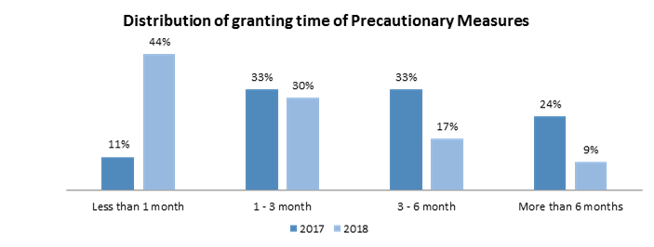

- Working meetings and hearings

- Article 25 of the IACHR’s Rules of Procedure provides that the Commission shall take appropriate follow-up measures related to the granting, observance and maintenance of precautionary measures. These measures may include, as appropriate, timetables for implementation, hearings, working meetings, and visits for follow-up and review. In 2018, the IACHR held 41 working meetings and 5 hearings on precautionary measures in the context of regular and special sessions. The table below lists these meetings and hearings.

Working Meetings

167th session (February 22 to March 2, 2018),
Bogota, Colombia
1 | MC-69-12 | Leonel Asdrúbal Dubón Bendfelt, his immediate family and members of the association El Refugio de la Niñez | Guatemala
2 | MC-376-15 | Irene Cuevas | Argentina
3 | MC-112-16 | Family members of Berta Cáceres | Honduras
4 | MC-197-10 | 135 inhabitants of San Juan Copala | Mexico
5 | MC-271-05 | Rosa Noemí Amaro et al La Oroya Community | Peru
6 | MC-412-17 | Evicted and displaced residents of Laguna Larga | Guatemala
7 | MC-416-13 | 18 members of the Movimiento Amplio por la Dignidad y la Justicia and their families | Honduras
8 | MC-600-15 | Angel Omar Vivas Perdomo | Venezuela
9 | MC-535-14 | Persons in immigration detention at Carmichael Road Detention Center | Bahamas
168th session (May 3 to 11, 2018), Santo Domingo, Dominican Republic
10 | MC-141-10 | Magdiel Alejandra Arboleda Mosquera and Daniel Eduardo Mosquera, Sandra Patricia Mosquera Dizu, Magdiel Alejandra Arboleda Mosquera and Daniel Eduardo Mosquera | Colombia
11 | MC-262-05 | Mashco Piro Yora Indigenous Peoples and Mashco Piro, Yora and Amahuaca Indigenous Peoples in Voluntary Isolation | Peru
12 | MC-409-14 | Students of the “Raúl Isidro Burgos” Rural School | Mexico
13 | MC-46-14 | Lonko Juana Calfunao | Chile
14 | MC-113-16 | 'Tres Islas' Native Community of Madre de Dios | Peru
15 | MC-180-01 | Embera Katio del Alto Sinu | Colombia
16 | MC-339-09 | Claudia Julieta Duque Orrego and María Alejandra Gómez Duque | Colombia
17 | MC-1039-17 | Child patients of the Nephrology Area of José Manuel de los Ríos Hospital | Venezuela
169th session (September 30 to October 5, 2018), Boulder, CO, United States
18 | MC-68-17 | “Panambi” | Paraguay
19 | MC-412-17 | Evicted and displaced residents of Laguna Larga | Guatemala
20 | MC-1039-17 | Child patients of Nephrology Area of Hospital José Manuel de los Ríos | Venezuela
21 | MC-416-13 | Movimiento Amplio por la Dignidad y la Justicia | Honduras
22 | MC-767-18 | Mónica Tereza Azeredo Benicio | Brazil
23 | MC-409-14 | Students of the “Raúl Isidro Burgos” Rural School | Mexico
24 | MC-120-16 | Residents of the Cuninico and another Community | Peru
25 | MC-309-18 | Javier Ortega Reyes, Paúl Rivas Bravo and Efraín Segarra Abril | Ecuador
26 | MC-310-18 | Javier Ortega Reyes, Paúl Rivas Bravo and Efraín Segarra Abril | Colombia
27 | MC-505-15 | Miskitu Indigenous Communities | Nicaragua
170th Regular Session (December 3 to 7, 2018) Washington D.C., United States
28 | MC-335-14 | Daniel Ceballos, Leopoldo López and families | Venezuela
29 | MC-310-18 | Javier Ortega Reyes, Paúl Rivas Bravo and Efraín Segarra Abril | Colombia
30 | MC-231-05 | Aura Lolita Chávez Ixcaquic et al | Guatemala
31 | MC-975-17 | Children and adolescents of the SENAME Playa Ancha | Chile
32 | MC-58-16 | Kamel Salame Ajami | Venezuela
33 | MC-309-18 | Javier Ortega Reyes, Paúl Rivas Bravo and Efraín Segarra Abril | Ecuador
34 | MC-21-05 | Wiwa de la Sierra Nevada de Santa Marta Indigenous People | Colombia
35 | MC-409-14 | Students of the “Raúl Isidro Burgos” Rural School | Mexico
36 | MC-140-14 | Yomaira Mendoza et al | Colombia
37 | MC-102-10 | Inhabitants of the Mixtec Indigenous Community of Zimatlán de Lázaro Cárdenas, Putla of Guerrero in Oaxaca | Mexico
38 | MC-70-99 | Members of CAVIDA | Colombia
39 | MC-772-17 | Residents/consumers of water from the Mezapa River | Honduras
40 | MC-496-14 y MC-37-15 | Persons deprived of liberty lodged in Judicial Police Departments of La Matanza and Lomas de Zamora | Argentina
41 | MC-242-09 | Members of the Consultoría para los Derechos Humanos y el Desplazamiento-CODHES- | Colombia

Hearings

168th Regular Session (May 3 to 11, 2018) Santo Domingo, Dominican Republic
1 | MC-409-14 | Special Follow-Up Mechanism on the Ayotzinapa Case | Mexico
169th Regular Session (September 30 to October 5, 2018) Boulder, United States
2 | MC-409-14 | Special Follow-Up Mechanism on the Ayotzinapa Case | Mexico
170th Regular Session (December 3 to 7, 2018) Washington D.C., United States
3 | MC-309-18 | Javier Ortega Reyes, Paúl Rivas Bravo & Efraín Segarra Abril | Ecuador
4 | MC-310-18 | Javier Ortega Reyes, Paúl Rivas Bravo & Efraín Segarra Abril | Colombia
5 | MC-112-16 | Family members of Berta Cáceres et al | Honduras

Activities of the IACHR in connection with the Inter-American Court of HR

- In 2018, the Commission continued to exercise its mandates under the Convention and its Rules of Procedure vis-à-vis the Inter-American Court. A detailed breakdown of the Commission’s activities before the Court is provided below, in the following order: i) submission of contentious cases; ii) requests for provisional measures; iii) appearance and participation in public and private hearings; iv) submission of written observations on the States’ reports in cases under supervision of compliance; and v) submission of written observations on the States’ reports on the implementation of provisional measures.

Submission of contentious cases

- Pursuant to Article 51 of the American Convention and Article 45 of its Rules of Procedure, the Commission referred 18 cases to the jurisdiction of the Inter-American Court in 2018.

        - Case of Néstor Rolando López et al v. Argentina (January 11, 2018)

- This case is about the international responsibility for violation of the right to humane and dignified treatment, to punishment serving a re-socialization function, to not be subjected to arbitrary interference in family life and to protection of the family, to the detriment of Néstor Rolando López, Miguel Ángel González Mendoza, José Heriberto Muñoz Zabala and Hugo Alberto Blanco. These individuals were criminally convicted in the Province of Neuquén and, while they were deprived of liberty in this Province, were transferred to other prison facilities of the federal system located from 800 to 2000 kilometers away from where their immediate families and/or close friends were located, from the judges overseeing their sentence execution and, in some instances, from their defense counsel. The Commission also concluded that Argentina is internationally responsible for the violation of the right to psychological and emotional integrity, to not be subjected to arbitrary interference in family life and to protection of the family, to the detriment of the immediate family members, who are identified by name in the report on the merits.

- The IACHR found that the transfers affected their ability to receive periodic visits from their next of kin and close friends and, therefore, their ability to stay in touch with the persons closest to them. This situation was not caused by exceptional circumstances of a temporary nature but spanned many years over which they had to serve their sentences under serious restrictions on their right to maintain contact with their family members and close friends. Lastly, the Commission concluded that the judicial remedies pursued by them were not effective and, therefore, it also declared a violation of the right to judicial protection.

- Case of Miguel Ángel Rodríguez Revolorio, Miguel Ángel López Calo and Aníbal Archila Pérez v. Guatemala (January 26, 2018)

- The case involves due process violations, which were committed in the context of criminal proceedings for the crime of murder and attempted murder by members of Patrol 603 of the Guatemalan National Police. The victims were found guilty and sentenced to the death penalty on May 23, 1996 by the Fourth Criminal Sentencing Court. The Commission established that the victims were sentenced to death on the grounds of future dangerousness, which is a concept provided for in the legal definition and punishment of the criminal offense of murder under Guatemalan law. The Commission concluded that the use of dangerousness as grounds to support criminal liability violates the principle of legality, inasmuch as it entails predictions and speculations and is an expression of an offender-based criminal law, which is incompatible with essential principles of a democratic society. Moreover, the Commission ascertained that the Presiding Judge of the Sentencing Court, which convicted the victims, had already acted as the oversight judge at the investigation stage. The Commission concluded that in performing both functions, the judge supervising the investigation as well as acting as sentencing judge, the guarantee of impartiality was violated because it meant that said judicial officer, prior to the trial proceedings, would form a pre-conceived notion of the facts and how these facts matched the statutory elements of the criminal offense.

- Additionally, the Commission determined that in the context of the proceedings, the State violated the right to legal counsel as well as the duty to provide reasons for a decision, based on the presumption of innocence because: 1) in collecting certain pieces of evidence, formal procedural requirements were not followed, as was established by the Court itself, and no reasons were given for why this situation did not prejudice the victims’ ability to mount a defense as well as the presumption of innocence; and 2) the sentencing Court excluded several exhibits of evidence introduced by the defense, and only noted that this evidence was untruthful, without providing any basis for such an assertion.

- The Commission also found that the State violated the right to appeal a conviction and the right to judicial protection, because when the motion of special appeal was denied, it was noted that said remedy “is exclusively for review of the legal field” and that it cannot be used to review the imposition of the punishment. In the context of the motion to appeal to the court of last review (recurso de casación) no review of factual issues was conducted either.

- Likewise, the Commission understood that the State violated the right to humane treatment, as the victims spent between 3 and 14 years on “death row” awaiting execution, while being held in inadequate conditions of detention. Lastly, the IACHR determined that the Guatemalan State violated the right to life, by imposing the death penalty in a case that involved violations of multiple due process protections.

- Case of Members of the Indigenous Communities of the Lhaka Honhat (Our Earth) Association v. Argentina (February 1, 2018)

- In its Report on the Merits No. 2/12, the Commission established the violation of the victims’ right to property on the grounds that they had not been given effective access to title to their ancestral territory, even though two decades had elapsed since 1991, when they had filed the initial request for title. It also found the violation of the right to property, insofar as the State abstained from ensuring legally recognized rights, thereby violating these indigenous communities’ right to the effective implementation of the law. On this point, the IACHR understood that the State frustrated the legitimate expectations that the provincial authorities’ actions had generated among the petitioner indigenous communities, to obtain a single common title to territorial property. It also found the violation of the right to a fair trial and judicial protection, because the State did not afford them an effective procedure to acquire recognition of their ancestral territory, and also because successive ad hoc variations were introduced in the administrative procedure, which were applicable to the resolution of their territorial claim, on no less than six occasions.

- The case also included disregard for the right to property, of access to information and the right to participate in matters that could affect the indigenous communities, in having carried out public works and granting concessions for oil and gas exploration in the ancestral territory without complying with the requirements, namely, to conduct expropriation proceedings, to ensure no impact on the survival of the indigenous communities, to conduct prior, free and informed consultations, to conduct prior social and environmental impact assessments, and to grant participation in the benefits derived from the works and concession. Lastly, the Commission found another violation of the right to property to the detriment of the indigenous communities, in having failed to exercise the required due diligence to control the deforestation of the ancestral indigenous territory by illegal loggers.

- Case of José Luis Hernández v. Argentina (February 8, 2018)

- The case involves the lack of access to health of José Luis Hernández, who contracted meningitis while deprived of his liberty and, because he did not receive timely and proper treatment, in the same conditions as a person not deprived of liberty would have, it caused permanent neurological sequelae, including total loss of vision in one eye, partial and permanent disability in one arm and memory loss. The Commission determined that the State violated José Luis Hernández’s right to humane treatment and to not be subjected to cruel, inhuman and degrading treatment. In this regard, the IACHR noted that on July 6, 1989, Mr. Hernández reported the symptoms of a potential disease, however, no medical examination or diagnosis of his ailments were conducted and his condition was later identified as meningitis. Once again, a little more than a year later, on August 1, 1990, it was reported to the judge presiding over his case that the victim was suffering from sharp encephalic pain, however, this judge did not order Mr. Hernandez to be provided medical care until August 14, 1990. Additionally, the tardy medical care that the victim received was inadequate. One of the hospitals to which he was transferred did not have any beds available to accommodate him and it refused to admit him twice. Consequently, the victim remained in the prison’s medical facility without any access to specialized and urgent care, as required by the nature and seriousness of his condition. The IACHR noted that according to the statement of a doctor: “if he had been properly treated, Hernández would not have suffered the damages” and it further noted that in the instant case there was an absolute failure of Argentina to provide an explanation about the situation of Mr. Hernández in terms of medical care, diagnosis and treatment while he remained in custody.

- Furthermore, the IACHR concluded that Mr. Hernández did not have any effective remedy available to him to protect his right to health. In this regard, it was a proven fact that when the victim’s mother reported the ailments he was suffering, the judge handling the case simply ordered medical care without any follow-up. Similarly, when it was reported that the victim was having bad headaches, the judge took two weeks to order specialized medical care. Similarly, it is on record that the victim filed a motion for special release to be able to access adequate medical treatment, however, the judge denied this motion and only noted that he was receiving such care.

- Additionally, the IACHR found that the victim’s right to personal liberty and the presumption of innocence were violated because pre-trail detention was mandatory. The basis for being held in custody during his trial proceedings is that the potential prison sentence for the crime for which he was being prosecuted (aggravated robbery) was more than six years and, therefore, pursuant to Article 1 of Law 10.484, he could not be granted release on his own recognizance or on bail throughout his trial proceedings. This provision of law is incompatible with the general standard that pre-trial detention is the exception to the rule, as well as the specific standard that the deciding criterion for release cannot be the potential prison sentence or the seriousness of the offense. The Commission also declared the violation of this right because the victim was deprived of liberty for one year and six months at a police station holding facility. Lastly, the IACHR found the violation of the right to humane treatment to the detriment of José Luis Hernández’s mother, who reported his health situation several times, inasmuch as the victim’s deprivation of liberty was particularly angst-producing for her.

- Case of Oscar Raul Gorigoitia v. Argentina (March 16, 2018)

- The case is about the absence of an ‘ordinary appeal’ or appeal as of right to the intermediate court (recurso ordinario) to allow a comprehensive review of a conviction for the crime of simple homicide in the context of a criminal proceeding in the Province of Mendoza, Argentina in 1997. The Commission concluded that Mr. Gorigoitia did not have a remedy before a hierarchical authority to fully review said conviction, including the issues of fact and of the evaluation of evidence pleaded by the defense through an automatic appeal to the court of last resort (recurso de casación). In this regard, the Commission concluded that the Argentine State violated the victim’s right to appeal the conviction as established in Article 8.2 h) of the Convention, in connection with the obligations set forth in Articles 1.1 and 2 of the same instrument. The Commission also concluded that as a consequence of the limited nature of the recurso de casación and, the even more limited nature of the special appeal (recurso extraordinario), the victim did not have available to him simple and effective remedies in the context of the criminal proceeding that led to his conviction, in violation, as well, of the right set forth in Article 25.1 of the Convention and in connection with the obligations of Article 1.1 and 2 of the same instrument.

- Case of Ramón Rosendo Carranza Alarcón v. Ecuador (March 29, 2018)

- The case deals with the unlawful and arbitrary detention of Ramón Rosendo Carranza Alarcón by State agents in November 1994, as well as with his unreasonably long pretrial detention in the context of an investigation that led to his criminal prosecution for murder. The IACHR found as established fact that Mr. Carranza Alarcón was held in preventive deprivation of liberty from November 1994 until December 1998, when a final judgment of conviction was handed down. The Commission believed that the reasoning for the decisions imposing pretrial detention for Mr. Carranza was essentially based on evidence suggesting his liability. In this regard, the IACHR concluded that both the applicable norms and the decisions adopted on the basis thereof were arbitrary and, therefore, incompatible with the American Convention. As for the duration of Mr. Carranza’s pretrial detention, the Commission found that the period of more than four years exceeds any reasonable criteria. Lastly, the IACHR concluded that the Ecuadorian State violated Mr. Carranza’s right to be tried within a reasonable time, since the criminal proceeding lasted five years and four months.

- Case of Mario Montesinos Mejía v. Ecuador (April 18, 2018)

- The case involves the victim’s unlawful and arbitrary detention by police officers in 1992, acts of torture inflicted on him, and the lack of due process in criminal proceedings against him. The Commission concluded that Mr. Montesinos’ arrest was carried out without a warrant and that he was not caught red-handed, as defined under domestic law. Furthermore, the Commission noted that Mr. Montesinos was held in protracted pre-trial detention for at least six years, an unreasonable length of time, without any justification as per the Convention. The IACHR further concluded that habeas corpus appeals, as they were regulated in Ecuador at the time of the events, did not comply with the standards of the American Convention. Moreover, in his specific case, although the Constitutional Rights Court granted the victim’s habeas corpus appeal, the prison authorities failed to comply with it for an extended period of time and they did not adopt measures to enforce that ruling of the Court.

- Additionally, in view of the serious omissions in failing to perform a thorough and comprehensive medical examination on Mr. Montesinos, even when he was transferred from one correctional facility to another, as well as the absence of an investigation into reports of torture, the Commission deemed that the victim had been subjected, at a minimum, to cruel, inhuman and degrading treatment at the initial stage of his detention. Finally, the IACHR concluded that the criminal proceedings brought against Mr. Montesinos violated the following due process rights: i) right to the exclusion of evidence obtained through coercion; ii) right to be provided legal counsel during the pretrial statement and any subsequent testimony once he is suspected of having committed a crime; iii) right to the presumption of innocence; and iv) the right to be tried within a reasonable period of time, insofar as the three criminal proceedings lasted more than six years, which amounts to an unreasonable period of time.

- Case of Tirso Román Valenzuela Ávila v. Guatemala (April 19, 2018)

- The case deals with several due process violations, which were committed in the context of the criminal proceedings in which the victim was tried for murder and was sentenced to death. It also deals with acts of torture perpetrated against the victim when he was arrested, after he was recaptured following his first escape from prison in June 1998, and again after he was recaptured following a second escape from prison in 2001. The case deals as well with the extrajudicial execution of the victim following a third escape, in 2005.

- As for violations of due process during criminal proceedings, the IACHR established that the State of Guatemala violated the principle of legality in connection with respect for the presumption of innocence, since Mr. Valenzuela Ávila was found criminally liable for the crime of murder and sentenced to death based on the concept of “dangerousness.” The bodies of the Inter-American system had previously ruled that this concept is incompatible with the principle of legality, because it is a manifestation of actor-based criminal law, rather than act-based criminal law. The IACHR also established that the State violated the victim’s the right to appeal the decision and to judicial protection, because the Appeals Court denied his special appeal in violation of Inter-American standards, which require a comprehensive review without excluding the facts and the evaluation of the evidence. The Commission established that the State violated the right to life in imposing the death penalty on the victim, based on a provision of law that is at odds with the principle of legality under criminal law and the presumption of innocence and in violation of the right to appeal the decision.

- The Commission further concluded that the State inflicted cruel, inhuman and degrading treatment on the victim, because he was held in custody for more than 6 years before his sentence was to be executed, which amounts to the “death row phenomenon.” In addition, the IACHR established that State agents subjected the victim to physical, psychological and sexual violence, which rises to the level of torture, and that the Guatemalan State has, to date, failed to carry out an investigation into the matter. In this regard, based on the foregoing, the State abstained from excluding Mr. Valenzuela Ávila’s confession, despite the fact that during his trial proceedings, he denounced the torture. Finally, the IACHR established that there is sufficient evidence to prove that, following his escape from prison in 2005, the victim was extrajudicially executed in December 2006, and thus that the State violated his right to life. Further, the criminal investigation into the victim’s death has been neither diligent nor effective in getting to the bottom of those incidents within a reasonable period of time.

        - Case of Mirey Trueba Arciniega v. México (April 28, 2018)

- The case involves the extrajudicial execution of a young man named Mirey Trueba Arciniega on August 22, 1998, by members of the Army in the state of Chihuahua. This crime took place in a context in which the Armed Forces were assigned by the Mexican State duties of maintaining public order in the area where Mr. Trueba was killed, despite all of the risks entailed therein and without having put into place any of the necessary safeguards in terms of regulation, training, equipment and oversight to prevent arbitrary deprivation of the right to life as a consequence of the use of force by these agents. The Commission further established that because of the simple fact of being wounded before he died, Mirey Trueba endured extreme physical suffering in violation of his right to humane treatment and that the State, through its agents, did not provide an immediate response, despite his serious condition, and seek medical assistance as soon as possible. The Commission also concluded that the State violated the right to due process and judicial protection because of the use of military criminal justice, as well as the lack of diligence in conducting the investigations.

- As of the present date, the Mexican State continues to incur international responsibility as a result of its failure to conduct an investigation into the extrajudicial execution of the victim under civilian jurisdiction, in order to provide the family with the truth and justice for the gross human rights violation that, under no circumstances, should be investigated and prosecuted under the military criminal justice system.

- Case of Raúl Rolando Romero Feris v. Argentina (June 20, 2018)

- The case deals with the unlawful and arbitrary detention of Raúl Rolando Romero Feris in 1999, as well as due process violations in criminal proceedings against him for offenses, which include fraudulent administration and illegal enrichment. The Commission established that Mr. Romero Feris was deprived of liberty for five additional months beyond the time for which his pretrial detention was extended. Consequently, the length of Mr. Romero Feris’s pretrial detention did not adhere to the applicable statutory limits. The IACHR further established that maintaining and extending Mr. Romero Feris’s pretrial detention was arbitrary and violated the principle of the presumption of innocence. Additionally, based on grounds that are incompatible with the American Convention on Human Rights, the August 1, 2001 ruling denying Mr. Romero Feris’s motion for release was not an effective remedy to challenge deprivation of liberty. Furthermore, the Commission established that throughout the criminal proceedings against Mr. Romero Feris, his defense pursued several different challenges linked to the right to be tried by a competent, independent and impartial authority. Notwithstanding, the motions pursued by him were denied under reasoning in which either general provisions of law were cited or it was ruled that the issue in question was not the subject of examination through the respective procedure. Consequently, the IACHR concluded that the State of Argentina violated the right to a fair trial and judicial protection.

- Case of Officials and Members of Unión Patriótica v. Colombia (June 29, 2018)

- The case concerns successive serious human rights violations perpetrated against more than 6,000 victims, who were officials and members of the political party Patriotic Union (UP from its Spanish language initials, Unión Patriótica) in Colombia, for over 20 years starting in 1984. The Commission described the events as extermination and established that they were extremely serious and unusually widespread.

- The Commission found the State internationally responsible for breaching both its obligation to enforce rights and to protect rights, due to the deprivation of the right to life, the forced disappearances, threats, harassment, forced displacements and attempted homicides to which the victims of the instant case were subjected, in which there was involvement of both state agents and non-state actors with the tolerance and acquiescence the former. The State only acknowledged its international responsibility for breaching its obligation to enforce rights by protecting them, insofar as it failed to prevent the murders and other acts of violence against members of the Patriotic Union, despite the evidence that persecution against them was afoot.

- Likewise, the IACHR established that the State had violated the right to personal liberty, to a fair trial, to privacy and judicial protection, because of its unjustified use of criminal law or baseless prosecutions and torture against the members and sympathizers of Patriotic Union political party in the case known as “La Chinita” as well as in other cases. The Commission further concluded that the State had violated political rights, freedom of thought and expression and freedom of association and the principle of equality and non-discrimination, given that the motive of the gross human rights violations and behind the victims’ extermination and the sustained persecution thereof was the fact that they belonged to a political party and expressed their ideas through that party.

- The IACHR also found that the State violated the right to privacy, particularly the honor and dignity of the officials and members of Patriotic Union party, because they were stigmatized by both state agents and non-state actors, which included branding them “terrorists” and the “FARC’s political wing,” and that such a smear campaign had helped to trigger the serious violence that was unleashed against them. Additionally, the Commission established that the State violated the right to a fair trial, judicial protection and the duty to investigate the gross human rights violations that were committed, after examining all violations as a whole, insofar as the investigations conducted by the State into the events in the instant case have been insufficient and have failed to reach beyond their early stages. These investigations have not been successful in providing the surviving victims, the families of the deceased victims, or Colombian society as a whole with true clarification regarding liability for the extermination of the officials and members of the Patriotic Union political party. Finally, the Commission concluded that the State violated the right to humane treatment of the families of the victims in the instant case, due to the scope and seriousness of the violations and the impact the violations have had on them.

- Case of Vicente Ariel Noguera and family v. Paraguay (July 2, 2018)

- The case involves the death of Vicente Ariel Noguera on January 11, 1996, who was a 17-year old recruit performing voluntary military service. The Commission established that the Paraguayan State did not offer a satisfactory explanation for the death of the adolescent boy, who was under its custody and, as such, was required but unable to undermine the multiple and consistent pieces of evidence that suggest it is internationally responsible for this death, as a consequence of the victim being subjected to excessive physical exercises as a form of punishment ordered by his superiors. Corporal Noguera’s death was investigated in the context of a proceeding under military jurisdiction, where it was dismissed on the grounds that his death was caused by a generalized pulmonary infection (October 22, 1997). The case was also archived due to procedural inactivity under civilian jurisdiction (November 6, 2002).

- The Commission concluded that the State of Paraguay is responsible for the violation of Articles 4.1, 5.2, 19, 8.1 and 25.1 of the American Convention on Human Rights, in connection with the obligations set forth in Articles 1.1 and 2 of the same instrument.

- Firstly, the Commission found that the State violated Articles 4.1, 5.2 and 19 of the American Convention, in connection with its duty to respect, as enshrined in Article 1.1 of the same instrument, to the detriment of Vicente Ariel Noguera, because the Paraguayan State did not provide a satisfactory explanation about his death while he was under its custody and it was unable to undermine the presumption of responsibility for this death, especially given that there were complaints and several signs that the death was caused by physical punishment and other abuses, for which the State gave no sufficient and satisfactory explanation to clarify the death and abuses that were reported.

- Secondly, the Commission established that the State violated the right to a fair trial and judicial protection, as set forth in Articles 8.1 and 25.1 of the American Convention, in connection with the obligations enshrined in Article 1.1 of the same instrument, to the detriment of the victims, because the case was first submitted to prosecution under military criminal jurisdiction, where violations of these rights were committed. And then, once the case was moved to civilian jurisdiction, further violations of these rights occurred due to a lack of due diligence in the investigations, mostly related to the collection of forensic and testimonial evidence; the failure to adequately get to the bottom of the information that emerged in the investigation suggesting the adolescent died as a consequence of the above-referenced excessive physical punishment; and because of violation of the reasonable time protection.

- Finally, the Commission established that Paraguay violated the rights of the child, as provided for in Article 19 of the American Convention in connection to the obligations set forth in Articles 1.1 and 2 of the same instrument, to the detriment of Vicente Ariel Noguera, because the State, in its special duty as guarantor, did not take into consideration Vicente Ariel Noguera’s condition as a minor nor did it take any special action, in view of the practice known as descuereo, a form of physical exercise-based punishment, literally meaning ‘flaying,’ which was widespread at the barracks, for his protection based on his developmental level during his military training after being recruited.

- Case of Gustavo Petro Urrego v. Colombia (August 7, 2018)

- The case involves several human rights violations committed in the context of a disciplinary proceeding, which led to the dismissal of Gustavo Petro as Mayor of Bogota, Colombia. The Commission established that on December 9, 2013, the Inspector General of the Nation (Procurador General de la Nación) removed the victim in this case from office and disqualified him from holding future office for a period of fifteen years. The Commission concluded that these punishments violated Mr. Petro’s political rights. In this regard, it recalled that pursuant to Article 23.2 of the American Convention, both punishments must be imposed by a criminal court following final judgment of conviction. The IACHR established that the imposition of punishments through this type of administrative proceeding may adversely affect the democratic system because, in principle, the electorate must decide the suitability of candidates through passive suffrage, that is, the right to stand for office.

- The IACHR further concluded that, in the context of the proceeding, the protection of impartiality was infringed in terms of the principle of presumption of innocence, because the same authority, who brought the disciplinary charges, decided on the victim’s disciplinary responsibility and this meant that the disciplinary authority had a preconceived notion about the facts and how they fit the elements of the alleged offense. Additionally, the IACHR established that the right to appeal the decision was violated because the motion for reconsideration filed by the victim against the decision to punish him, under the law, was settled by the same authority, who issued the punishment.

- Moreover, the IACHR established that the protection of a reasonable time and judicial protection were violated because following the denial of the motion for reconsideration, on March 31, 2014, the victim filed a suit to vacate (the decision) and reinstate (him in office), which as of the date of approval of the report on the merits, after 3 years and 6 months have elapsed, had not been decided.

- Finally, the IACHR concluded that the right to equal protection and judicial protection were violated because, in the context of the disciplinary proceeding, the victim argued that the disciplinary actions brought against him were based on discriminatory motivations. Notwithstanding, even though this selective application of disciplinary authority materialized with the punishment imposed on December 9, 2013, the victim introduced evidence on December 31, 2013, when he filed the motion for reconsideration to prove that alleged ulterior motive, but the evidence was not admitted on the grounds that the deadline to introduce evidence had lapsed.

- Case of Azul Rojas Marín and another woman v. Peru (August 22, 2018)

- This case deals with the illegal, arbitrary and discriminatory deprivation of liberty of Azul Rojas Marín, who was deprived of liberty on February 25, 2008, allegedly for purposes of identification. The Commission established that although the possibility of retention for identification purposes was provided for in Peruvian law in certain circumstances, this standard imposed a number of formal and substantive requirements that were not met in the case. In addition, the IACHR noted that there is no evidence in the case that would justify detention for prevention of a potential crime but that, instead, the deprivation of liberty was based on subjective assessments that are not related to this purpose. Likewise, the IACHR established that from the time Azul Rojas Marín was intercepted by state officials, they not only perpetrated physical violence against her, but also verbally assaulted her with repeated references to her sexual orientation through denigrating expressions.

- The Commission also established as proven fact that serious acts of physical and psychological violence had been committed, including various forms of sexual violence and rape against Azul Rojas Marín. The IACHR found that there is sufficient evidence to establish, based on the nature of and the way in which this violence was perpetrated, that the violence was particularly vicious because he was identified or perceived, at the time, as a gay man. The Commission established that what had happened to the victim should be regarded as violence based on prejudice and that the constituent elements of torture are also present.

- Lastly, the IACHR concluded that the crimes of the case have gone unpunished due to several reasons, including breach of the duty to investigate with due diligence from the initial stages of the investigation. In addition, the IACHR established that throughout the investigation the victim was discredited and her credibility called into question, in such a way that she was revictimized by both the authorities, who gathered the evidence, and in the context of the decisions that led to the case being dismissed. The Commission found that the State violated the obligation of care and protection of a victim, who reports sexual violence, with the aggravating factor of prejudice against LGBT people. The Commission also established how Azul Rojas Marín’s mother was affected.

- Case of Del Valle Ambrosio and Domínguez Linares v. Argentina (September 4, 2018)

- In December 1997, Cordoba’s Ninth Chamber of Criminal Law ruled Messrs. Del Valle Ambrosio and Domínguez Linares to be accessories to the crime of fraud and sentenced each of them to three years and six months in prison. Their defense counsel filed motions for cassation, that is, automatic appeals to the provincial court of last resort (recursos de casación), which were denied without any examination of the merits. The Commission established that the ruling on the motions amounted to a restrictive interpretation of the law and that because this was the only remedy available to challenge the conviction of a trail court, Messrs. Del Valle Ambrosio and Domínguez Linares were not afforded comprehensive review by the next level in the judicial hierarchical structure, including the review of issues of fact and evidentiary assessment alleged by the defense counsel through the above-referenced motions. The Commission noted that the special motions for leave to appeal to the federal court of last resort (recursos extraordinarios) brought by both victims, were also denied. The Commission concluded that the Argentine State violated both victims’ right to appeal the decision, as established in Article 8.2 h) of the American Convention on Human Rights, in connection with the obligations set forth in Articles 1.1 and 2 of the same instrument. The Commission further concluded that, as a consequence of the limited nature of the cassation remedy and, even more limited nature of the recurso extradordinario, the victims did not have any simple and effective remedies available to them in the context of the criminal proceedings that led to their conviction, also in violation of Article 25.1 of the Convention, in connection with the obligations set forth in Articles 1.1 and 2 of the same instrument.

- Case of the Fireworks Factory Workers in Santo Antonio de Jesús and their families v. Brazil (September 19, 2018)

- The case involves international responsibility of the State for violation of the right to life of 64 people, 22 of whom were children ages 11 to 17, and the personal integrity of 6 people, as a consequence of an explosion at a fireworks factory on December 11, 1998. The IACHR established that the State i) was aware that hazardous industrial activities were being conducted at the factory and, therefore, it should have performed inspections and oversight pursuant to domestic law and its international obligations; and that ii) emanating from that duty, it should have been aware that one of the worst forms of child labor was taking place at the factory and that gross irregularities involving high risk and imminent danger to the lives, personal integrity and health of all of the workers were being committed there. Therefore, the State not only breached its duties of protection of rights, but it also tolerated and acquiesced to infringements thereof. Likewise, the case deals with the violation of the right to work and the principle of equality and non-discrimination, inasmuch as fireworks manufacturing, at the time of the events, was the main, and apparently, even the only employment option available to the inhabitants of the municipality, who because of their situation of poverty, had no other choice than to accept a high risk job, with low pay and without adequate safety measures in place. Moreover, the case involves the violation of the right to a fair trial and judicial protection, because the State failed to ensure through any civil, criminal or labor proceeding, access to justice, discovery of the truth of what happened, investigation and punishment of the culprits, or reparation for the consequences of the human rights violations that were perpetrated in the case.

- Case of Juan Carlos Flores Bedregal and families v. Bolivia (October 18, 2018)

- The case is about the State’s international responsibility for the forced disappearance of Juan Carlos Flores Bedregal, leader of the Partido Obrero Revolucionario (Revolutionary Workers’ Party) and deputy to the national assembly, which began in the context of the coup d’état of July 1980 by military forces and the impunity in which the crimes have remained.

- The Commission determined that even though the court proceedings led to convictions, to date, the victim’s fate has not been fully ascertained, including the whereabouts of his remains, as a result of multiple cover-up schemes. In this regard, the Commission established that the existence of evidence of the death of Juan Carlos Flores Bedregal does not change the classification of forced disappearance, since 38 years after his disappearance, his family does not have any information about or access to the remains, in order to know with certainty the fate he met. In addition, it established that neither the trial determining liability, which concluded in 1993, nor the conviction handed down in 2007, have been effective remedies to get to the bottom of the truth about what happened to Mr. Flores Bedregal.

- Furthermore, taking into consideration Juan Carlos Flores Bedregal’s profile and activities and the context of the storming of the Bolivian workers’ union headquarters (Central Obrera Boliviana), the Commission established that the motive of the forced disappearance of the victim was to put down the exercise of political rights and freedom of association. Lastly, the Commission concluded that the Bolivian State thus far has not fulfilled its obligation to take steps aimed at obtaining, producing, analyzing, classifying, organizing and facilitating information from the military archives relating to the gross human rights violations of the recent past for the sake of society as a whole and that this has directly affected the State’s response to the specific requests of Juan Carlos Flores Bedregal’s family members.

- Case of Carlos Alberto Fernández and Carlos Alejandro Tumbeiro v. Argentina (November 13, 2018)

- This case concerns illegal and arbitrary detentions by agents of the Buenos Aires Police Department to the detriment of Carlos Alberto Fernández Prieto and Carlos Alejandro Tumbeiro in May de 1992 and January 1998, respectively. The Commission established that both arrests were conducted without warrant and the detainees were not caught in the act of committing a criminal offense. The IACHR noted that in neither case did the police records reflect the objective evidence giving rise to a reasonable degree of suspicion that the detainees had committed an offense. The Commission noted that in the case of Mr. Fernández Prieto, no explanation was provided whatsoever; while in the case of Mr. Tumbeiro, it indicated that the explanation described an alleged “state of nervousness” and “inconsistency” between the clothing the detainee was wearing, the objects he was carrying on him, and the area in which he was arrested, which are insufficient grounds for suspicion of having committed a crime. The IACHR also concluded that the explanation for the arrests suggests appearance-based discrimination and prejudice with respect to the area where the events took place. Consequently, the Commission established that the arrests and searches in question were illegal and did not constitute non-arbitrary treatment, and that judicial authorities did not go on to provide effective forms of redress. Instead, despite the absence of a just cause and charges that were based solely on suspicion, the authorities not only continued with proceedings, but also accepted the reasons given by the police officers as being legitimate.

Requests for provisional measures

- In 2018, the Commission filed two requests for provisional measures, which are explained below.

a. Matter of Edwin Leonardo Jarrín Jarrín, Tania Elizabeth Pauker Cueva and Sonia Gabriela Vera García, involving Ecuador

- The Inter-American Commission submitted on February 6, 2018 a request for provisional measures to the Court on behalf of Edwin Leonardo Jarrín Jarrín, Tania Elizabeth Pauker Cueva and Sonia Gabriela Vera García, for it to order the State to refrain from dismissing the members of the Council of Citizen Participation and Social Control of Ecuador (CPCCS) and from creating a Transitory Council that could imperil the democratic rule of law, including the principles of separation of powers and of judicial independence, which are fundamental for the effective enjoyment of human rights.

- On February 8, 2018, the Court issued its decision denying the request for provisional measures.

- Matter of the Inhabitants of Miskitu Indigenous Peoples Communities of the North Caribbean Coast Region, involving Nicaragua

- On August 9, 2018, the Inter-American Commission requested the Court to extend the provisional measures on behalf of the inhabitants of certain communities of the Miskitu indigenous people of the North Caribbean Coast Region of Nicaragua, in order to include among the beneficiaries human rights defenders Lottie Cunningham and José Coleman, who work on behalf of the rights of the Miskitu people.

- In view of the particular context of violence of the Northern Caribbean Coast region in terms of the territorial claims of the Miskitu people, the current general social context in Nicaragua, as monitored and reported by the IACHR, the type of threats on the lives and integrity of the petitioners directly tied to the defense of the indigenous people’s territorial rights they defend, as well as the link of these threats to state agents, the Commission established that this situation poses an extreme risk of irreparable harm to the lives and integrity of Cunningham and Coleman. Although the State of Nicaragua reported to the IACHR that it instructed the National Police to open investigations ex officio in accordance with specific standards for the protection of human rights defenders, it did not provide specific information about any measures of protection taken by it for the two proposed beneficiaries. Based on all of the evidence available to it, the IACHR finds that the State’s actions continue to be insufficient to address the risk factors and ensure the lives and personal integrity of the proposed beneficiaries.

- The Inter-American Commission understands that the serious incidents reported to it regarding Lottie Cunningham and José Coleman are factually connected to the provisional measures previously ordered by the Inter-American Court of HR, as the source of risk is the same for both of them. Consequently, the Commission requests the Court to extend the provisional measures granted to the members of certain Miskitu indigenous communities of the North Caribbean Coast region and order the State of Nicaragua “to protect and ensure the lives, personal and territorial integrity and cultural identity” on behalf of human rights defenders Lottie Cunningham and José Coleman.

- On August 23, 2018, the Court issued a decision extending the provisional measures to Lottie Cunningham and José Medrana Coleman. The provisional measures remain in effect until the date of approval of the instant report.

Appearance and participation in public and private hearings

- The Commission participated in the opening of the judicial year and in a total of 17 public hearings on contentious cases and public and private hearings on monitoring compliance with judgments. These hearings were:

- Case of Isaza Uribe et al (Colombia)
- Case of Lopez Soto et al (Venezuela)
- Case of Coc Max el al (Guatemala)
- Case of Cuscul Pivaral et al (Guatemala)
- Case of Terrones Silva et al (Peru)
- Supervision of compliance with judgment in the cases of Barrios Altos and La Cantuta (Peru)
- Supervision of compliance with judgment in the case of Durand and Ugarte (Peru)
- Case of Gómez Virula et al (Guatemala)
- Case of Eduardo Rico (Argentina)
- Case of Villaseñor Velarde et al (Guatemala)
- Case of Munárriz Escobar et al (Peru)
- Case of Alvarado Espinoza et al (México)
- Case of Colindres Schonenberg (El Salvador)
- Provisional measures of the Miskito Communities of Nicaragua
- Supervision of compliance with judgment in the cases of Veliz Franco et al and Velásquez Paiz et al (Guatemala)
- Supervision of compliance with judgment in the cases of the Garífunas Communities Triunfo de la Cruz and Punta Piedra (Honduras)
- Supervision of compliance with judgment in the case of Afrodescendant Communities of Cuenca del Río Cacarica (Colombia)

Presentation of Written Observations to State Reports in Cases under supervision on Compliance and on Provisional Measures

- In 2018, the IACHR submitted more than 80 written briefs to the Inter-American Court on monitoring compliance with judgments and provisional measures.

Status of Compliance with the Recommendations Issued by the IACHR in Merits Reports and Friendly Settlement Agreements Approved by the IACHR

1. IACHR’S Mandate to Follow-Up on its Recommendations and on the Friendly Settlement Agreements Homologated

- Total compliance with the decisions of the Inter-American Commission is an essential part of ensuring full respect for human rights in OAS member States, as well as helping to strengthen the Inter-American human rights protection system. Accordingly, in this section the IACHR offers an examination of the status of compliance with the decisions it has taken in published merits reports and the friendly settlement agreements (hereinafter “FSAs”) approved by it over the past eighteen years.

- On several occasions, the OAS General Assembly has encouraged Member States to follow up on the recommendations of the Inter-American Commission on Human Rights, as it did in Resolution AG/RES 1701 (XXX-O/2000), in which it urged States to do their utmost, in good faith, to implement the recommendations of the Inter-American Commission on Human Rights, (operative item 5.d). The OAS General Assembly issued similar encouragement in Resolution AG/RES. 2672 (XLI-O/11) “Observations and Recommendations on the Annual Report of the Inter-American Commission on Human Rights” (operative item 3.b).

- The Commission also understands that effectiveness of the Inter-American system rests, to a large measure, on compliance with the decisions of its organs, including the judgments of the Inter-American Court of Human Rights and IACHR Reports on Merits and Friendly Settlements, which set forth the recommendations and agreements on full reparation for victims of human rights violations. In this regard, States’ willingness to comply with the purposes and objectives of the American Convention on Human Rights and the American Declaration of the Rights and Duties of Man is essential, by virtue of the principle of pacta sunt servanda, under which States must comply in good faith with the obligations they undertake to fulfill in treaties.

- Both the American Convention (Article 41) and the Commission’s Statute (Article 18) expressly grant the IACHR the authority to request information from the member States and to produce such reports and recommendations, as it deems appropriate. Specifically, Article 48 of the IACHR’s Rules of Procedure provides the following:

Follow-Up

1. Once the Commission has published a report on a friendly settlement or on the merits in which it has made recommendations, it may adopt the follow-up measures it deems appropriate, such as requesting information from the parties and holding hearings in order to verify compliance with friendly settlement agreements and its recommendations.

2. The Commission shall report on progress in complying with those agreements and recommendations as it deems appropriate.

2. Methodology for Follow-Up on Recommendations and Friendly Settlement Agreements: Actions Carried Out during the Year

- In keeping with its powers under the Convention and the Statute and the above-cited resolutions, and pursuant to Article 48 of the Commission’s Rules of Procedure, the IACHR requests information from States on compliance with the recommendations issued in reports on the merits and the friendly settlement agreements it approves in homologation reports. This practice of the Commission began in 2000 and, as of that time, information has been requested on an annual basis from the parties to the different petitions and cases, in order to follow up on the IACHR’s decisions and on the status of compliance in each matter. The IACHR may also receive information at the hearings or working meetings, which are held over the year, and then conducts an analysis of the status of compliance with the recommendations or friendly settlement agreements, as the case may be, in each matter.

- In keeping with Program 21 of the IACHR’s 2017-2021 Strategic Plan, in 2018 the Commission reviewed and updated its methodology for the collection, systematization and analysis of information in the process of follow-up on recommendations and approved friendly settlements agreements, in order to optimize the process of follow up on implementation of its decisions and to highlight the individual and structural impacts of said decisions. This helped to undertake a more succinct and specialized follow-up in each particular case during the phase of collection of the information for the drafting of this Chapter. The cutoff date for information to be considered by the IACHR in the drafting of this Chapter was December 31, 2018. Any information received thereafter did not make it into the Chapter but will be taken into consideration for the 2019 Annual Report.

- The Commission decided to redesign this Chapter, based on the parameters of its Rules of Procedure, in order to provide a more comprehensive presentation and examination of information in follow-up on each case and to raise more awareness about progress achieved and challenges faced in the area of compliance with the IACHR’s decisions in petitions and cases. Thus, in the introductory portion of this report the IACHR offered a summary of the follow-up activities conducted by it, and then highlighted the major results in terms of total or partial substantial compliance with measures, based on progress achieved over the course of the year. Likewise, in this Report, the Commission calls greater attention to the instances of failure to comply it has identified over the course of the year, in relation to the agreements and recommendations that are the subjects of IACHR supervision. The Commission also provided a list of petitions and cases for which it has not received information from either of the parties, among other aspects of these cases.

- Additionally, it was decided to draw up an information sheet for each case with greater detail than in previous years. These sheets would be accessible through the links available in the friendly settlement and recommendation follow-up tables. The Commission believes that with its new methodology for follow-up on its decisions, it is able to highlight the major results achieved in compliance with recommendations or friendly settlement agreement clauses based on the information submitted by the parties in terms of individual and structural reparation.

- Lastly, it must be noted that as of 2018, the Commission has put into place a specialized area for follow-up on recommendations, which has taken on the task of examination of reports published under Article 51 of the Americana Convention. This makes it possible for both areas to conduct much more detailed and focused follow-up in each matter entrusted to them. Along this same line of logic, an explanation is provided below of progress made in compliance with friendly settlement agreements and recommendations issued in reports on the merits, in separate and specialized areas as well. This will help users to identify more clearly and readily the nature of each matter, actions reported in each case, the individual and structural impact thereof, and the items under which further action must be taken for total implementation.

2.1. Categories of Analysis

- In order to provide parties with objective information regarding the type of analysis conducted by the Commission in each case, the IACHR created a classification system of the information provided. These categories help the Commission to conduct a more detailed analysis of available information and help the parties to know whether the information submitted is relevant and timely for the IACHR to conduct its analysis on compliance with recommendations of published merits reports and clauses of approved friendly settlements. Listed below are the new information analysis categories:

- Information Provided Relevant: the information provided is relevant, up-to-date and extensive, regarding measures taken relative to compliance with at least one of the recommendations issued/friendly settlement agreement clauses, within the time period specified by the IACHR.
- Information Provided Not Relevant: the information was provided within the period of time specified by the IACHR but does not pertain to the measures adopted relating to compliance with at least one of the recommendations/friendly settlement agreement clauses that are pending for compliance, it is not up-to-date, or repeats information submitted in previous years without introducing new information.
- Information not provided: information about measures adopted to comply with the recommendations issued/friendly settlement agreement clauses was not provided; the IACHR is expressly advised that the information will not be submitted; or an extension or extensions was/were requested to submit information and, in the end, the information was not provided.

- The Commission also decided to expand the compliance status categories of its recommendations and friendly settlement agreement clauses in order to highlight States’ efforts to comply and to classify the status of compliance of each individual recommendation/clause. Thus, the Commission approved the following categories for individual analysis of clauses and recommendations:

- Total compliance: a recommendation/ or FSA clause in which the State has begun and satisfactorily completed the measure for compliance.
- Substantial partial compliance: a recommendation/ or FSA clause in which the State has adopted relevant measures for compliance and has provided evidence thereof, but the Commission finds that the measures for compliance thereof have still not been completed.
- Partial compliance: a recommendation/ or FSA clause in which the State has adopted some measures for compliance but it still must adopt additional measures.
- Compliance pending: a recommendation/ or FSA clause in which the State has not adopted any measure to comply with the recommendation; or the steps taken have still not produced concrete results; or the measure(s) adopted is/are not relevant to the situation under examination.
- Non-compliance: a recommendation/ or FSA clause in which, due to the State’s conduct, it is not possible for the State to comply or the State has expressly advised that it will not comply with the measure.

2.2 Categories of Compliance with the IACHR’s Decisions

- Lastly, the Commission decided to maintain the traditionally used categories of comprehensive examination of petitions and cases, which are:

- Total compliance: those cases in which the State has fully complied with all of the recommendations / or FSA clauses published by the IACHR. The Commission considers as total compliance, any recommendation or FSA clause in which the State has begun and satisfactorily completed the measures for compliance.
      - Partial compliance: those cases in which the State has partially complied with the recommendations / or FSA clauses published by the IACHR, either by having complied with only one or some of the recommendations or FSA clauses, or through incomplete compliance with all of the recommendations or FSA clauses; those cases in which the State has fully complied with all of the recommendations or FSA clauses published by the IACHR except for one of them, with which it has been unable to comply.
      - Compliance pending: those cases in which the IACHR considers that there has been no compliance with the recommendations/ or FSA clauses published by it, because no steps were taken to that end; or the steps taken have still not produced concrete results; because the State has expressly indicated that it will not comply with the recommendations or FSA clauses published by the IACHR; or the State has not reported to the IACHR and the Commission has no information from other sources to suggest otherwise.

- Finally, it must be noted that pursuant to Article 17.2.a of the IACHR’s Rules of Procedure, the President of the Commission, Commissioner Margaret May Macaulay, a Jamaican national, did not participate in the discussion or conclusions on the reports relating to said country; nor did Commissioners Luis Ernesto Vargas Silva in the matters of Colombia; Esmeralda Arosemena de Troitiño in matters of Panama; Francisco Jose Eguiguren Praeli in matters of Peru; Jose Hernandez Garcia in matters of Mexico; Antonia Urrejola Noguera in matters of Chile; and Flavia Piovesan in matters of Brazil.

3. Status of Compliance with Reports on Friendly Settlement Agreements, Approved pursuant to Article 49 of theAmerican Convention on Human Rights

- Herein, the Inter-American Commission on Human Rights is making an effort to more clearly communicate the progress made toward implementing friendly settlement agreements. In this first phase, the Commission prepared detailed compliance worksheets on each active case, identifying both the individual and structural impacts in each case. Later, the friendly settlement agreements published in the framework of processing different matters in the Individual Petition and Case System before the IACHR will be listed. Note that the table included below provides links to the compliance analysis worksheets, and also shows the overall level of compliance in each case and the percentage of agreements executed. The purpose of this latter metric is to increase the visibility of the progress made toward executing friendly settlement agreements by providing an estimated percentage, thus enabling the parties to visualize the implementation level of the agreement, beyond the categories of full, partial, and pending compliance. In the next phase of this process, the plan is to prepare individual worksheets for the cases in which compliance is full and where monitoring has concluded to create a unified and more detailed registry of the impacts of each case in terms of individual reparations, as well as the structural changes fostered through these friendly settlement agreements.

- The status of compliance with friendly settlement agreements as of December 31, 2018, is as follows:

CASE/PETITION | MONITORING WORKSHEET | FULL COMPLIANCE | PARTIAL COMPLIANCE | PENDING COMPLIANCE | COMPLIANCE PERCENTAGE | STATUS OF COMPLIANCE
- Case 11.307, Report No. 103/01, María Merciadri de Morini (Argentina) | Link to Worksheets of matters related to reports of friendly settlement agreement that are object of follow-up from Argentina | X |  |  | 100% | Closed
- Case 11.804, Report No. 91/03, Juan Ángel Greco (Argentina) |  |  | X |  | 38% | Active
- Case 12.080, Report No. 102/05, Sergio Schiavini and María Teresa Schnack (Argentina) |  |  | X |  | 22% | Active
- Case 12.298, Report No. 81/08, Fernando Giovanelli (Argentina) |  |  | X |  | 60% | Active
- Case 12.159, Report No. 79/09, Gabriel Egisto Santillán Reigas (Argentina) |  |  | X |  | 75% | Active
- Case 11.758, Report No. 15/10, Rodolfo Correa Belisle (Argentina) |  | X |  |  | 100% | Closed
- Case 11.796, Report No. 16/10, Mario Humberto Gómez Yardez (Argentina) |  | X |  |  | 100% | Closed
- Case 12.536, Report No. 17/10, Raquel Natalia Lagunas and Sergio Antonio Sorbellini (Argentina) |  |  | X |  | 80% | Active
- Petition 242-03, Report No. 160/10, Inocencia Luca Pegoraro (Argentina) |  |  | X |  | 78% | Active
- Petition 4554-02, Report No. 161/10, Valerio Castillo Báez (Argentina) |  | X |  |  | 100% | Closed
- Petition 2829-02, Report No. 11/19, Inocencio Rodríguez (Argentina) |  | X |  |  | 100% | Closed
- Case 11.708, Report No. 20/11, Aníbal Acosta and L. Hirsch (Argentina) |  | X |  |  | 100% | Closed
- Case 11.833, Report No. 21/11, Ricardo Monterisi (Argentina) |  | X |  |  | 100% | Closed
- Case 12.532, Report No. 84/11, Penitentiaries of Mendoza (Argentina) |  |  | X |  | 38% | Active
- Case 12.306, Report No. 85/11, Juan Carlos de la Torre (Argentina) |  |  | X |  | 33% | Active
- Case 11.670, Report No. 168/11, Menéndez and Caride (Argentina) |  | X |  |  | 100% | Closed
- Case 12.182, Report No. 109/13, Florentino Rojas (Argentina) |  |  | X |  | 60% | Active
- Petition 21-05, Report No. 101/14, Ignacio Cardozo et al. (Argentina) |  |  | X |  | 0% | Active
- Case 12.710, Report No. 102/14, Marcos Gilberto Chaves and Sandra Beatríz Chaves (Argentina) |  | X |  |  | 100% | Closed 2018
- Case 12.854, Report No. 36/17, Ricardo Javier Kaplun (Argentina) |  |  | X |  | 10% | Active
- Case 12.475, Report No. 97/05, Alfredo Díaz Bustos (Bolivia) | Link to worksheets of matters related to reports of friendly settlement agreement that are object of follow up from Bolivia | X |  |  | 100% | Closed 2018
- Case 12.516, Report No. 98/05, Raúl Zavala Málaga and Jorge Pacheco Rondón (Bolivia) |  | X |  |  | 100% | Closed
- Petition 269-05, Report No. 82/07, Miguel Ángel Moncada Osorio and James David Rocha Terraza (Bolivia) |  | X |  |  | 100% | Closed
- Petition 788-06, Report No. 70/07, Víctor Hugo Arce Chávez (Bolivia) |  | X |  |  | 100% | Closed
- Case 12.350, Report No. 103/14, M.Z. Bolivia. |  | X |  |  | 100% | Closed
- Case 11.289, Report No. 95/03, José Pereira (Brazil) | Link to worksheets of matters related to reports of friendly settlement agreement that are object of follow up from Brazil |  | X |  | 18% | Active
- Cases 12.426 and 12.427, Report No. 43/06, Raniê Silva Cruz, Eduardo Rocha da Silva and Raimundo Nonato Conceição Filho (Brazil) |  | X |  |  | 100% | Closed
- Case 11.715, Report No. 32/02, Juan Manuel Contreras San Martín et al. (Chile) | Link to worksheets of matters related to reports of friendly settlement agreement that are object of follow up from Chile | X |  |  | 100% | Closed
- Case 12.046, Report No. 33/02, Mónica Carabantes Galleguillos (Chile) |  | X |  |  | 100% | Closed
- Petition 4617/02, Report No. 30/04, Mercedes Julia Huenteao Beroiza et al. (Chile) |  |  | X |  | 33% | Active
- Case 12.337, Report No. 80/09, Marcela Andrea Valdés Díaz (Chile) |  | X |  |  | 100% | Closed
- Petition 490-03, Report No. 81/09 "X" (Chile) |  | X |  |  | 100% | Closed
- Case 12.281, Report No. 162/10, Gilda Rosario Pizarro et al. (Chile) |  | X |  |  | 100% | Closed
- Case 12.195, Report No. 163/10, Mario Alberto Jara Oñate (Chile) |  | X |  |  | 100% | Closed
- Case 12.232, Report No. 86/11, María Soledad Cisternas (Chile) |  | X |  |  | 100% | Closed
- Case 11.141, Report No. 105/05, Massacre of Villatina (Colombia) | Link to worksheets of matters related to reports of friendly settlement agreement that are object of follow up from Colombia |  | X |  | 86% | Active
- Case 10.205, Report No. 53/06, Germán Enrique Guerra Achuri (Colombia) |  | X |  |  | 100% | Closed
- Petition 477-05, Report No. 82/08 X and relatives (Colombia) |  | X |  |  | 100% | Closed
- Petition 401-05, Report No. 83/08 Jorge Antonio Barbosa Tarazona et al. (Colombia) |  |  | X |  | 67% | Active
- Case 12.376, Report No. 59/14, Alba Lucía, Rodríguez (Colombia) |  |  | X |  | 29% | Active
- Case 12.756, Report No. 10/15, Massacre Estadero El Aracatazzo (Colombia) |  |  | X |  | 60% | Active
- Petition 108-00, Report No. 38/15, Massacre of Segovia (28 family groups) (Colombia) |  |  | X |  | 40% | Active
- Petition 577-06, Report No. 82/15, Gloria González and family (Colombia) |  |  | X |  | 17% | Active
- Case 11.538, Report No. 43/16, Herson Javier Caro (Colombia) |  |  | X |  | 63% | Active
- Case 12.541, Report No. 67/16, Omar Zúñiga Vásquez and Amira Isabel Vásquez de Zúñiga (Colombia) |  |  | X |  | 22% | Active
- Case 11.007, Report No. 68/16, Massacre of Trujillo (Colombia) |  |  | X |  | 50% | Active
- Case 12.712, Report No. 135/17,  Rubén Darío Arroyave (Colombia) |  |  | X |  | 50% | Active
- Case 12.714, Report No. 137/17,  Belén Altavista Massacre (Colombia) |  |  | X |  | 60% | Active
- Case 11.421, Report No. 93/00, Edison Patricio Quishpe Alcívar (Ecuador) | Link to worksheets of matters related to reports of friendly settlement agreement that are object of follow up from Ecuador |  | X |  | 67% | Active
- Case 11.439, Report No. 94/00, Byron Roberto Cañaveral (Ecuador) |  |  | X |  | 67% | Active
- Case 11.445, Report No. 95/00, Ángelo Javier Ruales Paredes (Ecuador) |  | X |  |  | 100% | Closed
- Case 11.466, Report No. 96/00, Manuel Inocencio Lalvay Guamán (Ecuador) |  |  | X |  | 67% | Active
- Case 11.584, Report No. 97/00, Carlos Juela Molina (Ecuador) |  |  | X |  | 67% | Active
- Case 11.783, Report No. 98/00, Marcia Irene Clavijo Tapia, (Ecuador) |  |  | X |  | 67% | Active
- Case 11.868, Report No. 99/00, Carlos Santiago and Pedro Andrés Restrepo Arismendy (Ecuador) |  |  | X |  | 67% | Active
- Case 11.991, Report No. 100/00, Kelvin Vicente Torres Cueva (Ecuador) |  |  | X |  | 67% | Active
- Case 11.478, Report No. 19/01, Juan Clímaco Cuellar et al. (Ecuador) |  |  | X |  | 50% | Active
- Case 11.512, Report No. 20/01, Lida Ángela Riera Rodríguez (Ecuador) |  |  | X |  | 50% | Closed 2018
- Case 11.605, Report No. 21/01, René Gonzalo Cruz Pazmiño (Ecuador) |  |  | X |  | 50% | Active
- Case 11.779, Report No. 22/01, José Patricio Reascos (Ecuador) |  |  | X |  | 50% | Closed 2018
- Case 11.441, Report No. 104/01, Rodrigo Elicio Muñoz Arcos et al. (Ecuador) |  |  | X |  | 50% | Active
- Case 11.443, Report No. 105/01, Washington Ayora Rodríguez (Ecuador) |  |  | X |  | 50% | Active
- Case 11.450, Report No. 106/01, Marco Vinicio Almeida Calispa (Ecuador) |  |  | X |  | 50% | Active
- Case 11.542, Report No. 107/01, Ángel Reiniero Vega Jiménez (Ecuador) |  |  | X |  | 50% | Active
- Case 11.574, Report No. 108/01, Wilberto Samuel Manzano (Ecuador) |  |  | X |  | 50% | Active
- Case 11.632, Report No. 109/01, Vidal Segura Hurtado (Ecuador) |  |  | X |  | 50% | Active
- Case 12.007, Report No. 110/01, Pompeyo Carlos Andrade Benítez (Ecuador) |  |  | X |  | 50% | Closed
- Case 11.515, Report No. 63/03, Bolívar Franco Camacho Arboleda (Ecuador) |  |  | X |  | 50% | Closed 2018
- Case 12.188, Report No. 64/03, Joffre José Valencia Mero, Priscila Fierro, Zoreida Valencia Sánchez, Rocío Valencia Sánchez (Ecuador) |  |  | X |  | 50% | Closed 2018
- Case 12.394, Report No. 65/03, Joaquín Hernández Alvarado, Marlon Loor Argote and Hugo Lara Pinos (Ecuador) |  |  | X |  | 50% | Active
- Case 12.205, Report No. 44/06, José René Castro Galarza (Ecuador) |  |  | X |  | 50% | Active
- Case 12.207, Report No. 45/06, Lizandro Ramiro Montero Masache (Ecuador) |  |  | X |  | 50% | Closed 2018
- Case 12.238, Report No. 46/06, Myriam Larrea Pintado (Ecuador) |  |  | X |  | 33% | Active
- Case 12.558, Report No. 47/06, Fausto Mendoza Giler and Diógenes Mendoza Bravo (Ecuador) |  |  | X |  | 50% | Active
- Petition 533-05, Report No. 122/12, Julio Rubén Robles Eras (Ecuador) |  |  | X |  | 67% | Active
- Case 12.631, Report No. 61/13, Karina Montenegro et al. (Ecuador) |  |  | X |  | 33% | Active
- Case 11.312, Report No. 66/03, Emilio Tec Pop (Guatemala) | Link to worksheets of matters related to reports of friendly settlement agreement that are object of follow up from Guatemala |  | X |  | 67% | Active
- Case 11.766, Report No. 67/03, Irma Flaquer (Guatemala) |  |  | X |  | 92% | Active
- Case 11.197, Report No. 68/03, Community of San Vicente de los Cimientos (Guatemala) |  |  | X |  | 43% | Active
- Case 9.168, Report No. 29/04, Jorge Alberto Rosal Paz (Guatemala) |  |  | X |  | 60% | Active
- Petition 133-04, Report No. 99/05, José Miguel Mérida Escobar (Guatemala) |  |  | X |  | 63% | Active
- Case 11.422, Report No. 1/12, Mario Alioto López Sánchez (Guatemala) |  |  | X |  | 60% | Active
- Case 12,546, Report No. 30/12, Juan Jacobo Arbenz Guzmán (Guatemala) |  |  | X |  | 88% | Active
- Case 12.591, Report No. 123/12, Ángelica Jerónimo Juárez (Guatemala) |  | X |  |  | 100% | Closed
- Petition 279-03, Report No. 39/15. Fredy Rolando Hernández Rodríguez et al. (Guatemala) |  |  | X |  | 75% | Active
- Case 11.805, Report No. 124/12, Carlos Enrique Jaco (Honduras) | N/A | X |  |  | 100% | Closed
- Case 12.547, Report No. 62/13, Rigoberto Cacho Reyes (Honduras) | N/A | X |  |  | 100% | Closed
- Case 11.807, Report No. 69/03, José Guadarrama (Mexico) | Link to worksheets of matters related to reports of friendly settlement agreement that are object of follow up from Mexico | X |  |  | 100% | Closed
- Petition 388-01, Report 101/05 Alejandro Ortiz Ramírez (Mexico) |  | X |  |  | 100% | Closed
- Petition 161-02, Report No. 21/07, Paulina del Carmen Ramírez Jacinto (Mexico) |  | X |  |  | 100% | Closed
- Case 11.822, Report No. 24/09, Reyes Penagos Martínez et al. (Mexico) |  |  | X |  | 67% | Active
- Case 12.642, Report No. 90/10, José Iván Correa Arévalo (Mexico) |  |  | X |  | 83% | Active
- Case 12.660, Report No. 91/10, Ricardo Ucán Seca (Mexico) |  | X |  |  | 100% | Closed
- Case 12.623, Report No. 164/10, Luis Rey García (Mexico) |  | X |  |  | 100% | Closed
- Petition 318-05, Report No. 68/12, Gerónimo Gómez López (Mexico) |  | X |  |  | 100% | Closed
- Case 12.769, Report No. 65/14, Irineo Martínez Torres and Calendario (Mexico) |  | X |  |  | 100% | Closed 2018
- Case 12.813, Report No. 81/15, Blanca Olivia Contreras Vital et al. (Mexico) |  |  | X |  | 78% | Active
- Petition 1171-09, Report No. 15/16, Ananías Laparra and relatives (Mexico) |  |  | X |  | 58% | Active
- Case 12.847, Report No. 16/16, Vicenta Sanchez Valdivieso (Mexico) |  |  | X |  | 67% | Active
- Case 12.627, Report No. 92/17, Maria Nicolasa Garcia Reynoso (Mexico) |  |  | X |  | 50% | Active
- Case 12.848, Report No. 42/16, Mrs. N, (Panama) | N/A | X |  |  | 100% | Closed
- Case 12.358, Report No. 24/13, Octavio Rubén González Acosta (Paraguay) | Link to worksheets of matters related to reports of friendly settlement agreement that are object of follow up from Paraguay |  | X |  | 71% | Active
- Petition 1097-06, Report No. 25/13, Miriam Beatriz Riquelme Ramírez (Paraguay) |  | X |  |  | 100% | Closed
- Case 12.035; Report No. 75/02(bis), Pablo Ignacio Livia Robles (Peru) | Link to worksheets of matters related to reports of friendly settlement agreement that are object of follow up from Peru | X |  |  | 100% | Closed
- Case 11.149, Report No. 70/03 Augusto Alejandro Zúñiga Paz (Peru) |  | X |  |  | 100% | Closed
- Case 12.191, Report No. 71/03, María Mamerita Mestanza (Peru) |  |  | X |  | 44% | Active
- Case 12.078, Report No. 31/04, Ricardo Semoza Di Carlo (Peru) |  |  | X |  | 83% | Active
- Petition 185-02, Report No. 107/05, Roger Herminio Salas Gamboa (Peru) |  | X |  |  | 100% | Closed
- Case 12.033, Report No. 49/06, Rómulo Torres Ventocilla (Peru) |  | X |  |  | 100% | Closed
- Petition 711-01 et al., Report No. 50/06, Miguel Grimaldo Castañeda Sánchez et al.; Petition 33-03 et al., Report No. 109/06, Héctor Núñez Julia et al. (Peru); Petition 732-01 et al.; Petition 758-01 et al., Report 20/07 Eulogio Miguel Melgarejo et al. (Peru); Petition 758-01, Report No. 71/07, Hernán Atilio Aguirre Moreno et al. (Peru) |  |  | X |  | 50% | Active
- Petition 494-04, Report No. 20/08, Romeo Edgardo Vargas Romero (Peru) |  |  | X |  | 50% | Active
- Petitions 71-06 et al., Report No. 22/11, Gloria José Yaquetto Paredes et al. (Peru) |  |  | X |  | 80% | Active
- Case 12.041, Report No. 69/14, M.M. (Peru) |  | X |  |  | 100% | Closed
- Petition 288-08, Report No. 6916, Jesús Salvador Ferreyra González (Peru) |  | X |  |  | 100% | Closed 2018
- Petition 1339-07, Report No. 70/16, Tito Guido Gallegos Gallegos, (Peru) |  | X |  |  | 100% | Closed 2018
- Case 12.383, Report No. 137/17, Néstor Alejandro Albornoz Eyzaguirre (Peru) |  | X |  |  | 100% | Closed 2018
- Case 12.174, Report No. 12/31, Israel Geraldo Paredes Acosta (Dominican Republic) | N/A | X |  |  | 100% | Closed
- Petition 228-07, Report No. 18/10, Carlos Dogliani (Uruguay) | N/A | X |  |  | 100% | Closed
- Case 12.555, Report No. 110/06, Sebastián Echaniz Alcorta and Juan Víctor Galarza Mendiola (Venezuela) | Link to worksheets of matters related to reports of friendly settlement agreement that are object of follow up from Venezuela |  |  | X | 0% | Closed 2018
- Case 11.706, Report No. 32/12, Yanomami indigenous people of Haximú (Venezuela) |  |  | X |  | 60% | Active
- Case 12.473, Report No. 63/13, Jesús Manuel Cárdenas et al. (Venezuela) |  |  | X |  | 25% | Active
Total FSAs  published = 121  Total FSAs in Active Monitoring Phase = 67 |  | Compliance  total = 47 | Partial compliance = 73 | Pending compliance = 1 |  | Active matters: 65  Closed matters: 56

3.1 Follow-up activities conducted in 2018

- In 2018, the Commission held 40 working meetings to foster processes to negotiate and implement friendly settlement agreements on a variety of matters with Argentina, Bolivia, Brazil, Chile, Colombia, El Salvador, Guatemala, Honduras, Mexico, Panama, Paraguay, Peru, and Venezuela. The Commission also conducted four working visits—to Chile, Honduras, Bolivia, and Mexico—to facilitate friendly settlement processes. The Commission also held 20 videoconferences during the year on a variety of matters regarding Argentina, Bolivia, Costa Rica, El Salvador, Mexico, Panama, Paraguay, Peru, and Venezuela.

- During 2018, the Commission held 14 meetings to review the friendly settlement negotiation and monitoring portfolio with Argentina (4), Bolivia (1), Colombia (1), Chile (1), Ecuador (2), Guatemala (1), Honduras (1), Mexico (1), Paraguay (1), and Peru (1).

- In 2018, the Commission issued six press releases on friendly settlements, double what it issued in 2017, and it began highlighting friendly settlement agreements in which compliance was substantial. In the future, the Commission will give more visibility to compliance with the friendly settlement agreement measures that are implemented in the framework of the monitoring phase in order to incentivize the authorities in charge of executing those measures to comply with the commitments made by States under the friendly settlement agreements.

3.2. Relevant Results

a. Friendly Settlement Agreements Fully Complied with in 2018

- The Commission observes with satisfaction that this Annual Report is able to identify six approved friendly settlement agreements that have achieved full compliance, leading the Commission to move to conclude monitoring of them.

- In this regard, the Argentine State fully complied with the commitments it made in the friendly settlement agreement signed in Case 12.710, Marcos Gilberto Chaves and Sandra Chaves, on the life prison term given to Mr. Marcos Gilberto Chaves and his daughter, Sandra Beatriz Chaves, over the alleged homicide of Ms. Chaves’ partner in the framework of an investigation that involves violations of due process and judicial protection guarantees. Among the case’s individual impacts, the Argentine State commuted the life prison terms handed down to Sandra Beatriz Chaves and Marcos Gilberto Chaves; it provided the necessary psychological and medical care for Marco Gilberto Chaves, Sandra Beatriz Chaves, and the children of Sandra Chaves; and it adopted effective reintegration measures—particularly regarding employment—for Sandra Beatriz Chaves and Marcos González Chaves.

- Structurally, Emergency Decree of the Governor of the Province of Salta 2,654/14, which became Provincial Law 7,857, declared gender-based violence to be a public social emergency. The declaration included the establishment of five courts to hear matters of domestic and gender-based violence. Also, the process was completed to appoint the judges on domestic and gender-based violence who have been working since August 31, 2015 Likewise, one criminal prosecutor position was created; five positions were created for defense attorneys on domestic and gender-based violence; and the Office on the Evaluation of Gender-based Violence Risk was established under the Public Ministry. Also, as a result of the structural impacts of this case, a Temporary Protection Shelter was opened for women who are victims of violence and their minor children; panic buttons were provided, and a provincial plan was drawn up for preventing, addressing, and eradicating gender-based violence; and the Observatory on Violence against Women was established through Law 7,863 to design and implement public policies to prevent and eradicate violence against women. The Ministry of Justice provided courses and workshops on the gender approach and domestic violence for provincial security forces, healthcare officials, teachers, and the general public. These activities were carried out in Salta and its environs, as well as in several municipalities. A total of 18 training sessions were conducted, of which 14 had a gender component. They included 1,400 participants from different State agencies, including municipal police departments, professionals for municipal healthcare centers, provincial police departments, federal police departments, the National Gendarmerie, airport security, and the Office on Rescue and Support for Victims of Human Trafficking, as well as journalists, communication sciences students, penitentiary staff, and Family Court staff. (For more information on this case, see the corresponding entry in the table of cases above).

- Elsewhere, in Case 12,745, Alfredo Díaz Bustos, on the violation of the right to conscientious objection of a Jehovah's Witness who was drafted into military service on February 29, 2000, the Bolivian State succeeded in fully implementing the agreement. The impacts of this case include the delivery of the victim’s military passbook free of charge and the incorporation of the right to conscientious objection to military service in draft legislation to reform military law. It also fostered a legislative debate on the issue. The Commission takes this opportunity to urge Bolivia's legislative authorities to complete discussion of that legislation as soon as possible. (For more information on this case, see the corresponding entry in the table of cases above).

- Also, in case 12,769, Irineo Martínez Torres and Candelario, in which the victims were subjected to physical attacks by the judicial police at the time of their detention, the Mexican State fully complied with the commitments it made under the agreement, including the measures to restore the artisan workshops belonging to the two families of the victims and payment of financial compensation as reparations. Structurally, information was disseminated on the requirements for entering the Mexican healthcare system; a health desk was established and put in charge of advising anyone in the community who approached it to guarantee their right to health and proceed with their registration; an employment and workforce diagnostic was conducted in the community; productive community development projects were carried out as measures of social rehabilitation; an information campaign was conducted through a variety of media to inform the Purépecha community of the rights of people being detained; and a certificate program was offered to train indigenous language interpreters in the State of Michoacan on seeking and administering justice. (For more information on this case, see the corresponding entry in the table of cases above).

- Lastly, during this period, the Commission saw the Peruvian State achieve full compliance with the friendly settlement agreements signed in matters P-288-08, Jesús Salvador Ferreyra González; P-1339-07, Tito Guido Gallegos Gallegos and Case 12.383, Néstor Alejandro Albornoz Eyzaguirre, all involving the arbitrary dismissal of public officials in violation of the rights enshrined in Articles 8 (right to a fair trial) and 25 (judicial protection) of the American Convention on Human Rights, in conjunction with Articles 1(1) (obligation to respect rights) and 2 (domestic legal effects) thereof. The impacts of these matters include the restoration of the titles of the magistrates; the revocation of the administrative acts leading to their dismissal; the reinstatement of the officials in their positions; the recognition of time of service; and the application of new evaluation and confirmation processes. In the latter case, the State also apologized to the victim. (For more information on these cases, see the corresponding entry in the table of cases above).

- It is the Commission's view that this progress is very important, and it congratulates Argentina, Bolivia, and Peru for moving toward full implementation of the friendly settlement agreements and urges them to continue using the mechanism to resolve matters pending before the Individual Petition and Case System through the non-adversarial process.

b. Progress toward Implementing Friendly Settlement Agreements in 2018

- The Commission notes with satisfaction that with the progress made implementing measures under friendly settlement agreements, six petitions in cases moved from partial to full compliance, and one case moved from pending compliance to partial compliance.

- The Commission also notes that progress was made toward implementing 106 measures, with full compliance with 69 measures of reparation; substantial partial compliance in 20 measures of reparation; and partial compliance with 17 measures of reparation. Of the 106 measures on which progress was made in 2018, 48 are structural in nature and 58 are individual. It is worth noting that in 2017, the Commission declared full compliance with 16 measures, meaning that 2018 saw a considerable increase in this indicator as far as full compliance with reparation measures.

- In this regard, the Commission observes that the countries that made the most progress toward implementing measures were Colombia, in first place, with progress on 29 measures in 2018, with full compliance on 12, substantial partial compliance on 8, and partial compliance on 9. Likewise, Argentina was able to move forward with the execution of 26 clauses, of which full compliance was declared for 15 this year; substantial partial compliance was achieved in 5; and partial compliance was achieved in 6. Additionally, it is worth noting the work that the Peruvian State put into implementing 23 friendly settlement agreements measures, regarding which it achieved full compliance for 20 and substantial partial compliance for 3. Lastly, in the case of Guatemala, significant progress was made on 12 reparation measures, regarding which full compliance was achieved in 8 and substantial partial compliance was achieved in 4.

- Other countries that made progress implementing the agreements reached were Mexico, which achieved full compliance on 3 measures and partial compliance on 2 measures; Chile, which achieved full compliance on 4 clauses; and Brazil and Venezuela, which achieved full compliance in 3 clauses each.

- Following is a list of the specific progress made in each case, broken down by country, in terms of full, substantial partial, and partial compliance with friendly settlement agreements during 2018:

No. | Matter | Impact | Clause or measure |  | Level of compliance achieved
ARGENTINA
 | Case 11.804, Report No. 91/03, Juan Ángel Greco (Argentina) | Individual | Clause II(1): send a certified and notarized photocopy of Case File 1975/90, 1990. |  | Full 2018
 | Case 11.804, Report No. 91/03, Juan Ángel Greco (Argentina) | Structural | Clause II(2): Reopen the criminal case and corresponding investigations. |  | Substantial partial 2018
 | Case 11.804, Report No. 91/03, Juan Ángel Greco (Argentina) | Structural | Clause II(3): Order the reopening of preliminary administrative investigation 130/91-250690-1401. |  | Partial, substantial 2018
 | Case 11.804, Report No. 91/03, Juan Ángel Greco (Argentina) | Individual | Clause II(4): Ensure that the relatives of the victim have access to the judicial and administrative investigations. |  | Partial 2018
 | Case 11.804, Report No. 91/03, Juan Ángel Greco (Argentina) | Structural | Clause IV(2): Continue to push for legislative and administrative measures to improve protection of human rights. |  | Substantial partial, 2018
 | Case 12.080, Report No. 102/05, Sergio Schiavini and María Teresa Schnack (Argentina) | Structural | Clause B(1)(h): Draft a bill establishing a procedure for processing petitions found by the IACHR and the Inter-American Court to have merit. |  | Partial 2018
 |  | Structural | Clause B(2): Publish the agreement. |  | Full 2018
 | Case 12.298, Report No. 81/08, Fernando Giovanelli (Argentina) | Structural | Clause III(b)(1): Publish the agreement. |  | Full 2018
 |  | Structural | Clause III(b)(3): Invite the Government of the Province of Buenos Aires to include the "Giovanelli" case in the training materials of its police academies. |  | Full 2018
 |  | Structural | Clause III(b)(4): Draft a bill establishing a procedure for processing petitions found by the IACHR and the Inter-American Court to have merit. |  | Partial 2018
 | Case 12.159, Report No. 79/09, Gabriel Egisto Santillán Reigas (Argentina) | Structural | Clause B(1): Publish the agreement. |  | Full 2018
 |  | Structural | Clause B(2): Report on the status of the case files found in public agencies of the provincial jurisdiction until they are definitively closed. |  | Substantial partial, 2018
 |  | Structural | Clause B(3): Conduct an academic activity on the interaction and coordination of the Federal State and the Provincial States in terms of compliance with international obligations. |  | Full 2018
 | Petition 242-03, Report No. 160/10, Inocencia Luca Pegoraro (Argentina) | Structural | Clause 2(3)(a): Work toward adopting measures related to the use of the authority bestowed by Article 27 of Law 24,946 (Organic Law of the Public Ministry) to propose that the Attorney General of the Nation conduct training for prosecutors and other officials of the Public Ministry on how to properly handle the victims of these serious crimes. |  | Full 2018
 | Case 12.182, Report No. 109/13, Florentino Rojas (Argentina) | Individual | Clause B(c): Guarantee services to meet their basic, physical, and psychiatric needs, including homecare, therapeutic support, etc. |  | Substantial partial, 2018
 | Case 12.182, Report No. 109/13, Florentino Rojas (Argentina) | Individual | Clause C: Provide financial assistance equivalent to two and a half minimum monthly salaries. |  | Full 2018
 | Case 12.182, Report No. 109/13, Florentino Rojas (Argentina) | Individual | Clause D: Pay the fees for international litigation to the petitioners and their attorneys, along with the expenses incurred in the process. |  | Full 2018
 | Petition 21-05, Report No. 101/14, Ignacio Cardozo et al. (Argentina) | Individual | Clause 1: Establish an ad hoc Arbitration Tribunal to determine the amount of the pecuniary reparations. |  | Partial 2018
 | Case 12.710, Report No. 102/14, Marcos Gilberto Chaves and Sandra Beatríz Chaves (Argentina) | Individual | Clause B(1): Psychological treatment for the beneficiaries. |  | Full 2018
 |  | Individual | Clause Annex I(1) and (2): Psychological and medical care. |  | Full 2018
 |  | Individual | Clause Annex I- Commitments ceremony II(C)(1): Education measure. |  | Full 2018
 |  | Individual | Clause Annex I- Commitments ceremony II(C)(2): Job placement. |  | Full 2018
 |  | Individual | Clause Annex II- Social rehabilitation: Obtaining driver’s license and support in finding a job. |  | Full 2018
 | Case 12.854, Report No. 36/17, Ricardo Javier Kaplun (Argentina) | Structural | Clause III(1): Training officials. |  | Partial 2018
 |  | Structural | Clause III(2)(1)(1): Draft a bill to regulate and implement an audit of the disciplinary regime for security forces. |  | Partial 2018
 |  | Structural | Clause I: Publication of the agreement. |  | Full 2018
Argentina
Total number of measures on which progress was made: 26 (15 structural, 11 individual)
Full compliance 15
Substantial partial compliance: 5
Partial compliance: 6
BOLIVIA
 | Case 12.475, Report No. 97/05, Alfredo Díaz Bustos (Bolivia) | Structural | Clause e: Join the Vice Minister of Justice in pushing for congressional approval of military legislation that includes the right to conscientious objection to military service. |  | Full 2018
Bolivia
Number of measures on which progress was made: 1 (structural)
Full compliance 1
BRAZIL
 | Case 11.289, Report No. 95/03, José Pereira (Brazil) | Structural | Clause IV(1)(10): Implement the actions and proposed legislative changes outlined in the National Plan on the Eradication of Slave Labor. |  | Full 2018
 | Case 11.289, Report No. 95/03, José Pereira (Brazil) | Structural | Clause IV(1)(11): Make every effort to secure the legislative passage of bills on slave labor. |  | Full 2018
 | Case 11.289, Report No. 95/03, José Pereira (Brazil) | Structural | Clause IV(1)(11): Defend the establishment of federal competence to try crimes analogous to slavery. |  | Full 2018
Brazil
Number of measures on which progress was made: 3 (structural)
Full compliance 3
CHILE
 | Petition 4617/02, Report No. 30/04, Mercedes Julia Huenteao Beroiza et al. (Chile) | Structural | Clause 1(a): Constitutional recognition of indigenous peoples. |  | Full 2018
 |  | Structural | Clause 2(c): Enhance indigenous participation in the Indigenous Development Area (IDA) of Alto Bío Bío. |  | Full 2018
 |  | Structural | Clause 3(b): Enhance economic development in the Alto Bío Bío area. |  | Full 2018
 |  | Structural | Clause 3(c): Reach an agreement on mechanisms to facilitate and improve tourism at the Alto Bío Bío dams. |  | Full 2018
Chile
Number of measures on which progress was made: 4 (structural)
Full compliance 4
COLOMBIA
 | Case 11.141, Report No. 105/05, Massacre of Villatina (Colombia) | Structural | Clause on publication and dissemination of the agreement. |  | Partial 2018
 | Case 12.376, Report No. 59/14, Alba Lucía, Rodríguez (Colombia) | Individual | Clause 2: Financial compensation. |  | Full 2018
 |  | Structural | Clause 3: Training of officials. |  | Substantial partial, 2018
 |  | Individual | Clause 4: Provide medical, psychological and sexual and reproductive health care to Mrs. Alba Lucía Rodríguez and her life partner. |  | Substantial partial, 2018
 | Case 12.756, Report No. 10/15, Massacre Estadero El Aracatazzo (Colombia) | Structural | Clause 2: Continue with the obligation to investigate, try, and punish those responsible. |  | Substantial partial, 2018
 |  | Individual | Clause 3: to help them access the reparations plans, programs, and projects offered by the Colombian State. |  | Substantial partial, 2018
 |  | Individual | Clause 5: Financial compensation. |  | Full 2018
 | Petition 108-00, Report No. 38/15, Segovia Massacre (28 family groups) (Colombia) | Structural | Clause 3(ii): measures of symbolic reparation, such as actions involving historical memory and commemorations. |  | Substantial partial, 2018
 |  | Individual | Clause 5: Financial compensation. |  | Substantial partial, 2018
 | Case 11.538, Report No. 43/16, Herson Javier Caro (Colombia) | Structural | Clause 2: File a motion to review the judgment dated May 29, 2003, issued by the Fourth Criminal Military Court of the Villavicencio Meta Brigade, upheld by the Superior Military Tribunal on September 3, 2003. |  | Full 2018
 | Case 11.538, Report No. 43/16, Herson Javier Caro (Colombia) | Individual | Clause 3(2): Financial assistance for the measure on education. |  | Partial 2018
 | Case 11.538, Report No. 43/16, Herson Javier Caro (Colombia) | Individual | Clause 3(3): Exempt the beneficiary from obligatory military service. |  | Full 2018
 | Case 11.538, Report No. 43/16, Herson Javier Caro (Colombia) | Individual | Clause 4: To help them access the reparations plans, programs, and projects offered by the Colombian State. |  | Partial 2018
 | Case 11.538, Report No. 43/16, Herson Javier Caro (Colombia) | Individual | Clause 3(5): Implement health rehabilitation measures consisting of medical, psychological, and psychosocial care via the PAPSIVI. |  | Full 2018
 | Case 11.538, Report No. 43/16, Herson Javier Caro (Colombia) | Individual | Clause 3(6): Provide any kind of medication or treatment needed by the beneficiaries of the measures, including addressing physical, mental, and psychological health. |  | Full 2018
 | Case 11.538, Report No. 43/16, Herson Javier Caro (Colombia) | Individual | Clause 4: Financial compensation. |  | Partial 2018
 | Case 12.541, Report No. 67/16, Omar Zúñiga Vásquez and Amira Isabel Vásquez de Zúñiga (Colombia) | Structural | Clause 2: File a motion to review the resolution dated May 28, 2014, issued by the Office of the Public Prosecutor 73 Delegate before the Superior Tribunal of Bogotá. |  | Partial 2018
 |  | Individual | Clause 3(3): Financial assistance for the measure on education. |  | Partial 2018
 |  | Individual | Clause 3(6): Provide any kind of medication or treatment needed by the beneficiaries of the measures, including addressing physical, mental, and psychological health. |  | Substantial partial, 2018
 |  | Individual | Clause 3(7): Take steps toward providing rehabilitation treatment through specialized entities, in the framework of the General System of Health Social Security. |  | Partial 2018
 | Case 11.007, Report No. 68/16, Massacre of Trujillo (Colombia) | Structural | Clause 2: Establish a working group made up of the Specialized Prosecutor 17 from the Office of the National Public Prosecutor Specialized in Human Rights and International Humanitarian Law in order to move forward on prioritizing the investigative activities under case file number 040, on the Trujillo Massacre. |  | Substantial partial, 2018
 |  | Structural | Clause 3(2): Produce an audiovisual documentary on the efforts made by the relatives of the victims to search for truth and justice and to reclaim the memory of the victims and their relatives. |  | Full 2018
 |  | Structural | Clause 3(3): Provide financial support in the amounts of sixty-five million pesos ($65,000,000) to the Asociación Familiares Víctimas de Trujillo (AFAVIT) to be invested in developing a cultural agenda. |  | Full 2018
 |  | Structural | Clause 4(3): Take the administrative steps necessary to grant title to the homes constructed. |  | Full 2018
 | Case 12.712, Report No. 135/17,  Rubén Darío Arroyave (Colombia) | Individual | Clause 2: hold a private act of recognition of responsibility in which it will deliver a letter of apology to the family of the victim. |  | Full 2018
 |  | Individual | Clause 3: Financial compensation. |  | Partial 2018
 | Case 12.714, Report No. 137/17,  Belén Altavista Massacre (Colombia) | Structural | Clause 3(2): Construction of a commemorative plaque in remembrance of the events that occurred in the district of Belén-Altavista on June 29, 1996. |  | Full 2018
 |  | Structural | Clause 3(3): Logistical and technical support for the measures of satisfaction. |  | Full 2018
 |  | Individual | Clause 4: Financial compensation. |  | Partial 2018
Colombia
Total number of measures on which progress was made: 29 (12 structural, 17 individual)
Full compliance 12
Substantial partial compliance: 8
Partial compliance: 9
GUATEMALA
 | Case 11.197, Report No. 68/03, Community of San Vicente de los Cimientos (Guatemala) | Structural | Clause 5: Provide the 233 families with food during the transfer and placement in their new settlement, and provide a properly-equipped mobile healthcare unit for the duration of the transfer and as long as there is no formal healthcare facility at the new settlement. |  | Full 2018
 |  | Structural | Clause 6: To establish and settle the community, the Government of the Republic shall grant humanitarian aid, basic housing, and basic services. |  | Substantial partial, 2018
 | Case 9.168, Report No. 29/04, Jorge Alberto Rosal Paz (Guatemala) | Individual | Clause 4(a): Grant scholarships to the children of the victim. |  | Full 2018
 | Petition 133-04, Report No. 99/05, José Miguel Mérida Escobar (Guatemala) | Individual | Clause 2: Financial compensation. |  | Full 2018
 |  | Structural | Clause-Other forms of reparations: investigation. |  | Substantial partial, 2018
 |  | Individual | Clause 2- Measures to honor the memory of the victim. c: Place a plaque commemorating police investigator José Miguel Mérida Escobar on the National Civil Police Palace grounds in memory of José Miguel Mérida Escobar. |  | Full 2018
 |  | Structural | Clause 2: Measures to honor the memory of the victim. d: Change the name of the Santa Luisa neighborhood in the Municipio of San José del Golfo in the department of Guatemala to José Miguel Mérida Escobar. |  | Full 2018
 |  | Individual | Clause 3: Life pension: Provide a life pension to the parents of José Miguel Mérida Escobar and to his youngest son. |  | Full 2018
 |  | Individual | Clause 4: Take the relevant steps to ensure that the Ministry of Public Health provide for psychological treatment for Mrs. Rosa Amalia López, the widow of the victim, and for the youngest of his sons, Edilsar Omar Mérida Alvarado. |  | Full 2018
 |  | Individual | Clause 5: Take the relevant steps to ensure that the Ministry of Education arranges for a scholarship to be granted to the youngest son of the victim |  | Full 2018
 | Case 11.422, Report No. 1/12, Mario Alioto López Sánchez (Guatemala) | Structural | Clause 5: Investigate, try, and punish those responsible. |  | Substantial partial, 2018
 | Case 12,546, Report No. 30/12, Juan Jacobo Arbenz Guzmán (Guatemala) | Individual | Clause 3(k): Publish, in 2011, a book with a selection of photographs of former President Arbenz Guzmán. |  | Substantial partial, 2018
Guatemala
Total number of measures on which progress was made: 12 (5 structural and 7 individual)
Full compliance 8
Substantial partial compliance: 4
MEXICO
 | Case 12.769, Report No. 65/14, Irineo Martínez Torres and Calendario (Mexico) | Structural | Clause 2: Carry out a project to improve family or community conditions in the area and provide temporary financial support to anyone needing the project. |  | Full 2018
 | Case 12.813, Report No. 81/15, Blanca Olivia Contreras Vital et al. (Mexico) | Individual | Clause VII(2)(1)(1): Housing support: Enroll Mrs. Blanca Olivia Contreras Vital in the Tu Casa program of the National Affordable Housing Trust Fund at the Zacatecas Office of the Ministry of Social Development. |  | Partial 2018
 |  | Individual | Clause VII(2)(2): Housing support: Enroll Mr. Roberto Clemente Álvarez Alvarado in the Tu Casa program of the National Affordable Housing Trust Fund at the Aguascalientes Office of the Ministry of Social Development. |  | Partial 2018
 | Petition 1171-09, Report No. 15/16, Ananías Laparra and relatives (Mexico) | Individual | Clause VIII(2)(2): Health insurance: Take the steps necessary to provide the victims with comprehensive healthcare, preferably free of charge. |  | Full 2018
 |  | Individual | Clause VIII.2.5: Award educational scholarships to Rocío and José Ananías Laparra Godínez to enable them to complete the necessary and appropriate preparatory studies to pursue a university or technical degree of their choosing. |  | Full 2018
Mexico:
Total number of measures on which progress was made: 5 (1 structural and 4 individual)
Full compliance 3
Partial compliance: 2
PERU
 | Case 12.191, Report No. 71/03, María Mamerita Mestanza (Peru) | Structural | Clause 11(1): Adopt drastic measures against those responsible for the deficient pre-surgery evaluation of women who undergo sterilization. |  | Full 2018
 |  | Structural | Clause 11(2): Continuously conduct training courses for health personnel on reproductive rights, violence against women, domestic violence, human rights, and gender equity. |  | Full 2018
 |  | Structural | Clause 11(3):Adopt the necessary administrative measures so that the rules established for ensuring respect for the right of informed consent are scrupulously followed by health personnel. |  | Full 2018
 |  | Structural | Clause 11(4): Guarantee that the centers that offer sterilization surgery have proper conditions required by standards of the Family Planning Program. |  | Full 2018
 |  | Structural | Clause 11(5): Take strict measures to ensure that the compulsory reflection period of 72 hours is faithfully and universally honored. |  | Full 2018
 |  | Structural | Clause 11(7): Implement a mechanism or channels for efficient and expeditious receipt and processing of denunciations of violation of human rights in health establishments, in order to prevent or redress injury caused. |  | Substantial partial, 2018
 | Case 12.078, Report No. 31/04, Ricardo Semoza Di Carlo (Peru) | Individual | Clause 3(a): Recognition of the time that he was arbitrarily separated from the institution. |  | Full 2018
 |  | Individual | Clause 3(b): Regularization of pension rights, as of the date of his reinstatement, taking into account the new calculation of his time in service. |  | Full 2018
 |  | Individual | Clause 3(e): A public ceremony will be held. |  | Full 2018
 | Petition 711-01 et al., Report No. 50/06, Miguel Grimaldo Castañeda Sánchez et al.; Petition 33-03 et al., Report No. 109/06, Héctor Núñez Julia et al. (Peru); Petition 732-01 et al.; Petition 758-01 et al., Report 20/07 Eulogio Miguel Melgarejo et al. (Peru); Petition 758-01, Report No. 71/07, Hernán Atilio Aguirre Moreno et al. (Peru) | Individual | Clause 1: Reinstatement in the Judiciary or the Office of the Attorney General, respectively. The Judiciary or the Office of the Attorney General, in the cases, respectively, of judges or prosecutors, will order the reinstatement of the judge to his original position within the fifteen days following restoration of his title. Should his original position not be available, at the judge’s request, he shall be reinstated in a vacant position of the same level in the same Judicial District, or in another one. |  | Full 2018
 |  | Individual | Clause 2(c): Expenses and costs of the proceedings. |  | Full 2018
 |  | Individual | Clause 3: Public reparations ceremony. |  | Substantial partial, 2018
 | Petition 494-04, Report No. 20/08, Romeo Edgardo Vargas Romero (Peru) | Individual | Clause 2(2)(1): recognition of time served, retirement, and other employment benefits due under Peruvian law, the Peruvian State commits to recognizing as time in service the days not worked since the date of the decision not to confirm them. |  | Substantial partial, 2018
 |  | Individual | Clause 2.3: Expenses and costs of the process. |  | Full 2018
 | Petitions 71-06 et al., Report No. 22/11, Gloria José Yaquetto Paredes et al. (Peru) | Individual | Clause 2.1: Reinstatement in the Judiciary or the Office of the Attorney General, respectively. |  | Full 2018
 |  | Individual | Clause 2(2)(1): recognize as days of service the time spent removed from his position, counted from the date of the decision on non-confirmation, for purposes of calculating time served, retirement, and other work benefits granted by Peruvian law. |  | Full 2018
 |  | Individual | Clause 2(3): Financial compensation. |  | Full 2018
 |  | Individual | Clause 2(4): New process of evaluation and confirmation. |  | Full 2018
 | Petition 288-08, Report No. 6916, Jesús Salvador Ferreyra González (Peru) | Individual | Clause 2(4): New process of evaluation and confirmation. |  | Full 2018
 | Petition 1339-07, Report No. 70/16, Tito Guido Gallegos Gallegos, (Peru) | Individual | Clause 2(1): Restoration of titles by the National Council of the Magistrature |  | Full 2018
 |  | Individual | Clause 2(2): Reinstatement into the judiciary. |  | Full 2018
 |  | Individual | Clause 2(3)(1): Recognition of time in service. |  | Full 2018
 |  | Individual | Clause 2(4): New process of evaluation and confirmation. |  | Full 2018
Peru:
Total number of measures on which progress was made: 23 (6 structural and 17 individual)
Full compliance 20
Substantial partial compliance: 3
VENEZUELA
 | Case 12.473, Report No. 63/13, Jesús Manuel Cárdenas et al. (Venezuela) | Individual | Clause 1: Pay the 18 pensioners and their heirs, as appropriate, 100 percent of the pensions owed until the date of settlement. |  | Full 2018
 |  | Structural | Clause 2: Adopt a mechanism by which the victims and survivors can collect their retirement pensions going forward, following payment of the sums owed, in accordance with Venezuelan law. |  | Full 2018
 |  | Individual | Clause 3: Financial compensation. |  | Full 2018
Venezuela:
Total number of measures on which progress was made: 3 (1 structural and 2 individual)
Full compliance 3
TOTAL PROGRESS ON FRIENDLY SETTLEMENTS IN 2018
Total number of measures on which progress was made: |  |  |  | 106
Total number of measures fully complied with |  |  |  | 69
Total number of measures substantially partially complied with |  |  |  | 20
Total number of measures partially complied with |  |  |  | 17
Total number of structural measures with progress |  |  |  | 48
Total number of individual measures with progress |  |  |  | 58

- The Commission appreciates the efforts of the States of Argentina, Bolivia, Brazil, Chile, Colombia, Guatemala, Mexico, Peru, and Venezuela, and congratulates them on the progress they made toward implementing the clauses of the friendly settlement agreements contained in the commitments they made in each of the agreements with the victims and their relatives, and on complying with the decisions made by the Inter-American Commission on Human Rights to approve the agreements. The Commission reiterates that this compliance is crucial for imbibing the friendly settlement mechanism with legitimacy and building trust in what was agreed upon and in the good faith of States to comply with their international commitments. At the same time, the Commission takes this opportunity to urge all States that use the friendly settlements mechanism to comply with the measures being implemented so they can be deemed in full compliance with the friendly settlement agreements and monitoring of those matters can be closed.

c. Setbacks and Challenges in Implementing Friendly Settlement Agreements

- The Commission regrets having to announce the closure of compliance monitoring in five friendly settlement agreements with Ecuador in the following matters: Case 11.512, Report No. 20/01, Lida Ángela Riera Rodríguez; Case 11.779, Report No. 22/01, José Patricio Reascos, Case 11.515, Report No. 63/03, Bolívar Franco Camacho Arboleda, Case 12.188, Report No. 64/03, Joffre José Valencia Mero, Priscila Fierro, Zoreida Valencia Sánchez, Rocío Valencia Sánchez; and in Case 12.207, Report No. 45/06, Lizandro Ramiro Montero Masache. In those matters, both the petitioner and the State asked the IACHR to cease monitoring compliance with the agreements, in which only one of two clauses remain pending: specifically, on justice, investigation, and punishment of those responsible, as prescription for the criminal action had been applied and contact had been lost with the victims. In those matters, the Commission noted especially that the factual frameworks of the petitions did not involve grave violations of human rights considered exempt from prescription according to the case law of the Inter-American Court of Human Rights and the Commission. The Commission observes that 50% of the content of these agreements was executed, and decided in response to a request from the parties and after analyzing each case to move to conclude the monitoring of these friendly settlement agreements, while placing it explicitly on the record for each case in the Annual Report that the State failed to comply with its commitments on justice. The Commission observes with concern that in 26 of 27 friendly settlement agreements entered into since 2000 by Ecuador, the clause on investigating and punishing those responsible for the violations committed remains pending compliance, and in one case, compliance with the measure on justice is partial. It can therefore be stated that the State has not fully complied with any measure of justice established in friendly settlement agreements in the last 18 years, for which reason the Commission urges the Ecuadorian State to take urgent action to move forward and make it a priority to investigate and punish those responsible in the cases that remain under friendly settlement monitoring.

- Elsewhere, the Commission regrets announcing the conclusion of monitoring in Case 12.555, Report 110/06, Sebastián Echaniz Alcorta and Juan Víctor Galarza Mendiola regarding Venezuela in view of the evident lack of interest on the part of the petitioner in participating with the process to implement the measures of reparation established in the agreement, given its failure for 11 years to respond to the Commission's efforts to obtain information on the matter, and in light of the States explicit indication that it does not recognize the commitments made under the friendly settlement agreement since June 30, 2007, when it said that "based on Article 41 of the Rules of Procedure of the Commission, the Venezuelan State has decided not to continue with the friendly settlement process," indicating further that it expected that the IACHR would understand that the case had caused conflict with the Spanish government, “as a result of actions taken without consultation by Dr. María Auxiliadora Monagas, who was serving as State Human Rights Official at that time.”

- The Commission finds that the greatest challenges to moving forward with friendly settlement processes involve some States’ lack of willingness to execute the measures of reparation contained in the agreements, particularly the measures related to issues of justice. It is therefore crucial for States to develop mechanisms for independent, impartial, and specialized investigation to enable them to make it a priority to comply with completing the investigations derived from international decisions.

- Likewise, the Commission observes that there are challenges when it comes to coordinating institutions—both national and in federated states, between national governments and provincial governments—to execute the measures established in the friendly settlement agreements, and even to signing them. The Commission sees it as fundamental for States to involve all authorities in charge of executing friendly settlement agreements from the start of negotiations so that coordination has begun prior to execution of the commitments that the State assumes as an international subject.

- The Commission also observes that many of the clauses subject to supervision through this monitoring process are too broad and require the parties to hold a mutual dialog and keep minutes or memoranda of understanding to determine the content and definition of what was agreed upon, establishing components for clear measurement and roadmaps for short-term work to complete execution. The Commission makes itself available to users of the friendly settlement mechanisms to facilitate dialogue focused on securing that consensus.

- Lastly, the Commission views it as fundamental for States to move forward in establishing administrative, legislative, or other mechanisms to streamline the processes to negotiate and implement friendly settlement agreements and guarantee that the commitments made are fully executed.

d. New Friendly Settlement Monitoring Processes

- The Commission announces with satisfaction that five new friendly settlement monitoring processes have been added to the IACHR’s Annual Report for the first time: four of them with partial compliance and one with full compliance. The cases are Case 12.854, Report No. 36/17, Ricardo Javier Kaplun (Argentina); Case 12.712, Report No. 135/17, Rubén Darío Arroyave and Case 12,714, Report No. 137/17, Belén Altavista Massacre (Colombia); Case 12.627, Report No. 92/17, Maria Nicolasa Garcia Reynoso (Mexico); and Case 12.383, Report No. 137/17, Néstor Alejandro Albornoz Eyzaguirre (Peru)

- The Commission also announces the issuance of six approval reports during 2018, which will be subject to monitoring in the 2019 Annual Report. They are: Report No. 138/18, Petition 687/11, Gabriela Blas Blas and her daughter C.B.B., regarding Chile; Report No. 92/18, Case 12.941, Nicolasa and Familiares and Report No. 93/18, Petition 799/06, Isidoro León Ramírez et al., regarding Colombia; Report No. 167/18, Case 12.957, Bolívar Hernández de Ecuador; Report No. 130/18, Case 12.699, Pedro Antonio Centurión, regarding Paraguay; and Report No. 123/18, Petition 1516/08, Juan Figueroa Acosta, regarding Peru. Regarding this, the Commission praises the work of the States of Chile and Paraguay, which were able to substantially comply with these friendly settlement agreements. They are furthermore urged to prioritize these matters in 2019 so that compliance can be assessed as full in the next annual report.

4. Status of compliance with Recommendations Issued in Mertis Reports

- The Inter-American Commission on Human Rights, as part of its 2017-2021 Strategic Plan to enhance its processes for following up on its recommendations, has made efforts to bring visibility to the progress made in the implementation of merits reports published in accordance with Article 51 of the American Convention on Human Rights (ACHR). In this regard, with the aim of providing greater information and visibility regarding the status of compliance with the recommendations issued in its published merits reports, the Commission has prepared individual follow-up factsheets for each case with information on the status of compliance with the recommendations. In the preparation of these factsheets, the IACHR undertook a recommendation by recommendation analysis and identified the individual and structural results which have been informed by the parties. The individual follow-up factsheets provide the various users of the inter-American System with a tool which enables them to consult and understand, in a simple and agile manner, which recommendations are currently being followed up by the IACHR and which recommendations have already been complied with by States. The table below contains a list of published merits reports organized by State in chronological order according to their date of publication, with hyperlinks to the individual follow-up of recommendations factsheets in each case.

- The status of compliance of merits reports published as of December 31, 2018, is as follows:

CASE | Link to the follow-up factsheet | TOTAL COMPLIANCE | PARTIAL COMPLIANCE | PENDING COMPLIANCE
Case 11.732, Report No. 83/09, Horacio Aníbal Schillizzi (Argentina) | Link |  | X
Case 12.324, Report No. 66/12, Rubén Luis Godoy (Argentina) | Link |  | X
Case 12.632, Report No. 43/15, Adriana Beatriz Gallo, Ana María Careaga and Silvia Maluf De Christin (Argentina) | Link |  | X
Cases 12.067, 12.068 & 12.086, Report  No. 48/01, Michael Edwards, Omar Hall, Brian Schroeter and Jeronimo Bowleg (Bahamas) | Link |  | X
Case 12.265, Report No. 78/07, Chad Roger  Goodman (Bahamas) | Link |  | X
Case 12.513, Report No. 79/07, Prince Pinder  (Bahamas) | Link |  |  | X
Case 12.231, Report No. 12/14, Peter Cash (Bahamas) | Link |  | X
Case 12.053, Report No. 40/04, Mayan Indigenous Community of the Toledo District (Belize) | Link |  |  | X
Case 12.051, Report No. 54/01, Maria da Penha Maia Fernandes (Brazil) | Link |  | X
Cases 11.286, 11.406, 11.407, 11.412, 11.413, 11.415, 11.416 & 11.417, Report No. 55/01, Aluísio Cavalcante and others (Brazil) | Link |  | X
Case 11.517, Report No. 23/02, Diniz Bento da Silva (Brazil) | Link |  | X
Case 10.301, Report No. 40/03, Parque São Lucas (Brazil) | Link |  | X
Case 11.556, Report No. 32/04, Corumbiara (Brazil) | Link |  | X
Case 11.634, Report No. 33/04, Jailton Neri da Fonseca (Brazil) | Link |  | X
Case 12.001, Report No. 66/06, Simone André Diniz (Brazil) | Link |  | X
Case 12.019, Report No. 35/08, Antonio Ferreira Braga (Brazil) | Link |  | X
Case 12.310, Report No. 25/09, Sebastião Camargo Filho (Brazil) | Link |  | X
Case 12.440, Report No. 26/09, Wallace de Almeida (Brazil) | Link |  | X
Case 12.308, Report No. 37/10, Manoel Leal de Oliveira (Brazil) | Link |  | X
Case 12.213, Report No. 7/16, Aristeu Guida da Silva and family members (Brazil) | Link |  | X
Case 12.586, Report No. 78/11, John Doe (Canada) | Link |  | X
Case 11.661, Report No. 8/16, Manickavasagam Suresh (Canada) | Link |  | X
Case 11.771, Report No. 61/01, Samuel Alfonso Catalán Lincoleo (Chile) | Link |  | X
Case 11.725, Report No. 139/99, Carmelo Soria Espinoza (Chile) | Link |  | X
Case 12.142, Report No. 90/05, Alejandra Marcela Matus Acuña and others (Chile) |  | X
Case 12.469, Report No. 56/10, Margarita Barbería Miranda (Chile) | Link |  | X
Case 12.799, Report No. 48/16, Miguel Ángel Millar Silva and others (Radio Estrella del Mar de Melinka) (Chile) | Link |  | X
Case 11.654, Report No. 62/01, Ríofrío Massacre (Colombia) | Link |  | X
Case 11.710, Report No. 63/01, Carlos Manuel Prada González and Evelio Antonio Bolaño Castro (Colombia) | Link |  | X
Case 11.712, Report No. 64/01, Leonel de Jesús Isaza Echeverry (Colombia) | Link |  | X
Case 12.009, Report No. 43/08, Leydi Dayan Sánchez (Colombia) |  | X
Case 12.448, Report No. 44/08, Sergio Emilio Cadena Antolinez (Colombia) |  | X
Case 10.916, Report No. 79/11, James Zapata Valencia and José Heriberto Ramírez (Colombia) | Link |  | X
Case 12.414, Report No. 101/17, Alcides Torres Arias, Ángel David Quintero and others (Colombia) | Link |  | X
Case 10.455, Report No. 45/17, Valentín Basto Calderón and others (Colombia) | Link |  | X
Case 12.713, Report No. 35/17, José Rusbel Lara and others (Colombia) | Link |  | X
Case 12.476, Report No. 67/06, Oscar Elías Biscet and others (Cuba) | Link |  | X
Case 12.477, Report No. 68/06, Lorenzo Enrique Copello Castillo and others (Cuba) | Link |  |  | X
Case 11.992, Report No. 66/01, Dayra María Levoyer Jiménez (Ecuador) | Link |  | X
Case 12.487, Report No. 17/08, Rafael Ignacio Cuesta Caputi (Ecuador) | Link |  | X
Case 12.525, Report No. 84/09, Nelson Iván Serano Sáenz (Ecuador) | Link |  | X
Case 12.393, Report No. 44/17, James Judge (Ecuador) |  | X
Case 12.249, Report No. 27/09, Jorge Odir Miranda Cortez and others (El Salvador) | Link |  | X
Case 12.028, Report No. 47/01, Donnason Knights (Grenada) | Link |  | X
Case 11.765, Report No. 55/02, Paul Lallion (Grenada) | Link |  | X
Case 12.158, Report No. 56/02, Benedict Jacob (Grenada) | Link |  | X
Case 11.625, Report No. 4/01, María Eugenia Morales de Sierra (Guatemala) | Link |  | X
Case 9.207, Report No. 58/01, Oscar Manuel Gramajo López (Guatemala) | Link |  | X
Case 10.626 Remigio Domingo Morales & Rafael Sánchez; Case 10.627 Pedro Tau Cac; Case 11.198(A) José María Ixcaya Pixtay and others; Case 10.799 Catalino Chochoy and others; Case 10.751 Juan Galicia Hernández and others, and Case 10.901 Antulio Delgado, Report No. 59/01, Remigio Domingo Morales and others (Guatemala) | Link |  | X
Case 9.111, Report No. 60/01, Ileana del Rosario Solares Castillo and others (Guatemala) | Link |  | X
Case 11.382, Report No. 57/02, Finca “La Exacta” (Guatemala) | Link |  | X
Case 10.855, Report No. 100/05, Pedro García Chuc (Guatemala) | Link |  | X
Case 11.171, Report No. 69/06, Tomas Lares Cipriano (Guatemala) | Link |  | X
Case 11.658, Report No. 80/07, Martín Pelicó Coxic (Guatemala) | Link |  | X
Case 12.264, Report No. 1/06, Franz Britton (Guyana) | Link |  |  | X
Case 12.504, Report 81/07, Daniel and Kornel Vaux (Guyana) | Link |  | X
Case 11.335, Report No. 78/02, Guy Malary (Haiti) | Link |  |  | X
Cases 11.826, 11.843, 11.846 & 11.847, Report No. 49/01, Leroy Lamey, Kevin Mykoo, Milton Montique and Dalton Daley (Jamaica) | Link |  | X
Case 12.069, Report No. 50/01, Damion Thomas (Jamaica) | Link |  | X
Case 12.183, Report No. 127/01, Joseph Thomas (Jamaica) | Link |  | X
Case 12.275, Report No. 58/02, Denton Aitken (Jamaica) | Link |  | X
Case 12.347, Report No. 76/02, Dave Sewell (Jamaica) | Link |  | X
Case 12.417, Report No. 41/04, Whitley Myrie (Jamaica) | Link |  | X
Case 12.418, Report No. 92/05, Michael Gayle (Jamaica) | Link |  | X
Case 12.447, Report No. 61/06, Derrick Tracey (Jamaica) | Link |  | X
Case 11.565, Report No. 53/01, González Pérez Sisters (Mexico) | Link |  |  | X
Case 12.130, Report No. 2/06, Miguel Orlando Muñoz Guzmán (Mexico) | Link |  |  | X
Case 12.228, Report No. 117/09, Alfonso Martín del Campo Dodd (Mexico) | Link |  | X
Case 12.551, Report No. 51/13, Paloma Angélica Escobar Ledezma and others (Mexico) | Link |  | X
Case 12.689, Report No. 80/15, J.S.C.H and M.G.S (Mexico) |  | X
Case 11.564, Report No. 51/16, Gilberto Jiménez Hernández “La Grandeza” (Mexico) | Link |  |  | X
Case 11.381, Report No. 100/01, Milton García Fajardo (Nicaragua) | Link |  | X
Case 11.506, Report No. 77/02, Waldemar Gerónimo Pinheiro and José Víctor Dos Santos (Paraguay) | Link |  | X
Case 11.607, Report No. 85/09, Víctor Hugo Maciel (Paraguay) | Link |  | X
Case 12.431, Report No. 121/10, Carlos Alberto Majoli (Paraguay) |  | X
Case 11.800, Report No. 110/00, César Cabrejos Bernuy (Peru) |  | X
Case 11.031, Report No. 111/00, Pedro Pablo López González and others (Peru) | Link |  | X
Cases 10.247 and others, Report No. 101/01, Luis Miguel Pasache Vidal and others (Peru) | Link |  | X
Case 11.099, Report No. 112/00, Yone Cruz Ocalio (Peru) | Link |  | X
Case 12.269, Report No. 28/09, Dexter Lendore (Trinidad and Tobago) | Link |  |  | X
Case 9.903, Report No. 51/01, Rafael Ferrer Mazorra and others (United States) | Link |  | X
Case 12.243, Report No. 52/01, Juan Raúl Garza (United States) | Link |  |  | X
Case 11.753, Report No. 52/02, Ramón Martinez Villarreal (United States) | Link |  | X
Case 12.285, Report No. 62/02, Michael Domingues (United States) |  | X
Case 11.140, Report No. 75/02, Mary and Carrie Dann (United States) | Link |  |  | X
Case 11.193, Report No. 97/03, Shaka Sankofa (United States) | Link |  | X
Case 11.204, Report No. 98/03, Statehood Solidarity Committee (United States) | Link |  |  | X
Case 11.331, Report No. 99/03, Cesar Fierro (United States) | Link |  | X
Case 12.240, Report No. 100/03, Douglas Christopher Thomas (United States) | Link |  | X
Case 12.412, Report No. 101/03, Napoleón Beazley (United States) | Link |  | X
Case 12.430, Report No. 1/05, Roberto Moreno Ramos (United States) | Link |  | X
Case 12.439, Report No. 25/05, Toronto Markkey Patterson (United States) | Link |  | X
Case 12.421, Report No. 91/05, Javier Suarez Medina (United States) | Link |  | X
Case 12.534, Report No. 63/08, Andrea Mortlock (United States) | Link |  | X
Case 12.644, Report No. 90/09, Medellín, Ramírez Cárdenas and Leal García (United States) | Link |  | X
Case 12.562, Report No. 81/10, Wayne Smith, Hugo Armendariz and others (United States) | Link |  |  | X
Case 12.626, Report No. 80/11, Jessica Lenahan (Gonzales) (United States) | Link |  | X
Case 12.776, Report No. 81/11, Jeffrey Timothy Landrigan (United States) | Link |  |  | X
Cases 11.575, 12.333 & 12.341, Report No. 52/13, Clarence Allen Jackey and others; Miguel Ángel Flores, James Wilson Chambers (United States) | Link |  |  | X
Case 12.864, Report No. 53/13, Iván Teleguz (United States) | Link |  | X
Case 12.422, Report No. 13/14, Abu-Ali Abdur' Rahman (United States) | Link |  |  | X
Case 12.873, Report No. 44/14, Edgar Tamayo Arias (United States) | Link |  | X
Case 12.833, Report No. 11/15, Felix Rocha Diaz (United States) | Link |  | X
Case 12.831, Report No. 78/15, Kevin Cooper (United States) | Link |  | X
Case 12.994, Report No. 79/15, Bernardo Aban Tercero (United States) | Link |  | X
Case 12.834, Report No. 50/16, Undocumented workers (United States) | Link |  |  | X
Case 12.254, Report No. 24/17, Víctor Hugo Saldaño (United States) | Link |  |  | X
Case 11.500, Report No. 124/06, Tomás Eduardo Cirio (Uruguay) |  | X
Case 12.553, Report No. 86/09, Jorge, José y Dante Peirano Basso (Uruguay) | Link |  | X
Total: 109 |  | Total compliance: 9 | Partial compliance: 80 | Pending compliance: 20

  - Activities conducted as part of the follow-up process in 2018

- As part of the Special Program to Monitor IACHR Recommendations (Program 21) of the 2017-2021 Strategic Plan, in 2018, the IACHR created the Follow-up of Recommendations Section (SSR), the functions of which include following up on merits reports published in accordance with Article 51 of the American Convention. The creation of this section has been one of the most significant steps forward in the efforts of the Commission to promote an effective follow-up of its decisions and recommendations, as well as to verify the degree to which States have fulfilled and internalized their human rights commitments and obligations.

- Regarding the follow-up of individual cases as provided for in Article 48 of the IACHR’s Rules of Procedure, in 2018, the Commission adopted a strategy in relation to cases with published merits reports in the follow-up of recommendations stage which focused on increasing the number of follow-up actions undertaken throughout the year with the aim of building consensus around compliance with recommendations and of reestablishing contact with victims and their representatives in cases in which the IACHR had not received information in the last few years. Additionally, in order to introduce these parties to the new Follow-up of Recommendations Section and to remind them of the importance of presenting information to the IACHR for its 2018 Annual Report, the Commission held telephone conversations with victims and their representatives throughout the year. These measures resulted in a significant increase of more than 200% in the level of response, increasing from an average of 20 responses received in 2017 to more than 60 in 2018, received from States and from petitioners, in particular regarding cases concerning the region’s English-speaking countries. In this sense, it is important to note that the IACHR received information from at least one of the parties in 35% of cases in which it had not received information in more than three years.

- Within the framework of this strategy, the Commission held 15 working meetings in 2018, 9 of which were convened ex oficio, to promote compliance with recommendations in different cases with published merits reports. This amounted to a 500% increase from the number of working meetings regarding published merits reports held in 2017. In 2018, meetings were held to discuss cases concerning Argentina, Brazil, Chile, Colombia, El Salvador, Guatemala, Mexico and the United States.

- Throughout 2018, the Commission held more than 30 bilateral meetings in person and by videoconference with petitioners and victims regarding cases concerning Belize, Brazil, Canada, Chile, Colombia, El Salvador, Grenada, Guatemala, Jamaica, Mexico, Peru and the United States. Further, the Commission held 8 meetings to review the portfolios of cases in the follow-up of recommendations stage with Argentina (2), Brazil (1), Chile (1), Ecuador (1), Guatemala (1), Mexico (1), and Peru (1).

- The Commission also issued two press releases regarding the follow-up of recommendations in published merits reports in 2018.

- With the implementation of the abovementioned actions (requests for reports from the parties in each case, working meetings, bilateral and portfolio meetings, in person meetings, requests for information through letters from the IACHR, press releases, exchanges of information among the parties) the IACHR conducted, in 2018, compliance follow-up tasks in 100% of cases with published merits reports (Article 51), that is, in the 100 cases in the follow-up of recommendations stage.

  - Relevant results

  - Advances in the implementation of recommendations issued in published merits reports in 2018

- The Commission welcomes that, as a result of the progress made in the implementation of recommendations in published merits reports, 5 cases advanced from “pending compliance” to “partial compliance.” It is important to note that, as a result of the strategy adopted in 2018, the IACHR received information regarding a large number of cases in which it had not received information in several years. As a result, some of the information registered below regarding advances in implementation may refer to measures adopted prior to 2018.

- With regards to the information received in 2018, the Commission observes that progress was made in the implementation of 24 recommendations and 14 clauses from compliance agreements signed between the parties, resulting in: a. the total compliance of 11 reparation measures; b. the substantial partial compliance of 10 reparation measures; and, the partial compliance of 17 reparation measures. Of the 38 measures with regards to which progress was registered in 2018, 23 are structural in nature and 13 are individual in nature. The IACHR highlights that the structural measures related to legislation and regulations had the highest degree of compliance. At the same time, according to the information received, it is evident that States have achieved the greatest compliance with individual measures related to economic compensation and satisfaction.

- The IACHR has issued a total of 430 recommendations in the 109 merits reports published in accordance with Article 51 of the ACHR, of which 209 are of an individual nature and 223 are of a structural nature. Of the 430 recommendations issued, the IACHR notes that 207 have some level of advancement in their implementation (84 total compliance, 19 substantial partial compliance and 104 partial compliance), 212 are pending compliance and there has been incompliance with 12 recommendations. Of the 84 recommendations that have been totally complied, 48 are of an individual nature and 36 of a structural nature. The IACHR highlights that, over the years, States have achieved a greater level of compliance with individual measures related to financial compensation and satisfaction, and with structural measures related to legislation and regulations. On the other hand, the IACHR notes that individual measures related to truth and justice are the measures that States face the greatest obstacles to comply with, being these only 3 of the 84 recommendations that have been fully complied with.

- The specific progress in each case, organized by country, in the total compliance of the recommendations in published merits reports based on the information received in 2018 is detailed below:

Number of measures |  | Case | Impact | Recommendation or clause of compliance agreement |  | Informed results | Level of compliance achieved in 2018
ARGENTINA
1 |  | Case 12.632, Report No. 43/15, Adriana Beatriz Gallo, Ana María Careaga and Silvia Maluf de Christin (Argentina) | Structural | Clause 2. Measures of non-pecuniary reparations  A. Apology to the victims |  | • Recognition of the responsibility of the State and apology to the victims.  • Publication and dissemination of public apologies in the newspaper La República and before some agencies and entities that, in turn, were notified of the dismissal of the judges.  • Dissemination of the Compliance Agreement and the State’s acceptance of responsibility to all of the Superior Courts of Justice of the provinces and other state entities. |  |  | Total
BAHAMAS
2 |  | Case 12.231, Report No. 12/14, Peter Cash (Bahamas) | Individual | Rec. 1. Grant an effective remedy, which includes a re-trial of Mr. Cash in accordance with the fair trial protections under the American Declaration, or failing that, an appropriate remission or commutation of sentence. |  | Mr. Cash’s death sentence was declared invalid in November 2011 and he was subsequently re-sentenced to 30 years in prison on April 20, 2012. |  |  | Total
COLOMBIA
3 |  | Case 10.916, Report No. 79/11,  James Zapata Valencia and José Heriberto Ramírez (Colombia) | Individual | Rec. 3. That it provide adequate reparations to the families of James Zapata Valencia and José Heriberto Ramírez Llanos, taking into account the child special condition of José Heriberto Ramírez at the time of the events. |  | • Payment of compensation ($648,087,464.00 COP) through Resolution No. 6286 of dated August 11, 2017, to José Heriberto Ramírez Bernal (RIP), Blanca Oliva Llanos (RIP), Javier de Jesús Llanos, José Jair Llanos, Maria Yolanda Londoño Llanos, Herminia Londoño Llanos, José Orlando Ramírez Llanos and Jhon Meider Ramírez Llanos.  • Payment of compensation ($953.322.540,21 COP) through Resolution No. 0758 of October 11, 2017, to Marisela Valencia, José Fernando Zapata Valencia, Freddy Zapata Valencia, Dolly Estrella Zapata Valencia, Never Otoniel Alzate Valencia, Luz Dalida Alzate Valencia, Rosse Alison Alzate Valencia and Yuliana Patricia Alzate Valencia. |  |  | Total
4 |  | Case 10.455, Report No. 45/17, Valentín Basto Calderón (Colombia) | Individual | Clause 1. Pecuniary compensation: Compensation granted to the family members of Valentín Basto Calderón, the family members of Pedro Vicente Camargo and Carmenza Camargo. |  | • Payment of compensation ($1,449,663,394.23 COP) through Resolution No. 0916 of November 22, 2016 to Maria Santos Carvajal, Hilda Basto Ortiz, Araminta Basto Carvajal, Israel Basto Carvajal, Hernán Basto Carvajal, Rosa Erminda Basto Carvajal, Graciela Basto Carvajal, Pedro Pablo Camargo Sepúlveda, Javier Camargo Sepúlveda and Carmenza Camargo Sepúlveda.  • Payment of compensation to Mr. Nelson Camargo Sepúlveda through Resolution No. 0263 of April 20, 2017. |  |  | Total
5 |  |  | Individual | Clause 2.4. One academic scholarship granted to one of the members of each family. |  | Establishment of a trust for two scholarships for one member of each family group. |  |  | Total
6 |  |  | Individual | Clause 2.5. Creation of personal plaques for the family members. |  | • Presentation of personal plaques to the victims’ family members during the recognition of international responsibility ceremony held on April 17, 2016 in the town square of Cerrito, Santander. |  |  | Total
GUATEMALA
7 | Case 10.626 Remigio Domingo Morales and Rafael Sánchez; Case 10.627 Pedro Tau Cac; Case 11.198(A) José María Ixcaya Pixtay and others; Case 10.799 Catalino Chochoy and others; Case 10.751 Juan Galicia Hernández and others, and Case 10.901 Antulio Delgado, Report No. 59/01 Remigio Domingo Morales and others (Guatemala) |  | Structural |  | Rec. 4. That it effectively prevent a resurgence and reorganization of the Civil Patrols. | Decree 143-96 of the Congress of the Republic of Guatemala dated November 28, 1996 which dissolved the civil self-defense patrols. |  | Total
8 | Case 11.171, Report No. 69/06, Tomas Lares Cipriano (Guatemala) |  | Structural |  | Rec. 3. That it effectively prevent a resurgence and reorganization of the Civil Patrols. | Decree 143-96 of the Congress of the Republic of Guatemala dated November 28, 1996 which dissolved the civil self-defense patrols. |  | Total
9 | Case 11.658, Report No. 80/07, Martín Pelicó Coxic (Guatemala) |  | Structural |  | Rec. 2. That it effectively prevent a resurgence and reorganization of the Civil Patrols. | Decree 143-96 of the Congress of the Republic of Guatemala dated November 28, 1996 which dissolved the civil self-defense patrols. |  | Total
MEXICO
10 | Case 12.551, Report No. 51/13, Paloma Angélica Escobar Ledezma and others (Mexico) |  | Individual |  | Rec. 2. Make full reparation to the next-of-kin of Paloma Angélica Escobar for the violations of human rights established herein. | • The Ministry of the Interior delivered to Mr. Escobar Hinojos, for non-pecuniary damage, the amount agreed to on August 9, 2011.  • The Mexican State paid in cash to the victims Norma Ledezma and Fabián Alberto Escobar Ledezma, the total amount of [...].  • On February 23, 2012, the State held a public act recognizing international responsibility.  • On February 23, 2012, a memorial and a commemorative plaque were inaugurated.  • The Government of the State of Chihuahua awarded Fabián Alberto Escobar Ledezma an economic support to cover his university and postgraduate studies.  • From February 2, 2010, Norma Ledezma and Fabián A. Escobar were affiliated with the medical service provided by the Chihuahuan Health Institute. |  | Total
11 |  |  | Individual |  | Clause 2D. Norma Ledezma Ortega will receive from the State Government, as a payment in kind in the amount disclosed below, a dwelling from the State of Chihuahua Housing Institute in the city of Chihuahua, Chihuahua, at a location to be agreed upon by the State Government and the victim. The dwelling will be delivered within not more than three months counted from the date of the signing of this Agreement. | On July 4, 2018, an Agreement was signed between Norma Ledezma and the Government of the State of Chihuahua which established the impossibility of the Mexican State to grant her a dwelling, agreeing instead that compliance would be achieved through the payment to her of an amount in cash. On August 17, Mrs. Ledezma received the respective check. |  | Total

- The Commission appreciates the efforts put forth by the States of Argentina, Bahamas, Colombia, Guatemala and Mexico, and commends them for the progress made in the implementation of recommendations issued in published merits reports and in response to the victims of human rights violations. The Commission reiterates that such compliance is crucial to lend legitimacy to the inter-American human rights system and to build trust in the good faith of States to fulfill their international obligations. The Commission also avails itself of this opportunity to call on all OAS Member States to comply with the recommendations issued in merits reports published by the IACHR, in accordance with Article 51 of the ACHR, so that the IACHR can declare full compliance with these recommendations and cease its follow-up of these cases.

  - Cases in which no information was received in 2018

- In the following cases, the IACHR did not receive information from any of the parties as of the closing date of this report – December 31, 2018:

- Case 12.231, Report No. 12/14, Peter Cash (Bahamas)
- Case 12.513, Report No. 79/07, Prince Pinder (Bahamas)
- Case 12.265, Report No. 78/07, Chad Roger Goodman (Bahamas)
- Cases 12.067, 12.068 y 12.086, Report No. 48/01, Michael Edwards, Omar Hall, Brian Schroeter y Jeronimo Bowleg (Bahamas)
- Case 11.286 Report No. 55/01, Aluísio Cavalcante and others (Brazil)
- Case 11.556, Report No. 32/04, Corumbiara (Brazil)
- Case 12.001, Report No. 66/06, Simone André Diniz (Brazil)
- Case 11.771, Report No. 61/01, Samuel Alfonso Catalán Lincoleo (Chile)
- Case 11.725, Report No. 139/99, Carmelo Soria Espinoza (Chile)
- Case 11.710, Report No. 63/01, Carlos Manuel Prada González y Evelio Antonio Bolaño Castro (Colombia)
- Case 12.713, Report No. 35/17, José Rusbel Lara and others (Colombia)
- Case 12.476, Report No. 67/06, Oscar Elías Biscet and others (Cuba)
- Case 12.477, Report No. 68/06, Lorenzo Enrique Copello Castillo and others (Cuba)
- Case 12.504, Report No. 81/07, Daniel y Kornel Vaux (Guyana)
- Case 12.069, Report No. 50/01, Damion Thomas (Jamaica)
- Case 12.417, Report No. 41/04, Whitley Myrie (Jamaica)
- Case 12.418, Report No. 92/05, Michael Gayle (Jamaica)
- Case 12.447, Report No. 61/06, Derrick Tracey (Jamaica)

- The IACHR urges the parties to submit up-to-date information on actions adopted by the State to comply with the Commission’s recommendations in these cases.

  - Challenges regarding the implementation of published merits reports

Cases in which the State failed to comply with recommendations in 2018

- The IACHR condemned the judicial execution of Roberto Moreno Ramos, which took place on November 14, 2018, in Texas, United States, in violation of his fundamental rights and in defiance of the recommendations issued by the Commission in the Merits Report published in Merits Report No. 1/05. Upon receiving news that his execution date had been set, the Commission convened an ex oficio working meeting during its 169th Period of Sessions, sent additional letters to the State, and published press releases urging the State to suspend the execution, and subsequently, condemning Mr. Ramos’ execution in violation of his fundamental rights and contrary to the recommendations formulated by the IACHR in Merits Report No. 1/05. The Inter-American Commission declared that the United States, in executing Roberto Moreno Ramos pursuant to the criminal proceedings at issue in his case, committed a grave and irreparable violation of the fundamental right to life under Article 1 of the American Declaration. The IACHR deplored the failure of the United States and the state of Texas to comply with Recommendation No. 1 of Merits Report No. 1/05, an act which constituted a violation of the State’s international human rights obligations under the Charter of the Organization of American States (OAS) and related instruments as an OAS Member State.

  - New processes of follow-up of published merits reports

- The Commission announces that 4 new cases have entered the follow-up of recommendations stage for the first time in the Annual Report of the IACHR in 2018 (Article 48 of the Rules of Procedure):

- Case 10.455, Report No. 45/17, Valentín Basto Calderón and others (Colombia) – with a level of partial compliance;
- Case 12.713, Report No. 35/17, José Rusbel Lara and others (Colombia) – with a level of partial compliance;
- Case 12.414, Report No. 101/17, Alcides Torres Arias, Ángel David Quintero and others (Colombia) – with a level of partial compliance;
- Case 12.254, Report No. 24/17, Víctor Hugo Saldaño (United States) – with a level of pending compliance.

- The Commission also highlights that Case 12,393, Report No. 44/17, James Judge (Ecuador), was published in 2017 with a level of total compliance.

- Additionally, the Commission announces the publication of 4 merits reports in 2018 which will be subject to follow-up in the 2019 Annual Report:

- Case 11.656, Report No. 122/18, Marta Lucía Álvarez Giraldo (Colombia);
- Case 12.127, Report No. 27/18, Vladimiro Roca Antunez and others (Cuba);
- Case 10.573, Report No. 121/18, José Isabel Salas Galindo and others (United States);
- Case 12.958, Report No. 71/18, Russell Bucklew (United States).

- The IACHR thanks the parties for the information presented regarding the follow-up of recommendations in 2018. The Commission will continue to improve its work in order to enhance the presentation of results, progress and challenges related to compliance with the recommendations issued in merits reports (Article 51).

Vienna Convention on the Law of Treaties, U.N. Doc. A/CONF.39/27 (1969), Article 26: "Pacta sunt servanda". Every treaty in force is binding upon the parties to it and must be performed by them in good faith.
The percentage of agreement execution was calculated based on the total execution measures established in each friendly settlement agreement compared to the measures that have been fully complied with.
The Friendly settlement agreements that have been complied in full in the past are not object of supervision in this annual report.
The percentage of compliance was calculated taking into consideration the total number of measures established in each agreement as a 100%, and the number of clauses that have been totally complied with.
See IACHR, Annual Report 2008, Chapter III, Section D: Status of Compliance with IACHR Recommendations, paras. 38-40.
See IACHR, Annual Report 2015, Chapter III, Section D: Status of Compliance with IACHR Recommendations, para. 114.
See IACHR, Annual Report 2011, Chapter III, Section D: Status of Compliance with IACHR Recommendations, paras. 159-164.
See IACHR, Annual Report 2013, Chapter III, Section D: Status of Compliance with IACHR Recommendations, paras. 165 – 175.
See IACHR, Annual Report 2016, Chapter II, Section D: Status of Compliance with Recommendations and Friendly Settlements in individual cases, paras. 194-205.
See, IACHR, Annual Report 2014, Chapter II, Section D: States of Compliance with the Recommendations of the IACHR, paras. 173-181.
See IACHR, Annual Report 2012, Chapter III, Section D: Status of Compliance with IACHR Recommendations, paras. 180-183.
See IACHR, Annual Report 2013, Chapter II, Section D: Status of Compliance with IACHR Recommendations, paras. 225-252.
See IACHR, Annual Report 2009, Chapter III, Section D: Status of Compliance with IACHR Recommendations, paras. 109-114.
See IACHR, Annual Report 2009, Chapter III, Section D: Status of Compliance with IACHR Recommendations, paras. 115-119.
See IACHR, Annual Report 2009, Chapter III, Section D: Status of Compliance with IACHR Recommendations, paras. 120-124.
See IACHR, Friendly Settlement Report No. 103-14, Case 12.350, (M.Z. Bolivia), dated November 7, 2014. See IACHR, Annual Report 2015, Chapter II, Section D: Status of Compliance with IACHR Recommendations, paras. 290.
See IACHR, Annual Report 2008, Chapter III, Section D: Status of Compliance with IACHR Recommendations, paras. 162-175.
See IACHR, Annual Report 2007, Chapter III, Section D: Status of Compliance with IACHR Recommendations, paras. 187-190.
. See IACHR, Annual Report 2007, Chapter III, Section D: Status of Compliance with IACHR Recommendations, paras. 191-194.
See IACHR, Annual Report 2010, Chapter III, Section D: Status of Compliance with IACHR Recommendations, paras. 298-302.
See IACHR, Annual Report 2010, Chapter II, Section D: Status of Compliance with IACHR Recommendations, paras. 303-306.
See IACHR, Annual Report 2011, Chapter II, Section D: Status of Compliance with IACHR Recommendations, paras. 337-345.
See IACHR, Annual Report 2011, Chapter II, Section D: Status of Compliance with IACHR Recommendations, paras. 346-354.
See IACHR, Annual Report 2012, Chapter II, Section D: Status of Compliance with IACHR Recommendations, paras. 408-412.
See IACHR, Annual Report 2010, Chapter III, Section D: Status of Compliance with IACHR Recommendations, paras. 329-333.
See IACHR, Annual Report 2010, Chapter III, Section D: Status of Compliance with IACHR Recommendations, paras. 339-344.
See IACHR, Annual Report 2008, Chapter III, Section D: Status of Compliance with IACHR Recommendations, paras. 283-286.
See IACHR, Annual Report 2013, Chapter II, Section D: Status of Compliance with IACHR Recommendations, paras. 879-885.
See IACHR, Friendly Settlement Report No. 124/12, Case 11.805 (Carlos Enrique Jaco), dated November 12, 2012.
See IACHR, Annual Report 2014, Chapter II, Section D: Status of Compliance with IACHR Recommendations, paras. 956-960.
See IACHR, Annual Report 2007, Chapter III, Section D: Status of Compliance with IACHR Recommendations, paras. 552-560.
See IACHR, Annual Report 2007, Chapter III, Section D: Status of Compliance with IACHR Recommendations, paras. 561-562.
See IACHR, Annual Report 2012, Chapter III, Section D: Status of Compliance with IACHR Recommendations, paras. 833-844.
See IACHR, Annual Report 2012, Chapter III, Section D: Status of Compliance with IACHR Recommendations, paras. 876-881.
See IACHR, Annual Report 2011, Chapter III, Section D: Status of Compliance with IACHR Recommendations, paras. 982-987.
See IACHR, Friendly Settlement Report No. 68/12, Petition 318-05, (Gerónimo Gómez López vs. Mexico), dated July 17, 2012.
See IACHR, Report No. 42/16, Case 12,848. Friendly Settlement. Mrs. N. Panama. September 25, 2016.
See IACHR, Annual Report 2014, Chapter II, Section D: Status of Compliance with IACHR Recommendations, paras. 1101-1105.
See IACHR, Annual Report 2005, Chapter III, Section D: Status of Compliance with IACHR Recommendations, paras. 332-335.
See IACHR, Annual Report 2005, Chapter III, Section D: Status of Compliance with IACHR Recommendations, paras. 336 and 337.
See IACHR, Annual Report 2013, Chapter III, Section D: Status of Compliance with IACHR Recommendations, paras. 1094 and 1107.
See IACHR, Annual Report 2007, Chapter III, Section D: Status of Compliance with IACHR Recommendations, paras. 613-616.
See IACHR, Friendly Settlement Report No. 69/14, Case 12.041 (M.M. vs. Peru), dated July 25, 2014.
See IACHR, Report No. 135/17, Case 12,712. Friendly Settlement. Néstor Alejandro Albornoz Eyzaguirre October 25, 2017.
See IACHR, Friendly Settlement Report No. 31/12, Case 12,174 (Israel Gerardo Paredes Acosta vs. Dominican Republic), dated March 20, 2012.
See IACHR, Annual Report 2012, Chapter III, Section D: Status of Compliance with IACHR Recommendations, paras. 1033-1039.
266/18 - IACHR announces the publication of Friendly Settlement Report on the Case of Pedro Antonio Centurion, Paraguay. Washington, D.C., December 14, 2018. 264/18 - IACHR announces the publication of Report on Petition Gabriela Blas Blas and her daughter C.B.B., Chile. Washington, D.C., December 13, 2018. 206/18 - IACHR Presents Performance Report and Results Relating to Friendly Settlements for the First Eight Months of 2018.Washington, D.C., September 20, 2018. 114/18 - IACHR Welcomes Progress towards a Friendly Settlement in Case of Triqui Indigenous Human Rights Defender in Mexico. Washington, D.C., May 22, 2018. 100/18 - IACHR Releases Updated Report on the Impact of its Friendly Settlement Procedure. Santo Domingo, May 10, 2018. 24/18 - IACHR Conducts Visit to Chile on Friendly Settlements. Washington, D.C., February 9, 2018.
IACHR Report No. 102/14, Case 12.710, Friendly Settlement, Marcos Gilberto Chaves and Sandra Beatriz Chaves, Argentina, November 7, 2014.
IACHR Report No. 97/05, Petition 14/04, Friendly Settlement, Alfredo Diaz Bustos, Bolivia, October 27, 2005.
IACHR Report No. 24/09, Case 11.822, Friendly Settlement, Reyes Penagos Martínez et al., Mexico, March 20, 2009.
IACHR Report No. 69/16, Petition 288-08. Friendly Settlement. Jesús Salvador Ferreyra González. Peru. November 30, 2016.
IACHR Report No. 70/16, Petition 1339-07, Friendly Settlement, Tito Guido Gallegos Gallegos, Peru. November 30, 2016.
IACHR Report No. 137/17, Case 12,383. Friendly Settlement. Néstor Albornoz Eyzaguirre. Peru. October 25, 2017.
In the following matters: Case 12.710, Marcos Gilberto Chaves and Sandra Chaves, Argentina; Case 12.745, Alfredo Díaz Bustos, Bolivia; Case 12.769, Irineo Martinez Torres and Candelario, Mexico; and matters P-288-08, Jesús Salvador Ferreyra González; P-1339-07, Tito Guido Gallegos Gallegos, and Case 12.383, Néstor Alejandro Albornoz Eyzaguirre, Peru.
In matter 21/05, Ignacio Cardozo et al., Argentina.
Article 41. Withdrawal: The petitioner may at any time desist from his or her petition or case, to which effect he or she must so notify it in writing to the Commission. The statement by the petitioner shall be analyzed by the Commission, which may archive the petition or case if it deems it appropriate, or continue to process it in the interest of protecting a particular right.
In this regard, see IACHR press releases: 266/18 - IACHR announces the publication of Friendly Settlement Report on the Case Pedro Antonio Centurion, Paraguay. Washington, D.C., December 14, 2018. 264/18 - IACHR announces the publication of Report on Petition Gabriela Blas Blas and her daughter C.B.B., Chile, Washington, D.C., December 13, 2018.
See IACHR, Annual Report 2008, Chapter III, Section D: Status of compliance with the recommendations of the IACHR, paras. 216-224.
See IACHR, Annual Report 2016, Chapter II, Section D: Status of compliance with the recommendations and friendly settlements of the IACHR, paras. 602-614.
See IACHR, Annual Report 2009, Chapter III, Section D: Status of compliance with the recommendations of the IACHR, paras. 274-280.
See IACHR, Case 12.393, Report No. 44/17, James Judge (Ecuador), paras. 115-116 (only available in Spanish).
See IACHR, Annual Report 2016, Chapter II, Section D: Status of compliance with the recommendations and friendly settlements of the IACHR, paras. 1685-1708.
See IACHR Annual Report 2012, Chapter III, Section D: Status of compliance with the recommendations of the IACHR, paras. 904-908.
See IACHR Annual Report 2005, Chapter III, Section D: Status of compliance with the recommendations of the IACHR, paras. 928-935.
See IACHR Annual Report 2005, Chapter III, Section D: Status of compliance with the recommendations of the IACHR, paras. 185-186.
See IACHR, Annual Report 2010, Chapter III, Section D: Status of compliance with the recommendations of the IACHR, paras. 1020-1127.
During 2018, the Commission held working meeting during its 167th, 168th, 169th and 170th Periods of Sessions regarding the following cases: Case 12.632, Report No. 43/15, Adriana Beatriz Gallo, Ana María Careaga and Silvia Maluf de Christin (Argentina); Case 12.213, Report No. 7/16, Aristeu Guida da Silva (Brazil); Case 12.440, Report No. 26/09, Wallace de Almeida (Brazil); Case 12.310, Report No. 25/09, Sebastião Camargo Filho (Brazil); Case 12.799, Report No. 48/16, Miguel Ángel Millar Silva and others (Chile); Case 10.455, Report No. 45/17, Valentín Basto Calderón and others (Colombia); Case 11.656, Report No. 122/18, Marta Lucía Álvarez Giraldo (Colombia); Case 12.249, Report No. 27/09, Jorge Odir Miranda Cortez and others (El Salvador); Case 12.831, Report No. 78/15, Kevin Cooper (United States); Case 12.430, Report No. 1/05, Roberto Moreno Ramos (United States); Case 11.140, Report No. 75/02, Mary and Carrie Dann (United States); Case 12.254, Report No. 24/17, Víctor Saldaño (United States); Case 9.111, Report No. 9.111, Ileana del Rosario Solares Castillo, Ana María López Rodríguez and Luz Leticia Hernández (Guatemala); Case 11.565, Report No. 53/01, González Pérez Sisters (Mexico); Case 12.551, Report No. 51/13, Paloma Angélica Ledezma Escobar and others (Mexico).
IACHR, Press release No. 244/18 - IACHR Condemns Execution of Roberto Moreno Ramos in Texas. Washington DC, November 16, 2018; IACHR, Press release No. 234/18 - IACHR Urges the United States to Stay the Execution of Roberto Moreno Ramos. Washington, DC, November 1, 2018.
Case 12.632, Report No. 43/15, Adriana Beatriz Gallo, Ana María Careaga and Silvia Maluf de Christin (Argentina); Case 12.231, Report No. 12/14 Peter Cash (Bahamas); Case 11.661, Report No. 8/16, Manickavasagam Suresh (Canada); Case 12.873, Report No. 44/14, Edgar Tamayo Arias (United States); Case 12.831, Report No. 78/15, Kevin Cooper (United States).
Case 12.632, Report No. 43/15, Adriana Beatriz Gallo, Ana María Careaga and Silvia Maluf de Christin (Argentina), Recommendation 4 and Clause 2.C; Case 12.019, Report No. 35/08, Antonio Ferreira Braga (Brazil) Recommendation 4; Case 10.301, Report No. 40/03, Parque São Lucas (Brazil), Recommendation 2; Case 12.440, Report No. 26/09, Wallace de Almeida (Brazil), Recommendation 3; Case 10.455, Report No. 45/17, Valentín Basto Calderón (Colombia), Recommendation 1; Case 12.525, Report No. 84/09, Nelson Iván Serrano Sáenz (Ecuador), Recommendation 3; Case 12.551, Report No. 51/13, Paloma Angélica Ledezma Escobar and others (Mexico), Recommendation 8 y Clause 8A.
Case 12.632, Report No. 43/15, Adriana Beatriz Gallo, Ana María Careaga and Silvia Maluf de Christin (Argentina), Recommendation 3 and both Clauses 2.B; Case 12.019, Report No. 35/08, Antonio Ferreira Braga (Brazil) Recommendation 3; Case 12.051, Report No. 54/01, Maria Da Penha Maia Fernández (Brazil) Recommendations 4, 4b, 4c, 4d y 4e; Case 12.213, Report No. 07/16, Aristeu Guida Da Silva and family members (Brazil), Recommendation 3; Case 10.301, Report No. 40/03, Parque São Lucas (Brazil), Recommendation 4; Case 11.661, Report No. 8/16, Manickavasagam Suresh (Canada), Recommendation 2; Case 10.455, Report No. 45/17, Valentín Basto Calderón (Colombia), Clause 3.2; Case 11.992, Report No. 66/01, Dayra María Levoyer Jiménez (Ecuador), Recommendation 1; Case 12.873, Report No. 44/14, Edgar Tamayo Arias (United States), Recommendation 4; Case 12.831, Report No. 78/15, Kevin Cooper (United States), Recommendation 1; Case 12.028, Report No. 47/01, Donnason Knights (Grenada), Recommendation 1; Case 12.551, Report No. 51/13, Paloma Angélica Ledezma Escobar and others (Mexico), Recommendation 9.
IACHR, Press release No. 234/18 - IACHR Urges the United States to Stay the Execution of Roberto Moreno Ramos. Washington, DC, November 1, 2018.
IACHR, Press release No. 244/18 - IACHR Condemns Execution of Roberto Moreno Ramos in Texas. Washington DC, November 16, 2018.

