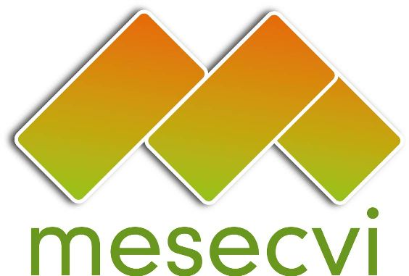
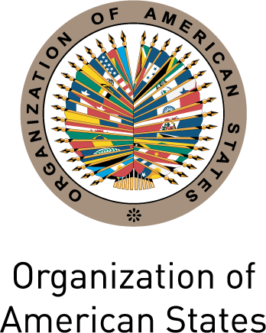

MECHANISM OF THE FOLLOW UP OEA/Ser.L/II.7.10
CONVENTION BELEM DO PARÁ (MESECVI) MESECVI-III/doc.52/11 rev.1
THIRD CONFERENCE OF STATES PARTIES 24 March 2011
March 24-25, 2011 Original: Spanish
Antigua, Guatemala

AGENDA

- Election of Authorities of the Conference of States Parties of the MESECVI.

- Approval of the draft agenda and the draft calendar of activities.

- Report of the Technical Secretariat on the implementation of the MESECVI.

- Evaluation of the Mechanism to Follow up on the Convention of Belem do Para – MESECVI – Performance and Impact of the First Multilateral Evaluation Round of the MESECVI: An Examination based on the opinion of key players” Natalia Gherardi – Equipo Latinoamericano de Justicia y Genero – ELA.

- Presentation of the Follow-Up Report on the Recommendations made by the CEVI in the Evaluation Stage of the First Multilateral Evaluation Round” and the Report “Evaluation of the CEVI on the advances and challenges of the MESECVI and Proposals for its Strengthening” Hilda Morales, Coordinator of the Committee of Experts – CEVI.

- Panel I: Strengthening and Challenges of the MESECVI.

- Panel II: Indicators on violence against women and comparative analysis of the initiatives supported by intergovernmental institutions. Evaluation of the existent ones in international organisms, conclusions and recommendations.

- Panel III: Violence against women from a citizen security perspective.

- Offer to host the Fourth Conference of States Parties.

- Adoption of the Decisions, Conclusions and Agreements of the Third Conference of States Parties

- Report of the Rapporteur of the Conference.

- Other business.
input.doc

