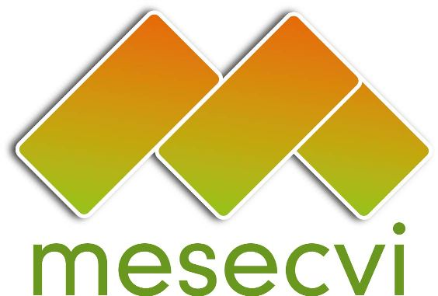
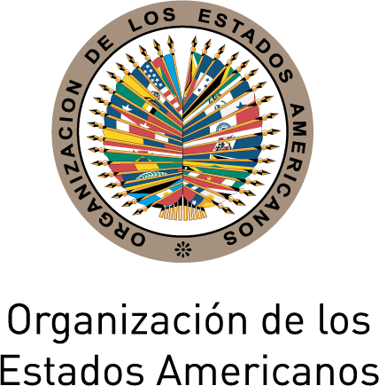

FOLLOW-UP MECHANISM TO THE OEA/Ser.L/II.7.10
BELÉM DO PARÁ CONVENTION (MESECVI) MESECVI-V doc.109/13 rev.4 corr.1
FIFTH CONFERENCE OF STATES PARTY November 27th, 2013
November 18th and 19th 2013 Original: Spanish

Washington D.C.

Agreements of the Fifth Conference of States Parties to the Mechanism to Follow Up on the Implementation of the Inter-American Convention on the Prevention, Punishment and Eradication of Violence against Women, “Convention of Belém do Pará” (MESECVI)
(Final)

The States Party to the Inter-American Convention on the Prevention, Punishment and Eradication of Violence against Women, Convention of Belém do Pará, gathered at the Fifth Conference of States Party to the MESECVI, from November 18th to 19th 2013 in Washington, D.C.;

RECALLING that, with the aim of ensuring the effective implementation of the provisions of the Convention, on October 26th 2004 the First Conference of States Party was organized at the headquarters of the Organization of American States (OAS) and adopted the “Statute of the Mechanism to Follow Up on the Implementation of the Inter-American Convention on the Prevention, Punishment and Eradication of Violence against Women, “Convention of Belém do Pará” (MESECVI);

CONSIDERING the importance of the MESECVI as a tool that contributes to the implementation of the Belém do Pará Convention, with respect for the diversity of the countries of region;

REITERATING that the access to justice of women victims of violence is one of the main challenges facing the region and one of the thematic priorities, as previously agreed by the Conference of States Party;

BEARING IN MIND that, at the beginning of the Second Multi-lateral Evaluation Round, the Conference of States Party agreed to generate different formulas for strengthening the MESECVI, in particular its Committee of Experts (CEVI), that would ensure its institutional recognition and the full implementation of its recommendations;

RECALLING that this Conference of States Party requested that, in pursuit of the effective implementation of the Convention, the matrix of indicators incorporate the efforts made by the different human rights protection and development organs, and that this agreement was fulfilled through the adoption by the Committee of Experts (CEVI), on May 21st 2013, of the document “Progress Indicators for Measuring the Implementation of the Inter-American Convention on the Prevention, Punishment and Eradication of Violence against Women – Belem do Para Convention” S (MESECVI/CEVI/doc.188 /13 rev.1);

BEARING IN MIND that, in accordance with Art. 25 of the CEVI Rules of Procedure, on July 30th and 31st the Follow-up Phase of the Second Multi-lateral Evaluation Round was initiated with the circulation of the document “Progress indicators to measure the implementation of the Belém do Pará Convention” (MESECVI/CEVI/doc.188 /13 rev.1); to invite to the States Parties to provide this relevant information taking advantage of the exchange that could possibly be done with the other States that have advanced in the matter, in order that the mechanism can have a wide vision of the efforts that the States Parties have developed;

REITERATING the importance for dialogue between the Competent National Authorities; the CEVI; the organizations and movements of women; and the organization of defense of women’s human rights;

RECOGNIZING the commitment and contributions of the Committee of Experts to the States Party through the Multi-lateral Evaluation Rounds, as well as the collaboration of civil society organizations and other social actors within the activities of the Mechanism;

REAFFIRMING the need to foster mechanisms for cooperation and the exchange of information and good practices between the States Party to the Convention, States that are not party, Permanent Observers to the OAS and other entities that address the issue at the sub-regional, regional and international levels;

THANKING the governments of Argentina, Mexico and Trinidad and Tobago for the financial support that they have provided to the MESECVI during 2013;

AGREE TO:

- Promote, through technical cooperation with the National Machineries for the Advancement of Women and other State bodies and the adoption of protocols for guaranteeing the access to justice of women victims of violence and improving the State response to gender-based violence;

- Foster activities to commemorate the twentieth anniversary of the adoption of the Belém do Pará Convention at the national, regional and sub-regional level, which contributes on the “Reflection Process for strengthening the MESECVI”.

- Encourage the States Party who have not yet done so, to designate their Principal and Alternate Experts, according to the Statute of the Mechanism; with the objective of strengthening the function of the Committee of Experts. States are encouraged to make these designations, as possible, before the “Hemispheric Forum on the Belém do Pará Convention” to be held in 2014 in Brazil;

- Continue promoting, with the support of the Technical Secretariat of the MESECVI, cooperation and exchange of good practices and information between the Mechanism and other entities that address violence against women at the sub-regional, regional and international levels, such as the justice institutions of the region, the organisms that bring them together, and any multi-lateral mechanisms that bring together authorities on gender and women’s issues, including the Central American Council of Women Ministers (COMMCA), the Council on Human and Social Development of the Caribbean Community (CARICOM), the Network of Women’s Machineries of the Andean Region (REMMA), the Meeting of Ministers and Highest Authorities on Women’s affairs of the MERCOSUR (RMAAM), and other specialized organs such as the Economic Commission for Latin America and the Caribbean (CEPAL), the Inter-American Development Bank (IADB), the United Nations Entity for Gender Equality and Empowerment of Women (UN Women), the Commission on the Status of Women (CSW) and the World Bank, among others;

- Foster the international cooperation for the exchange of ideas and experiences, as well as the execution of programs designed to protect women victims of violence as those set within the framework of the Memorandum of Understanding between the European Council and the MESECVI, in order to strengthened alliance with the Council of Europe; sharing its contributions for the future entry into force of the Convention on preventing and combating violence against women and domestic violence (Istanbul Convention);

- Reaffirm the commitments of the States with the strengthening of the MESECVI and the importance of propagate the progress, the good practices and challenges after 20 years of the Inter-American Convention on the Prevention, Punishment and Eradication of Violence against Women, “Convention of Belém do Pará”;

- Urge Member States and Permanent Observers to the OAS to consider as a matter of priority, to increase contribution to financial and human resources necessary to strengthen the work of the Mechanism in order to address the situation of violence against women;

- Encourage the Secretary General of the OAS, as a matter of priority, to consider assigning the human, technical and financial resources necessary for the optimal operation of the Technical Secretariat and the Mechanism, including the identification of sources of external funds, as well as the hosting of a donors meeting, and identify sources of external funds such as international and regional financial institutions, official national organs and others in order to finance the activities necessary to the optimal operation of the Mechanism and its Technical Secretariat and in accordance with Art. 11 of the Statute of the MESECVI;

- Request that the Technical Secretariat of the MESECVI generate tools for exchange, training and technical assistance with the States Party who request this, for the effective implementation of the “Progress indicators to measure the implementation of the Belém do Pará Convention” (MESECVI/CEVI/doc.188 /13 rev.1); and invite the States Parties to provide this relevant information taking advantage of the exchange that could possibly be done with the other States that have advanced in the matter, in order that the mechanism can have a wide vision of the efforts that the States Parties have developed;

- Continue fostering and motivating the participation of civil society and other actors in the activities of the MESECVI, in the framework of Article 10.2 of the Statute of the MESECVI, taking into consideration the Guidelines for the Participation of Civil Society Organizations in OAS Activities [CP/RES. 759 (1217/99)];

- Strengthen coordination with the corresponding authorities in order to promote the work of the Mechanism at the regional and national levels, and request that the Technical Secretariat broaden its dissemination through the MESECVI webpage and other methods of communication;

- Create a Working Group for the strengthening of the MESECVI so that prior to the next meeting of the Conference of the States Parties (to take place in October 2014 in Mexico), can consider and pass the recommendations that correspond to the Conference for the analysis of the following topics:
- The Strategic Plan of the MESECVI 2014-2017. The Strategic Plan which should follow the scope of mechanism, and will take into account the competencies established in the Statutes of the MESECVI for the Conference of the States Parties and the Committee of Experts;
- Guidelines for carrying out dialogues and/or meetings between the Conference of the States Party and the CEVI;
- Recommendations on the tools to promote a greater participation of the experts in CEVI meetings, including financing their participation in official CEVI meetings using Specific Fund from MESECVI, as created through Article 11 of the Statute of the Mechanism;
- The promotion of participation in civil society and other actors within society in accordance with the “Guidelines for the participation of civil society organizations in OAS activities” [CP/RES. 759 (1217/99)]

If as a result of the agreements reached, it is deemed necessary to modify the Statute of the MESECVI, the Working Group can also submit relevant recommendations on the issues set out in the mandate for consideration of the Conference of the States Party.

In the work calendar to be agreed on by the Working Group, priority will be given to the analysis of the Strategic Plan of the MESECVI with the objective of submitting the Working Group’s proposal for consideration of National Authorities by no later than March 2014.

The CEVI, through its President is invited to send recommendations, where pertinent, on the issues to be addressed by the Working Group in order to be considered by it.

The Working Group will count on the support of the Technical Secretariat of the MESECVI in an open forum, chaired by the Counselor Ana Lucia Nieto Frias, Alternate Representative of Peru to the OAS. The working group will designate their vice-presidents following the principle of regional representation.

- Request the Technical Secretariat of the MESECVI to create a biannual calendar, not coinciding with March 8th and November 25th, containing every activity and meeting that has been established and that will count on the participation of the Ministers and High Authorities on gender issues, and detailing all of the meetings of the Committee of Experts of the Mechanism for the Follow-Up on the Implementation of the Inter-American Convention to Prevent, Sanction, and Eradicate Violence Against Women (Belém do Pará Convention); for the consideration of the States;

- Take note of the presentation “Latin American Model Protocol for the Investigation of the Violent Deaths of Women for Gender-based Reasons (Femicide/Feminicide)” [Protocolo Latinoamericano de Investigación de las Muertes Violentas de Mujeres por Razones de Género (Femicidio/feminicidio)], developed by the Office of the UN High Commissioner for Human Rights (OHCHR) and the United Nations Entity for Gender Equality and Empowerment of Women (UN Women);

- Take not of the presentation of the Protocol for Judging from a Gender Perspective, developed by the Gender Equality Unit of the Supreme Court of Justice of the United States of Mexico;

- Thank Patricia Olamendi Torres, the expert from Mexico, for her work during 2011-2013 as Coordinator of the Committee of Experts (CEVI) of the Mechanism for the Follow-Up on the Implementation of the Inter-American Convention to Prevent, Sanction, and Eradicate Violence Against Women (Belém do Pará Convention- MESECVI);

- Request that the Inter-American Commission of Women, as Technical Secretariat of the MESECVI, develop and present within 90 days, a report to the State Parties on the work, achievements and challenges of the CEVI, including, work carried out by experts, the resources that are available to them, when they have held their meetings, and the issues they have worked on. This is with the objective to track the progress of the CEVI and its contribution to the MESECVI;

- welcome the accession of Italy to the Convention of Belén do Pará, which within the context of the Article 8 paragraph i of the convention, is an effective way to foster the international cooperation for the exchange of ideas and experiences and the execution of programs aimed at protecting women who are subjected to violence;

- Request that the Chair of this Conference present a report to the Sixth Conference of States Party, on the basis of the follow-up and periodic reports of the CEVI and the Technical Secretariat, as appropriate, on the measures adopted and progress made in the implementation of these agreements;

- Greet and positively welcoming the offer made by the delegation of Mexico to host the next Extraordinary Conference of States Parties to be held in October 2014; and by the delegation of Peru to host the next Ordinary Conference of States Parties, to be held in 2015;

CIM03526E01

In accordance with Guideline nº4, MESECVI-III/doc.59/11 rev.3
Conforme al acuerdo 6, MESECVI-III/doc.59/11 rev.3
In accordance with Art. 25 of the Rules of Procedure of the Committee of Experts of the MESECVI

