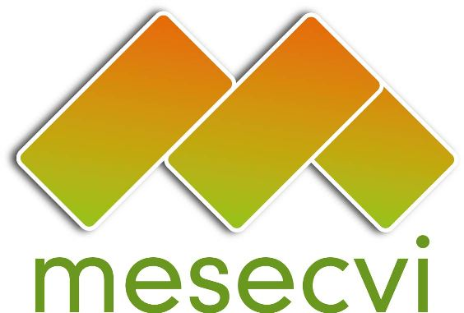


FOLLOW-UP MECHANISM OEA/Ser.L/II.7.10
BELÉM DO PARÁ CONVENTION (MESECVI) MESECVI/CEVI/doc.190/13 rev.2
Tenth Meeting of the Committee of Experts (CEVI) September 6th 2013
September 11th – 12th 2013 Original: Spanish
Washington D.C.

ORGANIZATION OF WORK
(Draft)

Date: September 11th – 12th 2013

Time: 9:00am – 6:00pm

Venue: Room Gabriela Mistral, OEA.

1889 F street NW. Washington D.C. (20006)

Wednesday September 11th

9:00 – 9:30 Inauguration

9:30 – 9:35 Break.

9:35 - 9:50 Adoption of the draft agenda and organization of work. (Item 1 of the Agenda)

9:50 - 11:30 Panel: Forms of operation of the mechanisms to follow-up Inter-American agreements. (Item 2 of the Agenda)
Moderator: Patricia Olamendi, Coordinator of the Committee of Experts of the Follow-up Mechanism to the Belém do Pará Convention (MESECVI)
9:50 - 10:40 ● Multilateral Evaluation Mechanism (MEM) of the Inter-American Drug Abuse Control Commission (CICAD).
Question and answer session

10:40 - 11:30 ● Mechanism for Follow-Up on the Implementation of the Inter-American Convention against Corruption (MESICIC)
Question and answer session

11:30 - 12:00 Presentation of the Department of Public Security (DPS) – Secretariat for Multidimensional Security (SMS).

12:00 - 12:20 Question and answer session

12:20 - 12:40 Report of the Technical Secretariat of the Follow-up Mechanism to the Belém do Pará Convention (MESECVI).
(Item 3 of the Agenda)
Luz Patricia Mejía, Technical Secretary of the MESECVI

12:40 - 1:00 Comments and dialogue.

1:00 - 2:00 Lunch- Lunch and working meeting of the Working Group for drafting the Manual on the Implementation of the Convention of Belém do Pará
Exposition by Soraya Long

2:00 - 2:10 Consideration of the proposal for the Modification of the Legal Instruments. (Item 4 of the Agenda)
Presentation of the proposal
Luz Patricia Mejía, Technical Secretary of the MESECVI

2:10 - 6:00 Comments, dialogue and agreements.

Thursday September 12 th

9:00 - 9:10 Consideration of the proposal for the “Declaration on Violence and Sexual and Reproductive Rights”. (Item 5 of the Agenda)
Presentation of the proposal
Luz Patricia Mejía, Technical Secretary of the MESECVI

9:10 - 1:00 Comments, dialogue and agreements.

1:00 - 2:00 Lunch

2:00 - 2:30 Status of responses of the States to the Progress Indicators for measuring the Implementation of the Belém do Pará Convention and adoption of the Methodology for the Follow-up Report.
(Item 6 of the Agenda)
Luz Patricia Mejía, Technical Secretary of the MESECVI

2:30 - 3:00 Comments and dialogue.

3:00 - 3:30 Determination of the composition of subgroups to analyze the information received from the States Parties they have been assigned to review, and election of the Coordinators and Alternate Coordinators of subgroups as necessary (Art. 3e) Rules of Procedure of the Committee). (Item 7 of the Agenda)

3:30 - 4:00 Evaluation of the Two-Year Work Plan for the CEVI (2013-2015).
(Item 8 of the Agenda)
Patricia Olamendi, Coordinator of the Committee of Experts of the MESECVI.

4:00 - 4:30 Comments, dialogue and agreements.

4:30 - 5:00 Election of authorities. (Item 9 of the Agenda)

5:00 – 5:30 Other matters. (Item 10 of the Agenda)
CIM03477E01

5:30 – 6:00 Adoption of agreements of the X meeting of the CEVI.
(Item 11 of the Agenda)

