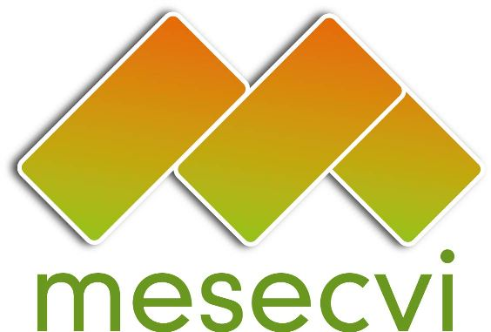
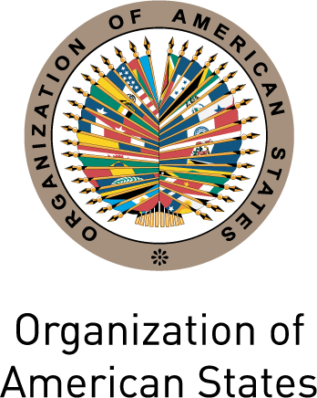

MECHANISM TO FOLLOW UP OEA/Ser.L/II.7.10
CONVENTION OF BELÉM DO PARÁ (MESECVI) MESECVI/CEVI/doc.98/10 rev. 2
COMMITTEE OF EXPERTS ON VIOLENCE (CEVI) 23 August 2010
Sixth Meeting of the Committee of Experts (CEVI) Original: Spanish
August 23 to 25, 2010
Santo Domingo de Heredia, Costa Rica

AGENDA

[Adopted at the Sixth Meeting of the Committee of Experts (CEVI),
held on August 23, 2010]
input.doc

- Adoption of the draft Agenda and the draft Working Procedures

- Presentation by civil society organizations

- Dialogue on Violence against Women, Security and Access to Justice

- Presentation of Reports:

- Report of the Coordinator of CEVI and the Secretariat
- Activities undertaken in the countries to publicize the MESECVI- Campaign to promote the MESECVI

- Implementation of the Second Multilateral Evaluation Round

- Preliminary country reports
- Alternative reports from civil society organizations

- CEVI’s Biennial Work Program 2010-2012

- CEVI’s Report to the MESECVI’s Third Conference of States Parties

- Evaluation of the MESECVI and proposals for its strengthening
- Follow-Up Report on the Implementation of the CEVI’s Recommendations to the States Parties

- Other business

