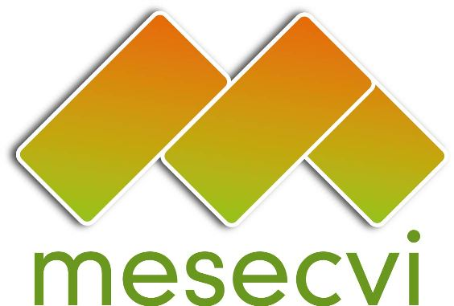
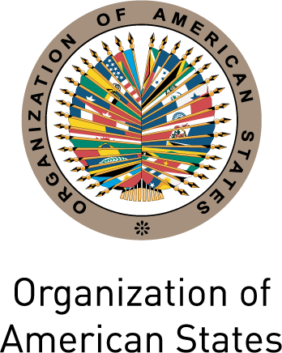

FOLLOW-UP MECHANISM OEA/Ser.L/II.7.10
BELÉM DO PARÁ CONVENTION (MESECVI) MESECVI/CEVI/doc.179/12 rev.3
Ninth Meeting of the Committee of Experts October 25th 2012
November 12th to 14th 2012 Original: Spanish
Mexico City, Mexico

ORGANIZATION OF WORK
(Draft)

Date: November 12th to 14th 2012

Time: 9:00am – 6:00pm

Venue: Secretariat for External Relations of Mexico

Monday November 12th

8:30 – 9:00 Registration

9:00 – 9:30 Inauguration
- Welcome message from the Representative of the Ministry of Foreign Affairs of Mexico
- Message from the Secretary General of the Organization of American States
- Remarks by Ana Güezmes, UN Women Regional Director for Mexico, Central America, Cuba and Dominican Republic
- Remarks by Patricia Olamendi, Coordinator of the Committee of Experts of the Follow-up Mechanism to the Belém do Pará Convention (MESECVI)
- Remarks by Rosario Robles, Deputy Coordinator of Social Policy for the transition team of the President-elect
9:30-12:00 Forum: Indigenous Women in the Inter-American Justice System
Moderator: Patricia Olamendi, Coordinator of the Committee of Experts of the Follow-up Mechanism to the Belém do Pará Convention (MESECVI)
- The experience of Indigenous Women in the Defense of Human Rights before the Inter-American Human Rights System
Inés Fernández Ortega y Valentina Rosendo Cantú (México)
- Indigenous women and access to justice. Positive experiences and good practices
Nina Pacari (Ecuador), Minister of the Constitutional Court of Ecuador
- Indigenous Women’s Rights. Obstacles and Challenges of the Inter-American Human Rights System in the Defense of Women’s Human Rights
Mirna Cunningham Kain (Nicaragua), member of the United Nations Permanent Forum on Indigenous Issues
- Protection of Indigenous Women’s Rights. Access to national and international justice
Otilia Lux de Coti (Guatemala), Director of International Forum of Indigenous Women
- Positive experiences monitoring and following up on Indigenous Women’s Rights
Martha Sánchez Nestor (Mexico), Coordinator of the Alliance of Indigenous Women of Central America and Mexico
- An example of good practices in access to justice
Alejandro Negrín (Mexico), Director of Human Rights and Democracy of the Ministry of Foreign Affairs

11:30-1:00 Question and answer session

1:00-2:30 Lunch

2:30-2:45 Adoption of the draft agenda and organization of work
(Item 1 of the agenda)

2:45-6:00 Discussion on the importance of indicators in addressing violence against women

Moderator: Patricia Olamendi, Coordinator of the Committee of Experts of the Follow-up Mechanism to the Belém do Pará Convention (MESECVI)
- Evaluation of the construction of indicators to measure the exercise of women’s right to live a life free of violence
Laura Pautassi MESECVI consultant
- Presentation of the Draft Indicators of the Second Multi-lateral Evaluation Round to Follow-up the Recommendations of the Committee of Experts (Item 4 of the agenda)
Luz Patricia Mejía, Coordinator of the MESECVI Technical Secretariat
- Human Rights’ Indicators according to the experience in the CEDAW
Line Bareiro, Committee on the Elimination of all Forms of Discrimination against Women Expert (CEDAW Committee)
  - Monitoring and evaluation indicators on violence against women and girls
Shelah S. Bloom, Carolina Population Centre, University of North Carolina
  - The importance of the indicators in the analysis of women’s rights
Godfrey St. Bernard, Sir Arthur Lewis Institute of Social and Economic Studies
Comments: Paz López, UN Women Regional Advisor for Mexico and Central America

Comments and discussion

Tuesday November 13th

9:30-11:30 Discussion on indicators for the fulfillment of the Belém do Pará Convention
Moderator: Patricia Olamendi, Coordinator of the Committee of Experts of the Follow-up Mechanism to the Belém do Pará Convention (MESECVI
Discussants:
  - The importance of health indicators in addressing violence against women
Alessandra Guedes, Regional Advisor on Intra-family Violence, Pan American Health Organization (PAHO/WHO)
- System of indicators to evaluate from the perspective of civil society the state compliance of the Convention on the Prevention, Punishment and Eradication of Violence Against Women (Belém do Pará)
Rose Mary Madden, Special Program on Women’s Human Rights, Inter-American Institute of Human Rights (IIDH)
- The importance of building rights-based indicators in the assessment of women’s right to live in a world free of violence
Liz Meléndez López, Coordinator of the Latin American and Caribbean Committee for the Defence of Women’s Rights (CLADEM) in Peru
- Positive experiences in implementing indicators to follow up the Convention of Belém do Pará
Doris Montenegro, Central American Feminist Network against Violence towards Women
Comments: Paz López, UN Women Regional Advisor for Mexico and Central America

11:30-1:00 Validation of the proposal for indicators to measure the exercise of women’s right to live a life free of violence
Discussion and agreements

1:30-3:00 Lunch

3:00-6:00 Validation of the proposal for indicators to measure the exercise of women’s right to live a life free of violence (continues)

Wednesday November 14th

9:30-12:00 Presentation of the Draft Two-Year Work Plan for the CEVI (2013-2015) (Item 3 of the agenda)
- Patricia Olamendi, Coordinator of the Committee of Experts of the Follow-up Mechanism to the Belém do Pará Convention (MESECVI)
Comments from the Experts

12:00-1:30 Presentation of the MESECVI Strategic Plan 2013-2017 (Item 5 of the agenda)
- Luz Patricia Mejía, Coordinator of the MESECVI Technical Secretariat
Comments from the Experts

1:30-3:00 Lunch

3:00-4:00 Other matters (Item 6 of the agenda)

CIM03357E01

