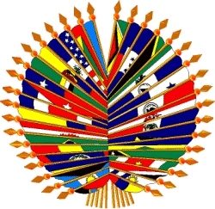
Organización de los Estados Americanos
Organização dos Estados Americanos
Organisation des États américains
Organization of American States

II MEETING OF THE INTER-AMERICAN COMMITTEE ON EDUCATION

INFORMATION BROCHURE

1. Site of the Meeting

Preparatory Meeting for Authorities and Executive Committee will take place in room Gabriela Mistral at the Organization of American States building on 1889 F. Street N.W. Suite 764-A, Washington, DC 20006.

The II Meeting of the CIE will take place in the Hall of the Americas which is located at the OAS headquarters at 17th and Constitution, Washington DC 20006.

2. Coordinating Officers

Jorge Baxter

Telephones (202) 458 6459
Fax: (202) 458 3744
E-mail: jbaxter@oas.org

David Edwards

Telephones: (202) 458 3659
Fax: (202) 458 3744
E-mail: dedwards@oas.org

Christian Medina

Telephones: (202) 458 6889
Fax: (202) 458 3744
E-mail: cmedina@oas.org

- Accommodation

The Technical Secretariat suggests the Washington Plaza Hotel and the George Washington University Inn for the accommodation of delegates.

State Plaza Hotel
E-mail umacnamara@stateplaza.com
Telephone (202)-861-8200 or 1-800-424-2859
2117 E Street, N.W. Washington D.C. 20037

George Washington University Inn
824 New Hampshire Ave. N.W.
Washington DC 20037
Telephone: 202 337 6620
Fax 202 298 7499

6. Requirements for entering and leaving the country

The requirements for entry to The United States are detailed for each country on the website of the State Department at http://travel.state.gov/visa/index.html

7. Registration of Participants

It is required for delegates to complete and send the attached registration form.

- Working Languages and Documents

The Preparatory Meeting will be conducted in English and Spanish. The II Meeting of the CIE will have simultaneous interpretation in the four official languages of the OAS.

10. Climate

In the month of October, temperatures vary around the 60 F
11.
- Time

Washington DC, is on Eastern time

12. Electricity

100 Voltage & 220 Voltage

- Social-Cultural Activities
National Galery of Art
National Air and Space Museum
American History
Hirschhorn Museum and Sculpture
Ford’s Theater
National Cathedral
Pentagon City Mall
Arena Theater
The Corcoran

- Business hours: 8:00 hrs to 19:00 hrs

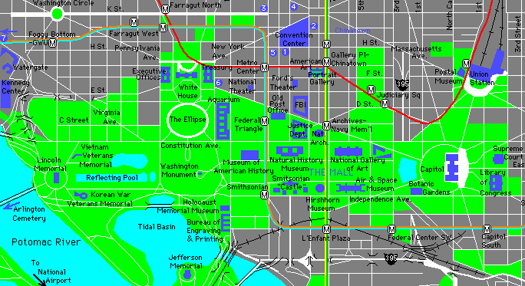
OAS
OAS/GSB

OAS: OAS Main Building: 17th and Constitution Ave. NW
OAS/GSB: OAS General Secretariat Building: 1889 F. st. NW

Annex I

FORMULARIO DE INSCRIPCIÓN/REGISTRATION FORM

II CIE MEETING

Please send to nruiz@oas.org or to the fax number (202) 458 37 44.
Por favor, enviarlo a la dirección de correo electrónico: nruiz@oas.org o al número de fax: (202) 458 37 44.

País u Organización/
Country or Organization

Representante titular / Principal representative
Representante suplente / Alternate representative
Observador / Observer
Otro / Other

Apellido /Last name:

Nombre / First name:

Cargo / Position:

Dirección permanente/ Permanent address:

Teléfono / Telephone:
Fax:
E-mail:
Dirección local/Local address:
Teléfono / Telephone

