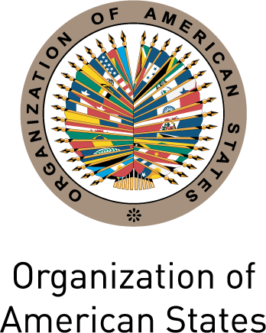
XLV LECTURE OF THE AMERICAS
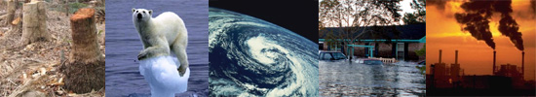
Climate Change:
What the Americas Can and Must Do

Friday, May 13, 2011

10:00-11:00 am

Hall of the Americas, Organization of American States
Washington, D.C.

PROGRAM
10:00 a.m. Welcoming remarks by OAS Secretary for External Relations, Alfonso Quiñonez
10:05 a.m. Introduction of the keynote speaker
10:10 a.m. Keynote speaker:
Christiana Figueres, Executive Secretary of the United Nations Framework Convention on Climate Change (UNFCCC)

10:35 a.m. Question and answer session moderated by Cletus Springer, Director, Department of Sustainable Development, Executive Secretariat for Integral Development (SEDI), OAS
To register please click here or send an e-mail to SER-DIA@oas.org

