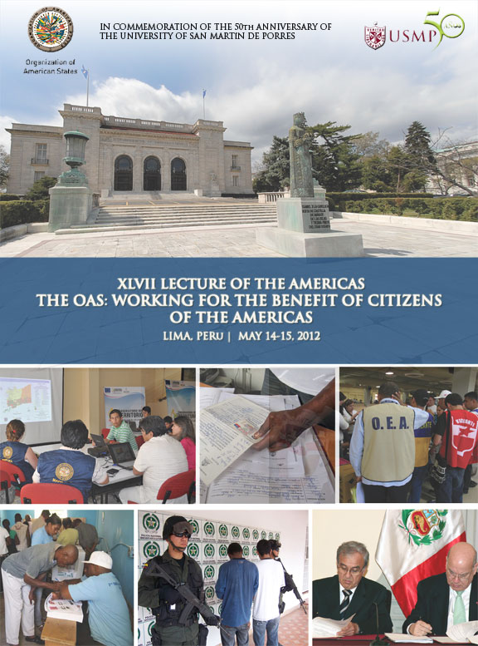

BACKGROUND OF THE LECTURE SERIES OF THE AMERICAS

The Lecture Series was created by the Organization of American States (OAS) to enrich the hemispheric debate on priority issues of the inter-American agenda through conferences featuring distinguished personalities sharing their experiences and helping to identify best practices to address the challenges facing the region.

With the continued support of its main sponsor, the University of San Martin de Porres (USMP) and contributions from Permanent Observer countries, the OAS has realized forty-six successful Lectures of the Americas. The effort of the University was formalized in December 2004 after the signing of a cooperation agreement through which the USMP pledged to financially support and promotion of eight lectures a year. This agreement demonstrates the prestige and recognition throughout the hemisphere of the USMP and its commitment to democratic values, making it stand out not only as the largest university in Peru, but also for its academic excellence, which places it among the top three private universities in the country.

The commitment of the USMP to the Lecture Series of the Americas has been fundamental to support the OSA in creating greater awareness about the importance of joining efforts to identify best practices to strengthen democratic institutions and contribute to the prosperity of the hemisphere.

Since the creation of the Lecture Series of the Americas in 2004, more than twelve thousand people have participated in this forum at OAS Headquarters in Washington, DC, among which include diplomats, representatives of member states and observer countries to the OAS, civil society, private sector, academia, students and staff of the OAS. In addition, thousands have followed the program over the Internet in Spanish and English; and, because of its topics of relevance, universities in the region use the Lectures as academic material in their programs of study.

PURPOSE AND DESCRIPTION OF THE PROGRAM

The Lecture "The OAS: Working for the Benefit of Citizens of the Americas" is to commemorate the 50th Anniversary of the USMP, and to reaffirm the commitment of the OAS to promote democratic values ​​in the Americas by strengthening democracy, protection of human rights, integral development, combating insecurity, and identify new challenges and best practices that help us tackle these issues.

This program is developed in the framework of the important collaboration between the USMP and the OAS, and the conviction of both institutions to have a space that allows for the dissemination and promotion of democratic values, rights and freedoms, and social inclusion in countries throughout the region, which is reflected in successful programs being carried out by the Organization, such as the Program for Universal Civil Identity in the Americas (PUICA), the Mission to Support the Peace Process in Colombia (MAPP / OAS), Inter-American Social Protection Network (IASPN), and programs aimed at defending and protecting human rights.

The Lecture "The OAS: Working for the Benefit of Citizens of the Americas" will be held at the Focum Culturae Auditorium of the School of Law of the University of San Martin de Porres lasting about a day and a half, during which time recognized experts in the region will address key issues of the hemispheric agenda.

EVENT COMMEMORATING 50 YEARS OF THE USMP

The Lecture will begin with an inaugural event to be held on May 14, which will be attended by Senator Daniel Abugattas, President of the Congress of the Republic of Peru; His Excellency Jose Miguel Insulza, OAS Secretary General; and Dr. José Antonio Chang Escobedo, President of the USMP.

This inaugural meeting of May 14 will be followed by six Lectures, where experts will speak on the role of the OAS in strengthening democratic institutions, human rights, social development and multidimensional security, followed by comments and questions and answers from the audience. The first Lecture will address: "The OAS and its importance in the hemisphere." The second Lecture will focus on "The preservation of democratic institutions: peacekeeping missions of the OAS" and the third: "Social inclusion and democratic governance." Following lunch, the fourth and last Lecture of the day will be held: "The OAS in the defense and protection of human rights."

Following, there will be a video screening about the Inter-American Democratic Charter, adopted in Lima in 2001, and will be proceeded by the presentation of a plaque and diploma by the OAS Secretary General to the USMP in commemoration of its 50th anniversary. The second day of activities, there will be two Lectures, one on "The protection of the rights of women: a task for all" and then following another brief recess will be the final Lecture on: "Reflections on the safety of citizens in the Americas." The memorial program will conclude with a luncheon hosted by the USMP.

ANOTATED AGENDA OF THE EVENT

Place: Auditorium Focum Culturae of the Law School of the University San Martín de Porres –Av. Alameda del Corregidor 1865 Urb. La Ensenada, La Molina

Monday, May 14, 2012

9:00 am Inaugural Ceremony
- Congressman Daniel Abuggatas, President of the Congress of Peru
- Dr. José Antonio Chang, USMP President
- H.E. Jose Miguel Insulza, OAS Secretary General

9:40 am General Introduction: "The OAS: Working for the Benefit of Citizens of the
Americas"
- Ambassador Hugo de Zela, Chief of Staff to the OAS Secretary General

10:00 am Lecture I: "The OAS and its importance in the hemisphere"
- H.E. Álvaro Colom, Former President of Guatemala
- H.E. Alan Garcia, Former President of Peru
Moderator:
- Dr. José Antonio Chang, USMP President

Question and Answer Session

10:50 am Coffee

11:00 am Lecture II: "Preservation of democratic institutions: OAS peacekeeping missions"
Panelist:
- Camilo Ospina, Former Minister of Defense of Colombia and Former Permanent Representative of Colombia to the OAS
Commentator:
- Marcelo Alvarez, Head of the Mission to Support the Peace Process in Colombia (MAPP/OEA)
Testimony:
- Pastora Mira, Council Member of the municipality of San Carlos, Antioquia, Colombia and the National Peace Prize Recipient 2011
Moderator:
- Raul Bao, USMP Vice President

Question and Answer Session

The OAS, through the implementation of the Charter, has acted as mediator, at the request of its Member States to prevent the escalation of political and institutional crises that could have endangered the democratic process or the legitimate exercise of power. Sending special missions and the opening of dialogue processes are some of the mechanisms used by the organization to overcome crisis situations that affect the democratic order.

This Lecture will present the perspective of those who led special missions, as well as important insights on the role of the OAS in the peace processes and in confidence-building and reconciliation for the development of a democratic culture and peaceful resolution of violence, and in developing programs to promote a culture of peace including through the Mission to Support the Peace Process in Colombia (MAPP), created in 2004 by agreement between the Government of Colombia and the OAS to verify and monitor the ceasefire and the cessation of hostilities between the government and illegal armed groups, as well as demobilization, disarmament and integration initiatives and support to communities who have been affected by violence.

12:00 pm Lecture III: "Social inclusion and democratic governance"
Panelist:
- Carolina Trivelli, Minister for Social Development and Inclusion of Peru
Commentators:
- Luis Carranza, Former Minister of Economy and Finance of Peru and Professor of the USMP
- Steven Griner, Coordinator of the Universal Civil Identity in the Americas Program (PUICA)
Testimony:
Felicitas Loayza Cardenas, Director of Mama Quilla in Huaycan
Moderator:
- Hugo Guerra, Director of the Lecture Series in Peru

Question and Answer Session

Reducing poverty and inequality is one of the greatest pillars of work of the OAS, which promotes the collaboration between the Member States in areas related to human, social, economic and sustainable development, through inter-American cooperation networks that promote the identification and exchange of experiences and best practices.

The objective of this Lecture is to provide the perspective of experts who carry out initiatives to address poverty, promoting social inclusion and democratic governance. This Lecture will feature the participation of the Coordinator of the Program for Universal Civil Identity in the Americas (PUICA), implemented by the OAS, who will address the importance of civic identity, necessary for the exercise of civil, political, economic and social rights; in addition to the testimony of a beneficiary of PUICA.

1:00 pm Lunch

2:30 pm Lecture IV: "The OAS in the defense and protection of human rights"
Panelists:
- Diego García Sayán, President of the Inter-American Court of Human Rights
- José De Jesús Orozco, Chair of the Inter-American Commission on Human Rights
Commentator:
- Marisol Pérez Tello, Congresswoman of the Republic of Peru
Moderator:
- David Cunza, Director of the Lecture Series in Peru

Question and Answer Session

The Lecture will focus on the importance of promoting, defending and protecting human rights in the region.

The promotion and protection of human rights is one of the main pillars of the work of the OAS. This important task has been undertaken through the Inter-American Commission on Human Rights (IACHR), created in 1959 and based in Washington DC and through the Inter-American Court of Human Rights, established in 1979, based in San Jose, Costa Rica.

The Commission consists of seven independent commissioners elected by Member States to promote the observance and defense of human rights. It receives, analyzes and investigates individual over 1300 petitions per year since 1959 and has processed over 13,000 cases.

The Inter-American Court of Human Rights is an autonomous judicial institution created by the American Convention on Human Rights (1969) also known as the Pact of San Jose and today represents the most advanced American system to depoliticize the implementation and respect human rights in the Hemisphere.

5:00 pm Projection of a video on the Inter-American Democratic Charter, produced by the OAS

5:30 pm Conferment Ceremony of an Honorary Doctorate Degree by the University of San Martin de Porres to H.E. Jose Miguel Insulza, OAS Secretary General
Location: Ruben Guevara Auditorium of the USMP School of Law

6:00 pm Toast of Honor

8:30 pm Cocktail hosted by the USMP and ceremony for the OAS to recognize the USMP’s 50th anniversary
Place: Marriott

Tuesday, May 15, 2012

9:00 am Lecture V: "The protection of the rights of women: a task for all"
Panelist:
- Carmen Moreno, Executive Secretary, Inter-American Commission of Women (CIM)
Commentators:
- Luz María Helguero, Chairman of Transparency International - Peru Section
- Elba Núñez Ibáñez, Regional Coordinator, Latin America and the Caribbean Committee for the Defense of Women's Rights (CLADEM)
Moderator:
- Hilda Abaca, Dean of the School of Obstetrics and Nursing, USMP

Question and Answer Session

This Lecture will review the progress and challenges to the full realization of human rights of women – from the ability of women to access education, equal payment for employment and access to social services and health, to the capacity of women to negotiate sexual relations and reproduction or to protect themselves from violence, including in their own homes.

The CIM is the principal hemispheric policy forum to promote and protect the rights of women and support to Member States in their efforts to ensure full access to civil, political, economic, social and cultural rights that allow women and men participate on an equal footing in all spheres of social life, to achieve full and equal enjoyment of the benefits of development and to share responsibility for the future.

10:15 am Coffee

10:30 am Lecture VI: "Reflections on the safety of citizens in the
Americas"
Panelist:
- Kevin Casas-Zamora, Secretary for Political Affairs, OAS
Commentators:
- Gabriel Prado Ramos, Manager of Citizen Security of the City of Lima
- Gino Costa, Former Minister of Interior of Peru

Moderator:
- Ruben Sanabria, Dean of the School of Law, USMP

Question and Answer Session

This Lecture will discuss how the OAS works on several fronts to ensure that the peoples of the Hemisphere are protected from the many threats of our modern world. Interesting statistics, best practices and policy recommendations resulting from OAS experience in this field will also be shared.

The concept of public security has come to be understood as more complex than in decades past. Security threats go beyond the traditional military sphere to include issues that have a direct impact on the lives of people, such as gang violence, cybercrime, trafficking in firearms, or in humans.

12:00 pm Closing Ceremony
- Dr. José Antonio Chang, USMP President
- H.E. José Miguel Insulza, OAS Secretary General
- H.E. Marisol Espinoza, First Vice President of the Republic of Peru

1:00 pm Luncheon hosted by the University of San Martin de Porres

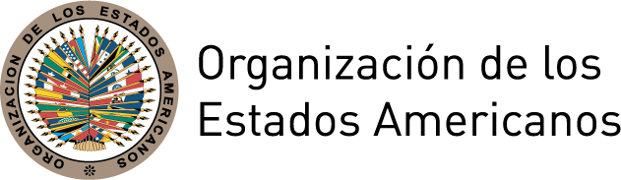
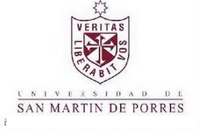
LECTURE SERIES OF THE AMERICAS:
THE OAS: WORKING FOR THE BENEFIT OF THE CITIZENS OF THE AMERICAS
Monday, May 14, 2012
Location: Focum Culturae Auditorium of the USMP School of Law
Av. Alameda del Corregidor 1865 Urb. La Ensenada, La Molina
TIME | SESSION
9:00 am | Inaugural Ceremony  - Congressman Daniel Abuggatas, President of the Congress of Peru  - Dr. José Antonio Chang, USMP President  - H.E. José Miguel Insulza, OAS Secretary General
9:40 am | General introduction: "The OAS: Working for the Benefit of Citizens of the Americas"  - Ambassador Hugo de Zela, Chief of Staff to the Secretary General of the OAS
10:00 am | Lecture I: "The OAS and its importance in the hemisphere"  - H.E. Álvaro Colom, Former President of Guatemala  - H.E. Alan García, Former President of Peru  Moderator:  - Dr. José Antonio Chang, USMP President  Question and Answer Session
10:50 am | Coffee
11:00 am | Lecture II: "Preservation of democratic institutions: peacekeeping missions of the OAS"  Panelist:  - Camilo Ospina, Former Minister of Defense of Colombia and Former Permanent Representative of Colombia to the OAS  Commentator:  - Marcelo Alvarez, Head of the Mission to Support the Peace Process in Colombia (MAPP/OEA)  Testimony:  - Pastora Mira, Council Member of the municipality of San Carlos, Antioquia, Colombia and the National Peace Prize Recipient 2011  Moderator:  - Raul Bao, USMP Vice President  Question and Answer Session
12:00 pm | Lecture III: "Social inclusion and democratic governance"  Panelist:  - Carolina Trivelli, Minister for Social Development and Inclusion of Peru  Commentators:  - Luis Carranza, Former Minister of Economy and Finance of Peru and Professor of the USMP  - Steven Griner, Coordinator of the Universal Civil Identity in the Americas Program (PUICA)  Testimony:  - Felicitas Loayza Cardenas, Director of Mama Quilla in Huaycan  Moderator:  - Hugo Guerra, Director of the Lecture Series in Peru  Question and Answer Session
1:00 pm | Lunch
2:30 pm | Lecture VI: "Reflections on the safety of citizens in the  Americas "  Panelists:  - Diego García Sayán, President of the Inter-American Court of Human Rights  - José De Jesús Orozco, Chair of the Inter-American Commission on Human Rights  Commentator:  - Marisol Pérez Tello, Congresswoman of the Republic of Peru  Moderator:  - David Cunza, Director of the Lecture Series in Peru  Question and Answer Session
5:00 pm | Projection of a video on the Inter-American Democratic Charter, produced by the OAS
5:30 pm | Conferment Ceremony of an Honorary Doctorate Degree by the University of San Martin de Porres to H.E. Jose Miguel Insulza, OAS Secretary General  Location: Ruben Guevara Auditorium, USMP School of Law
6:00 pm | Toast of Honor
Tuesday May 15, 2012
Location: Focum Culturae Auditorium of the USMP School of Law
Av. Alameda del Corregidor 1865 Urb. La Ensenada, La Molina
TIME | SESSION
9:00 am | Lecture V: "The protection of the rights of women: a task for all"  Panelist:  - Carmen Moreno, Executive Secretary, Inter-American Commission of Women (CIM)  Commentators:  - Luz María Helguero, Chairman of Transparency International - Peru Section  - Elba Núñez Ibáñez, Regional Coordinator, Latin America and the Caribbean Committee for the Defense of Women's Rights (CLADEM)  Moderator:  - Hilda Abaca, Dean of the School of Obstetrics and Nursing, USMP  Question and Answer Session
10: 15 am | Coffee
10:30 am | Lecture VI: "Reflections on the safety of citizens in the  Americas "  Panelist:  - Kevin Casas-Zamora, Secretary for Political Affairs, OAS  Commentators:  - Gabriel Prado Ramos, Manager of Citizen Security of the City of Lima  - Gino Costa, Former Minister of Interior of Peru  Moderator:  - Ruben Sanabria, Dean of the School of Law, USMP  Question and Answer Session
12:00 pm | Closing Ceremony  - Dr. José Antonio Chang, USMP President  - H.E. José Miguel Insulza, OAS Secretary General  - H.E. Marisol Espinoza, First Vice President of the Republic of Peru
1:00 pm | Luncheon offered by the University of San Martín de Porres

