
THE FORTY-THIRD LECTURE OF THE AMERICAS
Presentation of the OECD Report:
“Latin American Economic Outlook 2011
How Middle Class is Latin America?”

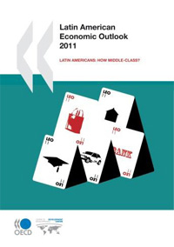 |  | 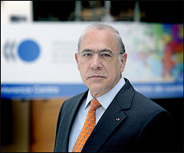

By ANGEL GURRIA

Secretary General of the Organisation for Economic Co-operation and Development (OECD)

Monday, December 6, 2010

3:00 pm
Hall of the Americas, Organization of American States
Washington, D.C.

PROGRAM
3:00 pm Welcoming remarks by OAS Secretary General, José Miguel Insulza
3:05 pm Introduction of the speaker by Ambassador María Isabel Salvador, Vice Chair of the Permanent Council and Permanent Representative of Ecuador to the OAS
3:10 pm Presentation of the Report by Mr. Gurría
3:40 pm Question and answer session with the public moderated by Irene Klinger, Director of the Department of International Affairs (DIA), Secretariat for External Relations (SER)
Please register by clicking here or send an e-mail to SER-DIA@oas.org

