Secretariat for External Relations / Department of International Affairs
Summits of the Americas Secretariat
In preparation for the VI Summit of the Americas, cordially invite you to the
XXXV OAS POLICY ROUNDTABLE:
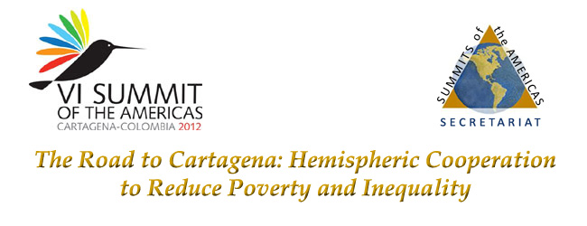
Friday, November 4
10:00 am - 12:00 pm
OAS Hall of the Americas, 17th Street and Constitution Ave. NW
Washington, DC 20006
Program
10:00 am Welcoming remarks by Sherry Tross, Executive Secretary Summits of the Americas Secretariat, OAS

10:10 am Discussion Panel moderated by Ana Evelyn Jacir de Lovo, Director of Social Development and Employment in the Executive Secretariat for Integral Development, OAS

    - Nancy Birdsall, President of the Center for Global Development (CGD)
    - George Gray Molina, Chief Economist, UNDP
    - Elsa Mata, Executive Director, CE-Mujer, Dominican Republic

11:10 am Question and answer session

11:40 am Event closing by Ambassador Luis Alfonso Hoyos, Permanent Representative of Colombia
Please register here or send an e-mail to SER-DIA@oas.org

