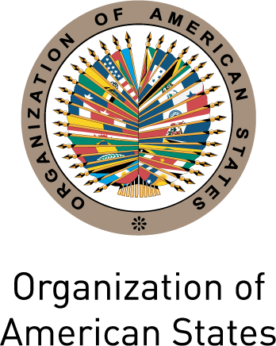

Secretariat for External Relations / Department of International Affairs

XXXVIII OAS POLICY ROUNDTABLE

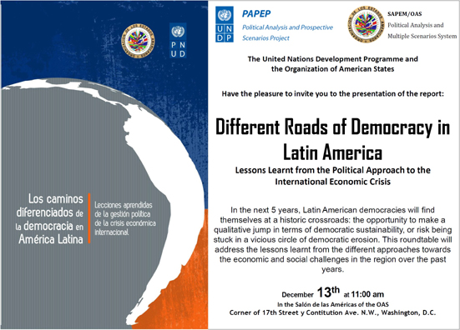

DIFFERENT ROADS OF DEMOCRACY IN LATIN AMERICA
Lessons Learnt from the Political Approach
to the International Economic Crisis.

Tuesday, December 13, 2011
11:00 am- 1:00 pm
Hall of the Americas, 17th Street and Constitution Ave. NW, Washington, DC 20006

11:00 am Welcoming remarks by José Miguel Insulza, Secretary General, OAS

11:15 am Remarks by Heraldo Muñoz, Regional Director for Latin America and the Caribbean, United Nations Development Programme (UNDP)

11:30 am Presentation of the OAS/ UNDP publication “Different Roads of Democracy in Latin America” by:

- Víctor Rico, Secretary for Political Affairs, OAS

- Antonio Aranibar, Regional Coordinator, Political Analysis and Prospective Scenarios for Improved Democratic Governance in Latin America (PAPEP), UNDP

12:00 pm Comments by

- Cynthia Arnson, Director, Latin American Program, Woodrow Wilson International Center for Scholars

- Kevin Casas, Director, Latin America Initiative, The Brookings Institution

12:20 pm Question and answer session

Please register here or send an e-mail to SER-DIA@oas.org

