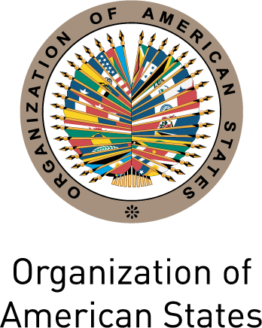

Secretariat for External Relations / Department of International Affairs
Organization of American States (OAS)

XXVII OAS POLICY ROUNDTABLE

TO CELEBRATE HUMAN RIGHTS DAY

Wednesday, December 15, 2010
3:30 PM
Hall of the Americas, 17th Street and Constitution Ave. NW
Washington, DC 20006

3:30-3:35 pm Welcoming remarks by OAS Secretary General, José Miguel Insulza

3:35- 4:15pm Panelists:
Maria Otero, Under Secretary of State for Democracy and Global Affairs, US Department of State
Santiago Canton, Executive Secretary of the Inter-American Commission on Human Rights
Juan Mendez, Former President of the International Center for Transitional Justice (ICTJ)

4:15-5:00 pm Question and answer session moderated by Irene Klinger, Director Department of International Affairs, Secretariat for External Relations, OAS

5:00 pm Closing of the event

Please register here or send an e-mail to SER-DIA@oas.org

