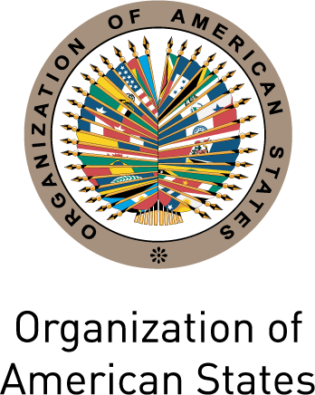

Secretariat for External Relations / Department of International Affairs
Organization of American States (OAS)

XXX OAS POLICY ROUNDTABLE
Inclusion and Democracy in the Americas
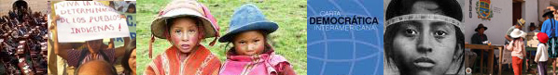
Monday, May 23, 2011
3:00 PM
Hall of the Americas, 17th Street and Constitution Ave. NW
Washington, DC 20006

3:00- 3:10 pm Welcoming remarks by Irene Klinger, Director of the Department of International Affairs, Secretariat for External Relations, OAS

3:10- 3:55 pm Panelists:
Margarita Gutiérrez, President of Organización Coordinadora Estatal de Mujeres Indígenas, Vinajel, Chiapas, Mexico
June L. Lorenzo, Attorney and Consultant on Indigenous Peoples Issues, Counsel to American Indian Law Alliance, Laguna Pueblo/ Dine
Alejandra Faúndez, Director for Latin America, Inclusión y Equidad, Chile

Moderator: María Isabel Rivero, press representative for the Inter-American Human Rights Commission

3:55- 4:30 pm Question and answer session moderated by Dante Negro, Director of the Department of International Law, Secretariat for Legal Affairs, OAS

4:30 pm Event closing

Please register here or send an e-mail to SER-DIA@oas.org

