Secretariat for External Relations / Department of International Affairs
XLI OAS POLICY ROUNDTABLE:
In preparation for the XLII OAS General Assembly
“Food Security with Sovereignty in the Americas”
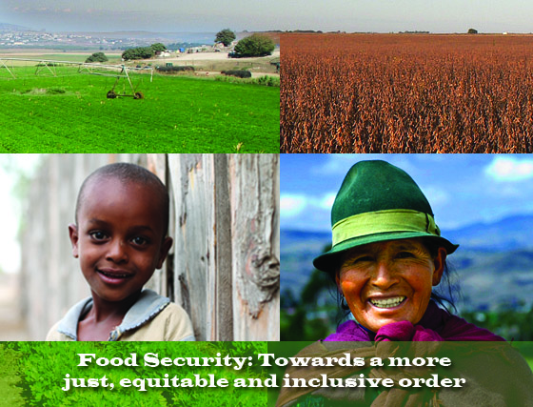
Monday, April 30, 2012
3:00 pm
OAS Hall of the Americas, 17th Street and Constitution Ave. NW
Washington, DC 20006

3:00 pm Welcoming remarks by José Miguel Insulza, OAS Secretary General

3:10 pm Introduction of the topic by Ambassador Diego Pary, Permanent Representative of Bolivia to the OAS

3:20 pm Discussion Panel:

    - René Orellana, Ex Minister for Water of Bolivia and expert in food security
    - James B. French, Director of Technical Cooperation, Inter-American Institute for Cooperation on Agriculture (IICA)
    - Florence Rolle, Officer in Charge, Liaison Office for North America, Food and Agriculture Organization of the United Nations (FAO)
    - Gemmo Lodesani, Regional Director for Latin America and the Caribbean, World Food Programme (WFP)
    - Gina Tambini, Area Manager of Family and Community Health, Pan American Health Organization (PAHO / WHO)

4:20 pm Question and answer session

4:50 pm Event closing

Please register here

