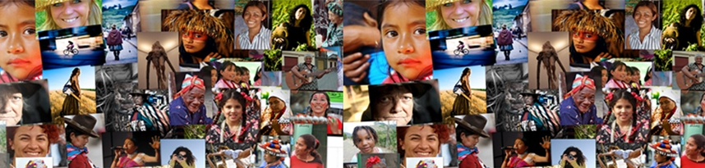
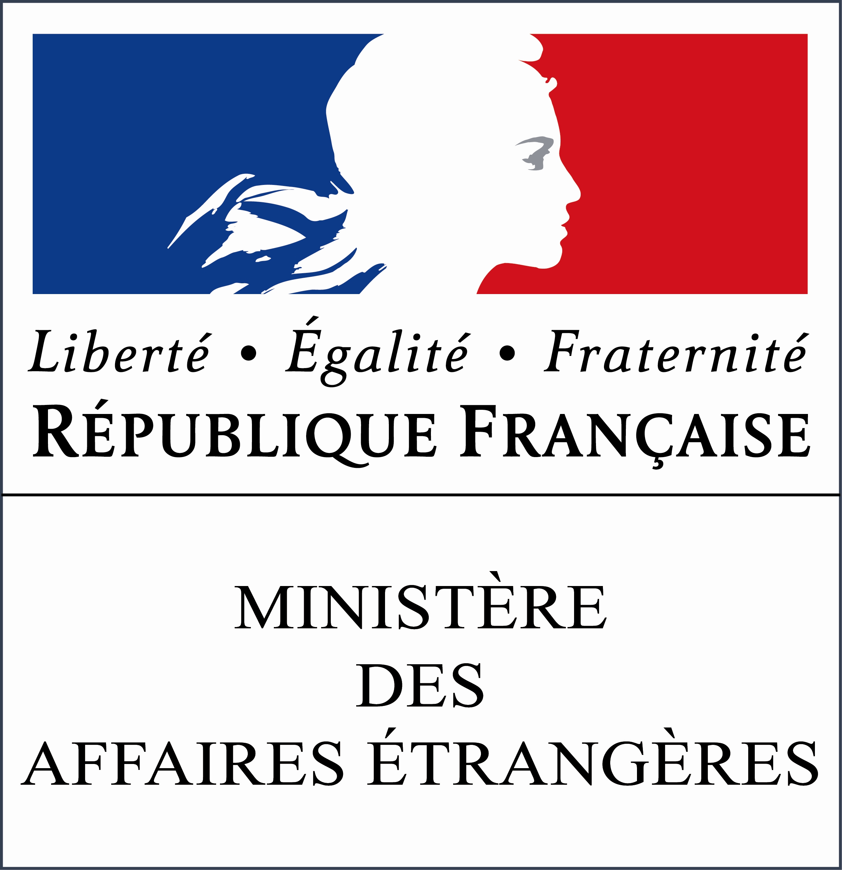
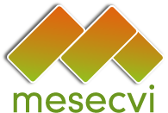
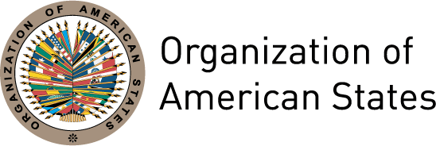
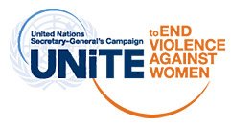

XLII OAS POLICY ROUND-TABLE

“Priorities for action in combating violence against women”

LAUNCH OF THE SECOND HEMISPHERIC REPORTO N THE IMPLEMENTATION OF THE BELÉM DO PARÁ

July 11th 2012 – 3:00 pm

Organization of American States
Hall of the Americas

17th Street and Constitution Avenue, Washington, DC, 20006

The Inter-American Convention on the Prevention, Punishment and Eradication of Violence against Women (Belém do Pará Convention), adopted by the OAS in 1994, reaffirms that the elimination of violence against women is indispensable for their individual and social development and constitutes a violation of their human rights and an offense to human dignity.
The entry into force of the Convention – March 5th 1995 – stimulated initiatives for its monitoring and implementation through action and information campaigns, adoption of legal norms and models of care, sensitization and training processes and advisory and care services for victims and their families.
In spite of these significant advances, violence continues to be a daily reality for millions of women and girls in the region and around the world. Since 2008, the United Nations, led by its Secretary-General, has been implementing a world-wide campaign to end violence against women with the aim of placing the issue at the forefront of public agendas.
In 2004, the Member States of the OAS created the Follow-up Mechanism to the Belém do Pará Convention (MESECVI) in order to monitor the fulfillment of the commitments that they had adopted and analyze their implementation, through Multilateral Evaluation Rounds. MESECVI also fosters technical cooperation between governments for the exchange of information, experiences and good practices in the elimination of violence against women.
MESECVI is made up of a policy body – the Conference of States Party, and a technical body – the Committee of Experts. The Committee is composed of specialists on violence against women, appointed by their governments. In the context of each Evaluation Round, the Committee adopts country reports and prepares a Hemispheric Report that synthesizes their findings at the regional level.
The Second Hemispheric Report on the Implementation of the Belém do Pará Convention, which will be launched during this Policy Round-table, is the final result of the second Multilateral Evaluation Round and identifies noteworthy government actions – either because they were coordinated with civil society or because they have had positive effects in terms of the prevention and punishment of violence against women. The Hemispheric Report concludes with 42 recommendations to governments that are focused on six key areas – Legislation, National plans, Access to justice, Specialized services, Budgets, and Information and statistics.
The Hemispheric Report also includes 14 reference tables that can be used by governments, experts and other stakeholders to track relevant information by country, over time. These comparative tables summarize advances and set-backs faced by the States Party in their implementation of the Convention.
This event aims to publicize the Second Hemispheric Report and to create a space for dialogue in which the panelists will share their own findings and recommendations on eliminating violence against women.

AGENDA

3:00-3:15 Welcome by the Secretary General of the OAS, José Miguel Insulza

3:15-3:30 Elizabeth Quiroa, President of the Conference of States Party to the Belém do Pará Convention (Guatemala)

3:30-5:00 Panel: An action agenda for the elimination of violence against women
Moderator: Carmen Moreno, Executive Secretary, Inter-American Commission of Women, OAS

- Patricia Olamendi, Coordinator of the MESECVI Committee of Experts
- Maryvonne Lyazid, Assistant Ombudsperson of France and Vice-President of the Department for the Fight against Discrimination and the Promotion of Equality
- Elizabeth Abi-Mershed, Acting Executive Secretary, Inter-American Commission of Human Rights, OAS
- María Leticia Guelfi, UN Women, representing the Secretary-General of the United Nations’ “Unite to End Violence against Women” Campaign

5:00-5:30 Question and answer session

5:30 Reception on the Aztec Patio

