Secretariat for External Relations / Department of International Affairs
Summits of the Americas Secretariat
In preparation for the VI Summit of the Americas, cordially invite you to the
XXXIX OAS POLICY ROUNDTABLE:

“The Road to Cartagena: Hemispheric Cooperation to Promote Access to Technology”

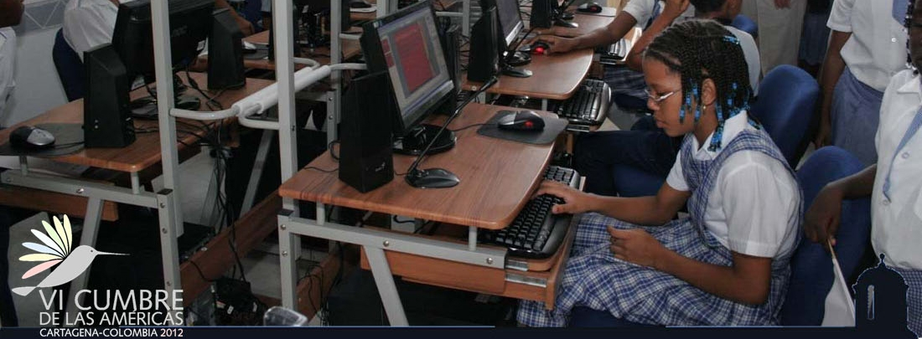
Tuesday, January 17, 2012
3:00 pm
OAS Hall of the Americas, 17th Street and Constitution Ave. NW
Washington, DC 20006
Program

3:00 pm Welcoming remarks by José Miguel Insulza, OAS Secretary General

3:10 pm Discussion Panel moderated by Peter Hakim, President Emeritus of the Inter-American Dialogue (IAD):

    - Jodi Bond, Vice President for the Americas at U.S. Chamber of Commerce, former Vice President, Government Relations and Country Management at Motorola
    - Marcelo D'Agostino, Manager of Knowledge Management and Communication, Pan American Health Organization (PAHO/WHO)
    - Carlos Arguello, Founder and Executive Director, Studio C

4:00 pm Question and answer session

4:30 pm Event closing by Ambassador Jaime Girón, Coordinator of the VI Summit of the Americas

Please register here or send an e-mail to SER-DIA@oas.org

