XXXVII OAS Policy Roundtable:
The Latin American Economic Outlook 2012
Transforming the State for Development

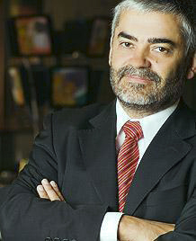
Carlos Álvarez is the Deputy Director of the Organisation for Economic Co-operation and Development (OECD) Development Centre. He has developed his professional career in the field of the competitiveness and innovation policies, holding positions of the highest responsibility for the Government of Chile, among them, Vice Minister of Economy from 2004 to 2006, and Executive Vice-President of the National Economic Development Corporation – CORFO from 2006 to 2010.

Since 1990, Mr. Alvarez has served in different positions in the Chilean public sector, having played an important role in the design, implementation and management of the set of programs to support economic competitiveness that exist today in Chile. Specifically he has made significant contributions in the fields of the technological innovation, promotion, attraction of investment, and promotion to the small and medium enterprises (SME).

Mr. Alvarez is an Industrial Engineer of the University of Chile and holds an MSc in Economic Engineering from the same University (1990). He also obtained his Master in Public Administration at the John F. Kennedy School of Government at Harvard University (1995).

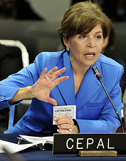
Inés Bustillo is the Director of the Washington Office of the United Nations Economic Commission for Latin America and the Caribbean (ECLAC).

She joined ECLAC in 1989 as Economic Affairs Officer working on a variety of areas ranging from macroeconomic analysis, international trade, and financial flows. In addition, she has been involved as coordinator of ECLAC’ s provision of technical support to the ongoing negotiations for a free trade area in the Western Hemisphere.

Prior to joining ECLAC, Dr. Bustillo was Professor of Economics at the Universidad Anáhuac in Mexico City, where she taught international trade and finance and microeconomic theory. She has also been Visiting Faculty at American University in Washington D.C.

Previous positions include consultant to the World Bank, the Center for Latin American and Monetary Studies (CEMLA), and Operadora de Bolsa in Mexico City. She is the author of several articles and is a frequent lecturer on the Latin American economies at universities, think tanks, and other fora. Dr. Bustillo holds a doctorate in Economics from American University.

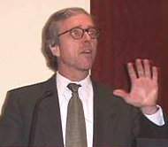
Robert Devlin is the Director of the Department Effective Public Administration of the OAS. He previously served as Regional Advisor for the United Nations Economic Commission for Latin America and the Caribbean (ECLAC) in Santiago, Chile (2005 – 2009).

Dr. Devlin worked for the Inter-American Development Bank (IADB) for 12 years until 2005, his last position being Deputy Manager in the Integration and Regional Programs Department, where he managed the Bank’s regional integration and trade sub-department. From 1975 and until his transition to the IADB in 1993, he worked at ECLAC, rising to the position of Deputy Director of the International Trade and Finance Division.

He has lectured at the prestigious Johns Hopkins School for Advanced International Studies (SAIS) and sits on the Advisory Committee of the Latin American Trade Network (LATN); the Chaire Mercosur at the Institut d'Etudes Politiques, Paris, France; the Red Mercosur in Montevideo, Uruguay; the North American Economics and Finance Association (NAEFA), and the CARICOM Regional Negotiating Machinery. Dr. Devlin holds a Ph.D. in Economics from American University in Washington D.C.

