The Organization of American States and the
Organisation for Economic Co-operation and Development
Cordially invite you to the
XXXVII OAS Policy Roundtable:
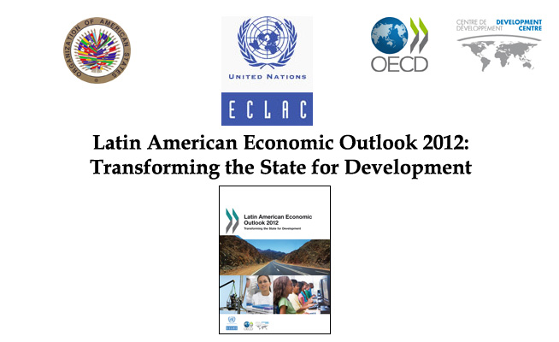
Thursday, December 8, 2011
10:00am
OAS Hall of the Americas, 17th Street and Constitution Avenue, NW, Washington, D.C.

PRELIMINARY PROGRAM:

10:00 am Welcoming remarks by Irene Klinger, Director, OAS Department of International Affairs (DIA), Secretariat for External Relations (SER)

10:10 am Presentation of the Latin American Economic Outlook
2012: Transforming the State for Development
* Carlos Álvarez, Deputy Director, Development Centre, Organisation for Economic Co-operation and Development (OECD)
* Inés Bustillo, Director, Washington Office, Economic Commission for Latin America and the Caribbean (ECLAC)
10:40 am Comments by Robert Devlin, Director of the Department for Effective Public Management, Secretariat for Political Affairs, OAS

10:50 am Question and Answer Session moderated by Irene Klinger, Director, OAS/DIA
11:30 am Event closing
Please register here or send an e-mail to SER-DIA@oas.org

