
Secretariat for External Relations / Department of International Affairs
Organization of American States (OEA)

XXXVI OAS POLICY ROUNDTABLE
The Dialogue between Religious Communities And States
In Latin America And The Caribbean

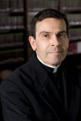
Robert John Araujo, S.J. is a Professor at Loyola University School of Law. He is a contributor to The Mirror of Justice, a web log dedicated to the development of Catholic Legal Theory, and has authored numerous law review articles on topics that include jurisprudence, public international law, Constitutional law, and Catholic legal theory. He has coauthored a series of books on papal diplomacy and international organizations.
Upon completing military service as an officer in the United States Army, Fr. Araujo served as a trial attorney and attorney advisor in the Solicitor's Office of the United States Department of the Interior (1974-1979). In 1979 he joined the Law Department of The Standard Oil Company (Ohio) and served in a variety of capacities until 1985.
After corporate service, he joined the general corporate department of a New England law firm and remained there until entering the Society of Jesus in 1986. Since 1997, he has served as an advisor to the Holy See providing counsel on issues dealing with public international law.
Fr. Araujo’s extensive experience as a scholar includes teaching as a visiting Professor at Georgetown University Law Center; St. Louis University School of Law; and Boston College School of Law, among many others.
Fr. Robert Araujo holds the following academic degrees: A.B. from Georgetown University, M.Div., S.T.L., Weston School of Theology; Ph.B. from St. Michael's Institute;
B.C.L. from Oxford University; J.D. from Georgetown University; and
LL.M. and J.S.D. from Columbia University.

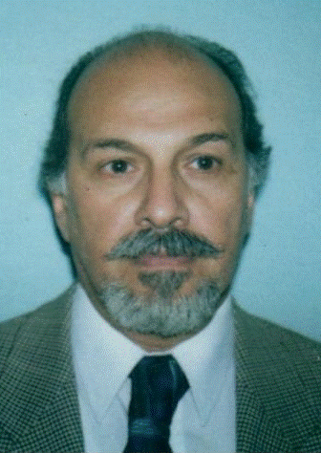
Muhammad Yusuf Hallar is a Vice Moderator, Latin American and Caribbean Council of Religious Leaders - Religions for Peace and serves as the General Secretary of the Islamic Organization for Latin America and the Caribbean (OIPALC)

Mr. Hallar has held important positions in a number of organizations related to the dissemination of Islamic culture and dialogue, among them Director of the Office of Culture and Islamic Outreach -Argentina, member of the Constituent Council and official representative for Latin America of the World Islamic League, Secretary General of the Islamic Organization for Latin America and the Caribbean, Vice-president of the Superior Islamic Council for Islamic Education and Culture in the West, member of Egypt’s Azahar University’s High Representative Commission for Latin America and member for Africa and the Middle East of the Argentine Council for International Relations (CARI).

He is also the Americas and the Caribbean representative for of the Islamic Organization foe Education, Science and Culture (ISESCO) which represents 52 Islamic countries.

Muhammad Yusuf Hallar is a graduate of the School of Architecture and Urban Design of the University of Buenos Aires.

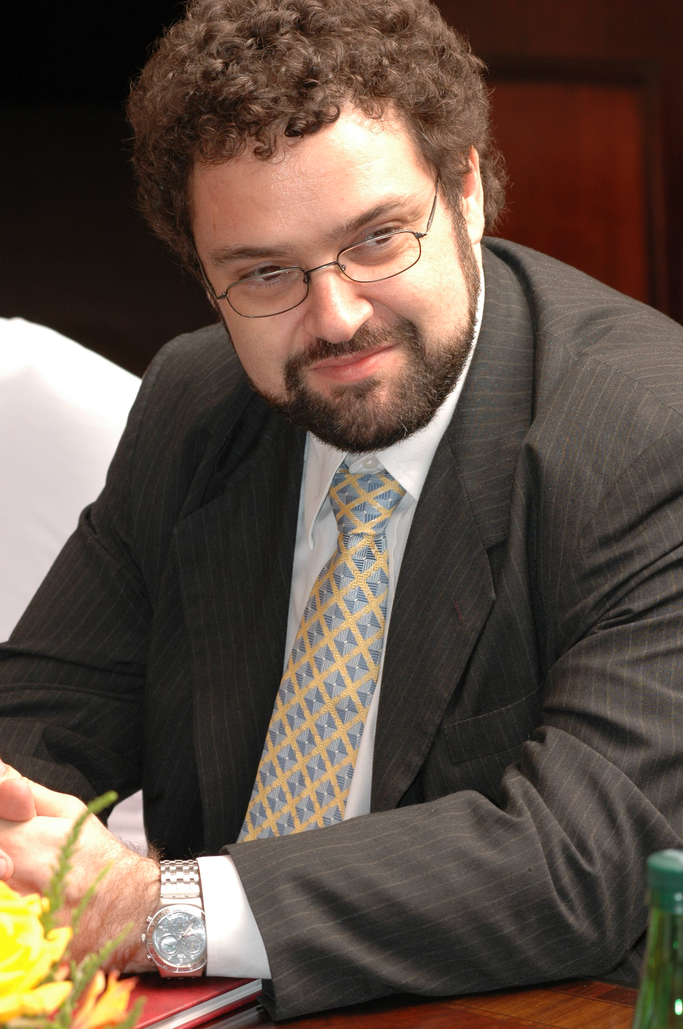
Claudio Epelman is a Vice Moderator, Latin American and Caribbean Council of Religious Leaders - Religions for Peace and the Executive Director of the Latin American Jewish Congress (CJL)

He joined the World Jewish Congress in 2003 as Director of its Latin American branch, the CJL. In this position, he has represented the World Jewish Congress and the Latin American Jewish Congress in several interviews, conferences and meetings with heads of State, as well as in sessions, panels and ceremonies at the UN, OAS and the Organization for Security and Cooperation in Europe.

Mr. Epelman has worked extensively in interfaith matters, serving as Jewish Observer at the V General Conference of the Latin American Episcopal Council (CELAM) in Brasil, meeting with Pope Benedict XVI and actively promoting dialogue between Jews and Muslims in the region. His work in promoting peaceful and respectful interfaith understanding earned him an award from the government of Argentina.

He is a member of the Executive Committee of the Latin American and Caribbean Council of Religious Leaders (LACCRL).

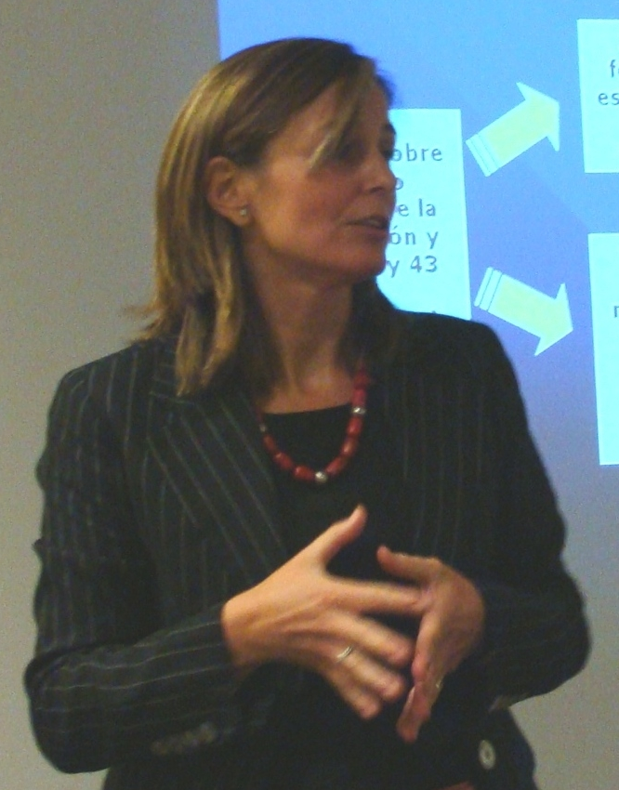
Nerea Aparicio (Moderator) is a specialist at the Inter-American Commission for Human Rights (ICHR), where she currently serves as ad interim coordinator of the Andean Region II (Bolivia and Peru) and has previously served as ad interim coordinator of the Andean Region I (Colombia, Venezuela and Ecuador) and Assistant Coordinator of the Southern Region (Argentina, Chile, Uruguay and Paraguay).

Her prior experience includes working as a consultant for Development Alternatives Inc., (DAI) / U.S. Agency for International Development (USAID) in Washington D.C., (2005) where she authored a paper focusing on Guatemalan parliamentary immunity. She also served at the Office of the UN High Commissioner for Human Rights in Colombia (UNHCHR) as a UN International Consultant from 2002 to 2003; as a Human Rights and Justice Officer from 1997 to 2000 at the United Nations Mission for the Verification of the Peace Accords in Guatemala (MINUGUA); and as a staff attorney at the Centre for Justice and International Law (CEJIL), in San Jose, Costa Rica (1997).

Ms. Aparicio holds a law degree from the University of Deusto in Bilbao, Spain and an LL.M. (Master of Laws) in International Legal Studies from American University, Washington College of Law in Washington, D.C.

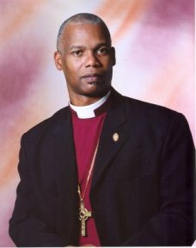
The Rt. Rev. Julio Murray Thompson is an Executive Committee Member, Latin American and Caribbean Council of Religious Leaders - Religions for Peace and the President of the Latin American Council of Churches (CLAI) as of January 2001. He has also been serving as the Vice – President of the Chamber of Bishops of the Anglican Church of Central America since April 2002.

He studied at the University of Panama and went on to theological Studies at the Latin American Biblical Seminary in San José Costa Rica; at the Universidad Nacional de Heredia and finally at the Latin American Biblical University in San José, Costa Rica.
After his ordainment, Bishop Murray developed his pastoral ministry at the Cathedral of San Lucas, the Church of San Isidro Labrador and the Church of Santa María Virgen in Arraiján from 1988-1990. From 1990 until 1997, he also served as rector of the four Episcopalian congregations in the province of Bocas del Toro, seeing the population through the difficult period following the 1991 earthquake. Near the end of 1997, he was named Canon of the Cathedral of San Lucas. He was elected Diocesan Bishop in a Special Convention on May 20, 2000.
Bishop Murray has represented the Episcopal Church of Panama as delegate to the Provincial Synod of the Central American Anglican Church and as delegate to the General Conventions of the Episcopal Church held in Philadelphia, Indianapolis and Phoenix. He has also collaborated with the youth ministry of the Episcopal Church of Panama as a member of the Reflection Committee of the National Pastoral Youth Council and as chaplain in summer camps and youth gatherings.
A prolific writer, he is the author of The Episcopal Church and the Family, and The History of Anglicanism in Costa Rica, among others.
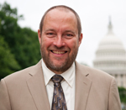
Rev. Galen Carey is the Director of Government Affairs for the National Association of Evangelicals (NAE). He is responsible for representing the NAE to Congress, the White House and the Courts. He works to advance the approach and principles of the NAE document, “For the Health of the Nation: An Evangelical Call to Civic Responsibility.”

Before joining the NAE staff, Carey served for more than twenty-five years with World Relief, the relief and development arm of the NAE, in Croatia, Mozambique, Kenya, Indonesia, Burundi and the USA.

He is known as a leading evangelical voice on refugee, immigration, and international relief and development issues. His work included directing housing reconstruction, livelihoods rehabilitation, agriculture and community health projects. Most recently he was based in Bujumbura, Burundi and worked as the Regional Program Advisor for the World Relief Great Lakes Region establishing an HIV/AIDS support network.

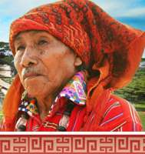
Maya Grand Elder Alejandro Cirilo Perez Oxlaj is an Executive Committee Member, Latin American and Caribbean Council of Religious Leaders - Religions for Peace as well as the Chief Elder of the Continental Council of Indigenous Elders and Spiritual Guides of the Americas, and an Extraordinary Itinerary Ambassador for Indigenous Peoples of Guatemala.
His spirit name is Wakatel Utiw, which means “Wandering Wolf” in his native language. He is a 13th generation Quiche Mayan High Priest and an international lecturer of the Mayan culture. He is recognized as a primary keeper of the teachings, visions, & prophecies of the Mayas. He has spoken in a number of countries across the Hemisphere and his teachings have resonated with people of all faiths and beliefs across the globe.
Among many other positions and duties, Grand Elder Perez also serves as leader of the National Mayan Council of Elders of Guatemala and Day Keeper of the Mayan Calendar.

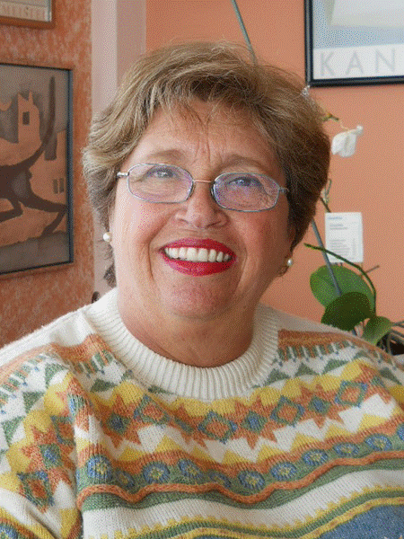
Evelyn Zentner de Falck (Moderator) is the coordinator of the Latin American and Caribbean Network of Women of Faith and a member of the Executive Committee of the Latin American and Caribbean Council of Religious Leaders - Religions for Peace, in addition to presiding over the Inter-religious Affairs Committee of the International Council of Jewish Women, having served as President for Latin America of the International Council of Jewish Women from 2002 to 2006, and as President of the Female Israelite Society of Quito from 1997 to 2003

She has recently participated in the IV Meeting of the Coordinating Committee of the Latin American and Caribbean Women of Faith Network (LACWFN), as well as in the IV Plenary Session of the Latin American and Caribbean Council of Religious Leaders - Religins for Peace, both held in Mexico City in 2010.

Ms. Zentner has also participated in the creation of the Regional Network of Women of Faith in Latin America and the Caribbean in 2003 as part of the Global Women’s Network of the World Conference on Religion and Peace (WCRP).

Her experience also includes participating in the II Meeting of the Andine Network of Women of Faith in Lima in 2009, the II Tri-party Latin American and Caribbean Forum on Inter-religious Cooperation for Development, in Buenos Aires in 2008, the Latin American and Caribbean Inter-religious Consultation on Children, held in Panama.

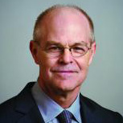
Dr. William F. Vendley has served as Secretary General of Religions for Peace since 1994. He is a member of its World Council, which is composed of outstanding international religious leaders. He also serves as the organization’s chief executive officer, overseeing the international secretariat in Asia, Africa, Latin America, Europe, the Middle East and North Africa.

He coordinates the international activities and projects of Religions for Peace’s Interreligious Councils in more than seventy states around the world, and works in areas engaged in armed conflict to mobilize and equip religious communities to mediate and mitigate violent conflict, prevent conflict, build a climate of peace, and rebuild societies in the aftermath of violence.

Dr. Vendley was a participant in His Majesty King Abdullah’s historic inter-religious meeting in Madrid, Spain in 2008 and has been requested by the Muslim World League to serve on its Follow-up Committee. He also advises the White House through President Barack Obama’s Interreligious Dialogue and Cooperation Task Force.

Dr. Vendley is a theologian and has served as a professor and dean in graduate schools of theology. He lectures frequently in academic, United Nations and NGO fora. He holds a doctorate in systematic theology from Fordham University and a master’s degree in religious studies from the Maryknoll School of Theology.
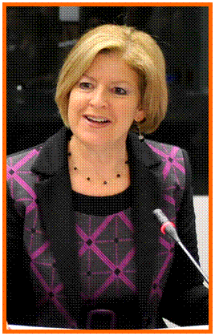
Irene Klinger is the Director of the Department of International Affairs at the Secretariat for External Relations at the OAS. She is responsible for advising on relations with the Permanent Observers, UN system agencies, Inter-American agencies, international finance institutions, and civil society; developing and implementing outreach programs, such as the Lecture Series of the Americas — a conference series on particular issues of hemispheric interest, the Model OAS General Assembly, the OAS Policy Roundtable Series, the Policy Breakfasts for Ambassadors and the OAS Briefings Program.

She previously served as Executive Secretary with the OAS Summit of the Americas Secretariat and as Director of External Relations for the Pan-American Health Organization.

Ms. Klinger graduated from the University of Chile and holds a doctorandus degree in Economics from the University of Amsterdam.

