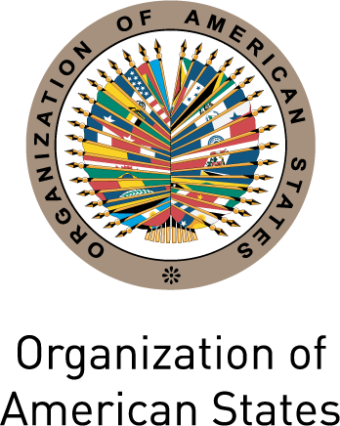 |  | 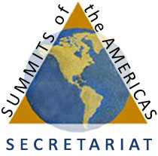

Secretariat for External Relations / Department of International Affairs
Summits of the Americas Secretariat
In preparation for the VI Summit of the Americas, cordially invite you to the
XXXI OAS POLICY ROUNDTABLE
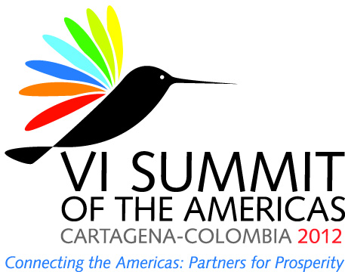
Wednesday, September 14, 2011
3:00 PM
OAS Hall of the Americas, 17th Street and Constitution Ave. NW
Washington, DC 20006
Program
3:00- 3:05 pm Welcoming remarks by Irene Klinger, Director, Department of International Affairs, Secretariat for External Relations

3:05- 4:30 pm Panelists:
Jaime Giron, Coordinator of the VI Summit of the Americas and Chair of the Summits Implementation Review Group (SIRG)
Carlos Portales, Director, International Organizations, Law and Diplomacy Program of American University and former Ambassador of Chile to the United Nations in Geneva and the OAS
John F. Maisto, former U.S. Ambassador to the OAS and former U.S. National Summit Coordinator

4:30- 5:00 pm Question and answer session and event closing by
Sherry Tross, Executive Secretary, Summits Secretariat
Please register here or send an e-mail to SER-DIA@oas.org

