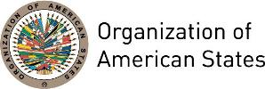

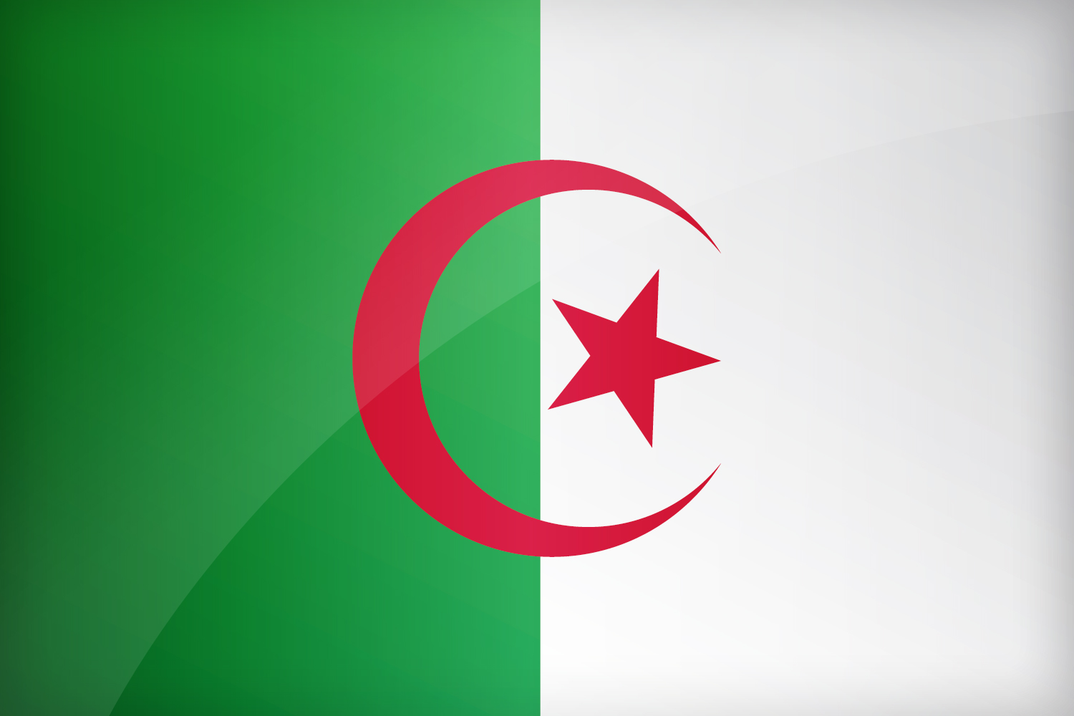
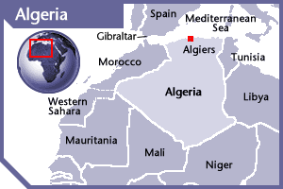

ALGERIA
PERMANENT OBSERVER

Date of Entry: June 10, 1987
National Day: November 1
Capital: Algiers
Type of Government: Presidential Republic
Head of State: President Abdelaziz Bouteflika (since April 15, 1999, re-elected in 2004 and 2009)
Head of Government: Prime Minister Abdelmalek Sellal (May 25, 2017)
Minister of Foreign Affairs: Abdelkader Messahel
Permanent Observer: Ambassador Madjid Bouguerra (February 23, 2015)

ECONOMIC INDICATORS | 2010 | 2011 | 2012 | 2013 | 2014 | 2015 | 2016
Population (in millions) | 36.11 | 36.81 | 37.56 | 38.33 | 39.11 | 39.87 | 40.60
GDP (in US$ billions) | 161.207 | 200.01 | 209.04 | 209.784 | 213.98 | 164.77 | 156.08
GDP per capita (US$) | 4,463.395 | 5,432.25 | 5,564.826 | 5,471.867 | 5,470.851 | 4,132.76 | 3,843.752
Source: www.tradingeconomics.com | The World Bank Group

FOREIGN RELATIONS POLICIES:
- Algeria’s foreign policy is shaped by the distinctive characteristic of being an Arab, Moslem, African and Mediterranean country. Therefore its policy is based on three main national policy documents: (i) the government programme of May 2004; (ii) the follow-up economic growth support programme 2005-2009; and (iii) the Association Agreement implementation Action Plan.
- Three major objectives based on the abovementioned documents underline the government’s policy:
- Completing reform and national reconciliation, which includes as priority objectives the reform of the role and organization of the State; combatting crime, trafficking, fraud, smuggling and corruption; improving the investment framework; incrementing the effectiveness of the State's economic role; revising current legislation under national requirements and international standards, and modernizing the judiciary system and prison reform.
- Pursuing sustainable human development, in conjunction with the regional planning policy to reduce population concentration in coastal areas; the stimulation of business fabric and exploitation of national resources, the efficient management of water resources and the preservation of the environment.
- Promoting a socio-cultural policy referred as the improvement of the quality of the health care system and the implementation of the reform of the national education system in addition to the cultural policy geared to the national cohesion and development through the enhancement and restoration of the cultural and historical heritage.
- Algeria has friendly relations with its neighbors in the Maghreb (Northwest Africa), Tunisia and Libya, and with its Sub-Saharan neighbors Mali and Niger, and as a member of the Arab Maghreb Union (AMU), Algeria attaches the greatest importance to Maghreb integration and tries its best to act in conformity with the spirit of the treaty binding the Arab Maghreb Union Member States. Algeria closely monitors developments in the Middle East and has been a strong proponent of the rights of the Palestinian people, as well as a supporter of Iraq's democratic transition.
- Algeria is a member of the League of Arab States, the African Union and the United Nations.
- Algeria also sits on certain committees or conferences, including the Mediterranean dialogue with NATO, the 5+5 in the Western Mediterranean, the Mediterranean dialogue with OSCE and coordination of the Sahel countries. Among economic institutions, Algeria is a member of the World Bank, the African Bank, the International Monetary Fund (IMF), the Organization of the Petroleum Exporting Countries (OPEC), the Organization of Arab Petroleum Exporting Countries (OAPEC), and the World Customs Organization. Negotiations are in progress for its membership of the World Trade Organization (WTO).
- Algeria has been active on the international scene, particularly in Africa where it has carried out peace initiatives (Ethiopia-Eritrea) and, together with Egypt, Nigeria, Senegal and South Africa, launched the new partnership for Africa (NEPAD).
- As a Mediterranean country Algeria enjoys close ties with the European Union through the European Neighborhood Policy and the Union for the Mediterranean (Formerly the Euro-Mediterranean Partnership). The EU has concentrated most of its efforts in Algeria to strengthening and improving its political system and protecting the Mediterranean environment.
- Algeria signed an Association Agreement with the European Union in September 2005. This Association Agreement provides for the gradual liberalization of trade over a 12-year period. It also provides for institutionalized, regular political dialogue and identifies human rights as an essential aspect (as is the case in all association agreements). Moreover, the Agreement outlines plans for future cooperation in a wide range of different areas, including the economy, justice, education and culture, and the fight against crime, money laundering, drug-trafficking and terrorism.

INVOLVEMENT WITH THE AMERICAS:
- Algeria has diplomatic relations with the following OAS Member States: Argentina, Bolivia, Brazil, Canada, Chile, Colombia, Cuba, Ecuador, Mexico, Nicaragua, Paraguay, Peru, Trinidad and Tobago, the United States, Uruguay and Venezuela. Albania has diplomatic missions in the following countries: Argentina, Brazil, Canada and the United States.

SOURCES:
PRÉSIDENCE DE LA RÉPUBLIQUE DE L’ALGÉRIE  http://www.el-mouradia.dz/  MINISTRY OF FOREIGN AFFAIRS OF ALGERIA  www.mae.dz  EUROPEAN COMMISSION, EXTERNAL RELATIONS  http://ec.europa.eu/external_relation/algeria/  ARAB MAGHREB UNION  http://www.maghrebarabe.org/en | SECOND SUMMIT OF ARAB-SOUTH AMERICAN COUNTRIES  http://www.qatar-conferences.org/south/  EMBASSY OF ALGERIA TO THE UNITED STATES OF AMERICA  http://www.algerianembassy.org/  WORLD BANK – TRADING ECONOMICS  www.tradingeconomics.com

This page was last updated on July 6, 2017.

