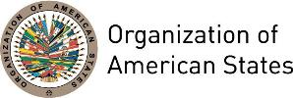

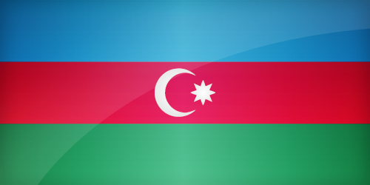
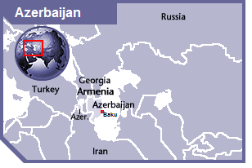

AZERBAIJAN
PERMANENT OBSERVER

Date of Entry: April 5, 2001
National Day: May 28
Capital: Baku
Type of Government: Republic
Head of State: President Ilham Aliyev (October 24, 2008)
Head of Government: Prime Minister Artur Rasizade (November 4 2003)
Minister of Foreign Affairs: Elmar Maharram Oglu Mammadyarov (April 2, 2004)
Director Azerbaijan International Development Agency (AIDA): Ashraf Shikhaliyev
Permanent Observer: Ambassador Elin Suleymanov (October 2011)

ECONOMIC INDICATORS | 2010 | 2011 | 2012 | 2013 | 2014 | 2015 | 2016
Population (in millions) | 9.05 | 9.17 | 9.29 | 9.41 | 9.53 | 9.64 | 9.76
GDP (US$ in billions) | 52.90 | 65.95 | 65.95 | 74.16 | 75.24 | 53.07 | 37.84
GDP per capita (US$) | 5,842.806 | 7,189.691 | 7,496.336 | 7,875.757 | 7,891.3 | 5,500.31 | 3,876.936
Source: www.tradingeconomics.com | The World Bank Group

FOREIGN RELATIONS POLICIES:
- Azerbaijan has been following an active foreign policy since its independence in 1991. This policy aims at the strengthening and development of the state system and the protection of the national interests of Azerbaijan.
- Azerbaijan builds its foreign policy on the principle of respect to the international legal standards and norms, the state sovereignty and territorial integrity and the principles of nonintervention into the internal affairs.
- The major priorities of the foreign policy of Azerbaijan are:
- Develop a pluralist democracy based on market economy and supremacy of the law;
- Follow an independent foreign policy for the purposes of restoration of territorial integrity and sovereignty of Azerbaijan;
- Overcome risks aimed at security, political independence, sovereignty and the territorial integrity of Azerbaijan;
- The development of friendly neighborhood and mutual advantageous relations with bordering states;
- Fortifying security and stability in the region;
- Prevent illegal transportation of weapons and other equipment in the region;
- Devotion to existing global regimes on prevention of the spread of nuclear weapons and the creation of a nuclear-weapons free zone in the South Caucasus:
- Demilitarization of the Caspian basin;
- Integration to structures of European and Transatlantic security and co-operation including the NATO, the European Union, the Union of Western Europe and the Council of Europe;
- Expediting the development of different spheres of the economy in order to maximize the important strategic-geographical position of Azerbaijan as a bridge between the East and the West;
- Develop the Eurasian transport corridor with the participation of Azerbaijan.
- Azerbaijan is expanding and developing its regional and global activity and international cooperation, became the member of a number of international organizations such as United Nations, the Organization on Security and Cooperation in Europe, European Council, Organization of Islamic Conference, Commonwealth of Independent States and others. Moreover, Azerbaijan was one of the cofounders of GUAM (Organization for Democracy and Economic Development of Georgia, Ukraine, Azerbaijan, and Moldova). Azerbaijan protects and implements its national interests through participating in the regional initiatives and the aforementioned organizations.
- Azerbaijan, as an emerging donor of international aid in the region, established in 2010 a specialized entity: the Azerbaijan International Development Agency (AIDA), which identifies and provides funds to countries in need of assistance.

AZERBAIJAN INTERNATIONAL DEVELOPMENT AGENCY (AIDA)
- The Azerbaijan International Development Agency (AIDA) is an agency of the Ministry of Foreign Affairs of the Republic of Azerbaijan, which coordinates activities of relevant state organizations providing foreign countries with technical, financial and humanitarian assistance.
- The main goals of are to support global peace and security efforts internationally, as well as sustainable economic development and efficient civil service systems.
- Financial assistance was provided to Cuba and Panama in 2012 to support the humanitarian and relief efforts in those countries following Hurricane Sandy and heavy rain seasons.
- AIDA also works closely with the Colombia Presidential Agency for International Cooperation (APC Colombia) on the implementation of joint projects.

INVOLVEMENT WITH THE AMERICAS:
- Azerbaijan maintains embassies in Argentina, Brazil, Canada, Cuba, Mexico and the United States of America.

CASH CONTRIBUTIONS 2010-2016:
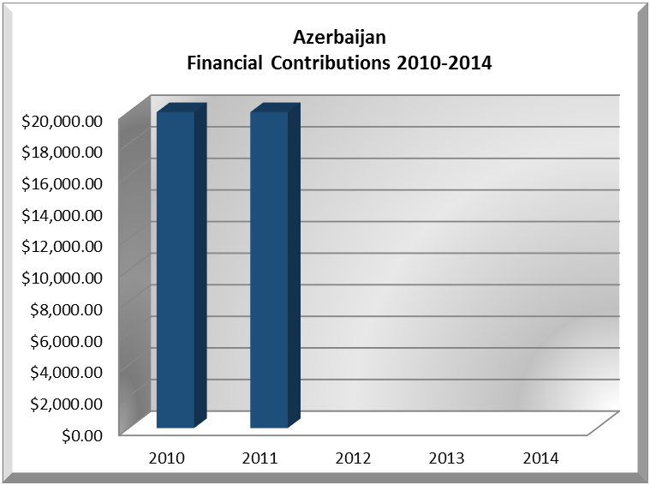
YEAR | AZERBAIJAN | P.O. FINANCIAL CONTRIBUTIONS | %
2010 | $20,000.00 | $15,781,991.00 | 0.13%
2011 | $20,000.00 | $15,692,757.00 | 0.13%
2012 |  | $13,239,705.00 | 0.00%
2013 |  | $16,926,686.00 | 0.00%
2014 |  | $10,999,882.00 | 0.00%
2015 |  | $17,489,206.00 | 0.00%
2016 |  | $14,048,254.00 | 0.00%
Total US$ | $40,000.00 | $104,178,481.00 | 0.04%

AZERBAIJAN CONTRIBUTIONS:
YEAR | PROJECTS | FINANCIAL CONTRIBUTIONS  IN US$ | IN-KIND CONTRIBUTIONS  IN US$
2010 | Secretariat for political affairs/Department of sustainable Democracy and special missions-peace fund-General fund | $10,000.00
2010 | Inter-American Children's Institute- Inter-American Programme for Prevention and Eradication of Commercial Sexual Exploitation, Smuggling of and trafficking in minors (CDRC) | $10,000.00
SUBTOTAL |  | $25,000.00
2011 | Inter-American Commission on Human Rights- Strategic plan 2011-2015 | $5,000.00
2011 | Secretariat for political affairs/Department of sustainable Democracy and special missions-peace fund-General fund. | $5,000.00
2011 | Inter-American Children's Institute- Support to the activities of the Inter-American Children's Institute. | $10,000.00
SUBTOTAL |  | $20,000.00
TOTAL |  | $40,000.00

SOURCES:
MINISTRY OF FOREIGN AFFAIRS OF AZERBAIJAN  http://dmfa.nakhchivan.az/  PERMANENT MISSION OF THE REPUBLIC OF AZERBAIJAN TO THE UN  http://www.un.int/azerbaijan/ | GOVERNMENT – AZERBAIJAN  http://azerbaijan.az/portal/StatePower/General/generalInfo_e.html  WORLD BANK – TRADING ECONOMICS  www.tradingeconomics.com
This page was last updated on July 6, 2017.

