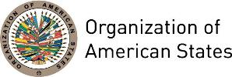

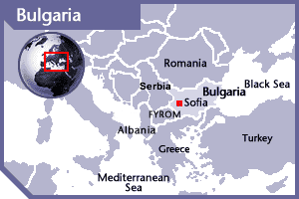
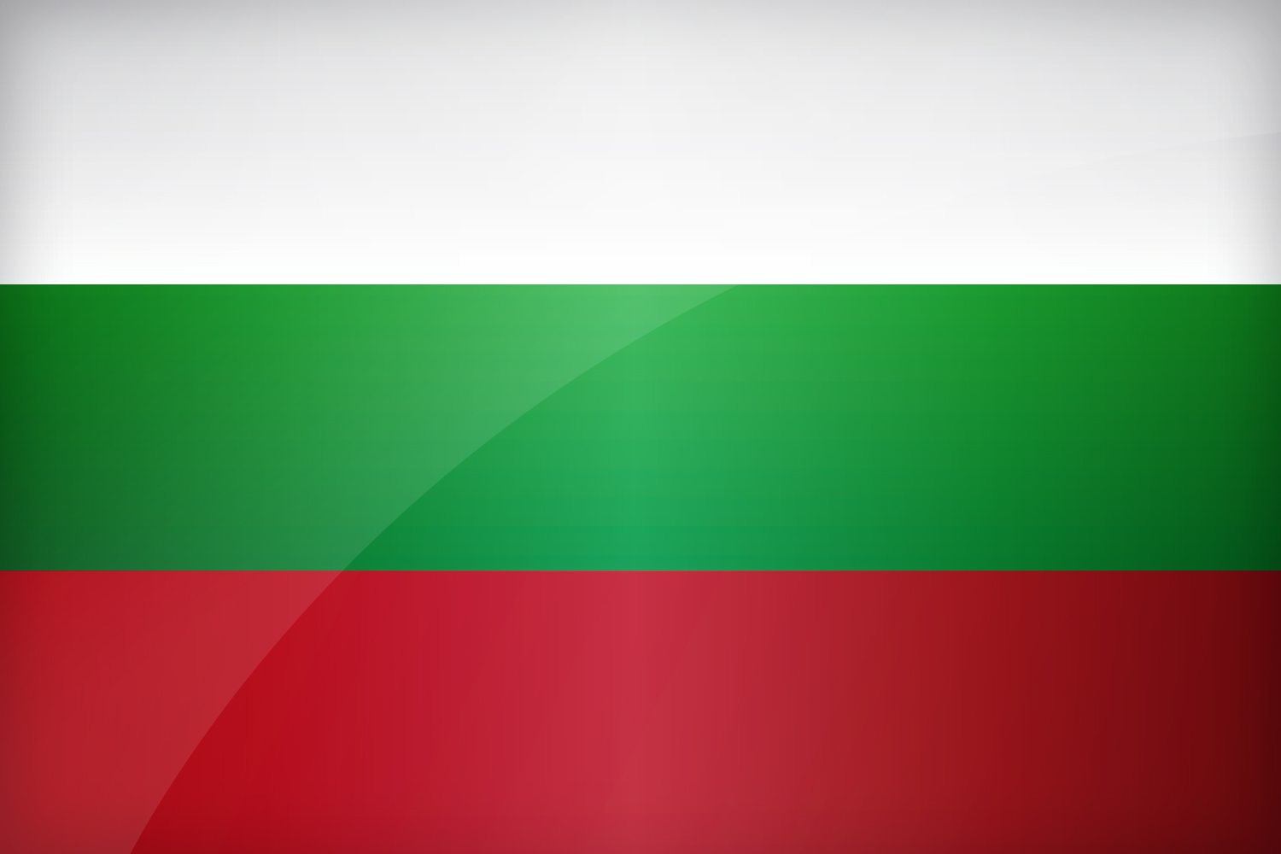

BULGARIA
PERMANENT OBSERVER

Date of Entry: October 28, 1997
National Day: March 3
Capital: Sofia
Type of Government: Parliamentary Republic
Head of State: President Rumen Radev (January 22, 2017)
Head of Government: Prime Minister Boyko Borissov (May 4, 2017)
Minister of Foreign Affairs in the Caretaker Government: Ekaterina Zaharieva (May 4, 2017)
Permanent Observer: Ambassador Timohir Stoytchev (2012)

ECONOMIC INDICATORS | 2010 | 2011 | 2012 | 2013 | 2014 | 2015 | 2016
Population (in millions) | 7.39 | 7.34 | 7.30 | 7.26 | 7.22 | 7.17 | 7.12
GDP (US$ in billions) | 50.61 | 57.41 | 53.90 | 55.75 | 56.73 | 50.19 | 52.39
GDP per capita (US$) | 6,843.263 | 7,813.803 | 7,378.026 | 7,674.861 | 7,853.335 | 6,993.477 | 7,350.796
Source: www.tradingeconomics.com | The World Bank Group

FOREIGN RELATIONS POLICIES:
- The Republic of Bulgaria has an active and targeted policy for peace, stability, security, human rights, democracy and prosperity regionally and globally. Energy, foreign trade and attracting foreign investment are the main priorities in the foreign policy of the government of Bulgaria.
- Another continuing priority of Bulgaria is to maintain constructive and mutually beneficial relationships with key partners and factors in the international arena such as the United States; Russia; some countries in Asia, Africa, America, Australia and the Middle East.
- Bulgaria became a formal member of the North Atlantic Treaty Organization (NATO) on March 29, 2004 and joined the European Union (EU) on January 1, 2007. As a member of NATO and the EU, Bulgaria's foreign policy focus is on further integration with the EU and other European political and security structures. Bulgaria actively pursues EU’s expansion in the Balkans and its own accession to the Schengen area.
- Bulgaria is an ally to the UN and other international governmental organizations. It is also a reputable partner in bilateral international relations. The Ministry of Foreign Affairs is the creator of the foreign policy of the government and coordinates its policies within the European Union (EU).
- The main development policy objective of Bulgaria is the eradication of poverty and associated issues to improve the quality of life in developing countries. Development cooperation is implemented by the Ministry of Foreign Affairs through the International Development Cooperation Council (IDCC) whose members represent all relevant ministries and government institutions. Bulgaria builds partnerships for development taking into account the following criteria:
- Existence of a certain level of political, diplomatic, trade, economic and cultural contacts with the respective country;
- Comparative advantages of Bulgaria for offering assistance: better experience compared to other donors in certain spheres, or better knowledge of the local needs and specificities;
- Meeting of the general conditions for cooperation with the donor community: undertaking of real steps by the recipient country to cope with the problems of its own development.
- Bulgaria focused development cooperation in sectors where it held comparative advantages in assistance delivery, expertise and capacity such as: education and training; infrastructure building and maintenance; reforms in economic, financial, administrative, social and healthcare areas; cultural diversity and tolerance; environmental protection and promotion of sustainable development; security and post-conflict recovery.
- On the basis of these criteria, Bulgaria also identifies two groups of countries for cooperation in the sphere of development. The first group, Priority States comprises states from the region of Southeast Europe and the Black Sea basin. The second group consists of states with respect to which Bulgaria has undertaken international commitments within international organizations and coalitions (e.g., participation in the operations for the reconstruction of Iraq and Afghanistan).
- The geographic priorities of the Bulgarian assistance for development do not restrict the providing of humanitarian aid or urgent ad hoc actions aimed at preventing or mitigating the consequences of crises, armed conflicts or actions against international terrorism.

INVOLVEMENT WITH THE AMERICAS:
- Bulgaria maintains diplomatic relations with all countries of Latin America and the Caribbean. At the moment, Bulgaria has embassies in: Argentina, Brazil, Canada, Cuba, Mexico, and the United States of America.

SOURCES:
PRESIDENT OF THE REPUBLIC OF BULGARIA  http://www.president.bg/  NATIONAL ASSEMBLY OF THE REPUBLIC OF BULGARIA  http://www.parliament.bg/en  REPUBLIC OF BULGARIA, COUNCIL OF MINISTERS  http://www.government.bg/fce/index.shtml?s=001&p=0023 | MINISTRY OF FOREIGN AFFAIRS OF THE REPUBLIC OF BULGARIA  http://www.mfa.bg/  EMBASSY OF THE REPUBLIC OF BULGARIA  http://74.81.82.58/~bulgaria/  WORLD BANK – TRADING ECONOMICS  www.tradingeconomics.com

This page was last updated on July 7, 2017.

