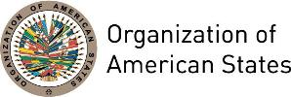

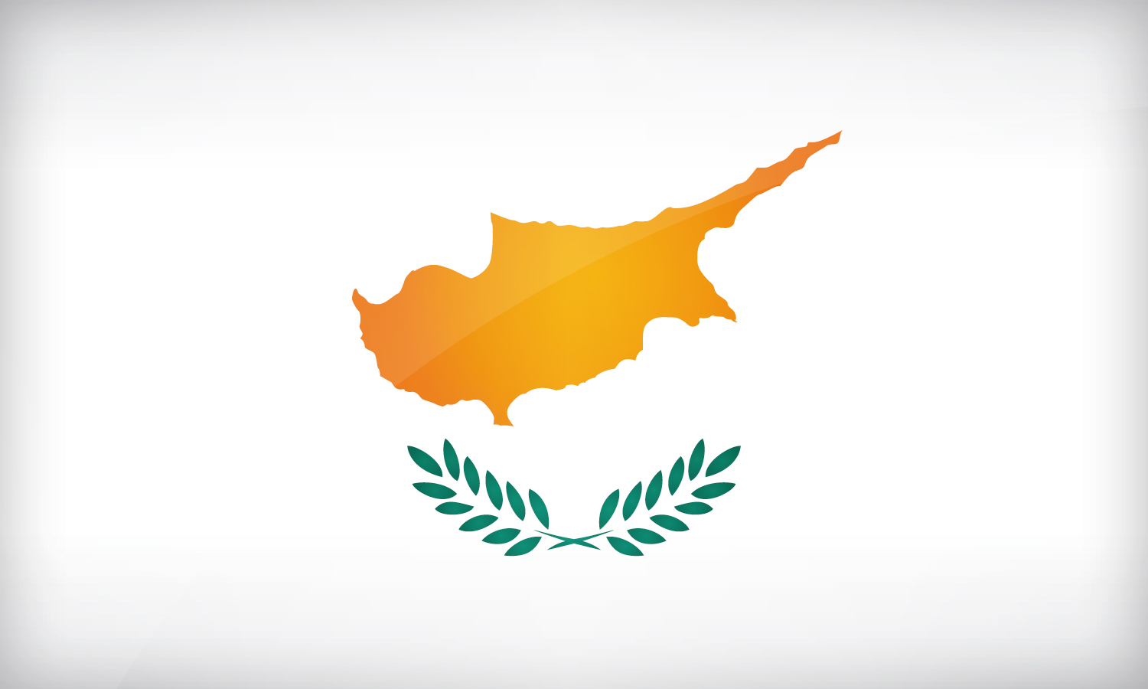
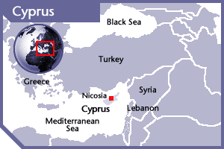

CYPRUS
PERMANENT OBSERVER

Date of Entry: April 17, 1985
National Day: October 1
Capital: Nicosia
Type of Government: Presidential Republic
Head of State: President Nicos Anastasiades (February 24, 2013)
Minister of Foreign Affairs: Ioannis Kasoulides (March 1, 2013)
Permanent Observer: Ambassador Marios Lysiotis

ECONOMIC INDICATORS | 2010 | 2011 | 2012 | 2013 | 2014 | 2015 | 2016
Population (in millions) | 1.11 | 1.12 | 1.13 | 1.14 | 1.15 | 1.16 | 1.17
GDP (US$ in billions) | 23.56 | 27.42 | 25.01 | 24.05 | 23.30 | 19.56 | 19.80
GDP per capita (US$) | 30,818.46 | 32,233.839 | 28,951.156 | 27,907.967 | 27,340.884 | 23,075.113 | 23,324.202
Source: www.tradingeconomics.com | The World Bank Group

FOREIGN RELATION POLICIES:
- The aim of the foreign policy of Cyprus is to have an active involvement in processes that contribute to the promotion of international cooperation, peace, stability, and sustainable development.
- Its geographic position enables it to play a role both in the Eastern Mediterranean region and within the European family. Its accession to the European Union initiated new era in its relations with third countries, thus becoming a bridge of communication between the European Union and these countries.
- The Multilateral Affairs Department is the competent Division of the Ministry of Foreign Affairs for its relations with International Organizations and other Forums.
- Its foreign policy objectives include human rights, measures against money laundering and measures against terrorism.
- Cyprus is a member of the United Nations (UN) since 20 September 1960, and supports the primacy of the United Nations and its Charter and the importance of the implementation of UN resolutions and Development Goals. Through its membership and participation in the UN bodies, Cyprus contributes to the promotion of its objectives of peace, security, justice and the respect of human rights and social and economic development on a global level.
- Cyprus has been a member of the Council of Europe from its very first days of independence and since its accession in May 1961, has always contributed vigorously to the implementation of the Council’s founding principles and values dedicated to the ideals of Democracy, the protection of Human Rights and the Rule of Law. Furthermore, some of the relevant topics regarding the participation of Cyprus in the Council of Europe are the following: prevention of torture, fight against racism, protection of social rights, protection of minorities, fight against corruption, fight against money laundering and fight against trafficking in human beings.

CYPRUS DEVELOPMENT COOPERATION:
- The development cooperation policy of Cyprus is aligned with that of the European Union in order to promote the Millennium Development Goals. The bilateral development cooperation program of the country has been designed on the basis of best practices and on the model of delegated cooperation to achieve a high level of aid effectiveness within the global development architecture.
- For the period 2010-2013, Cyprus has been participating in the fast-start financing mechanism for climate change and since 2011 it has been contributing substantially to the EU Development Budget.
- For the period of 2009-2015, Cyprus has contributed and will continue to support activities related to innovative financing for development and in particular to UNITAID.

Involvement with the AMERICAS:
- Cyprus has diplomatic relations with most of the OAS Member States with the exception of the Commonwealth of Dominica and has diplomatic missions in: Mexico, which also serves to Bolivia, Colombia, Costa Rica, Cuba, the Dominican Republic, Ecuador, El Salvador, Guatemala, Nicaragua, Panama Peru and Venezuela, and the United States. The embassy in Washington, D.C. is concurrent for the Bahamas, Barbados, Canada, Guyana and Jamaica and the consulate in New York serves to Antigua and Barbuda, Brazil, Grenada, Saint Lucia and Trinidad and Tobago.

FINANCIAL CONTRIBUTIONS TO THE OAS 1999-2014
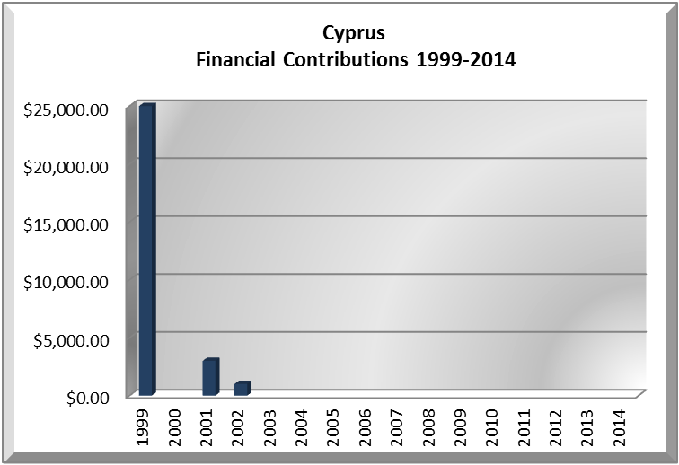
YEAR | CYPRUS | P.O. FINANCIAL CONTRIBUTIONS | %
1999 | $25,000.00 | $8,015,935.00 | 0.01%
2000 |  | $9,515,678.00 | 0.00%
2001 | $3,000.00 | $6,923,000.00 | 0.00%
2002 | $1,000.00 | $8,460,084.00 | 0.00%
Total US$ | $29,000.00 | $199,101,033.00 | 0.01%

CYPRUS CONTRIBUTIONS:
YEAR | PROJECTS | FINANCIAL CONTRIBUTIONS  IN US$ | IN-KIND CONTRIBUTIONS  IN US$
1999 | Hurricane Mitch - Disaster Assistance in the region | $25,000.00
SUBTOTAL |  | $25,000.00
2001 | Peace Fund (Belize-Guatemala) | $3,000.00
SUBTOTAL |  | $3,000.00
2002 | Special OAS Mission in Haiti | $1,000.00
SUBTOTAL |  | $1,000.00
TOTAL |  | $29,000.00

SOURCES:
PRESIDENCY OF THE REPUBLIC OF CYPRUS  http://www.presidency.gov.cy/Presidency/Presidency.nsf/DMLindex_en/DMLindex_en?OpenDocument  MINISTRY OF FOREIGN AFFAIRS OF THE REPUBLIC OF CYPRUS  http://www.mfa.gov.cy/mfa/mfa2006.nsf/index_en/index_en?OpenDocument | WEB PORTAL OF THE REPUBLIC OF CYPRUS  http://www.cyprus.gov.cy/portal/portal.nsf/government_en?OpenForm&SectionId=government&CategoryId=none&SelectionId=home&print=0&lang=en  EMBASSY OF CYPRUS IN WASHINGTON, D.C.  http://www.cyprusembassy.net/home/  WORLD BANK – TRADING ECONOMICS  www.tradingeconomics.com

This page was last updated on July 10, 2017.

