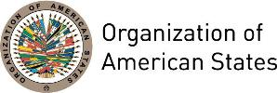

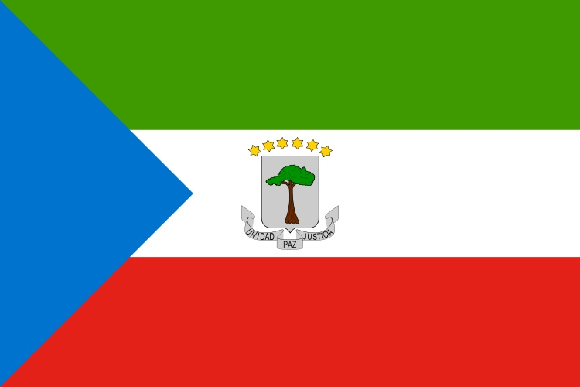
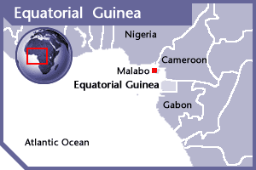

EQUATORIAL GUINEA
PERMANENT OBSERVER

Date of Entry: March 4, 1987
National Day: October 12
Capital: Malabo
Type of Government: Presidential Republic
Head of State: President Teodoro Obiang Nguema Mbasogo (since 1989)
Head of Government: Prime Minister Francisco Pascual Eyegue (June 23, 2016)
Minister of Foreign Affairs and Cooperation: Agapito Mba Mokuy
Permanent Observer: Ambassador Miguel Ntutumu Evuna Andeme (February 23, 2015)

ECONOMIC INDICATORS | 2010 | 2011 | 2012 | 2013 | 2014 | 2015 | 2016
Population (millions) | 0.95 | 0.99 | 1.03 | 1.08 | 1.12 | 1.17 | 1.22
GDP (US$ in billions) | 16.29 | 21.32 | 22.39 | 21.94 | 21.46 | 12.16 | 10.17
GDP per capita (US$) | 17,136.446 | 21,451.886 | 21,557.653 | 20,246.993 | 19,002.597 | 10,347.313 | 8,333.238
Source: www.tradingeconomics.com | The World Bank Group

FOREIGN RELATIONS POLICIES:
- The Ministry of Foreign Affairs formulates and coordinates Equatoguinean foreign policy based on the instructions given by the Federal Council. Its activities are guided by its principal foreign policy objectives:
- Coordinate and foster diplomatic, consular and cooperation relations with countries and international organizations;
- Participate in the conception, coordination and control of the execution of agreements and programs ratified with other countries, international organizations, governmental entities and NGOs;
- Coordinate activities of special missions with the foreign countries and international organizations; and
- Watch for the protection and promotion of the national interests abroad; among others.
- Guinea has been active in efforts toward regional integration and cooperation, especially regarding the Organization of African Unity and the Economic Community of West African States (ECOWAS). It has participated in diplomatic and military efforts to resolve conflicts in Liberia, Sierra Leone, and Guinea-Bissau, and has contributed troops to peacekeeping operations in all three countries as part of ECOMOG, the Military Observer Group of ECOWAS.
- Equatorial Guinea is member of the Central African Economic and Monetary Union (CEMAC), which includes Cameroon, Central African Republic, Chad, Congo (Brazzaville), and Gabon.
- It also is a member of the Franc zone. Parallel to the Equatoguinean rapprochement with its Francophone neighbors, France's role has significantly increased following Equatorial Guinea's entry into the CFA Franc Zone and the BEAC. French technical advisers work in the finance and planning ministries, and agreements have been signed for infrastructure development projects.

INVOLVEMENT WITH THE AMERICAS:
- Equatorial Guinea has embassies in the following countries: Brazil, Cuba, and the United States and a consulate in Argentina.

SOURCES:
GUINEA ECUATORIAL, PÁGINA OFICIAL DEL GOBIERNO  http://www.guineaecuatorialpress.com/index.php  MINISTERIO DE ASUNTOS EXTERIORES Y COOPERACIÓN DE LA REPÚBLICA DE GUINEA ECUATORIAL  http://www.mae-ge.org/index.php | EQUATORIAL GUINEA EMBASSY IN WASHINGTON D.C.  http://egembassydc.com/  WORLD BANK – TRADING ECONOMICS  www.tradingeconomics.com

This page was last updated on July 10, 2017.

