
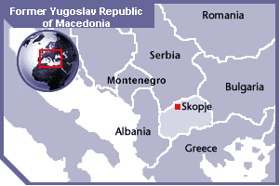
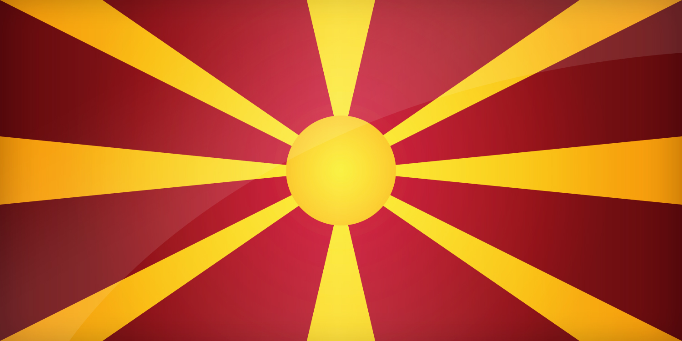
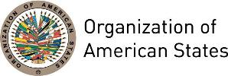
FORMER YUGOSLAV REPUBLIC OF MACEDONIA
PERMANENT OBSERVER

Date of Entry: May 18, 2011
National Holiday: September 8 , (1991)
Capital: Skopje
Type of Government: Democratic Parliamentary Republic
Head of State: President Gjorge Ivanov (May 12, 2009)
Head of Government: Prime Minister Zoran Zaev (May 31, 2017)

Minister of Foreign Affairs: Nikola Poposki (July 28, 2011)
Permanent Observer: Ambassador Vasko Naumovski (February 25, 2015)

ECONOMIC INDICATORS | 2010 | 2011 | 2012 | 2013 | 2014 | 2015 | 2016
Population (in millions) | 2.07 | 2.07 | 2.07 | 2.07 | 2.08 | 2.08 | 2.08
GDP (US$ in billions) | 9.407 | 10.495 | 9.745 | 10.818 | 11.362 | 10.052 | 10.9
GDP per capita (US$) | 4,542.9 | 5,064.04 | 4,698.6 | 5,219.5 | 5,469.2 | 4,834.1 | 5,237.1
Source: www.tradingeconomics.com | The World Bank Group

FOREIGN RELATIONS POLICIES:
- The Former Yugoslav Republic of Macedonia has increased cooperation with those countries working to achieve and maintain interconnected societies based on freedom, peace and democracy, respect for human freedoms and rights, and the rule of law. Through its foreign policies – bilaterally and multilaterally – the country promotes its national values and interests to contribute to the challenges of today’s globalized world.
- Gaining membership in the European Union and the North Atlantic Treaty Organization (NATO) remains its top priority, as well as improving its international relations by promoting its national identity, political approach, economic stability, and cultural interests based on the principles of peace, equality, good relations with its neighbors, strengthened regional cooperation and multilateralism, and respect for international law.
- It is a member of the United Nations (UN), the International Organization of the Francophonie (OIF), the Council of Europe, the Organization for Security and Cooperation in Europe, and the World Trade Organization (WTO).
- The foreign policy and strategic objectives of the Work Program of the Government of the Former Yugoslav Republic of Macedonia for the period 2011–2015 is focused on the following priorities:
- Accession to the North Atlantic Treaty Organization (NATO) and the European Union;
- Strengthen anti-corruption and anti-crime policies through reforms in the judiciary and public administration;
- Strengthen economic and public diplomacy, as well as regional cooperation in Southeastern Europe;
- Attraction of foreign investment and improvement of economic growth and employment;
- Promotion of the non-proliferation of weapons of mass destruction, arms control and disarmament;
- Protection and promotion of human rights. The country participates in peacekeeping missions (UN, NATO, and EU) in support of peace, security, and stability; it contributes with about 240 officers to international operations, or about 3.5% of its own military forces. The Former Yugoslav Republic of Macedonia participates with its own troops in Afghanistan (ISAF), Iraq (Iraqi Freedom), Bosnia and Herzegovina (ALTHEA), and Lebanon (UNIFIL), and also provides logistical support to the Kosovo Forces (KFOR). With regard to the participation in NATO-led international missions, the Former Yugoslav Republic of Macedonia has been given the highest assessment by NATO, which sees the country as a stable military partner to the Alliance.
- Accession to the Executive Board of UNESCO (2011–2015) and to the UN Human Rights Council (2013–2016). The Former Yugoslav Republic of Macedonia supported the creation of the UN Human Rights Council in 2006, a forum for future promotion of human rights and basic freedoms through universal partnership and dialogue. In its efforts to promote universal human rights, it contributed to the organization of two world conferences for inter-religious and inter-civilizations dialogue that took place in Ohrid in 2007 and 2010. Within the Ohrid Framework Agreement, the country supports the preservation of good inter–ethnic relations based on the principles of mutual tolerance and respect.
- Investment in education, science and information technology as key elements of a knowledge–based society.

CURRENT COOPERATION AGREEMENTS WITH THE OAS:
- Arrangement between the Ministry of Education and Science of the Government of the Former Yugoslav Republic of Macedonia and the General Secretariat of the OAS, through an exchange of letters on February 6, 2014, to provide 15 scholarships each year during a five-year period to individuals from OAS Member States to attend the University for Information Science and Technology – St. Paul the Apostle in Ohrid.

INVOLVEMENT WITH THE AMERICAS:
- The Former Yugoslav Republic of Macedonia presence in Latin America has been rather limited, given the relatively small number of diplomatic missions, exchanges of official visits, and limited trade and economic activity involving it.
- The Former Yugoslav Republic of Macedonia for the period of 2011–2015, in accordance with its financial possibilities, will consider expanding its diplomatic network with an embassy in Brazil, and will continue to foster its relations with: Argentina, Barbados, Belize, Canada, México, Paraguay, Peru, Saint Vincent and the Grenadines, Saint Lucia, Saint Kitts and Nevis, Suriname, Trinidad and Tobago, and the United States. The Government of the Former Yugoslav Republic of Macedonia maintains formal diplomatic delegations in Canada, Mexico and the United States.

CONTRIBUTIONS FROM THE FORMER YUGOSLAV REPUBLIC OF MACEDONIA TO THE OAS:
YEAR | PROJECTS | FINANCIAL CONTRIBUTIONS  IN US$ | IN-KIND CONTRIBUTIONS  IN US$
2014 | Department of Human Development and Education / Executive Secretariat for Integral Development - University of Information Science and Technology (10 scholarships awarded) |  | $174,000.00
SUBTOTAL |  |  | $174,000.00
TOTAL |  |  | $174,000.00

SOURCES:

FORMER YUGOSLAV REPUBLIC OF MACEDONIA  http://vlada.mk/?language=en-gb  FORMER YUGOSLAV REPUBLIC OF MACEDONIA, Presidency  http://www.president.gov.mk/en.html  FORMER YUGOSLAV REPUBLIC OF MACEDONIA, Ministry Of Foreign Affairs  www.mfa.gov.mk | UNITED STATES’ DEPARTMENT OF STATE  www.state.gov  WORLD BANK – TRADING ECONOMICS  www.tradingeconomics.com

This page was last updated on July 10, 2017.

