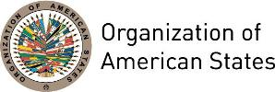
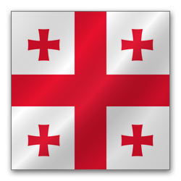
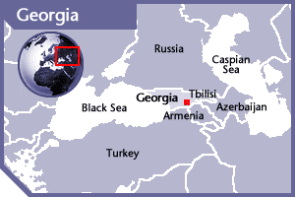


GEORGIA
PERMANENT OBSERVER

Date of Entry: April 24, 2002
National Day: May 26
Capital: Tbilisi
Type of Government: Semi-presidential Republic
Head of State: President Giorgi Margvelashvili (October 27, 2013)
Head of Government: Prime Minister Giorgi Kvirikashvili (December 30, 2015)
Minister of Foreign Affairs: Mikheil Janelidze (November 11, 2014)
Permanent Observer: Ambassador Davit Bakradze (November 2016)

ECONOMIC INDICATORS | 2010 | 2011 | 2012 | 2013 | 2014 | 2015 | 2016
Population (in millions) | 3.93 | 3.88 | 3.83 | 3.78 | 3.73 | 3.68 | 3.72
GDP (US$ in billions) | 11.63 | 14.44 | 15.85 | 16.14 | 16.51 | 13.99 | 14.33
GDP per capita (US$) | 2,964.5 | 3,725.1 | 4,142.9 | 4,274.4 | 4,429.7 | 3,764.6 | 3,853.6
Source: www.tradingeconomics.com | The World Bank Group

FOREIGN RELATIONS POLICIES:
- Georgia’s foreign policy is based on the values established in the modern democratic world and promotes the national interests of Georgia, protects the rights of Georgian citizens abroad, and contributes to a better world community.
- Its main priorities are: to protect the interests of the country and the society; to reinforce the state independence, restore territorial integrity, and reinforce the state security system; to promote the formation of a democratic society; establish the judicial state that would be based on the rule of law, institute legal and institutional guarantees for the protection of basic human rights and freedoms, and promote the reinforcement of strong civil society; to promote a free market economy, through the reinforcement of the economic potential of the country, establish stable guarantees for social welfare and social development; to establish democratic state institutions in Georgia; to integrate into the Euro Atlantic sphere, reinforce partnership based on cooperation with the neighboring states; to fight against corruption; to support democratic reforms; and to cooperate with public organizations for the purpose of establishing transparent systems.
- Georgia participates actively in international organizations and coalitions such as the United Nations (UN), The European Union, the Council of Europe, the Organization for Security and Cooperation in Europe (OSCE), the UNESCO, the Commonwealth of Democratic Choice (CDC), North Atlantic Treaty Organization (NATO), the Organization for Democracy and Development – GUAM, the Black Sea Economic Co-operation (BSEC) Organization, the Commonwealth of Independent States (CIS) and the World Trade Organization (WTO), as well as other organizations, conventions, and initiatives, governmental and non-governmental structures of economic, cultural, ecological, scientific, juridical or educational.

INVOLVEMENT WITH THE AMERICAS:
- Georgia has diplomatic relations with most of the OAS Member States and has established diplomatic missions in: Argentina, Brazil, Canada, Mexico and the United States.

SOURCES:

THE PRESIDENT OF GEORGIA WEBSITE  http://www.president.gov.ge/  GOVERNMENT OF GEORGIA WEBSITE  http://www.government.gov.ge/index.php?sec_id=1&lang_id=ENG  MINISTRY OF FOREIGN AFFAIRS OF GEORGIA  http://www.mfa.gov.ge/index.php?lang_id=ENG&sec_id=1 | EMBASSY OF GEORGIA IN WASHINGTON DC  http://usa.mfa.gov.ge/index.php?lang_id=GEO&sec_id=38&lang_id=ENGsec_id=38  WORLD BANK – TRADING ECONOMICS  www.tradingeconomics.com

This page was last updated on July 10, 2017.

