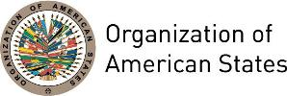

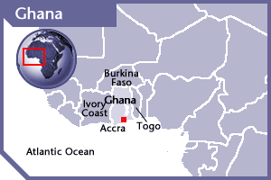
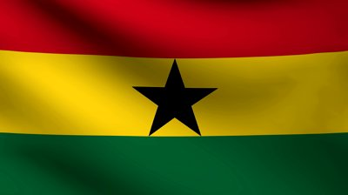

GHANA
PERMANENT OBSERVER

Date of Entry: October 9, 1996
National Day: March 6
Capital: Accra
Type of Government: Presidential Democracy
Head of State: President Nana Addo Dankwa Akufo-Addo (January 7, 2017)
Minister of Foreign Affairs, Regional Integration: Shirley Ayorkor Botchway (January 28, 2017)
Permanent Observer: H.E. Dr. Barfuor Adjei-Barwuah (July 21, 2017)

ECONOMIC INDICATORS | 2010 | 2011 | 2012 | 2013 | 2014 | 2015 | 2016
Population (in millions) | 24.51 | 25.12 | 25.73 | 26.34 | 26.96 | 27.58 | 28.20
GDP (US$ in billions) | 32.17 | 39.56 | 41.94 | 47.80 | 38.61 | 37.54 | 42.69
GDP per capita (US$) | 1,312.60 | 1,574.97 | 1,629.8 | 1,814.49 | 1,432.22 | 1,361.11 | 1,513.46
Source: www.tradingeconomics.com World Bank

FOREIGN RELATIONS POLICIES:
- The Ministry of Foreign Affairs has the responsibility for conducting Ghana's foreign policy.
- The fundamental principles that guide Ghana's foreign policy are the promotion and protection of national interests; establishment of a just and equitable international, economic, political and social order; respect for international law and treaty obligations; settlement of international disputes through peaceful means; and adherence to the principles enshrined in the Charter of the United Nations, African Union, Economic Community Of West African States (ECOWAS), Commonwealth, and the Non-Aligned Movement, among others.
- Ghana's foreign policy, involves the protection and defense of the territorial integrity of Ghana, ensuring peace and stability for Ghana and the sub-region, contributing to wider international peace and security, cultivating a favorable image of Ghana abroad and defending that image.
- Ghana’s foreign policy objectives include:
- Good neighborliness: Sustaining the climate of peace and stability in the West African sub-region and maintaining cordial relations between Ghana and her neighbors to address common development challenges.
- Regional integration: Deriving maximum benefit from Ghana's membership in ECOWAS and other regional economic communities for Ghana's socio-economic advancement.
- Support for the African Union: Playing a leading role in collective efforts to promote peace, stability and economic development on the African continent and active participation in the African Union.
- Developing and sustaining international goodwill, attracting foreign direct investment, solidarity and support for national development.
- Economic diplomacy: Diversifying and increasing Ghana's export base and tourism for job creation by seeking markets for Ghanaian products abroad and taking advantage of preferential arrangements and multilateral trade agreements.
- Participation in the deliberations of multilateral organizations: Helping seek solutions to the challenges confronting international peace, stability and development and to articulate Ghana's views in major international conferences and deliberations of multilateral institutions.
- Promoting cooperation in scientific and technical research.
- Promoting cooperation in human resource development: Facilitating the award of scholarships to Ghanaian students to study abroad under existing frameworks for bilateral cooperation.
- Promoting cooperation in the health sector: Boost healthcare delivery in Ghana through the instrumentality of various Joint Commissions for Cooperation and other bilateral and multilateral arrangements for additional resources including medical personnel, equipment and technical assistance.
- Promoting and protecting the welfare of Ghanaian nationals abroad.
- Biometric Passports: Complying with directives of ICAO and ECOWAS and improving the security and integrity of the Ghanaian passport.

INVOLVEMENT WITH THE AMERICAS:
- Ghana has diplomatic relations with all OAS Member States and has established embassies in Brazil, Cuba, and the United States of America, and a High Commission in Canada.

SOURCES:
THE PRESIDENCY OF THE REPUBLIC OF GHANA  http://www.presidency.gov.gh/  MINISTRY OF FOREIGN AFFAIRS AND REGIONAL INTEGRATION  http://www.mfa.gov.gh/  GOVERNMENT OF GHANA OFFICIAL PORTAL  http://www.ghana.gov.gh/ | EMBASSY OF THE REPUBLIC OF GHANA IN WASHINGTON D.C.  http://www.ghanaembassy.org/  WORLD BANK – TRADING ECONOMICS  www.tradingeconomics.com

This page was last updated on July 10, 2017.

