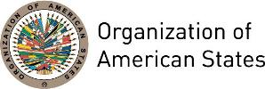

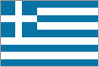
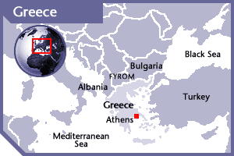

GREECE
PERMANENT OBSERVER

Date of Entry: September 27, 1979
Official Country name: The Hellenic Republic
Capital: Athens
National Holiday: March 25
Type of Government: Parliamentary Republic
Head of State: President Prokopis Pavlopoulos (March 13, 2015)
Head of Government: Prime Minister Alexis Tsipras (September 21, 2015)
Minister of Foreign Affairs: Nikos Kotzias (September 23, 2015)
Permanent Observer: Ambassador Haris Lalacos (October 24, 2016)

ECONOMIC INDICATORS | 2010 | 2011 | 2012 | 2013 | 2014 | 2015 | 2016
Population (in millions) | 11.12 | 11.10 | 11.05 | 10.97 | 10.89 | 10.82 | 10.74
GDP (US$ in billions) | 299.36 | 287.79 | 245.67 | 239.86 | 236.08 | 194.86 | 194.56
GDP per capita (US$) | 26,917.7 | 25,916.2 | 22,242.7 | 21,874.8 | 21,673.7 | 18,007.7 | 18,103.9
Source: www.tradingeconomics.com | The World Bank Group

FOREIGN RELATIONS POLICIES:
- Greek foreign policy is based on the respect for international law and human rights, the cultivation of bilateral relations, as well as their participation in the European Union and other international organizations. Greece is a founding member of the United Nations (UN), member of the European Union (EU), and the North Atlantic Treaty Organization (NATO).
- At the top of the Greek foreign policy agenda are the issues: the Greek-Turkish relations, the Cyprus situation, the EU accession perspective of the Western Balkans, the matter of the name of the Former Yugoslav Republic of Macedonia, and the Greek National Minority in Albania.
- At a global level, Greece priorities cooperation through international organizations, such as the United Nations, on issues related to drugs, organized crime, human trafficking, terrorism, responsibility to protect, combating piracy, human rights, international sanctions, disarmament, weapons of mass destruction, environment and climate change.

DEVELOPMENT COOPERATION:
- Development cooperation is an integral part of Greece’s foreign policy. Organization and management of Greek development cooperation is based in the Hellenic International Development Cooperation Department (HELLENIC AID) of the Ministry of Foreign Affairs. Greece develops strategic approaches to multilateral assistance by considering ongoing international dynamics and applying its experience from the EU, United Nations, and the Organization for Economic Cooperation and Development (OECD) memberships.
- The framework of Greek development cooperation in the Americas, through HELLENIC AID is particularly focused on migration, climate change, education facilities and training, social/welfare services, material relief assistance and services, environmental policy and administrative management, and STD control including HIV/AIDS

INVOLVEMENT WITH THE AMERICAS:
- Greece maintains embassies in Argentina, Brazil, Canada, Chile, Cuba, Mexico, Peru, United States of America, Uruguay and Venezuela.

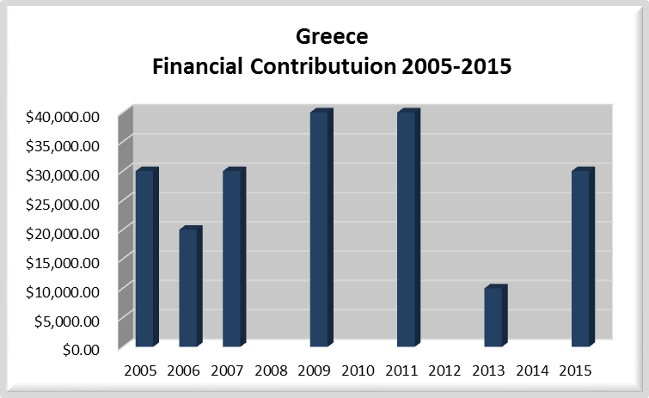
FINANCIAL CONTRIBUTIONS 2005-2016:
YEAR | GREECE | P.O. FINANCIAL CONTRIBUTIONS | %
2005 | $30,000.00 | $11,650,039.00 | 0.26%
2006 | $20,000.00 | $19,060,470.00 | 0.10%
2007 | $30,000.00 | $20,398,686.00 | 0.15%
2008 |  | $22,684,500.00 | 0.00%
2009 | $40,000.00 | $20,318,115.00 | 0.20%
2010 |  | $15,781,991.00 | 0.00%
2011 | $40,000.00 | $15,692,757.00 | 0.25%
2012 |  | $13,239,105.00 | 0.00%
2013 | $10,000.00 | $16,926,686.00 | 0.06%
2014 |  | $10,999,882.00 | 0.00%
2015 |  | $17,489,205.00 | 0.00%
2016 |  | $14,048,254.00 | 0.00%
Total US$ | $170,000.00 | $198,289,690.00 | 0.09%

GREECE CONTRIBUTIONS:
YEAR | PROJECTS | FINANCIAL CONTRIBUTIONS  IN US$ | IN-KIND CONTRIBUTIONS  IN US$
2003 | Office of External Relations- Conference Series | $20,000.00
SUBTOTAL |  | $20,000.00
2005 | Department of Communications and External Relations (DCER)- Lecture Series of the Americas | $15,000.00
2005 | DCER- Meeting of Government Spokesperson of the Americas | $15,000.00
SUBTOTAL |  | $30,000.00
2006 | Multidimensional Security / Study of Gangs Involved in Human Trafficking | $10,000.00
2006 | Department of External Relations / Lecture Series of the Americas | $10,000.00
SUBTOTAL |  | $20,000.00
2007 | Multidimensional Security / Human Trafficking | $30,000.00
SUBTOTAL |  | $30,000.00
2009 | Multidimensional Security / Inter-American Drug Abuse Control Commission – Counternarcotics | $40,000.00
SUBTOTAL |  | $40,000.00
2011 | Inter-American Commission on Human Rights | $20,000.00
2011 | Multidimensional Security /Inter-American Drug Abuse Control Commission | $20,000.00
SUBTOTAL |  | $40,000.00
2013 | Department of International Affairs / Secretariat for External Relations - OAS Policy Roundtables | $10,000.00
SUBTOTAL |  | $10,000.00
2015 | Department of Human Development and Education / Executive Secretariat for External Relations - Virtual Platform for the Americas Network for Education and Development | $30,000.00
SUBTOTAL |  | $30,000.00
TOTAL |  | $220,000.00

SOURCES:
PRESIDENCY OF THE HELLENIC REPUBLIC  http://www.presidency.gr/?&lang=en  HELLENIC REPUBLIC, MINISTRY OF FOREIGN AFFAIRS  http://www.mfa.gr/en/ | THE WORLD BANK GROUP  www.tradingeconomics.com

This page was last updated on July 10, 2017.

