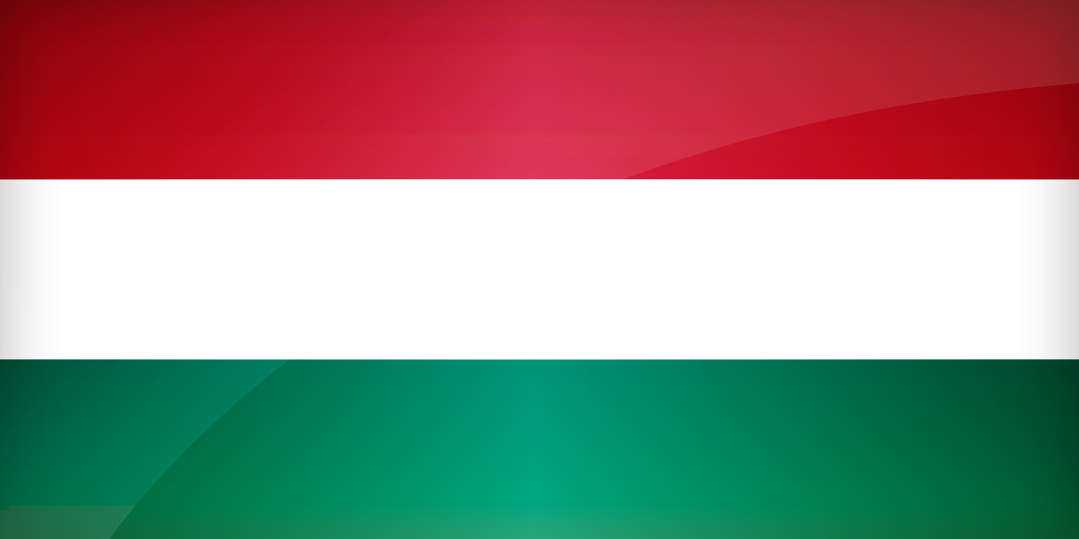
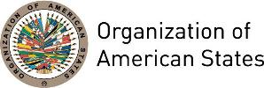

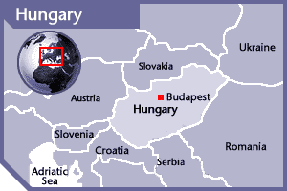

HUNGARY
PERMANENT OBSERVER

Date of Entry: September 12, 1990
National Day: August 20
Capital: Budapest
Type of Government: Parliamentary democracy
Head of State: János Áder (May 10, 2012)
Head of Government: Prime Minister Viktor Orbán (May 29, 2010)
Minister of Foreign Affairs and Trade: Péter Szijjártó (September 2014)
Permanent Observer: Ambassador László Szabó

ECONOMIC INDICATORS | 2010 | 2011 | 2012 | 2013 | 2014 | 2015 | 2016
Population (in millions) | 10.03 | 10.01 | 9.99 | 9.93 | 9.91 | 9.91 | 9.91
GDP (US$ in billions) | 130.25 | 140.42 | 127 | 134 | 139.3 | 121.75 | 124.46
GDP per capita (US$) | 13,025.53 | 14,048.9 | 12,834.32 | 13,613.6 | 14,117.98 | 12,365.626 | 12,664.95
Source: www.tradingeconomics.com World Bank

FOREIGN RELATIONS POLICIES:
- The Ministry of Foreign Affairs is responsible for shaping and maintaining Hungary’s international relations, for representing national interests at a global level, and for achieving Hungary’s foreign affairs goals.
- The overall foreign policy goal is to make Hungary a strong and acknowledged player in the Central European Region, the European Union and in the international political and cultural arena.
- Hungary acceded to the North Atlantic Treaty Organization (NATO) in 1999 and the European Union in 2004. The Ministry develops the Hungarian government’s standpoint on general foreign and security policy issues, with particular reference to our membership of the European Union and the North Atlantic Treaty Organization (NATO).
- The Foreign Ministry oversees relations with the European Union and directs cultural diplomacy. It is responsible for Hungary’s role in global international organizations, and for obligations in humanitarian and human rights fields. It supervises the development of Hungary’s standpoint on global economic affairs, sustainable development, energy security and other questions related to global challenges.
- Hungary’s strategic partner countries include Serbia, Montenegro, Bosnia and Herzegovina, and Vietnam as well as the Former Yugoslav Republic of Macedonia, Moldova, Mongolia, Kyrgyzstan, Ukraine, and the Palestinian Authority.
- Hungary has international commitments in both Afghanistan and Iraq, and it partners with certain Least Developed Countries, including Ethiopia, Yemen, Cambodia, and Laos.

International Development Cooperation Program of Hungary:
- Hungary concentrates its development assistance activities primarily in the following areas:
- Sharing Hungarian experiences associated with the political-economic transition (establishment and operation of democratic structures, creating conditions for the transition to a free-market economy, privatization, providing assistance to small- and medium-sized enterprises, and the application of the criteria of good governance).
- Knowledge transfer, knowledge-based assistance (methodological procedures, know-how, software, transfer of organizational and planning methods, etc.)
- Promoting education (university and postgraduate), training of experts and technicians, developing curriculum, organizing distance learning.
- Developing health services (planning, equipping, and running of hospitals and polyclinics, birth control, combating epidemics, etc.)
- Agriculture (dissemination of state-of-the-art plant and animal breeding methods, seed improvement, plant hygiene - plant protection, freshwater fish breeding, forestation programs, farm development plans, biotechnology, agro-meteorology, training of specialists and engineers in farming-related areas), food industry (planning of slaughterhouses.)
- Contributing to water management and water resources development, planning and providing technical advice (reservoirs and barrages, water purification plants, planning of dikes, inland drainage, exploration and assessment of water stocks, etc.)
- Developing general infrastructure.
- Helping general and transport engineering activity, cartography.
- Providing technical advice on environmental protection.
- The priorities of Hungary’s international development cooperation program are to:
- Preserve and support international peace and security, and to create and sustain regional, political and economic stability;
- Reduce poverty, and contribute to sustainable economic and social development;
- Protect human rights and equal opportunities, to strengthen democracy and civil society structures, and to support local community autonomies;
- Support efforts aimed at creating economic and social development (basic necessities, healthcare, primary education);
- Promote good governance; and
- Protect and improve environmental resources.

INVOLVEMENT WITH THE AMERICAS:
- Hungary has diplomatic relations with all the OAS Member States and maintains embassies in: Argentina, Brazil, Canada, Chile, Cuba, Mexico and the United States of America.
- Hungary aims to reposition itself in Latin America, strengthening its ties with the region; in order to achieve this objective, the Hungarian Government is planning to expand its diplomatic presence, economic agreements and scholarship exchange programs that would make it possible for 450 students from Brazil and 100 students from Mexico to study in Hungary.

SOURCES:
OFFICE OF THE PRESIDENT OF THE REPUBLIC  http://www.keh.hu/index.html  HUNGARIAN EMBASSY IN WASHINGTON D.C.  http://washington.kormany.hu/ | WEBSITE OF THE HUNGARIAN GOVERNMENT  http://www.kormany.hu/en  WORLD BANK – TRADING ECONOMICS  www.tradingeconomics.com

This page was last updated on July 11, 2017.

