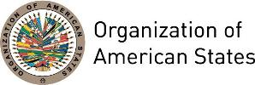

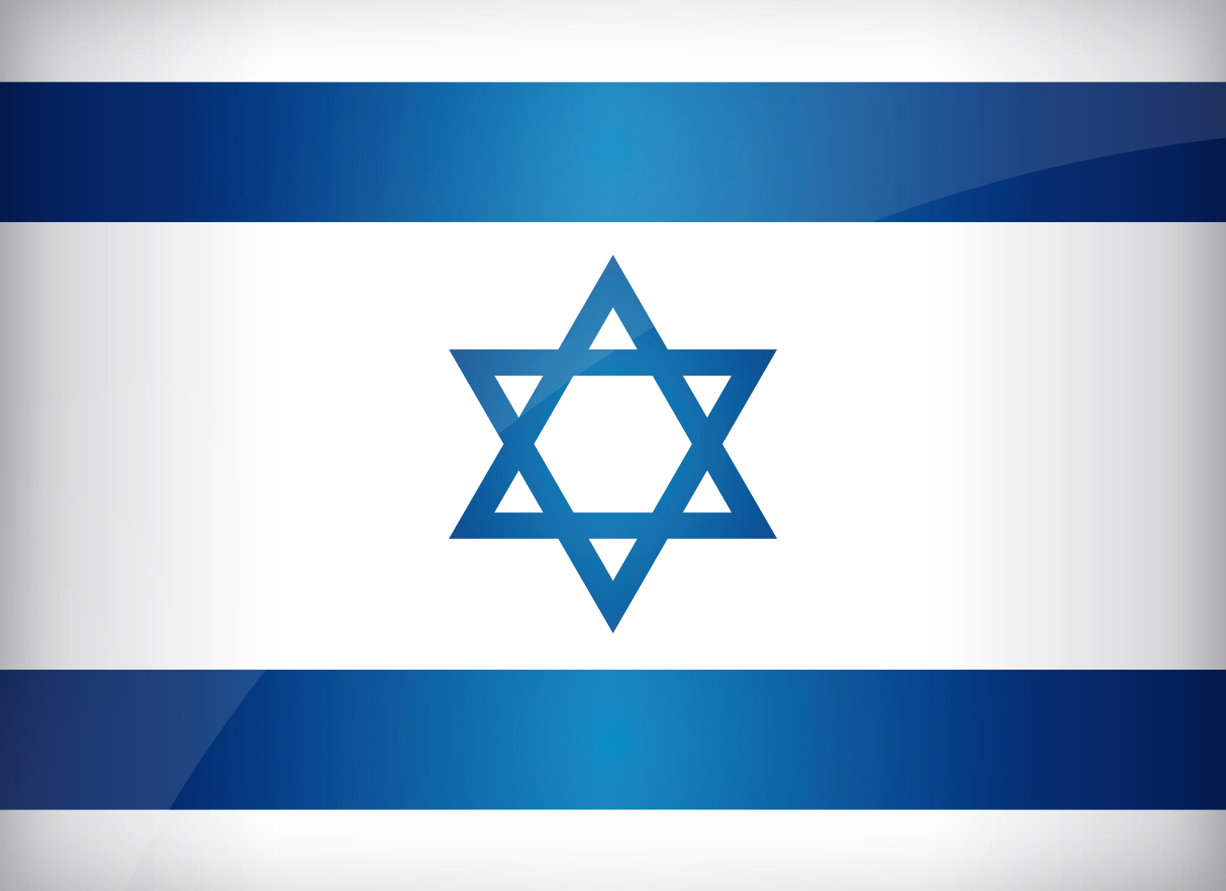
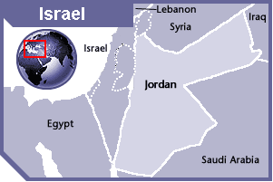

ISRAEL
PERMANENT OBSERVER

Date of Entry: February 2, 1972
National Day: May 14
Capital: Jerusalem
Type of Government: Parliamentary democracy
Head of State: President Reuven Rivlin (July 27, 2014)
Head of Government: Prime Minister Benjamin Netanyahu (1996-1999; 2009 - present)
Minister of Foreign Affairs: Benjamin Netanyahu (May 14, 2015)
Head Israel’s Agency for International Development Cooperation MASHAV: Gil Haskel (2014)
Permanent Observer: Ambassador Ron Dermer (December 3, 2013)

ECONOMIC INDICATORS | 2010 | 2011 | 2012 | 2013 | 2014 | 2015 | 2016
Population (in millions) | 7.62 | 7.76 | 7.91 | 8.06 | 8.21 | 8.38 | 8.54
GDP (US$ in billions) | 233.75 | 261.375 | 257.64 | 293.31 | 308.76 | 299.41 | 318.744
GDP per capita (US$) | 30,661.99 | 33,657.15 | 32,569.59 | 36,393.66 | 37,582.84 | 35,729.37 | 37,292.612
Source: www.tradingeconomics.com | The World Bank Group

FOREIGN RELATIONS AND DEVELOMENT COOPERATION POLICIES:
- The Foreign Ministry formulates implements and presents the foreign policy of the Government of Israel; it represents the state vis-à-vis foreign governments and international organizations, explains its positions and problems throughout the world, endeavors to promote its economic, cultural, and scientific relations, and fosters cooperation with developing countries.
- The goals of Israeli foreign policy are to achieve recognition and friendly relations with as many nations as possible, both in the Middle East and beyond. It has also sought to foster increased Jewish immigration to Israel and to protect vulnerable Jewish communities in the Diaspora.
- Israel is a member of the United Nations (UN) and many agencies within it including the United Nations Educational, Scientific and Cultural Organization (UNESCO), the Office of the United Nations High Commissioner for Refugees (UNHCR), and the Food and Agriculture Organization (FAO). Israel also participates in other international organizations such as the International Atomic Energy Agency (IAEA) and the World Health Organization (WHO).
- Israel has joined the European Union's Framework Programs for Research and Technological Development (FP), and is a member of the European Organization for Nuclear Research (CERN), the European Molecular Biology Organization (EMBO) and the European Molecular Biology Laboratory (EMBL). Israel is a member of North Atlantic Treaty Organization’s (NATO) Mediterranean Dialogue forum.

AGENCY FOR INTERNATIONAL DEVELOPMENT COOPERATION –MASHAV–:
- The Center for International Cooperation of the Foreign Ministry of Israel (MASHAV) has an extensive program of cooperation throughout the developing world with the aim of promoting sustainable development and social equity. MASHAV serves as a bridge between Israel’s medical community and the developing world.
- MASHAV’s priorities areas of cooperation are poverty alleviation, provision of food security, empowerment of women and upgrade of basic health and education services, climate change, environment, desertification, water management, rural and community development, and human capacity building.

INVOLVEMENT WITH THE AMERICAS:
- Today Israel maintains full diplomatic relations with all the countries of Latin America and the Caribbean region, except Cuba, Bolivia and Venezuela (the latter two severed relations with Israel in 2009). These relations are reflected in productive cooperation in the political, economic and cultural spheres, as well as in a large number of bilateral agreements in many areas.
- Israel maintains embassies in 15 OAS member states: Argentina, Brazil, Canada, Chile, Colombia, Costa Rica, Dominican Republic, Ecuador, El Salvador, Guatemala, Mexico, Panama, Peru, United States of America, and Uruguay.
- Exports within the region include chemicals, hi-tech software, agricultural produce, machinery and electronics; Imports comprise meat, grain, corn, sugar, cocoa, coffee, and metals; Israeli banks, construction firms and agricultural planning and development companies are active in the countries of Latin America and the Caribbean.
- In February 2014, Israel became an Observer to the Pacific Alliance and seeks to increase its trade with Latin America, especially Chile, Colombia, Mexico and Peru.
- In 2014, the Israeli Government approved a three-year 50 million New Israeli Shekel-NIS (US$14.4 million) to strengthen economic ties with Latin American countries and reduce its dependence on the European market.

COOPERATION AGREEMENTS WITH THE OAS:
- Memorandum of Understanding between the GS/OAS and Israel’s Agency for International Development Cooperation (MASHAV), to advance regional cooperation in areas of mutual interest such as capacity building, training courses and field technical assistance in the framework of integral development (early education, professional development, environment, economic and social development, employment and poverty reduction), gender equity, disaster mitigation and relief, sustainable agriculture, management of natural resources, and security. Signed on December 12, 2014 for an initial period of 2 years and to be renewed automatically.
- Memorandum of Understanding between the GS/OAS and Israel’s Agency for International Development Cooperation (MASHAV), to advance regional cooperation in areas of mutual interest such as capacity building, training courses and field technical assistance in the framework of integral development (early education, professional development, environment, economic and social development, employment and poverty reduction), gender equity, disaster mitigation and relief, sustainable agriculture, management of natural resources, and security. Signed on May 17, 2010 for a period of 2 years.
- Israel is the largest in-kind contributor to the Young Americas Business Trust, offering fellowships, training courses, etc. In 2012, MASHAV and the GS/OAS formalized an agreement through which Israel contributed US$1 million to the Young Americas Business Trust from 2011 to 2014 for the Business Labs and Nex Links program. In November 2014, the Head of MASHAV presented a letter to the Secretary General, expressing the government’s intention to renew the cooperation from 2015 to 2017.
- In 2011 the Secretariat of the Inter-American Committee against Terrorism (CICTE) and the Ministry of Foreign Affairs of the State of Israel signed a Work Plan of Activities to carry out joint projects from 2010 to 2012 in the areas of preventing terrorism financing, radicalization, aviation security and crisis management.

CASH CONTRIBUTIONS 2010-2016:
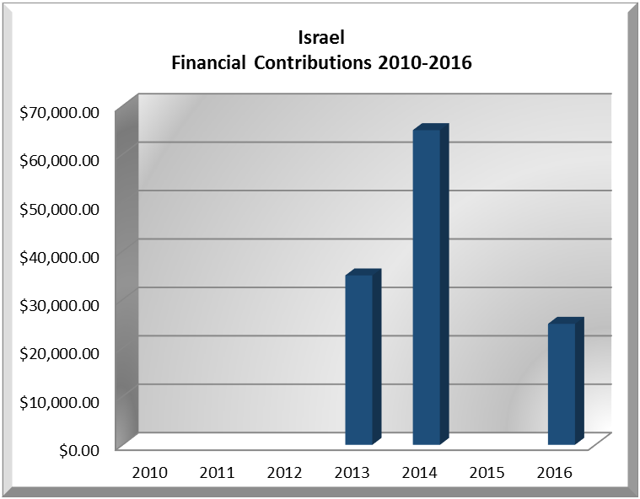
Year | ISRAEL | FINANCIAL CONTRIBUTIONS P.O.s | %
2010 |  | $15,781,991.00 | 0.00%
2011 |  | $15,692,757.00 | 0.00%
2012 |  | $13,239,105.00 | 0.00%
2013 | $35,000.00 | $16,926,686.00 | 0.21%
2014 | $65,000.00 | $10,999,882.00 | 0.59%
2015 |  | $17,489,205.00
2016 | $25,000.00 | $14,048,254.00 | 0.18%
Total US$ | $125,000.00 | $104,177,880.00 | 0.12%

ISRAEL CONTRIBUTIONS:
YEAR | PROJECTS | FINANCIAL CONTRIBUTIONS  IN US$ | IN-KIND CONTRIBUTIONS  IN US$
1999 | Fellowships |  | $350,000.00
SUBTOTAL |  |  | $350,000.00
2000 | CIDI | $30,000.00
2000 | Fellowships |  | $182,625.00
SUBTOTAL |  | $30,000.00 | $182,625.00
2001 | Peace Fund | $20,000.00
2001 | Fellowships |  | $390,000.00
SUBTOTAL |  | $20,000.00 | $390,000.00
2003 | Fellowships and Training Programs |  | $11,465.00
SUBTOTAL |  |  | $11,465.00
2004 | Office of the ASG – Special Mission in Haiti | $20,000.00
2004 | Fellowships and Training Programs (5) |  | $13,600.00
SUBTOTAL |  | $20,000.00 | $13,600.00
2006 | YABT – Training Courses |  | $100,000.00
SUBTOTAL |  |  | $100,000.00
2007 | YABT – Training Courses |  | $54,000.00
SUBTOTAL |  |  | $54,000.00
2008 | YABT – Training Courses |  | $348,000.00
SUBTOTAL |  |  | $348,000.00
2009 | YABT – “Business Labs” Training Courses |  | $348,000.00
SUBTOTAL |  |  | $348,000.00
2010 | Training Seminars for the Young Americas Business Trust |  | $348,000.00
2010 | Executive Secretariat for Integral Development / Department of Economic Development, Education and Culture – Course: Promoción del Desarrollo Económico Local – DEL – Mediante la Planificación Estratégica – 1 scholarship |  | $2,150.00
2010 | Executive Secretariat for Integral Development / Department of Economic Development, Education and Culture – Course: Policia y Comunidad – 2 scholarships |  | $4,000.00
2010 | Executive Secretariat for Integral Development / Department of Economic Development, Education and Culture – Course: Lucha contra la Desertificación, Gestión del Agua, Desarrollo Agropecuario y Forestación – 1 scholarship |  | $2,000.00
2010 | Executive Secretariat for Integral Development / Department of Economic Development, Education and Culture – Course: Integración Social de Jovenes Marginales – 5 scholarships |  | $10,000.00
SUBTOTAL |  |  | $366,150.00
2011 | Young Americas Business Trust – Training Seminars |  | $300,000.00
2011 | Executive Secretariat for Integral Development / Department of Human Development, Education and Culture – Implementation of Education for Sustainable Development in Schools of Indigenous Communities in Central America (17 Scholarships) |  | $47,430.00
2011 | Executive Secretariat for Integral Development / Department of Human Development, Education and Culture – Social Integration for Marginalized Youth (18 Scholarships) |  | $33,750.00
SUBTOTAL |  |  | $381,180.00
2012 | Young Americas Business Trust – Training Seminars |  | $300,000.00
2012 | Executive Secretariat for Integral Development / Department of Human Development, Education and Culture – Mashav/Weitz Center onsite OAS Scholarship Program (15 scholarships |  | $30,000.00
SUBTOTAL |  |  | $330,000.00
2013 | Secretariat for Political Affairs / Department of Electoral Cooperation and Observation – Electoral Observation Mission – Presidential and parliamentary elections in Paraguay, April 2013 | $20,000.00
2013 | Secretariat for Political Affairs / Department of Electoral Cooperation and Observation – Electoral Observation Mission - Presidential and Legislative Elections in Honduras, November 2013 | $15,000.00
2013 | Young Americas Business Trust – Training Seminars |  | $300,000.00
2013 | Department of Human Development, Education and Employment / Executive Secretariat for Integral Development - 9 Scholarships Awarded with the Support of the Mashav/Weitz Center | PDSP |  | $18,000.00
SUBTOTAL |  | $35,000.00 | $318,000.00
2014 | Secretariat for Political Affairs / Department of Electoral Cooperation and Observation – Electoral Observation Mission General Elections in Costa Rica - February 2, 2014 | $10,000.00
2014 | Secretariat for Political Affairs / Department of Electoral Cooperation and Observation – Electoral Observation Mission Presidential Elections in El Salvador - February 2, 2014 | $10,000.00
2014 | Secretariat for Political Affairs / Department of Electoral Cooperation and Observation – Presidential Elections in Colombia - May/June 2014 | $10,000.00
2014 | Secretariat for Political Affairs / Department of Electoral Cooperation and Observation – General Elections in Peru - October 5, 2014 | $10,000.00
2014 | Secretariat for Political Affairs / Department of Electoral Cooperation and Observation – Electoral Observation Mission Fund | $25,000.00
2014 | Young Americas Business Trust - Training for young entrepreneurs via Business Labs and Nexlinks programs |  | $332,000.00
SUBTOTAL |  | $65,000.00 | $332,000.00
2015 | Young Americas Business Trust - Training for young entrepreneurs via Business Labs and Nexlinks programs |  | $332,000.00
SUBTOTAL |  |  | $332,000.00
2016 | The Department of Electoral Cooperation and Observation – EOM 2016 Dominican Republic | $10,000.00
2016 | EOM Unprogrammed Fund | $15,000.00
SUBTOTAL |  | $25,000.00
TOTAL |  | $195,000.00 | $3,857,020.00

SOURCES:
ISRAEL MINISTRY OF FOREIGN AFFAIRS  http://mfa.gov.il/MFA/Pages/default.aspx  MASHAV - ISRAEL'S AGENCY FOR INTERNATIONAL DEVELOPMENT COOPERATION  http://www.mfa.gov.il/MFA/Mashav+–+International+Development/What+is+Mashav/MASHAV_under_construction.htm | WORLD BANK – TRADING ECONOMICS  www.tradingeconomics.com  THE EMBASSY OF ISRAEL TO THE UNITED STATES  http://www.israelemb.org/washington/Pages/default.aspx

This page was last updated on July 5, 2017.

