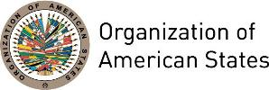
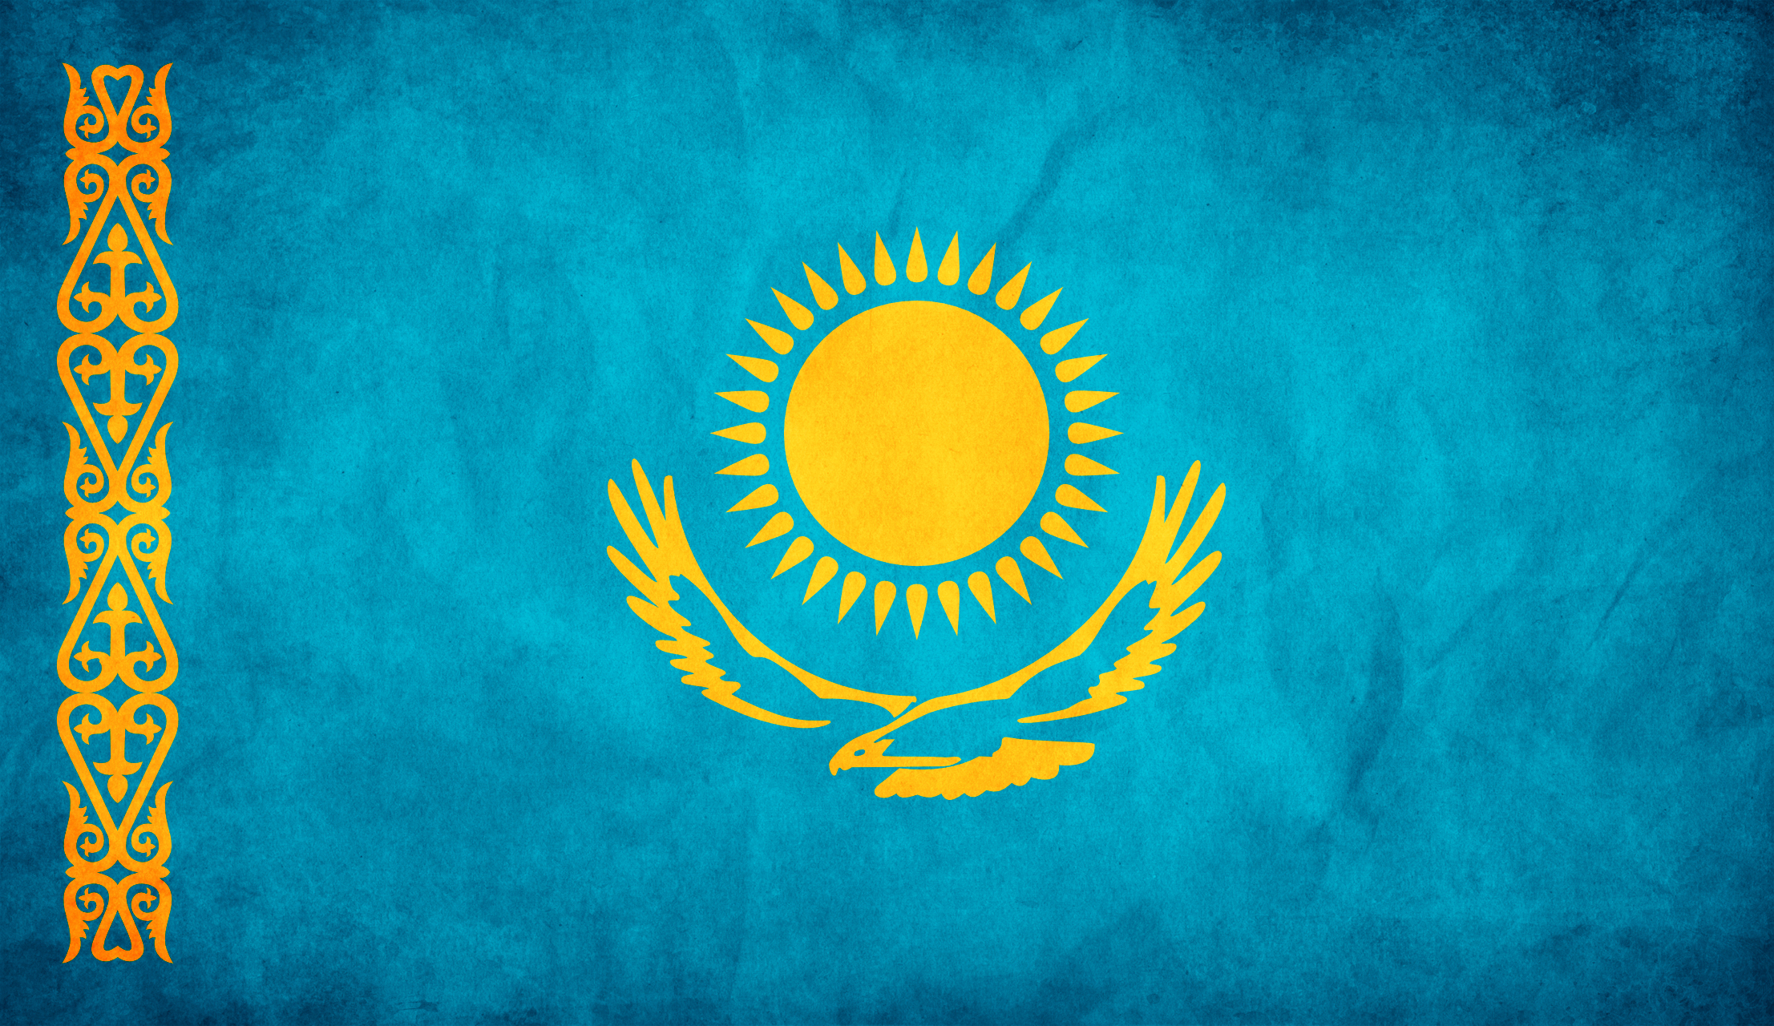

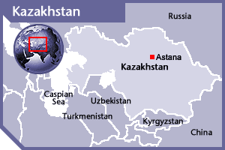

KAZAKHSTAN
PERMANENT OBSERVER

Date of Entry: February 22, 1996
National Holiday: December 16
Capital: Astana
Type of Government: Constitutional Republic
Head of State: President Nursultan Abishevich Nazarbayev (December 1, 1991)
Head of Government: Prime Minister Bakhytzhan Abdiruly (September 16, 2016)
Minister of Foreign Affairs: Kairat Abdrakhmanov (December 30, 2016)
Permanent Observer: Ambassador Kairat Umarov (January 4, 2013)

ECONOMIC INDICATORS | 2010 | 2011 | 2012 | 2013 | 2014 | 2015 | 2016
Population (in millions) | 16.32 | 16.56 | 16.79 | 17.04 | 17.29 | 17.54 | 17.79
GDP (US$ in billions) | 148.047 | 192.627 | 207.999 | 236.635 | 221.416 | 184.388 | 133.657
GDP per capita (US$) | 9,070.6 | 11,634.4 | 12,387.2 | 13,890.8 | 12,806.5 | 10,508.9 | 7,510.07
Source: www.tradingeconomics.com | The World Bank Group

FOREIGN RELATIONS POLICY:
- Kazakhstan’s foreign policy main goals are to protect national interests; provide favorable conditions for political and economic development; develop cooperation programs with leading countries and regions; improve cooperation with international organizations; strengthen democratic principles; contribute to global and regional security and stability while confronting new threats such as, terrorism, drug trafficking, and organized crime; participate in the processes of regional and global economic integration; promote democracy as well as social and human development; and protect the environment and sustain development.
- Economic integration also remains among the main priorities of Kazakhstan’s foreign policy and an essential part of the country’s vision of economic development. As the one developing exporter of energy resources Kazakhstan has declared itself as the active participant of the world efforts on maintenance of energy safety and a leader of global negotiations on issues of the Movement of non-proliferation and disarmament.
- Kazakhstan has established active cooperation with the majority of North American, European, and Asian countries as well as their chief regional organizations, including: the Organization for Security and Cooperation in Europe (OSCE); the Economic Cooperation Organization (ECO); and the Organization of the Islamic Conference (OIC). It is an active participant in the North Atlantic Treaty Organization's (NATO) Partnership for Peace program. Kazakhstan has developed five inter-religious and interethnic dialogue at all levels.
- Kazakhstan has also engaged in regional security dialogue with the Association of Southeast Asian Nations (ASEAN). In June, 2011, Kazakhstan became the chairman of the Foreign Ministers’ Council of the Organization of Islamic Cooperation, and in 2012 hosted a ministerial meeting for the Conference on Interaction and Confidence Building Measures in Asia. Kazakhstan is also a member of the Collective Security Treaty Organization and the Shanghai Cooperation Organization.
- Kazakhstan as member of the United Nations (UN) favors a comprehensive and continued international effort, led by the UN to bring lasting peace, economic recovery, and humanitarian relief to Afghanistan and this situation has become one of Kazakh’s priorities on its foreign policy agenda exerting serious efforts to facilitate its reconstruction which plays a crucial role in the long-term security and stability in Central Asia.

COMMISSION ON COOPERATION OF THE REPUBLIC OF KAZAKHSTAN WITH INTERNATIONAL ORGANIZATIONS
- The Commission on cooperation of the Republic of Kazakhstan with international organizations was established on December 11, 2009 as an advisory body of the Ministry of Foreign Affairs which main function is to develop recommendations on cooperation of the Government agencies of the Republic of Kazakhstan with international organizations and participation in international treaties.
- According to its rules, the main objectives and functions of the Commission are to draft recommendations on the following issues:
- Proposals on participation and cooperation of Kazakhstan within international organizations and universal international treaties and on ensuring the most effective implementation of commitments, including financial;
- Proposals on accession, participation and withdrawal of the Republic of Kazakhstan from international organizations and international treaties based on the proposals from the Government agencies;
- Proposals on ensuring observance of certain conditions (legislative, financial and other) for accession and participation of the Republic of Kazakhstan in international organizations and international treaties.
INVOLVEMENT WITH THE AMERICAS:
- Kazakhstan has diplomatic representations with embassies in Brazil, Canada, Cuba and the United States, and diplomatic relations with Argentina, Chile, Colombia, Costa Rica, Guatemala, Mexico, Panama, Peru, and Venezuela.
- In From January to May, 2013, Kazakhstan established diplomatic relations with Bolivia, Ecuador, the Commonwealth of Dominica, St. Lucia, Guyana, St. Kitts and Nevis and Suriname by signing of a Joint Communique on the level of permanent representatives of the Republic of Kazakhstan and these countries to the United Nations in New York. Kazakhstan is especially interested in developing bilateral cooperation with South American countries in the field of energy, economy, trade and tourism.

CASH CONTRIBUTIONS TO THE OAS 2010-2016:
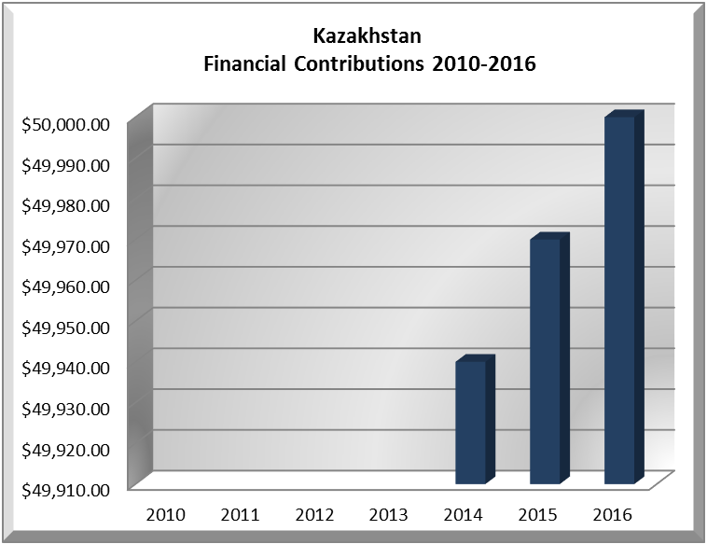
YEAR | KAZAKHSTAN | P.O. FINANCIAL CONTRIBUTIONS | %
2010 |  | $15,781,991.00 | 0.00%
2011 |  | $15,962,757.00 | 0.00%
2012 |  | $13,239,105.00 | 0.00%
2013 |  | $16,926,686.00 | 0.00%
2014 | $49,940.00 | $10,999,882.00 | 0.45%
2015 | $49,970.00 | $17,489,205.00 | 0.29%
2016 | $50,000.00 | $14,048,254.00 | 0.36%
Total US$ | $149,910.00 | $104,447,880.00 | 0.14%

KAZAKHSTAN CONTRIBUTIONS:
YEAR | PROJECTS |  | FINANCIAL CONTRIBUTIONS  IN US$ | IN-KIND CONTRIBUTIONS  IN US$
2014 | Inter-American Commission of Women (CIM) - Virtual Training Course "Gender Justice for the Rights of Women" |  | $24,970.00
2014 | Executive Secretariat for Integral Development / Department of Sustainable Development - Strengthening Decision Support Systems for Disaster Risk Management in Central America and the Caribbean |  | $24,970.00
SUBTOTAL |  |  | $49,940.00
2015 | Secretariat for Political Affairs / Department of Electoral Cooperation and Observation - Fund for OAS Electoral Observation: Methodologies, EOMs and Implementation of Recommendations |  | $24,985.00
2015 | Executive Secretariat for Integral Development / Department of Human Development and Education - Building a Sustainable Americas Network for Education and Development |  | $24,985.00
SUBTOTAL |  |  | $49,970.00
2016 |  | The Department of Electoral Cooperation and Observation (64C)  EOM 2016 Peru | $15,000
 |  | Department of Sustainable Development (74I)  Int. Disaster Assistance Phase I (CARICOM) | $35,000
SUBTOTAL |  |  | $50,000
TOTAL |  |  | $149,910.00

SOURCES:
GOVERNMENT OF THE REPUBLIC OF KAZAKHSTAN  http://en.government.kz/  MINISTRY OF FOREIGN AFFAIRS OF THE REPUBLIC OF KAZAKHSTAN  http://www.mfa.kz/index.php/en/ | OFFICIAL SITE OF THE PRESIDENT OF THE REPUBLIC OF KAZAKHSTAN  http://www.akorda.kz/index.php  EMBASSY OF THE REPUBLIC OF KAZAKHSTAN TO THE UNITED STATES  http://www.kazakhembus.com/

This page was last updated on July 5, 2017.

