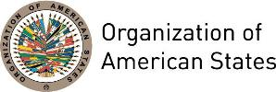

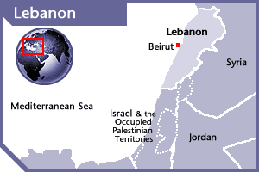
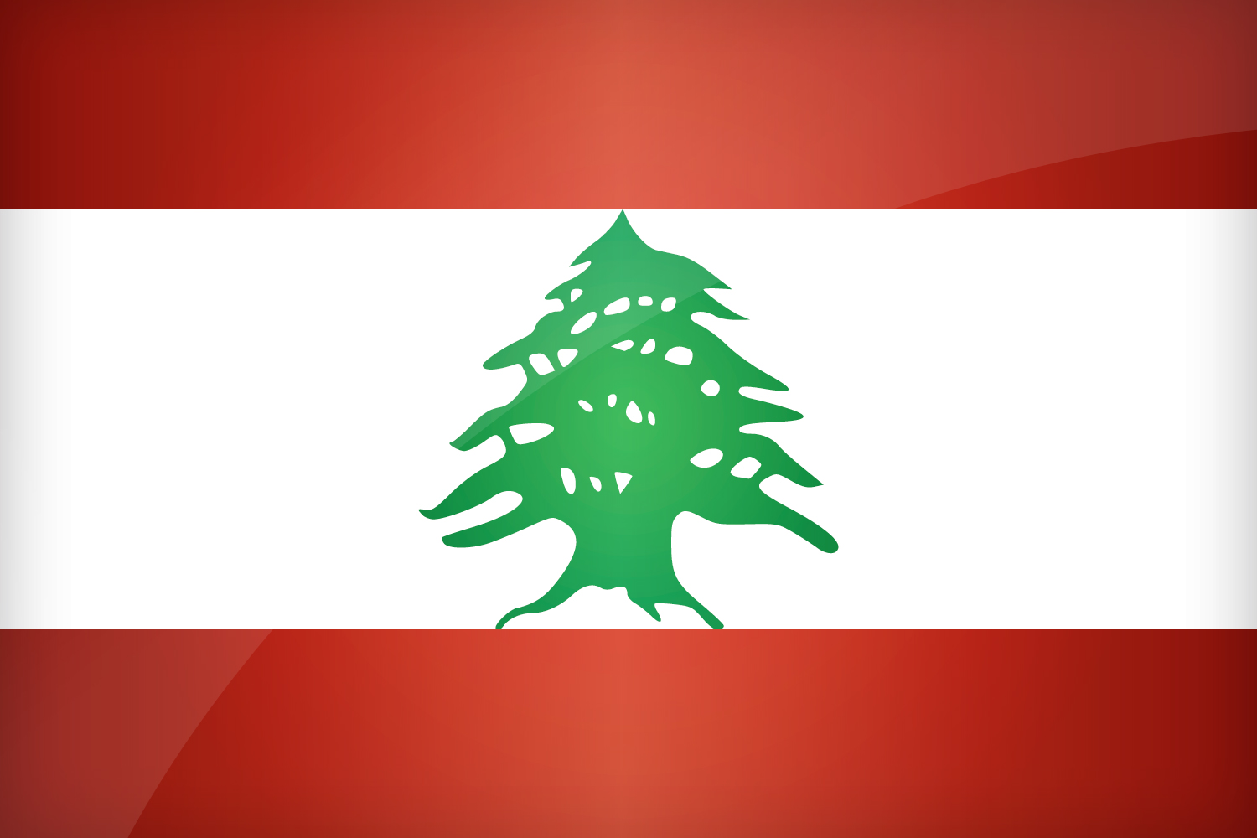

LEBANON
PERMANENT OBSERVER
Date of Entry: April 5, 2001
National Holiday: November 22
Capital: Beirut
Type of Government: Republic
Head of State: President Michel Naim Aoun (October 31, 2016)
Head of Government: Prime Minister Saad Al-Harir (December 18, 2016)
Ministers of Foreign Affairs & Emigrants: Gebran Gerge Bassil (Feburary 14, 2014)
Permanent Observer: Ambassador Carla Jazzar
ECONOMIC INDICATORS | 2010 | 2011 | 2012 | 2013 | 2014 | 2015 | 2016
Population (in millions) | 4.25 | 4.34 | 4.38 | 4.42 | 4.47 | 4.51 | 4.54
GDP (US$ in billions) | 38.01 | 40.1 | 43.2 | 44.35 | 45.73 | 47.1 | 47.53
GDP per capita (US$) | 8,763.8 | 8,734.9 | 8,787.95 | 8,406.29 | 8,161.46 | 8,046 | 7914
Source: www.tradingeconomics.com World Bank

FOREIGN RELATIONS POLICIES:
- The foreign policy of Lebanon reflects its geographic location, the composition of its population, and its reliance on commerce and trade.
- Lebanon's foreign and internal policies have been heavily influenced by Syria.
- Lebanon is member of the United Nations since 1945. Following the July/August 2006 crisis in the country the Council enhanced the Force and decided that in addition to the original mandate (The United Nations Interim Force in Lebanon), monitor the cessation of hostilities; accompany and support the Lebanese armed forces as they deploy throughout the south of Lebanon; and extends its assistance to help ensure humanitarian access to civilian populations and the voluntary and safe return of displaced persons.
- Lebanon has bilateral trade agreements with several Arab states and is working toward accession to the World Trade Organization. Lebanon enjoys good relations with most other Arab countries, and hosted an Arab League Summit in March 2002 for the first time in more than 35 years. Lebanon also is a member of the Organization of Islamic Cooperation and maintains a close relationship with Iran, largely centered on Shia Muslim links. Lebanon is a member of the Francophone countries and hosted the Francophone Summit in October 2002 and the Francophone Games in 2009.
- The World Bank supports Lebanon in a wide range of sectors, including in emergency reconstruction and rehabilitation; municipal development and infrastructure; revenue enhancement; and administrative rehabilitation; agriculture and irrigation; solid waste and environmental reform; vocational and technical education; education and health; roads; power; community development; water and wastewater; urban transport; and protection of cultural heritage.

INVOLVEMENT WITH THE AMERICAS:
- Lebanon maintains embassies in Argentina, Brazil, Canada, Chile, Colombia, Cuba, Mexico, United States of America, Uruguay and Venezuela.

SOURCES:
THE PRESIDENCY OF THE REPUBLIC  http://www.presidency.gov.lb/English/Pages/default.aspx  MINISTRY OF FOREIGN AFFAIRS AND EMIGRANTS OF THE REPUBLIC OF LEBANON  http://www.foreign.gov.lb/ | EMBASSY OF LEBANON IN THE UNITED STATES  http://www.lebanonembassyus.org/  WORLD BANK – TRADING ECONOMICS  www.tradingeconomics.com

This page was last updated on July 11, 2017.

