
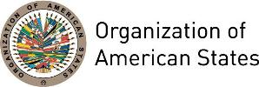

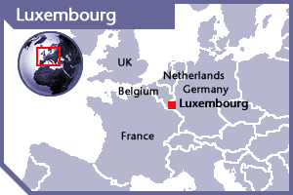

LUXEMBOURG
PERMANENT OBSERVER

Date of Entry: February 4, 2004
National Holiday: June 23
Capital: Luxembourg
Type of Government: Constitutional Monarchy
Head of State: H.R.H. Grand Duke Henri (October 7, 2000)
Head of Government: Prime Minister Xavier Bettel (October 20, 2013)
Minister of Foreign and European Affairs, Minister of Immigration and Asylum: Jean Asselborn (December 3, 2013)
Permanent Observer: Sylvie Lucas (August 25, 2016)

ECONOMIC INDICATORS | 2010 | 2011 | 2012 | 2013 | 2014 | 2015 | 2016
Population (in millions) | 0.51 | 0.52 | 0.53 | 0.54 | 0.56 | 0.57 | 0.58
GDP (US$ in billions) | 53.212 | 60.005 | 56.678 | 61.808 | 66.298 | 58.048 | 59.948
GDP per capita (US$) | 104,965.306 | 115,761.5 | 106,749014 | 113,751.8 | 119,172.742 | 101,909.822 | 102,831.321
Source: www.tradingeconomics.com World Bank

FOREIGN RELATIONS POLICIES:
- Luxembourg's foreign policy is committed to multilateralism, especially in the field of international trade by resisting protectionist tendencies and fighting against barriers to trade in order to foster economic development.
- Luxembourg holds a non-permanent seat in the United Nations Security Council for the period 2013-2014.
- Luxembourg’s cooperation aims are primarily to contribute to implementing the Millennium Development Goals (MDGs) by 2015 and the post-2015 Development Agenda. The general strategy and principles of Luxembourg Development Cooperation are complemented by ten sector strategies covering the main areas of Luxembourg’s global cooperation, namely: health, humanitarian action, agriculture and food security, local development, water and sanitation, education, training and employability, environment protection, climate change, gender, governance and microfinance.
- Luxembourg belongs to a number of international organizations, including the United Nations, North Atlantic Treaty Organization, Euro-Atlantic Partnership Council, Organization for Security and Cooperation in Europe, Organization for Economic Cooperation and Development, International Monetary Fund, World Bank, and World Trade Organization.

DEVELOPMENT COOPERATION
- The Ministry for Development Cooperation and Humanitarian Affairs is responsible for international development cooperation.
- From 2013 to 2018, the Government of Luxembourg will allocate 1% of its GNI to official development assistance (ODA). This amounted to approximately €323 million in 2013.
- Its cooperation programs are based on the principles of the Global Partnership for Effective Development Cooperation as specificed in Busan in 2011: 1) The use of national systems; 2) Taxation and the mobilization of internal resources; 3) Triangular and south-south cooperation; 4) Cooperation with the private sector in partner countries; and 5) Cooperation with civil society in partner countries.
- Luxembourg has identified nine partner countries as recipients of its cooperation programs: Burkina Faso, Cape Verde, Mali, Niger, Senegal, Laos, Vietnam, El Salvador and Nicaragua. 17% of its ODA was aimed at Central America in 2013.
- The government of Luxembourg and each of the respective partner countries have adopted an Indicative Cooperation Programme (ICP), which is a multi-annual program that defines the main areas of cooperation (sectors, geographic areas, terms and conditions of intervention) and the multi-year budget set aside for each program.

INVOLVEMENT WITH THE AMERICAS:
- Luxembourg has diplomatic relations with all OAS Member States and has embassies in Nicaragua and the United States of America.

CASH CONTRIBUTIONS 2008-2016:
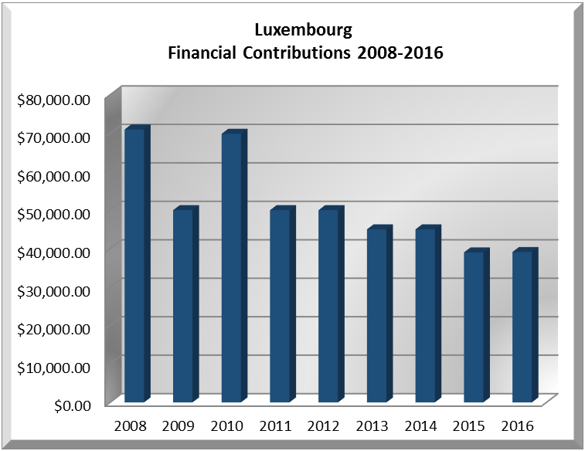
YEAR | LUXEMBOURG | P.O. FINANCIAL CONTRIBUTIONS | %
2008 | $70,979.00 | $22,684,500.00 | 0.31%
2009 | $49,989.00 | $20,318,115.00 | 0.25%
2010 | $69,836.00 | $15,781,991.00 | 0.44%
2011 | $49,989.00 | $15,766,616.00 | 0.32%
2012 | $49,989.00 | $13,239,105.00 | 0.38%
2013 | $45,000.00 | $16,926,000.00 | 0.27%
2014 | $44,989.00 | $10,999,882.00 | 0.41%
2015 | $38,984.00 | $17,489,205.00 | 0.22%
2016 | $39,095.00 | $14,048,254.00 | 0.28%
Total US$ | $458,850.00 | $147,253,668.00 | 0.31%

LUXEMBOURG CONTRIBUTIONS:
YEAR |  | PROJECTS | FINANCIAL CONTRIBUTIONS  IN US$ | IN-KIND CONTRIBUTIONS  IN US$
2004 |  | Department of Democratic and Political Affairs (DDPA)- Inter-American Forum on Political Parties | $63,880.00
SUBTOTAL |  |  | $63,880.00
2008 |  | Inter-American Commission on Human Rights (IACHR) – Project to Protect Human Rights in the Caribbean | $70,979.00
SUBTOTAL |  |  | $70,979.00
2009 |  | Inter-American Commission on Human Rights (IACHR) – Strengthening Access to Justice in the Americas | $49,989.00
SUBTOTAL |  |  | $49,989.00
2010 |  | The Executive Secretariat of the Inter-American Commission on Human Rights (IACHR) - Rapporteurship on the Rights of the Child | $64,989.00
 |  | Department of Electoral Cooperation and Observation (DECO) - OAS Electoral Observation Mission to Haiti - Second Round | $4,847.00
SUBTOTAL |  |  | $69,836.00
2011 |  | Executive Secretariat for Integral Development / Department of Economic Development, Trade and Tourism – Small Tourism Enterprises Network | $49,989.00
SUBTOTAL |  |  | $49,989.00
2012 |  | Civil Registry and Identity Project of the Organization of Eastern Caribbean States (OECS) PUICA | $49,989.00
SUBTOTAL |  |  | $49,989.00
2013 |  | Reconstruction of Civil Records in Colombia, Guatemala and Peru within the Universal Civil Identity Program of the Americas (PUICA) | $45,000.00
SUBTOTAL |  |  | $45,000.00
2014 |  | Secretariat for Political Affairs / Department of Electoral Cooperation and Observation - Electoral Observation Mission for Presidential and Legislative Elections in Costa Rica and Presidential Elections in El Salvador (February 2, 2014) | $44,989.00
SUBTOTAL |  |  | $44,989.00
2015 |  | Secretariat for Political Affairs / Department of Electoral Cooperation and Observation - Electoral Observation Mission El Salvador (Legislative Assembly, the Central American Parliament, and Members of the Municipal Councils, March 1, 2015) | $38,984.00
SUBTOTAL |  |  | $38,984.00
2016 | The Department of Electoral Cooperation and Observation (64C)  EOM 2016 Dominican Republic |  | $39,095.00
SUBTOTAL |  |  | $39,095.00
TOTAL |  |  | $522,730.00

SOURCES:
COUR GRAND-DUCALE DE LUXEMBOURG  www.monarchie.lu  MINISTÈRE DES AFFAIRES ÉTRANGÈRES  Grand-Duché de Luxembourg  http://www.mae.lu/ | GOUVERNEMENT DU GRAND-DUCHÉ DE LUXEMBOURG  http://www.gouvernement.lu/  EMBASSY OF LUXEMBOURG IN WASHINGTON D.C.  http://washington.mae.lu/en

This page was last updated on July 5, 2017.

