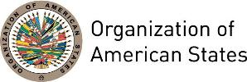

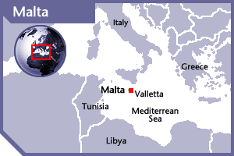
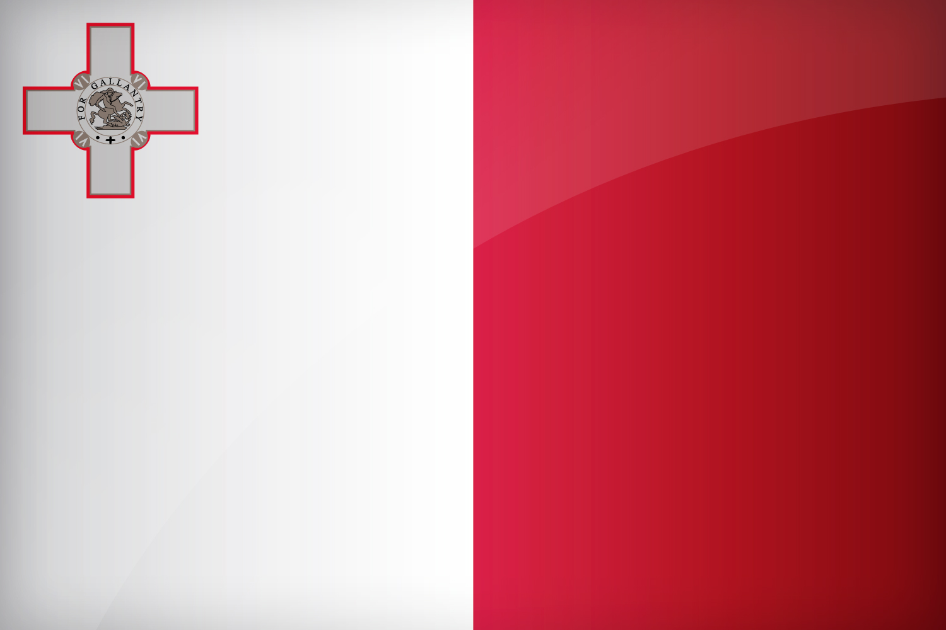

MALTA
PERMANENT OBSERVER

Date of Entry: September 21, 2011
National Day: 21 September
Capital: Valleta
Type of Government: Republic
Head of State: President Marie-Louise Coleiro Preca (April 1, 2014)
Head of Government: Prime Minister Joseph Muscat (March 11, 2013)
Minister of Foreign Affairs: Carmelo Abela (June 9, 2017)
Permanent Observer: Ambassador Keith Azzopardi

ECONOMIC INDICATORS | 2010 | 2011 | 2012 | 2013 | 2014 | 2015 | 2016
Population (in millions) | 0.41 | 0.41 | 0.41 | 0.42 | 0.42 | 0.43 | 0.43
GDP (US$ in billions) | 8.74 | 9.5 | 9.2 | 10.13 | 11.18 | 10.29 | 10.95
GDP per capita (US$) | 21,087.8 | 22,821.84 | 21,930 | 23,930 | 26,181.2 | 23,819 | 25,058
Source: www.tradingeconomics.com World Bank

FOREIGN RELATIONS:
- The Ministry for Foreign Affairs ensures that Malta’s foreign policy objectives with respect to the European Union, bilateral relations; regional and global issues are pursued. The Ministry also coordinates the negotiation and conclusion of bilateral agreements. To achieve these objectives the Government of Malta has set forth the following goals:
- Ensuring active participation in the European Union’s Common Foreign and Security Policy (CFSP).
- Maintaining and enhancing Malta’s relations with international organizations, including the United Nations and its Agencies and the Commonwealth.
- Through Malta’s Overseas Development Policy, addressing poverty through development, targeting specific action areas such as climate change, Information, Communication and Technology (ICT) for development and democratization.
- Participating in election observations missions organized by the European Union (EU) and other international organizations.
- Ensuring active participation in regional forums and initiatives of direct relevance to the Mediterranean region, namely the Euro-Mediterranean Process, the European Neighborhood Policy, the Western Mediterranean (5+5) Dialogue and the Med Forum.
- Promoting the enhancement of dialogue between the EU and the Arab League through concrete initiatives.
- Since its accession to the European Union (EU) in 2004 and the Eurozone in 2008, Malta has devoted considerable energy and resources to developing its relations with EU institutions and with EU member states. Malta will hold the EU presidency in 2017.
- Foreign policy focuses on Malta’s relations with its immediate neighbors, in particular Libya, Egypt, Tunisia and Algeria and others further afield such as the United States, Russia and China with whom Malta has traditionally always enjoyed very good relations.
- In February 2008, Malta hosted the first EU-Arab League Ministerial meeting and is now home to the EU-Arab League Liaison Office. More recently, Malta has pursued enhanced engagement with India, China and the Middle East, with an emphasis on business and commercial relations
- The Foreign Ministry monitors developments in the long-standing Middle East conflict and contributes to the formulation of specific policy stances through effective participation in the pertinent European Union (EU) and United Nations (UN) structures. In addition Malta participates actively in the Council of Europe, the Organization for Security and Cooperation in Europe (OSCE), the Commonwealth, the Union for the Mediterranean (UfM); and Malta rejoined North Atlantic Treaty (NATO) Organization’s Partnership for Peace in 2008.
- Malta’s Foreign Policy Objectives for cooperation include: Address international aspects of illegal immigration; contribute to further development and good governance within the Commonwealth; promote stronger political and economic relations with the countries of Maltese migration; work with the international Community to defeat terrorism and extremism; promote democratization and further respect for the rule of law and human rights; promote respect of the International Rule of Law and the prevention and peaceful resolution of conflict; address issues like Energy Security, Climate Change, Small States, Aging and Children; and maintain a special focus on furthering dialogue, peace, stability and prosperity in the Mediterranean and the Middle East.
MALTA’S INTERNATIONAL DEVELOPMENT COOPERATION (IDC):
- International Development Cooperation (IDC) is within the portfolio of the Maltese Ministry of Foreign Affairs (MFA).
- Its primary objective is poverty reduction with the complementary aims of promoting democracy, good governance and greater respect for human rights to ensure the stability and development of developing countries.
- The ODA is channeled through three main mechanisms: 1) financial contributions to the European Union budget’s external assistance programs; 2) financial contributions to the European Development Fund; and 3) financial contributions to bilateral or multilateral organizations on projects related to climate change, biodiversity and sustainable development.
- Geographically, Maltese development policy focuses on: the Mediterranean, particularly Palestine; the Sub-Saharan Africa, especially the Horn of Africa and the Sudan; the Small Island States and the Commonwealth.
- Thematically, the main aim of Malta’s development policy is to contribute to the attainment of the Millennium Development Goals (MDGs). Priority sectors include:

- Democratization and Good Governance
- Migration and Asylum
- Education, Training and Human Capacity Development
- Health
- Gender Equality
- Vulnerable Groups
- Climate Change
- Water
- Information and Communication Technologies
- Trade and Investment

INVOLVEMENT WITH THE AMERICAS:
- Malta has diplomatic relations with most of the OAS Member States with the exception of the Dominican Republic, Haiti, and Suriname. Malta holds an embassy in Washington D.C. (US), and has a consul-general representative in Toronto, Canada.
- Malta has honorary consular representatives in the following countries: Argentina, Bahamas, Bolivia, Brazil, Canada, Chile, Colombia, Costa Rica, Ecuador, Guatemala, Nicaragua, Panama, Paraguay, Peru, United States of America, and Uruguay.
- Malta is represented through its Ministry of Foreign Affairs to the following countries: Antigua and Barbuda, Barbados, Belize, Dominica, El Salvador, Grenada, Guyana, Honduras, Jamaica, Mexico, Saint Lucia, Saint Kitts and Nevis, Saint Vincent and the Grenadines, Trinidad and Tobago and Venezuela.

SOURCES:
PRESIDENT OF THE REPUBLIC OF MALTA WEBSITE  http://president.gov.mt/home?l=1  PRIME MINISTER OFFICE WEBSITE  https://opm.gov.mt/en/Pages/primeministerhome.aspx  GOVERNMENT OF MALTA  www.gov.mt/en/Pages/gov.mt%20homepage.aspx  MINISTRY OF FOREIGN AFFAIRS OF MALTA  http://www.foreign.gov.mt/ | EMBASSY OF MALTA IN WASHINGTON D.C.  http://www.foreign.gov.mt/default.aspx?MDIS=504  WORLD BANK – TRADING ECONOMICS  www.tradingeconomics.com

This page was last updated on July 11, 2017.

