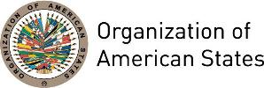

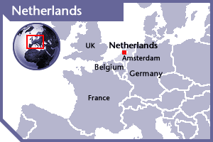
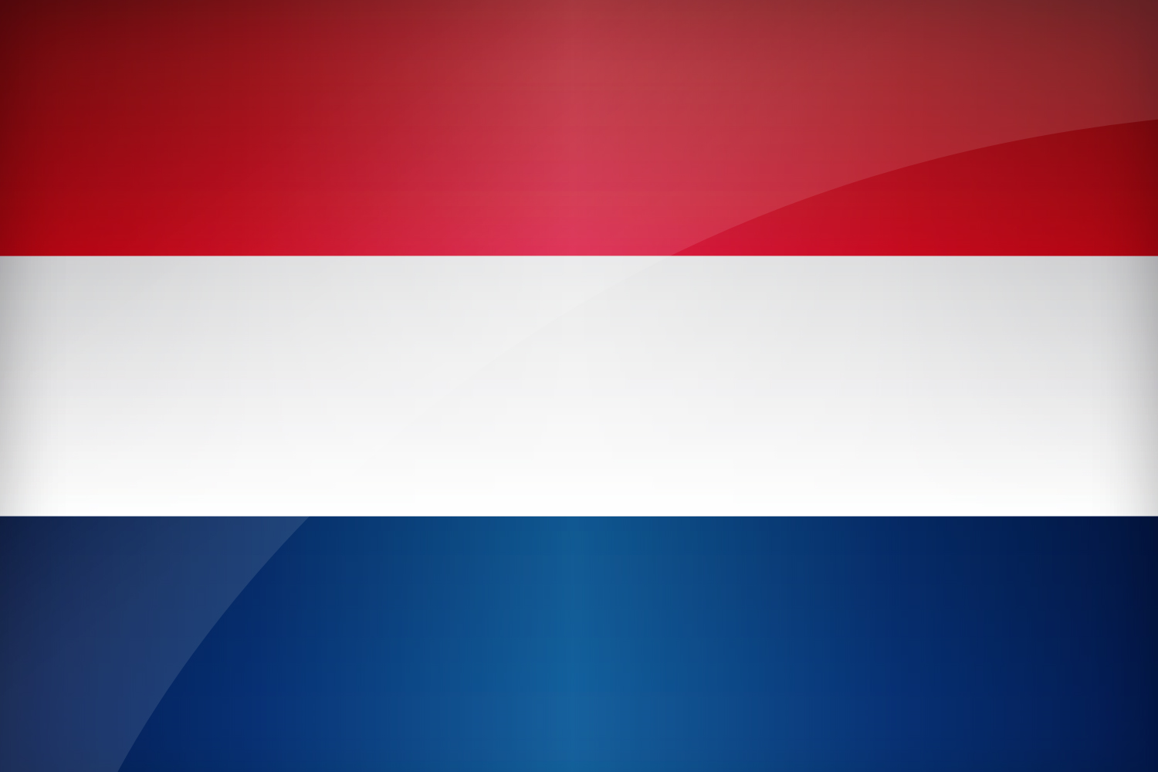

NETHERLANDS
PERMANENT OBSERVER

Date of Entry: March 15, 1972

National Holiday: April 30

Capital: Amsterdam

Type of Government: Constitutional Monarchy
Head of State: King Willem-Alexander (since April 30, 2013)
Prime Minister, Minister of General Affairs: Mark Rutte (October 14, 2010 (currently in third term)
Minister of Foreign Affairs: Halbe Zijlstra (October 26, 2017)
Permanent Observer: Ambassador Henne Schuwer (September 7, 2015)

ECONOMIC INDICATORS | 2010 | 2011 | 2012 | 2013 | 2014 | 2015 | 2016
Population (in millions) | 16.62 | 16.69 | 16.80 | 16.80 | 16.87 | 16.94 | 17.02
GDP (US$ in billions) | 836.39 | 893.757 | 828.947 | 866.68 | 879.635 | 750.318 | 770.845
GDP per capita (US$) | 50,338.255 | 53,540.605 | 49,474.706 | 51,574.789 | 52,157.407 | 44,292.885 | 45,294.78
Source: www.tradingeconomics.com World Bank

FOREIGN RELATIONS POLICIES:
- The Ministry of Foreign Affairs coordinates and carries out Dutch foreign policy. The Minister of Foreign Affairs is assisted by the Minister for Foreign Trade and Development Cooperation, in the formulation and implementation of foreign aid, trade and development cooperation policy.
- In its foreign policy the government aims to reinforce the following three pillars: security, global prosperity and freedom. Its foreign policy priorities also include addressing global poverty and inequality, climate change and other environmental threats, energy security, international terrorism, proliferation of weapons of mass destruction and human trafficking; in addition the Netherlands has a long history of promoting human rights worldwide as an essential part of its foreign policy.
- The Netherlands is a significant aid donor spending approximately 0.65 per cent of GDP to Overseas Development Assistance of which its majority has been granted through multilateral organizations. The current government has committed itself to raising ODA-levels back to 0.7 per cent of GDP by 2021. The Netherlands distributes aid in four ways: (1) bilaterally to partner countries; (2) through multilateral channels, such as the Inter-American Development Bank (IADB), the Organization of American States (OAS), the World Bank, and the United Nations (UN); 3) through civil society organizations; and 4) through partnerships with the private sector.
- The Netherlands is host to seven international legal organizations: the Permanent Court of Arbitration, the International Court of Justice, The Hague Conference on Private International Law, the Iran-US Claims Tribunal, the International Criminal Tribunal for the former Yugoslavia, the International Criminal Court, and the Special Tribunal for Lebanon. The first six are situated in The Hague, as is the EU's criminal intelligence agency, Europol and the EU’s judicial cooperation agency, Eurojust. It is also host to the Organization for the Prohibition of Chemical Weapons (OPCW).

INVOLVEMENT WITH THE AMERICAS:
- Partly due to the location of the autonomous countries of the Kingdom of the Netherlands in the region, is the Western Hemisphere of enormous importance to the Netherlands.
- The Netherlands has diplomatic relations with all the OAS Member States and maintains embassies in 14 countries of the Americas: Argentina, Brazil, Canada, Chile, Colombia, Costa Rica, Cuba, Dominican Republic, Mexico, Peru, Suriname, Trinidad and Tobago, United States of America, and Venezuela.
- The Dutch Government has gradually phased out its bilateral assistance to Latin American countries and has increased contributions to multilateral funds to prioritize sustainable development, climate change mitigation, access to education, and minority and women’s rights in the region.

COOPERATION AGREEMENTS WITH THE OAS:
- Cooperation with the OAS includes support to the OAS Mission to Support the Peace Agreement and Peace Process in Colombia (2011-2017), support for the OAS Inter-American Program of Judicial Facilitators (2012-2017) and support for the Inter-American Commission on Human Rights (2011-2020).

CASH CONTRIBUTIONS 2005-2016:
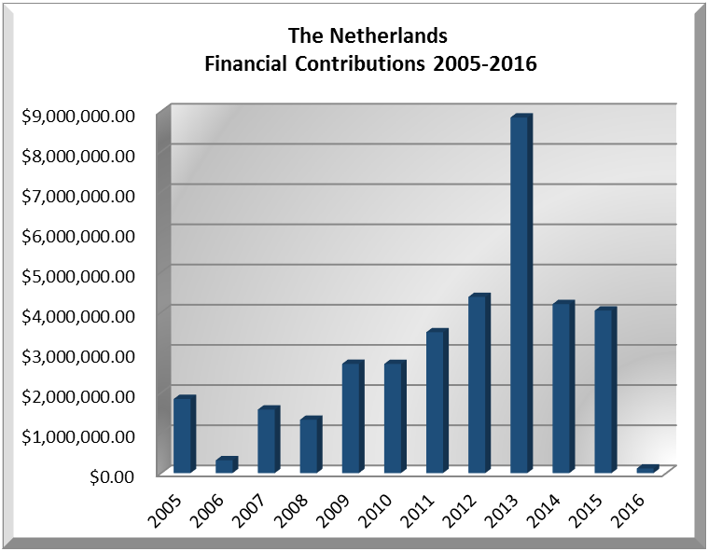
YEAR | NETHERLANDS | P.O. FINANCIAL CONTRIBUTIONS | %
2005 | $1,844,109.00 | $11,650,039.00 | 15.83%
2006 | $318,577.00 | $19,060,470.00 | 1.67%
2007 | $1,580,644.00 | $1,573,778.00 | 100.44%
2008 | $1,325,597.32 | $22,684,500.00 | 5.84%
2009 | $2,717,219.00 | $20,318,115.00 | 13.37%
2010 | $2,715,110.00 | $15,781,991.00 | 17.20%
2011 | $3,504,328.00 | $15,692,757.00 | 22.33%
2012 | $4,383,261.22 | $13,239,105.00 | 33.11%
2013 | $8,847,417.00 | $16,926,686.00 | 52.27%
2014 | $4,203,709.00 | $10,999,882.00 | 38.22%
2015 | $4,042,785.00 | $17,489,205.00 | 23.12%
2016 | $114,305.00 | $14,048,254.00 | 0.81%
Total US$ | $35,597,061.54 | $179,464,782.00 | 19.84%

NETHERLANDS CONTRIBUTIONS:
YEAR | PROJECTS |  | FINANCIAL CONTRIBUTIONS  IN US$ | IN-KIND CONTRIBUTIONS  IN US$
1999 | Inter-American Children’s Institute (IIN)-International Conference About Adoption |  | $32,413.00
1999 | Unit for the Promotion of Democracy (UPD) |  | $71,785.00
SUBTOTAL |  |  | $104,198.00
2000 | Unit for the Promotion of Democracy (UPD) |  | $711,205.00
SUBTOTAL |  |  | $711,205.00
2001 | Unit for the Promotion of Democracy (UPD)- Guatemala ATE Plan |  | $681,156.00
2001 | Unit for the Promotion of Democracy (UPD)- Political Management of Guatemala |  | $228,563.00
SUBTOTAL |  |  | $909,719.00
2002 | Unit for the Promotion of Democracy (UPD)- Technical Assistance Plan for Guatemala |  | $655,455.00
2002 | Unit for the Promotion of Democracy (UPD) – Political Management, Guatemala |  | $168,671.00
2002 | USDE– Strategic Plan of Action for the San Juan River Basin |  | $78,015.00
2002 | USDE– Caribbean Dialogue on Water and Climate (DWC) |  | $149,145.00
2002 | USDE– Flood Vulnerability Reduction and Development of Early Warning Systems in Minor River Basins in Central America (SVP) |  | $55,849.00
SUBTOTAL |  |  | $1,107,135.00
2003 | Programa de Apoyo al Tribunal Supremo Electoral de Guatemala – 2003 Elections |  | $429,594.00
2003 | Unit for the Promotion of Democracy (UPD) – Electoral Observation Mission to Guatemala, 2003 |  | $100,000.00
2003 | Unit for the Promotion of Democracy (UPD) |  | $5,436.00
2003 | Unit for the Promotion of Democracy (UPD)/Gerencia Política Guatemala |  | $151,262.00
2003 | Unidad de Desarrollo Sostenible y Medio Ambiente |  | $25,005.00
SUBTOTAL |  |  | $711,297.00
2004 | Department of Democratic Sustainability and Special Missions (DSDSM)- Mission to Support the Peace Process in Colombia (MAPP) |  | $974,283.00
SUBTOTAL |  |  | $974,283.00
2005 | Permanent Secretariat for the Inter-American Commission of Women – Participation & Gender Equality and Public Finance |  | $100,000.00
2005 | Department of Democratic and Political Affairs (DDPA)- Inter-American Forum on Political Parties |  | $10,004.00
2005 | Department of Electoral Cooperation and Observation (DECO), Electoral Observation Mission Bolivia |  | $94,955.00
2005 | Department of Democratic Sustainability and Special Missions (DSDSM)- Mission to Support the Peace Process in Colombia (MAPP) |  | $1,500,000.00
2005 | Political Management Guatemala |  | $139,150.00
SUBTOTAL |  |  | $1,844,109.00
2006 | Executive Secretariat for Integral Development (SEDI)- Support to ministerial Meeting on Sustainable Development |  | $150,511.00
2006 | Secretariat for Political Affairs (SPA)- Promotion of Democracy MOE 2006 Nicaragua |  | $98,066.00
2006 | Inter-American Commission on Women (CIM)- Participation and Gender Equity in Nicaragua |  | $70,000.00
SUBTOTAL |  |  | $318,577.00
2007 | Department of Electoral Cooperation and Observation – MAPP/OAS Mission to Support |  | $1,234,538.00
2007 | Inter-American Commission on Women (CIM) – Participation & Gender Equality in Public Finance |  | $241,606.00
2007 | Department of Electoral Cooperation and Observation - EOM 2006 Venezuela |  | $97,634.00
SUBTOTAL |  |  | $1,573,778.00
2008 | Department of Democratic Sustainability and Special Missions (DSDMS) - Mission to Support the Peace Process in Colombia (MAPP) |  | $1,234,528.00
2008 | Inter-American Commission of Women (CIM) – Equity and Gender Participation in Public Finance in Municipalities in Nicaragua |  | $84,203.32
2008 | Department of Conferences and Meetings Management (DCMM) |  | $6,866.00
SUBTOTAL |  |  | $1,325,597.32
2009 | Secretariat for Legal Affairs (SLA)– Judicial Facilitators in Nicaragua |  | $346,000.00
2009 | Department of Public Security (DPS) – Support to the Final Phase of Demining in Nicaragua |  | $1,136,692.00
2009 | OAS Good Mission to Support the Peace Process in Colombia (MAPP/OEA); OAS Good Offices Mission in Colombia and Ecuador (MIB/OEA) |  | $1,234,527.00
SUBTOTAL |  |  | $2,717,219.00
2010 | Department of Democratic Sustainability and Special Missions (DSDMS) / Secretariat for Political Affairs - Mission to Support the Peace Process in Colombia (MAPP) |  | $1,399,920.00
2010 | Department of Electoral Cooperation and Observation (DECO) / Secretariat for Political Affairs – Electoral Observation Mission to Colombia |  | $279,680.00
2010 | Department of International Law / Secretariat for Legal Affairs – Judicial Facilitators Nicaragua |  | $263,000.00
2010 | Department of International Law / Secretariat for Legal Affairs – Judicial Facilitators Nicaragua |  | $352,970.00
2010 | Department of International Law / Secretariat for Legal Affairs – Judicial Facilitators Guatemala |  | $419,540.00
SUBTOTAL |  |  | $2,715,110.00
2011 | Department of Democratic Sustainability and Special Missions (DSDMS) / Secretariat for Political Affairs - Mission to Support the Peace Process in Colombia (MAPP) |  | $178,862.00
2011 | Department of Democratic Sustainability and Special Missions (DSDMS) / Secretariat for Political Affairs - Mission to Support the Peace Process in Colombia (MAPP) |  | $2,000,000.00
2011 | Department of International Law / Secretariat for Legal Affairs – Judicial Facilitators Nicaragua |  | $299,970.00
2011 | Department of International Law / Secretariat for Legal Affairs – Judicial Facilitators Nicaragua |  | $199,970.00
2011 | Department of International Law / Secretariat for Legal Affairs – Judicial Facilitators Guatemala |  | $319,960.00
2011 | Department for Electoral Cooperation and Observation / Secretariat for Political Affairs – Electoral Observation Mission to Colombia |  | $103,960.00
2011 | Inter-American Commission on Human Rights/Strategic Plan 2011-2015 |  | $401,606.00
2011 | Executive Secretariat for Integral Development / Department of Human Development, Education and Culture – Scholarships (OAS Partnerships Program for Education and Training): Master’s in Development Studies (2 Scholarships) |  |  | $10,666.00
SUBTOTAL |  |  | $3,504,328.00 | $10,666.00
2012 | Secretariat for Legal Affairs - Inter-American Judicial Facilitators Program – Nicaragua |  | $222,970.00
2012 | Inter-American Commission on Human Rights/Strategic Plan 2011-2015 |  | $248,746.22
2012 | Department of Democratic Sustainability and Special Missions (DSDMS) / Secretariat for Political Affairs - Mission to Support the Peace Process in Colombia (MAPP) |  | $572,154.00
2012 | Secretariat for Legal Affairs - Inter-American Judicial Facilitators Program |  | $1,909,970.00
2012 | Electoral Observation Mission Colombia 2011 |  | $1,615.00
2012 | Department of Democratic Sustainability and Special Missions (DSDMS) / Secretariat for Political Affairs - Mission to Support the Peace Process in Colombia (MAPP)- Basket Fund |  | $1,427,806.00
2012 | The International Institute of Social Studies- University of Rotterdam Onsite OAS Scholarship Program (3 scholarships) |  |  | $16,113.00
SUBTOTAL |  |  | $4,383,261.22 | $16,113.00
2013 | Secretariat for Legal Affairs - Inter-American Judicial Facilitators Program |  | $5,629,080.62
2013 | Department of Democratic Sustainability and Special Missions (DSDMS) / Secretariat for Political Affairs - OAS Strengthening of and Support to Victims and their Organizations in Colombia - MAPP |  | $2,874,930.00
2013 | Inter-American Commission on Human Rights - Strategic Plan 2011-2015 |  | $343,406.59
2013 | 2 Scholarships Awarded with the Support of The International Institute of Social Studies- University of Rotterdam| PAEC - PDSP |  |  | $91,200.00
2013 | 11 Scholarships Awarded with the Support of UNESCO – Institute for Water Education | PAEC-Academic |  |  | $41,580.00
SUBTOTAL |  |  | $8,847,417.21 | $132,780.00
2014 | Inter-American Commission on Human Rights - Strategic Plan 2011-2015 |  | $317,632.00
 | Secretariat for Legal Affairs - Inter-American Judicial Facilitators Program |  | $3,886,077.00
 | The International Institute of Social Studies- University of Rotterdam (2 scholarships awarded) | PAEC - PDSP |  |  | $10,248.00
SUBTOTAL |  |  | $4,203,709.00 | $10,248.00
2015 | Department of Sustainable Democracy and Special Missions (DSDMS) / Secretariat for Political Affairs - Mission to Support the Peace Process (MAPP) in Colombia |  | $649,970.00
 | Inter-American Commission on Human Rights Work Plan 2011-2015 |  | $264,801.00
 | Inter-American Judicial Facilitators Program (Central America) |  | $3,128,014.00
SUBTOTAL |  |  | $4,042,785.00 | $0.00
2016 |  | The Secretariat of the Inter‐American Committee against Terrorism CICTE (84D), Cyber Security | $14,975
 |  | The Department of Effective Public Management (94B),  OAS Fellowship Open Gov. Americas | $54,365
 |  | The Department of Electoral Cooperation and Observation (64C),  EOM 2016 Colombia | $44,965
SUBTOTAL |  |  | $99,330
TOTAL |  |  | $40,158,179.54 | $169,807.00

SOURCES:
GOVERNMENT OF THE NETHERLANDS  http://www.government.nl/  THE ROYAL NETHERLANDS EMBASSY  http://www.nlintheusa.com | WORLD BANK – TRADING ECONOMICS  www.tradingeconomics.com

This page was last updated in December 2017.

