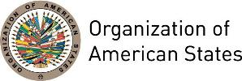

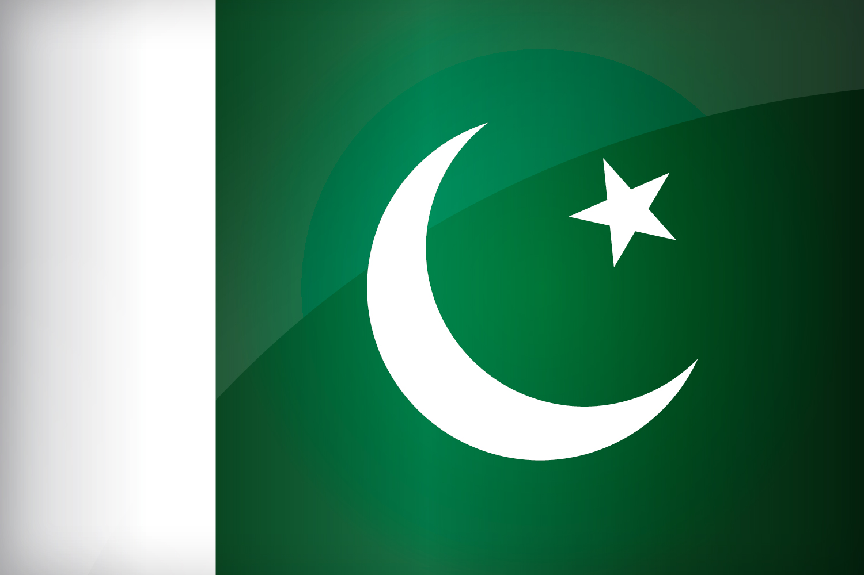
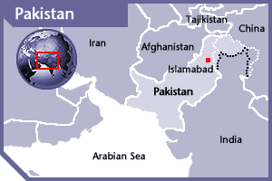

PAKISTAN
PERMANENT OBSERVER

Date of Entry: January 6, 1988
National Holiday: March 23
Capital: Islamabad
Type of Government: Federal Republic
Head of State: President Mamnoon Hussain (September 8, 2013)
Head of Government: Prime Minister Muhammad Nawaz Sharif (June 5, 2013)
Adviser to the Prime Minister on National Security and Foreign Affairs: Sartaj Aziz (June 7, 2013)
Permanent Observer: Ambassador Asad Majeed Khan

ECONOMIC INDICATORS | 2010 | 2011 | 2012 | 2013 | 2014 | 2015 | 2016
Population (in millions) | 169.95 | 173.5 | 177.1 | 180.71 | 184.35 | 189.38 | 193.2
GDP (US$ in billions) | 177.41 | 213.58 | 224.39 | 231.22 | 244.36 | 271.1 | 283.66
GDP per capita (US$) | 1,040 | 1,226 | 1,261 | 1,272 | 1,316 | 1,431 | 1468.2
Source: www.tradingeconomics.com World Bank

FOREIGN RELATIONS POLICIES:
- Pakistan’s foreign policy is primarily directed to seeking peace and stability through international cooperation. Special emphasis is on economic diplomacy to take advantage of the globalization process and face 21st century challenges.
- Pakistan’s foreign policy promotes interstate relations, such as the respect for sovereignty and territorial integrity of all States, non-interference in the internal affairs of other State; non-aggression and peaceful settlement of disputes.
- Foreign policy objectives include: promoting Pakistan as a progressive, moderate, and democratic Islamic country; developing friendly relations with all countries of the world; Safeguarding national security and geo-strategic interests, including Kashmir; consolidating commercial and economic international cooperation, safeguarding the interests of Pakistani Diaspora; and ensuring optimal use of national resources for regional and international cooperation.
- The Afghan Peace Process is another priority for stability in the region. The foreign office focuses special attention in developing a strategy to facilitate the Afghan reconciliation process in the aftermath of American Troops leaving the Afghan soil, and thus the President is committed to ensuring maximum cooperation with the Karzai government.

PAKISTANI DEVELOPMENT COOPERATION:
- Pakistan is mainly a recipient of development aid, given that a significant portion of Pakistanis live in poverty. Ongoing conflict in the Kashmir region and India has also contributed to instability and slows development progress. Internal political conflict further hinders the formation of a foreign development plan or agency.
- The World Bank and the Asian Development Bank are the largest providers of development loans to the country. In bilateral cooperation, the USA, United Kingdom, Japan, and European Commission are the biggest supporters of Pakistan’s development cooperation, especially for: achieving broad-based economic growth focusing on the rural economy, improving governance and consolidating devolution, investing in human capital and delivery of basic social services, targeting the poor and vulnerable, attaining the Millennium Development Goals (MDGs) for sustainable development and poverty reduction, and forging alliances between civil society and the private sector.

INVOLVEMENT WITH THE AMERICAS:
- Pakistan maintains diplomatic relations with all OAS Member States and has established embassies and consulates in Argentina, Brazil, Canada, Chile, Colombia, Cuba, Ecuador, El Salvador, Mexico and the United States.

SOURCES:
PRESIDENCY OF THE ISLAMIC REPUBLIC OF PAKISTAN  http://www.presidentofpakistan.gov.pk/  GOVERNMENT OF PAKISTAN WEBSITE  http://www.pakistan.gov.pk/default.html  MINISTRY OF FOREIGN AFFAIRS, PAKISTAN  http://www.mofa.gov.pk/ | EMBASSY OF THE ISLAMIC REPUBLIC OF PAKISTAN  http://www.embassyofpakistanusa.org/index.php  WORLD BANK – TRADING ECONOMICS  www.tradingeconomics.com

This page was last updated on July 11, 2017

