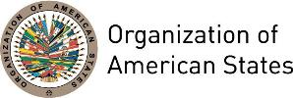

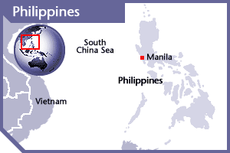
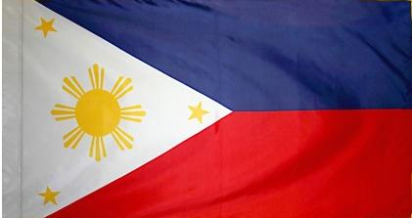

PHILIPPINES
PERMANENT OBSERVER

Date of Entry: August 26, 1999
National Holiday: June 12
Capital: Manila
Type of Government: Republic
Head of Government: President Rodrigo Duterte (June 30, 2016)
Secretary of Foreign Affairs: Alan Peter Cayetano (May 18, 2017)
Permanent Observer: Ambassador Patrick A. Chuasoto (June, 2016)

ECONOMIC INDICATORS | 2010 | 2011 | 2012 | 2013 | 2014 | 2015 | 2016
Population (in millions) | 91.02 | 92.6 | 94.18 | 98.48 | 100.11 | 101 | 103.3
GDP (US$ in billions) | 199.59 | 224.14 | 250.09 | 271.83 | 284.59 | 292.78 | 304.91
GDP per capita (US$) | 2,192.90 | 2,352.5 | 2,581.82 | 2,760.3 | 2,842 | 2,837 | 2,951.1
Source: www.tradingeconomics.com World Bank

FOREIGN RELATIONS POLICIES:
- The Department of Foreign Affairs is the primary agency of the government of Philippines responsible for the pursuit of the state's foreign policy. The three pillars of the Philippine Foreign Policy, include:
- Preservation and enhancement of national security
- Promotion and attainment of economic security
- Protection of the rights and promotion of the welfare and interest of Philippine overseas.
- The Department of Foreign Affairs implements the foreign policy pursuing bilateral, regional and multilateral relations to advance the interest of the Philippines and Philippine citizens. It builds partnerships with national security and development agencies, think-tanks and academia, private sector, media and civil society.
- In the global arena, it works for social justice especially for the poor, human rights and fundamental freedoms, democratic way of life, as well as to secure a world free from serious environmental degradation, transnational crime and proliferation of nuclear weapons.
- In pursuit of these goals, the Department of Foreign Affairs contributes to enhancing national security and protecting territorial integrity and national sovereignty; participates in the national endeavor to sustain development and enhance the Philippines’ competitive edge in a global milieu; protects the rights and promotes the welfare of Philippine citizens overseas and mobilize them as partners in national development; projects a positive image of the Philippines; increases international understanding of Philippine culture; and increases and maximizes human, financial, technological and other resources to optimize the performance of the department.
- Special consideration is given to relations with China, Japan and the United States in the areas of security and economic evolution of East Asia; as well as with the international Islamic community.
- Philippine foreign policy in the context of ASEAN is of special interest for the Government as well as the strengthening of multilateral and inter-regional organizations to promote common interests.
- The Philippines belongs to a number of international organizations, including the United Nations; the Association of Southeast Asian Nations (ASEAN) Regional Forum; Asia-Pacific Economic Cooperation forum; the International Monetary Fund; the World Bank; and the World Trade Organization among others.

PHILIPPINE DEVELOPMENT COOPERATION:
- The Philippines is traditionally a recipient of development aid; however, the establishment of the Technical Cooperation Council of the Philippines (TCCP) in 1992, the country began an initiative to help other developing countries, particularly the least developed countries. The TCCP formulates and implements a National Technical Cooperation Program in line with Philippine commitments to Technical Cooperation among Developing Countries (TCDC) and Economic Cooperation among Developing Countries (ECDC) under the auspice of the United Nations Development Program, especially the UN Millennium Development Goals to reduce poverty.
- The TTCP has focused its support in the form of non-degree training courses on programs that would help alleviate poverty, including livelihood, income-generating skills, small and medium enterprise, science and technology transfer, and agricultural management. Beneficiaries of these programs are mainly from Asia-Pacific, Africa, Latin America.

INVOLVEMENT WITH THE AMERICAS:
- The Philippines have formal diplomatic relations with all OAS Member States and embassies in Argentina, Brazil, Canada, Chile, Mexico and the United States of America.
- The Philippines and Latin America have traditionally shared a collaborative relationship based on trade and common ideological and cultural roots.

CONTRIBUTIONS TO THE OAS:
YEAR | PROJECTS | FINANCIAL CONTRIBUTIONS  IN US$ | IN-KIND CONTRIBUTIONS  IN US$
2004 | Inter-American Commission of Women | $7,500.00
2004 | Inter-American Children's Institute | $7,500.00
SUBTOTAL |  | $15,000.00
TOTAL |  | $15,000.00

SOURCES:
THE OFFICIAL GAZETTE OF THE PHILIPPINES  http://www.gov.ph/  OFFICE OF THE PRESIDENT OF THE PHILIPPINES  http://www.president.gov.ph/  DEPARTMENT OF FOREIGN AFFAIRS  https://www.dfa.gov.ph/ | EMBASSY OF THE PHILIPPINES, WASHINGTON D.C.  http://www.philippineembassy-usa.org/  WORLD BANK – TRADING ECONOMICS  www.tradingeconomics.com

This page was last updated on July 11, 2017.

