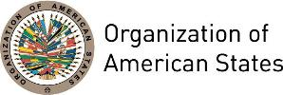

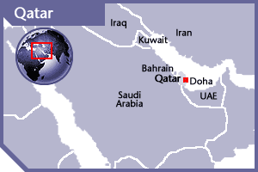


QATAR
PERMANENT OBSERVER

Date of Entry: October 16, 2002
National Holiday: December 18, 1878 (Founder's Day) | September 3, 1971 (Independence Day)
Capital: Doha
Type of Government: Constitutional Emirate
Emir (Chief of State): H.H.Sheikh Tamim Bin Hamad Al-Thani (June 25, 2013)
Head of Government: Prime Minister Abdullah bin Nasser bin Khalifa Al Thani (June 26, 2013)
Minister of Foreign Affairs: Mohammed bin Abdulrahman Al Thani (June 2016)
Permanent Observer: Ambassador Sheikh Meshal bin Hamad Al-Thani

ECONOMIC INDICATORS | 2010 | 2011 | 2012 | 2013 | 2014 | 2015 | 2016
Population (in millions) | 1.77 | 1.95 | 2.1 | 2.25 | 2.37 | 2.48 | 2.6
GDP (US$ in billions) | 125.11 | 167.8 | 186.83 | 198.73 | 206.45 | 164.6 | 152.5
GDP per capita (US$) | 70,306.23 | 85,948.1 | 88,564.82 | 88,304.88 | 86,852.71 | 66,346 | 59,330.8
Source: www.tradingeconomics.com | The World Bank Group

FOREIGN RELATIONS POLICIES:
- Qatar works to establish cooperation with peaceful countries; provides financial aid to developing countries in Asia and Africa and contributes to regional and international cooperation aid funds.
- Qatar supports the Gulf Cooperation Council (GCC) and strengthens ties of mutual trust and communication between Arab countries in resolving disputes among countries.
- Qatar is a member of the United Nations, International Monetary Fund, World Bank, and World Trade Organization, the Organization for Islamic Cooperation, the Gulf Cooperation Council, and the Arab League.
- The United Development Company (UDC) invests in long-term projects for joint ventures in the areas of hydrocarbons and energy, infrastructure and utilities, maritime and environmental related businesses, real estate, urban development, education, information technology, hospitality, communications, insurance, security and other services.

QATAR’S NATIONAL DEVELOPMENT STRATEGY (2011-2016)
- Aims to sustain its development and provide a high standard of living for its people.
- Qatar’s development agency – the General Secretariat for Development Planning (GSDP) – analyses issues of national significance to Qatar’s development priorities, reviews and assesses selected domestic laws and regulations, and monitors international developments that can impact Qatar’s development efforts.

INVOLVEMENT WITH THE AMERICAS
- Qatar has diplomatic relations with all OAS Member States and maintains embassies in Brazil, Canada, Costa Rica, Cuba, Dominican Republic, Ecuador, El Salvador, Panama, Paraguay, Peru, the United States, Uruguay and Venezuela.

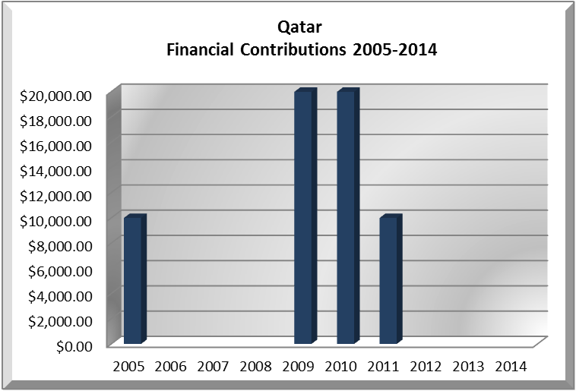
CASH CONTRIBUTIONS 2005-2016:
YEAR | QATAR | P.O. FINANCIAL CONTRIBUTIONS | %
2005 | $10,000.00 | $11,650,039.00 | 0.09%
2006 |  | $19,060,470.00 | 0.00%
2007 |  | $20,398,686.00 | 0.00%
2008 |  | $22,684,500.00 | 0.00%
2009 | $20,000.00 | $20,318,115.00 | 0.10%
2010 | $20,000.00 | $15,781,991.00 | 0.13%
2011 | $10,000.00 | $15,692,757.00 | 0.06%
2012 |  | $13,239,105.00 | 0.00%
2013 |  | $16,926,686.00 | 0.00%
2014 |  | $10,999,882.00 | 0.00%
2015 |  | $17,489,205.00 | 0.00%
2016 |  | $14,048,254.00 | 0.00%
Total US$ | $60,000.00 | $198,289,690.00 | 0.03%

CONTRIBUTIONS TO THE OAS:
YEAR | PROJECTS | FINANCIAL CONTRIBUTIONS  IN US$ | IN-KIND CONTRIBUTIONS  IN US$
2005 | Art Museum of the Americas | $10,000.00
SUBTOTAL |  | $10,000.00
2009 | Department of Sustainable Democracy and Special Missions – Secretariat for Political Affairs - The Peace Fund | $10,000.00
2009 | Department of Human Development – Secretariat for Integral Development – OAS Professional Development Scholarships | $10,000.00
SUBTOTAL |  | $20,000.00
2010 | Department of Sustainable Democracy and Special Missions – Secretariat for Political Affairs - Peace Fund | $20,000.00
2010 | Executive Secretariat for Integral Development / Department of Human Development, Education and Culture – – Professional Development Training – Strengthening of Democratic Institutions – 2 Scholarships |  | $2,340.00
2010 | Executive Secretariat for Integral Development / Department of Human Development, Education and Culture –Professional Development Training – Economic Diversification and Integration, Trade Liberalization and Market Access – 1 Scholarship |  | $2,100.00
2010 | Executive Secretariat for Integral Development / Department of Human Development, Education and Culture –Professional Development Training – Strengthening of Democratic Institutions – 2 Scholarships |  | $2,340.00
2010 | Executive Secretariat for Integral Development / Department of Human Development, Education and Culture – Professional Development Training – Sustainable Development of Tourism – 1 Scholarship |  | $2,100.00
SUBTOTAL |  | $20,000.00 | $8,880.00
2011 | Secretariat for External Relations / Art Museum of the Americas – Youth Orchestra Program | $10,000.00
SUBTOTAL |  | $10,000.00
TOTAL |  | $60,000.00 | $8,880.00

SOURCES:

ORGANIZATION OF AMERICAN STATES  http://www.oas.org  MINISTRY OF FOREIGN AFFAIRS, QATAR  http://www.english.mofa.gov.qa  THE GENERAL SECRETARIAT FOR DEVELOPMENT PLANNING, QATAR  http://www.planning.gov.qa/ | EMBASSY OF QATAR IN THE UNITED STATES  http://www.qatarembassy.net  QATAR NATIONAL DEVELOPMENT STRATEGY (2011-2016)  http://www.gsdp.gov.qa/gsdp_vision/docs/NDS_EN.pdf  WORLD BANK – TRADING ECONOMICS  www.tradingeconomics.com

This page was last updated on July 10, 2017.

