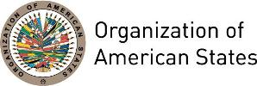


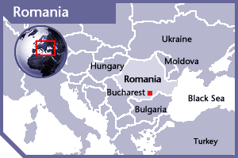

ROMANIA
PERMANENT OBSERVER

Date of Entry: October 31, 1990
National Holiday: May 9
Capital: Bucharest
Type of Government: Republic
Head of State: President Klaus Iohannis (December 21, 2014)
Head of Government: Prime Minister Sorin Grindeanu (January 17, 2015)
Minister of Foreign Affairs: Teodor Meleșcanu
(January 4, 2017)
Permanent Observer: Ambassador George Maior (September 15, 2015)

ECONOMIC INDICATORS | 2010 | 2011 | 2012 | 2013 | 2014 | 2015 | 2016
Population (in millions) | 20.44 | 20.29 | 20.2 | 20.0 | 19.9 | 19.8 | 19.7
GDP (US$ in billions) | 168 | 185.4 | 171.66 | 191.5 | 199.5 | 177.52 | 186.7
GDP per capita (US$) | 8,297.66 | 9,200.4 | 8,558.4 | 9,585 | 10,020 | 8,959 | 9,474
Source: www.tradingeconomics.com World Bank

FOREIGN RELATIONS POLICIES:
- Romania centers it foreign policy in global warming, pollution, affected biodiversity and deserts expansion, income inequality, deepening of the gaps between the rich and poor countries, erosion of traditional cultural identities, and proliferation of destructive weaponry, cross-border criminality and terrorism. Romania adopted the Millennium Declaration, adopting clearly-defined targets in the fields of sustainable development, peace and security, and fighting international terrorism.
- Romania is primarily a recipient of foreign assistance for the promotion of democracy and free market. As a result, there is no official foreign aid budget. Romania has several bilateral agreements and works through multiple multilateral organizations that work for development cooperation and provide assistance to developing countries. They also provide in-kind contributions of development assistance in the transfer of technology in shipbuilding and steel.
- Romania is active in the North Atlantic Treaty Organization (NATO), and has provided significant contributions of troops, equipment, and other assistance in Afghanistan and Kosovo. Romania’s efforts to promote greater cooperation among its Black Sea neighbors in the areas of defense, law enforcement, energy, economic development, and environment, enhance stability in this region.
- Romania continues to improve its capabilities for NATO and multinational operations, and has repeatedly demonstrated its willingness to provide forces and assets in support of shared national security interests.

INVOLVEMENT WITH THE AMERICAS:
- Romania’s foreign policy objectives are centered primarily in Europe; however, the country maintains diplomatic relations with Latin American and Caribbean and has embassies in 11 countries in the Western Hemisphere: Argentina, Brazil, Canada, Chile, Colombia, Cuba, Mexico, Peru, United States, Uruguay, and Venezuela.

SOURCES:
MINISTRY OF FOREIGN AFFAIRS, ROMANIA  http://www.mae.ro  EMBASSY OF ROMANIA TO THE UNITED STATES OF AMERICA  http://washington.mae.ro/en | WORLD BANK – TRADING ECONOMICS  www.tradingeconomics.com

This page was last updated on July 11, 2017.

