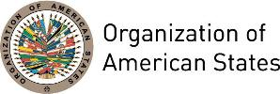

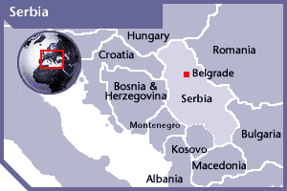
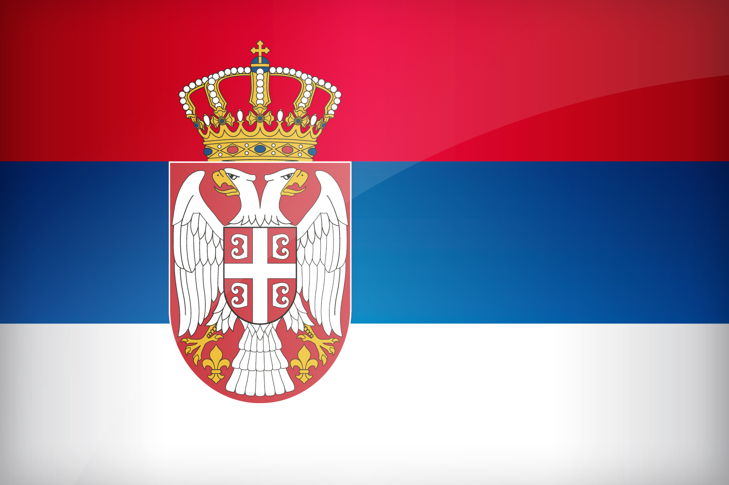

REPUBLIC OF SERBIA
PERMANENT OBSERVER

Date of Entry: September 25, 2002
National Holiday: February 15
Capital: Belgrade
Type of Government: Parliamentary Republic
Head of State: President Aleksandar Vučić (May 31, 2017)
Head of Government: Prime Minister of Serbia Ivica Dacic (May 31, 2017)
First Deputy Prime Minister and Minister of Foreign Affairs: Ivica Dacic (April 27, 2014)
Permanent Observer: Ambassador Djerdj Matkovic (2015)
ECONOMIC INDICATORS | 2010 | 2011 | 2012 | 2013 | 2014 | 2015 | 2016
Population (in millions) | 7.30 | 7.23 | 7.20 | 7.16 | 7.13 | 7.10 | 7.06
GDP (US$ in billions) | 39.46 | 46.47 | 40.74 | 45.52 | 44.21 | 37.16 | 37.74
GDP per capita (US$) | 5,411.9 | 6,423.3 | 5,659.4 | 6,353.8 | 6,200.2 | 5,237.2 | 5,348.3
Source: www.tradingeconomics.com | The World Bank Group

FOREIGN RELATIONS POLICIES:
- Serbia promotes and protects human rights at national and international levels, as the axle of its Foreign Policy in accordance with the United Nations Charter, and the Universal Declaration of Human Rights. This Policy aims to strengthen its international position through the creation of political cooperation, confidence building and security cooperation in the region.
- Its European integration is one of the most important foreign policy objectives. This integration is based on the establishment and promotion of regional cooperation in Western Balkans.
- The General Directorate for Multilateral Cooperation is in charge of Serbian activities with international organizations, bodies and conventions such as the United Nations, the North Atlantic Treaty Organization (NATO), the International Monetary Fund (IMF), and the World Bank.
- In the context of the United Nations, Serbia is a member of more than 20 specialized agencies and its cooperation areas focus on human rights, refugees and their repatriation, environmental protection, and peace-keeping.
- Serbian’s Security Policy aims to cooperate with the European Union (EU) in the field of Common Security and Defense Policy (CSDP), cooperation in the framework of the NATO Partnership for Peace Program, as well as cooperation in the framework of the United Nations, the Organization for Security and Cooperation in Europe, international forums and initiatives concerning disarmament, non-proliferation and arms control. Serbia is also working on developing a comprehensive policy on combating International Terrorism.
- Other objectives of Serbian’s Foreign Policy in the field of multilateral cooperation are:
- strengthening multilateralism related to climate change, combating terrorism, sustainable development, energy problems,
- attracting foreign investments
- developing tourism and improving the country's prestige in the world at large;
- combating stock-piling and use of chemical weapons
- The priority areas for intergovernmental cooperation are based on establishing and developing the public supply infrastructure (energy supply, district heating networks, and water supply), and promoting small and medium-sized enterprises to improve Serbia’s productivity.

INVOLVEMENT WITH THE AMERICAS:
- Serbia maintains embassies in six countries of the Americas: Argentina, Brazil, Canada, Cuba, Mexico and the United States of America.

COOPERATION AGREEMENTS WITH THE OAS:
- Memorandum of Understanding between the Government of the Republic of Serbia and the OAS General Secretariat, through which Serbia will contribute a minimum of US$20,000, beginning in 2011, to OAS programs aimed at strengthening democracy and outreach programs to promote democratic values. Signed June 6, 2010.

CASH CONTRIBUTIONS 2009-2016:
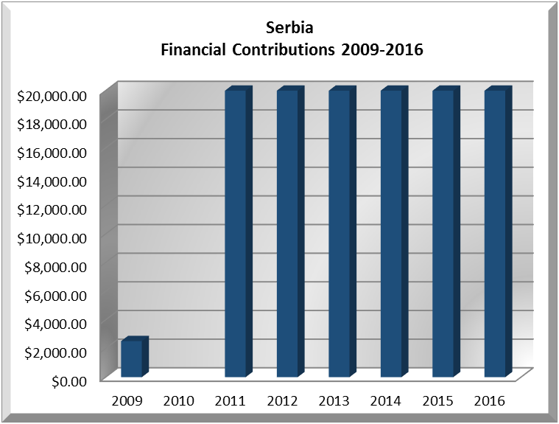
YEAR | SERBIA | P.O. FINANCIAL CONTRIBUTIONS | %
2009 | $2,516.00 | $20,318,115.00 | 0.01%
2010 |  | $15,781,991.00 | 0.00%
2011 | $20,000.00 | $16,692,757.00 | 0.12%
2012 | $20,000.00 | $13,239,105.00 | 0.15%
2013 | $20,000.00 | $16,926,686.00 | 0.12%
2014 | $20,000.00 | $10,999,882.00 | 0.18%
2015 | $20,000.00 | $17,489,205.00 | 0.11%
2016 | $20,000.00 | $14,048,254.00 | 0.14%
Total US$ | $122,516.00 | $125,495,995.00 | 0.10%

SERBIA CONTRIBUTIONS:
YEAR | PROJECTS |  | FINANCIAL CONTRIBUTIONS IN US$ | IN-KIND CONTRIBUTIONS  IN US$
2004 | Department of Democratic and Political Affairs – Proyecto de Registros Seguros Caribeños |  | $3,000.00
SUBTOTAL |  |  | $3,000.00
2009 | DECO – EOM at St. Vincent and the Grenadines |  | $2,516.00
SUBTOTAL |  |  | $2,516.00
2011 | Secretariat for Political Affairs / Department for Electoral Cooperation and Observation – OAS Electoral Observation Mission to Guyana |  | $5,000.00
2011 | Secretariat for Political Affairs / Department for Electoral Cooperation and Observation – OAS Electoral Observation Mission to Nicaragua |  | $5,000.00
2011 | Secretariat for External Relations / Department of International Affairs – Lecture Series of the Americas and Policy Roundtable Series |  | $10,000.00
SUBTOTAL |  |  | $20,000.00
2012 | Secretariat for Political Affairs / Department for Electoral Cooperation and Observation – Electoral Observation Mission Fund |  | $10,000.00
2012 | Executive Secretariat for Integral Development (SEDI) / Department of Economic Development Trade and Tourism -Small Tourism Enterprises Networks- |  | $10,000.00
SUBTOTAL |  |  | $20,000.00
2013 | Secretariat for Political Affairs / Department for Electoral Cooperation and Observation – Forum on the Issues of Political Campaign Financing in Caribbean |  | $10,000.00
2013 | Secretariat for External Relations / Department of International Affairs – Policy Roundtable Series / TIC Americas |  | $10,000.00
SUBTOTAL |  |  | $20,000.00
2014 | Secretariat for Political Affairs / Department of Electoral Cooperation and Observation – Electoral Observation Mission for the Presidential and Legislative Elections in Bolivia (October 5, 2014) |  | $5,000.00
2014 | Secretariat for Political Affairs / Department of Electoral Cooperation and Observation – Electoral Observation Mission for the Parliamentary Elections in Antigua and Barbuda |  | $5,000.00
2014 | Secretariat for Multidimensional Security / Department of Public Security - MAS Caribbean “Supporting CARICOM’s Crime and Security Strategy” |  | $10,000.00
SUBTOTAL |  |  | $20,000.00
2015 | Secretariat for Political Affairs / Department of Electoral Cooperation and Observation – OAS Electoral Observation Mission for the Federal Elections in Mexico - June 7, 2015 |  | $5,000.00
2015 | Secretariat for Political Affairs / Department of Electoral Cooperation and Observation – OAS Electoral Observation Mission for the General Elections in Guatemala - September 13, 2015 |  | $5,000.00
2015 | Executive Secretariat for Integral Development / Department of Economic Development - Small Tourism Enterprises Network (STEN) |  | $10,000.00
SUBTOTAL |  |  | $20,000.00
2016 |  | The Department of Electoral Cooperation and Observation (64C),  XI I‐A Meeting of Electoral Authorities | $10,000
 |  | The Executive Secretariat for Integral Development (74A),  Preparing Students for 21st Century Employment | $10,000
SUBTOTAL |  |  | $20,000.00
TOTAL |  |  | $125,516.00

SOURCES:
SERBIAN PRESIDENT WEBSITE  http://www.predsednik.rs/  SERBIAN GOVERNMENT WEBSITE  http://www.srbija.gov.rs/  MINISTRY FOR FOREIGN AFFAIRS OFFICIAL WEB SITE  http://www.mfa.gov.rs/en/ | THE WORLD BANK GROUP  www.tradingeconomics.com  UNITED NATIONS  http://www.un.org

This page was last updated on July 5, 2017.

