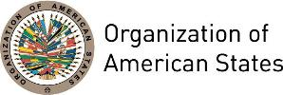
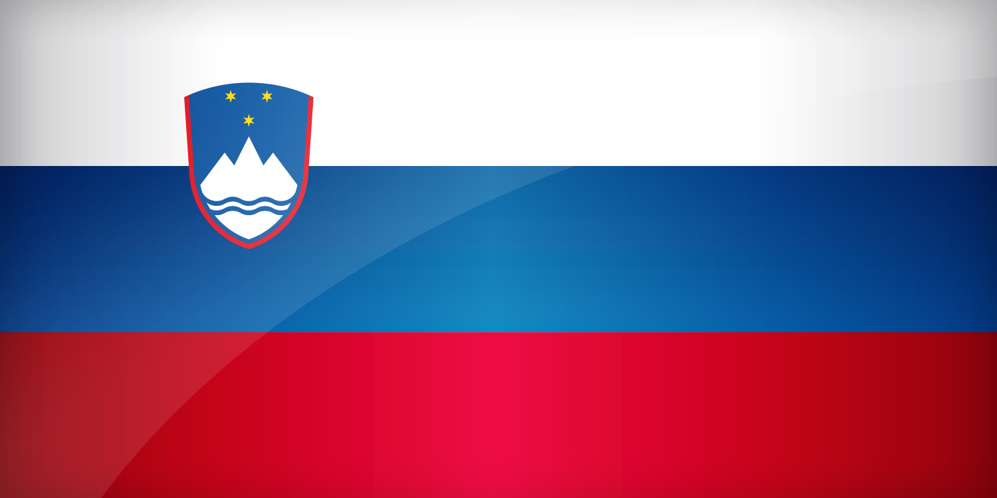

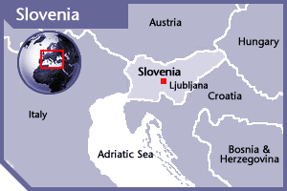

SLOVENIA
PERMANENT OBSERVER

Date of Entry: October 14, 2003
National Holiday: June 25
Capital: Ljubljana
Type of Government: Democratic Parliamentary Republic
Head of State: President Borut Pahor (December 2, 2012)
Head of Government: Prime Minister Miro Cerar (September 18, 2014)
Minister of Foreign Affairs: Karl Viktor Erjavec (March 2012)
Permanent Observer: Ambassador Božo Cerar (September 17, 2013)

ECONOMIC INDICATORS | 2010 | 2011 | 2012 | 2013 | 2014 | 2015 | 2016
Population (in millions) | 2.04 | 2.05 | 2.05 | 2.06 | 2.06 | 2.06 | 2.06
GDP (US$ in billions) | 49.06 | 51.29 | 46.26 | 47.69 | 49.53 | 42.77 | 43.99
GDP per capita (US$) | 23,437 | 24,985.3 | 22,486.5 | 23,150 | 24,021 | 20,729 | 21,304
Source: www.tradingeconomics.com | The World Bank Group

FOREIGN RELATIONS POLICIES:
- Slovenia’s foreign policy aims to guarantee two fundamental values: the security and the welfare of the state and its citizens, maintaining the Slovenian national identity and, at the same time, an openness to the world.
- The Republic of Slovenia bases its foreign policy on the fundamental principles of the constitutional system of the state and the international law. It strives to strengthen Slovenian statehood based on the national, cultural and linguistic sovereignty of the Slovenian nation and the guaranteed rights of the Italian and Hungarian ethnic communities assisting them in strengthening ties of emigrants and migrant workers with Slovenia, and promote their endeavors to preserve a Slovenian identity.
- The prime foreign policy task of the Republic of Slovenia is the settlement of relations with neighboring countries based on mutual trust and respect as well as good cooperation in economic and other fields.
- In the field of international relations, the Slovenia strives for a peaceful settlement of conflicts and renounces the use of force. It promotes disarmament and the non-proliferation of arms of mass destruction, as well as the combat against terrorism, drugs trafficking and all other forms of international crime in accordance with the Constitution and international law and respecting and promoting the right of nations to self-determination
- The Slovenian foreign policy supports the strengthening of cooperation and trust and overall respect for human rights as laid down in international agreements and other international acts or customary international law. It strives for the settlement of succession issues in accordance with international law, taking into consideration the dissolution of the former state, equal treatment of all newly independent successor states and proportionate assumption of succession rights and obligations.
- In the field of global and regional international economic relations, the Republic of Slovenia encourages solutions which guarantee full employment, a higher quality of life and conditions for economic and social progress and development.
- In order to accelerate economic development and strengthen its international role, the Republic of Slovenia seeks to achieve active cooperation on an equal footing in prominent international organizations and institutions such as the European Union (EU), the North Atlantic Treaty Organization (NATO) and the United Nations (UN).

INTERNATIONAL DEVELOPMENT COOPERATION AND HUMANITARIAN ASSISTANCE:
- The objectives of Slovenia’s international development cooperation are shaped on the following principles: (i) compatibility with the values and development policies of Slovenia’s society and economy; (ii) compatibility with the development objectives of the international community, especially the EU and the UN; and (iii) compatibility with foreign policy objectives, which also include international development cooperation. This cooperation aims at:
- Reducing poverty by bolstering economic and social development;
- Ensuring peace and security, and combating HIV/AIDS and other diseases affecting less developed countries;
- Providing education for all, ensuring sustainable development and good governance; and
- Strengthening bilateral and multilateral cooperation with priority countries.
- In 2008, the National Assembly of the Republic of Slovenia adopted a Resolution on International Development Cooperation until 2015, which sets out the geographical and sector-specific priorities:
- Thematic areas for cooperation include strengthening of good governance, the rule of law and social services; protecting the environment; and women’s empowerment.
- Bilateral development cooperation is focused mostly on the Western Balkan countries, with other cooperation in Eastern Europe, the Caucasus and Central Asia.
- Through multilateral cooperation, Africa is the geographic priority. Most cooperation is conducted through multilateral funds in the context of the European Union, United Nations and OECD.
- In addition, Slovenia’s humanitarian and post-conflict assistance is divided into assistance in emergencies such as natural and other disasters, conflicts, etc., and into regular humanitarian and post-conflict assistance. This assistance aims to the reduction of poverty and hunger; demining actions and the assistance to children in post-conflict situations.
- As an EU Member State, Slovenia has made the following commitments relating to its international development cooperation:
- To increase development cooperation funds to 0.33% by 2015;
- To channel development assistance to the least developed countries, including those in Africa;
- To ensure the respect for the principles of complementarity, coordination and coherence;
- To respect the arrangements on the division of labor between Member States and on boosting the efficiency of development cooperation;
- To respect commitments to policy coherence for development in twelve areas namely: trade, environment, climate change, security, agriculture, fisheries, social dimension of globalization, employment and decent work, migration, research, information society, transport, and energy.

RELATIONS WITH THE AMERICAS:
- Slovenia maintains diplomatic relations with all OAS Member States countries and has embassies in Argentina, Brazil, Canada, and the United States of America.

YEAR | PROJECTS | FINANCIAL CONTRIBUTIONS | IN-KIND CONTRIBUTIONS  IN US$
2011 | Secretariat for Political Affairs / Department for Electoral Cooperation and Observation – OAS Electoral Observation Mission to Observe the Second Round of the Presidential and Legislative Elections in Haiti | $9,704.10
SUBTOTAL |  | $9,704.10
TOTAL |  | $9,704.10

SOURCES:
PRESIDENT OF THE REPUBLIC OF SLOVENIA  http://www.up-rs.si/up-rs/uprs-eng.nsf/  PRIME MINISTER OF THE REPUBLIC OF SLOVENIA  http://www.kpv.gov.si/en/  GOVERNMENT OF THE REPUBLIC OF SLOVENIA  http://www.vlada.si/en/home/  STATE PORTAL OF THE REPUBLIC OF SLOVENIA  http://e-uprava.gov.si/e-uprava/en/portal.euprava | MINISTRY OF FOREIGN AFFAIRS OF THE REPUBLIC OF SLOVENIA  http://www.mzz.gov.si/en  THE WORLD BANK  http://www.worldbank.org  EMBASSY OF THE REPUBLIC OF SLOVENIA IN WASHINGTON DC  http://washington.embassy.si/index.php?id=399&L=1

This page was last updated on July 7, 2017.

