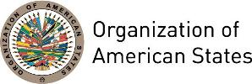

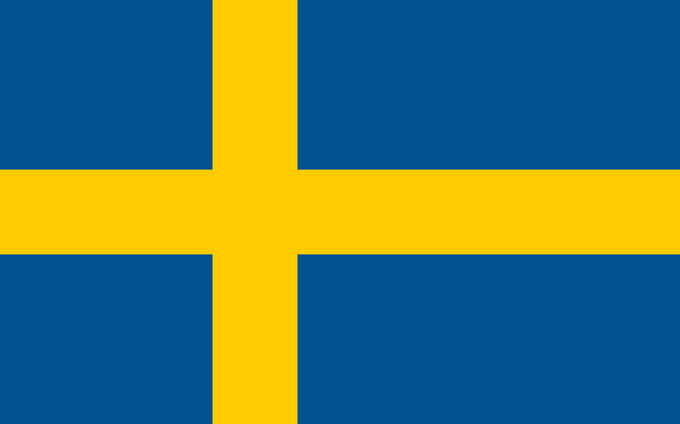
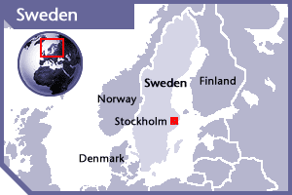

SWEDEN
PERMANENT OBSERVER

Date of Entry: March 20, 1996

National Holiday: June 6

Capital: Stockholm

Type of Government: Constitutional Monarchy, Parliamentary Democracy

Head of State: King Carl XVI Gustaf (September 15, 1973)

Head of Government: Prime Minister Stefan Löfven (October 3, 2014)

Minister for Foreign Affairs: Margot Wallström (October 3, 2014)

Permanent Observer: Ambassador Björn Lyrvall (September 20, 2013)

ECONOMIC INDICATORS | 2010 | 2011 | 2012 | 2013 | 2014 | 2015 | 2016
Population (in millions) | 9.38 | 9.45 | 9.52 | 9.60 | 9.70 | 9.80 | 9.90
GDP (US$ in billions) | 488.378 | 563.11 | 543.881 | 578.742 | 573.818 | 495.694 | 511
GDP per capita (US$) | 52,076.2 | 59,593.2 | 57,134.1 | 60,283.2 | 59,180.2 | 50,585.2 | 51,599.9
Source: www.tradingeconomics.com | The World Bank Group

FOREIGN POLICY:
- The Swedish foreign policy focuses on promoting democracy, human rights, gender equality, sustainable development and freedom from violence through bilateral and multilateral cooperation, especially through the United Nations and European Union.
- The European Union continues to be Sweden’s main foreign policy arena and Sweden works to strengthen the Common Security and Defense Policy. Besides that, Sweden supports the strengthening of EU-NATO cooperation and the cooperation with the UN.
- The Ministry of Foreign Affairs continued to focus on achieving the Millennium Development Goals, particularly with respect to sexual and reproductive health and rights, sanitation. Sweden has a feminist agenda, which seeks to ensure that women and girls can enjoy their fundamental rights.
- Sweden also supports peace, conflict resolution and humanitarian assistance in the Middle East and Africa.
- In the Americas, Sweden’s foreign policy prioritizes Brazil (climate, research and economic growth), Mexico (non-proliferation

SWEDISH DEVELOPMENT COOPERATION:
- Development assistance in 2014 will be estimated at 1% of GNI. Nearly 50% of Sweden’s development cooperation is through multilateral organizations, especially the United Nations bodies, the World Bank and the European Union.
- Bilateral aid is administered by the Swedish International Development Cooperation Agency (Sida), while multilateral cooperation is largely dealt with through the Ministry for Foreign Affairs. The overall target of Sweden’s development assistance is to ensure that those in poverty have the ability to improve their living conditions through equitable and sustainable global development.
- Sweden believes that with the help of aid, poor countries get opportunities to develop their trade and industry, which leads to export incomes for those countries and job opportunities for their residents. Besides that, Sweden promotes the removal of trade barriers in order for poor countries to gain access to the world market.
- Sida acts in 10 fields of work: humanitarian aid; democracy, human rights and freedom of expression; gender equality; environment and climate; health; market development; agriculture and food security; education; sustainable societal development; conflict resolution, peace and security.
- In Latin America, Sweden’s development cooperation concentrates on long-term democratic development in Bolivia, and peace and conflict resolution in Colombia and Guatemala.
- Sweden’s Global Development Policy focuses on two perspectives: 1) poverty reduction and the promotion of equitable and sustainable global development, with priority on poor women, men and children; and 2) human rights that prioritizes gender and children’s rights, as well as democracy, non-discrimination, participation, openness and transparency.

INVOLVEMENT WITH THE AMERICAS:
- Sweden has embassies in Argentina, Bolivia, Brazil, Canada, Chile, Colombia, Cuba, Guatemala, Mexico and the United States of America.
- Sweden’s contributions in Latin America are centering its support on three countries: Bolivia, Colombia and Guatemala. The purpose is making the division of responsibility between donors more effective with greater insight and measurable results.
- In Guatemala and Colombia, Sweden is working on issues concerning peace and security and the promotion of democracy. In Colombia, Swedish support has contributed to the adoption of a law against sexually-related violence; in Guatemala, Sida-supported microloans have helped 40,000 women escape extreme poverty. In Bolivia, Sida has contributed to reducing corruption in public administration.

CASH CONTRIBUTIONS 1999-2016:
YEAR | SWEDEN | P.O. FINANCIAL CONTRIBUTIONS | %
1999 | $3,443,967.00 | $8,015,935.00 | 42.96%
2000 | $5,313,850.00 | $9,515,678.00 | 55.84%
2001 | $1,637,000.00 | $6,923,000.00 | 23.65%
2002 | $2,393,504.00 | $8,460,084.00 | 28.29%
2003 | $3,793,688.00 | $12,125,944.00 | 31.29%
2004 | $6,668,629.00 | $11,908,651.00 | 56.00%
2005 | $4,707,846.00 | $11,650,039.00 | 40.41%
2006 | $6,766,383.00 | $19,060,470.00 | 35.50%
2007 | $4,005,033.00 | $20,398,686.00 | 19.63%
2008 | $4,545,430.00 | $22,684,500.00 | 20.04%
2009 | $1,467,524.00 | $20,318,115.00 | 7.22%
2010 | $1,856,674.00 | $15,781,991.00 | 11.76%
2011 | $1,529,705.00 | $15,692,757.00 | 9.75%
2012 | $118,491.00 | $13,239,105.00 | 0.90%
2013 | $1,145,290.00 | $16,926,686.00 | 6.77%
2014 | $99,975.00 | $10,999,882.00 | 0.91%
2015 | $207,067.00 | $17,489,205.00 | 1.18%
2016 | $256,364.00 | $14,048,254.00 | 1.82%
Total US$ | $49,956,420.00 | $255,238,982.00 | 19.57%
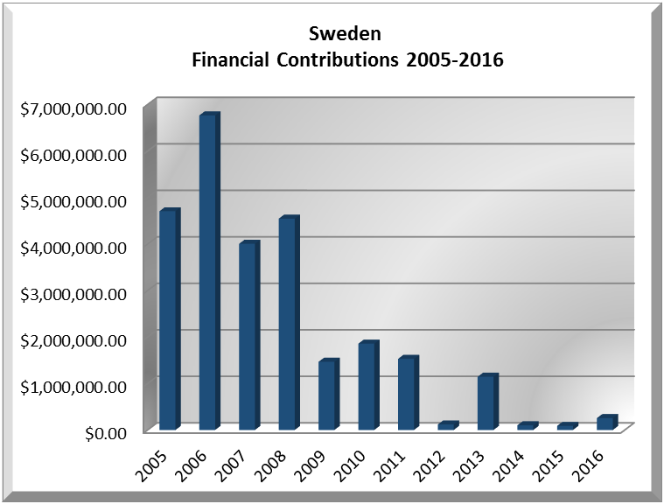

SWEDEN CONTRIBUTIONS:
YEAR | PROJECTS | FINANCIAL CONTRIBUTIONS IN US$ | IN-KIND CONTRIBUTIONS  IN US$
1999 | Unit for the Promotion of Democracy (UPD) | $3,368,683.00
1999 | Inter-American Commission on Human Rights (IACHR) - Freedom of Expression Report | $75,284.00
SUBTOTAL |  | $3,443,967.00
2000 | Inter-American Commission on Human Rights (IACHR) | $69,106.00
2000 | Unit for the Promotion of Democracy (UPD) | $5,244,744.00
SUBTOTAL |  | $5,313,850.00
2001 | Unit for the Promotion of Democracy (UPD)- TCP- Phase II | $718,000.00
2001 | Unit for the Promotion of Democracy (UPD)- Electoral Observation Mission, Nicaragua | $62,000.00
2001 | Unit for the Promotion of Democracy (UPD)- Electoral Observation Mission, Peru | $29,000.00
2001 | Unit for the Promotion of Democracy (UPD)- Electoral Observation Mission, Honduras | $68,000.00
2001 | Unit for the Promotion of Democracy (UPD)- Demining Project | $640,000.00
2001 | Inter-American Commission on Human Rights (IACHR) | $120,000.00
SUBTOTAL |  | $1,637,000.00
2002 | Unit for the Promotion of Democracy (UPD)- TCP II | $821,545.00
2002 | Unit for the Promotion of Democracy (UPD)- Hijos del Río | $199,587.00
2002 | Unit for the Promotion of Democracy (UPD)- Rural Judicial Facilitators | $549,119.00
2002 | Unit for the Promotion of Democracy (UPD)- Electoral Observation Mission Nicaragua 2002 | $99,819.00
2002 | Unit for the Promotion of Democracy (UPD)- Central American Program | $212,793.00
2002 | Unit for the Promotion of Democracy (UPD)- Electoral Observation Mission Bolivia 2002 | $52,657.00
2002 | Unit for the Promotion of Democracy (UPD)- Demining Program | $332,956.00
2002 | Special OAS Mission in Haiti | $104,028.00
2002 | Inter-American Children’s Institute (IIN) | $21,000.00
SUBTOTAL |  | $2,393,504.00
2003 | Unit for the Promotion of Democracy (UPD)- Program Honduras | $500,647.00
2003 | Unit for the Promotion of Democracy (UPD)- Program Guatemala | $356,204.00
2003 | Unit for the Promotion of Democracy (UPD)- Program Nicaragua | $1,269,850.00
2003 | Unit for the Promotion of Democracy (UPD)- Political Parties, Central America | $43,931.00
2003 | Unit for the Promotion of Democracy (UPD)- Demining Project | $1,289,131.00
2003 | Inter-American Commission on Human Rights (IACHR) - Office of the Special Rapporteur for Freedom of Expression | $92,589.00
2003 | Special OAS Mission in Haiti | $126,753.00
2003 | Office of the Assistant Secretary General- Peace Fund- Belize/Guatemala | $114,583.00
SUBTOTAL |  | $3,793,688.00
2004 | Inter-American Commission on Human Rights (IACHR) - Office of the Special Rapporteur for Freedom of Expression | $103,866.00
2004 | Unit for the Promotion of Democracy (UPD)- Demining Project | $926,052.00
2004 | Secretariat for Political Affairs / Department of Electoral Cooperation and Observation (DECO) | $3,086,837.00
2004 | Secretariat for Political Affairs / Department of Electoral Cooperation and Observation (DECO) - Guatemala | $559,638.00
2004 | Secretariat for Political Affairs / Department of Electoral Cooperation and Observation (DECO) - Nicaragua | $24,975.00
2004 | Secretariat for Political Affairs / Department of Electoral Cooperation and Observation (DECO) - Democratic values and political management program, Guatemala | $411,516.00
2004 | Secretariat for Political Affairs / Department of Electoral Cooperation and Observation (DECO) - Nicaragua | $1,236,383.00
2004 | Secretariat for Political Affairs / Department of Electoral Cooperation and Observation (DECO) - Electoral Observation Mission Nicaragua | $144,475.00
2004 | Secretariat for Political Affairs / Department of Sustainability and Special Missions- Mission to Support the Peace Process in Colombia (MAPP) | $174,887.00
SUBTOTAL |  | $6,668,629.00
2005 | Inter-American Commission on Human Rights (IACHR) - Follow-up Demobilization Process in Colombia | $181,922.00
2005 | Inter-American Commission on Human Rights (IACHR) - Rapporteurship for Freedom of Expression | $65,537.00
2005 | Secretariat for Political Affairs / Department of Electoral Cooperation and Observation (DECO) - Electoral Observation Mission Bolivia 2005 | $100,276.00
2005 | Secretariat for Political Affairs / Department of Electoral Cooperation and Observation (DECO)) - Electoral Program Support | $953,721.00
2005 | Secretariat for Political Affairs / Department of Sustainable Democracy and Special Missions (DSDSM)- Mission to Support the Peace Process in Colombia (MAPP) | $92,559.00
2005 | Secretariat for Political Affairs / Department of Electoral Cooperation and Observation (DECO) - Modernization and Legislative Agenda of Congress | $634,100.00
2005 | Secretariat for Political Affairs / Department of Electoral Cooperation and Observation (DECO) - Political Management Guatemala | $421,734.00
2005 | Secretariat for Political Affairs / Department of Electoral Cooperation and Observation (DECO) - Electoral System Guatemala 2005-2007 | $350,834.00
2005 | Secretariat for Political Affairs / Department of Electoral Cooperation and Observation (DECO) - Modernization of Electoral System in Guatemala | $59,024.00
2005 | Department of Democracy and Political Affairs (DDPA)- Support to Rural Judicial Facilitators | $1,438,393.00
2005 | Department of Multidimensional Security (DMS)- Demining PADCA Nicaragua | $409,746.00
SUBTOTAL |  | $4,707,846.00
2006 | Secretariat for Political Affairs / Department of Sustainable Democracy and Special Missions (DSDSM)- Mission to Support the Peace Process in Colombia (MAPP) | $1,243,556.00
2006 | Secretariat for Political Affairs / Department of Electoral Cooperation and Observation (DECO) - Promotion of Democracy Honduras | $767,998.00
2006 | Secretariat for Political Affairs / Department of Electoral Cooperation and Observation (DECO) - Promotion of Democracy Guatemala | $536,317.00
2006 | Secretariat for Political Affairs / Department of Electoral Cooperation and Observation (DECO) - Promotion of Democracy Guatemala | $668,470.00
2006 | Secretariat for Political Affairs / Department of Electoral Cooperation and Observation (DECO) - Promotion of Democracy Guatemala | $394,229.00
2006 | Secretariat for Political Affairs / Department of Electoral Cooperation and Observation (DECO) - Promotion of Democracy Nicaragua | $1,240,189.00
2006 | Secretariat for Political Affairs - Promotion of Democracy MOE 2006 Nicaragua | $410,773.00
2006 | Inter-American Commission on Human Rights (IACHR) - Support to Human Rights Activities related to the Mission to Support the Peace Process in Colombia (MAPP) | $198,483.00
2006 | Department of Prevention of Threats against Public Security- Demining Program | $1,306,368.00
SUBTOTAL |  | $6,766,383.00
2007 | Secretariat for Political Affairs / Department of Sustainable Democracy and Special Missions (DSDSM)- Mission to Support the Peace Process in Colombia (MAPP) | $1,871,234.00
2007 | Department of Electoral Cooperation and Observation – EOM 2007 Colombia | $314,695.00
2007 | Department of Electoral Cooperation and Observation – Support Electoral Systen 2005-07 Guatemala | $925,219.00
2007 | Department of Electoral Cooperation and Observation – Modernization & Legislative Agenda Congress 2005-07 | $745,425.00
2007 | Inter-American Commission on Human Rights (IACHR) – Rapporteurship – Freedom of Expression | $148,460.00
SUBTOTAL |  | $4,005,033.00
2008 | Secretariat for Political Affairs / Department of State Modernization and Good Governance (DMEG) – Modernization and Legislative Agenda of Guatemalan Congress | $314,264.00
2008 | Secretariat for Political Affairs / Department of Sustainable Democracy and Special Missions (DSDSM)- Mission to Support the Peace Process in Colombia (MAPP) | $1,925,379.00
2008 | Secretariat for Legal Affairs (SLA)– Support to Establish a National System of Judicial Facilitators in 73 Municipalities in Nicaragua | $1,163,260.00
2008 | Inter-American Human Rights Commission (IACHR) – Office of the Special Rapporteur on Freedom of Expression in the Americas | $77,965.00
2008 | Secretariat for Political Affairs / Department of Electoral Cooperation and Observation (DECO) – Program on Electoral Reforms in Honduras January 2008 – June 2010 | $244,918.00
2008 | Secretariat for Political Affairs – Strengthening of the Supreme Electoral Authority in Honduras | $428,232.00
2008 | Inter-American Children’s Institute (IIN) – Save the Children | $4,000.00
2008 | Executive Secretariat for Integral Development (SEDI) – Project of Civil Society Registry in Honduras | $387,412.00
SUBTOTAL |  | $4,545,430.00
2009 | Secretariat for Political Affairs / Department of State Modernization and Good Governance (DMEG) – Modernization of the Legislative Agenda of the Guatemalan Congress | $293,319.00
2009 | Secretariat for Political Affairs / Department of Sustainability and Special Missions (DSDSM)- Mission to Support the Peace Process in Colombia (MAPP) | $905,685.00
2009 | Inter-American Commission on Human Rights (IACHR), Office of the Special Rapporteur on Freedom of Expression in the Americas | $268,520.00
SUBTOTAL |  | $1,467,524.00
2010 | Secretariat for Political Affairs / Department of Electoral Cooperation and Observation (DECO) – Electoral Observation Mission, Colombia | $416,645.00
2010 | Secretariat for Political Affairs / Department of Electoral Cooperation and Observation (DECO) - Electoral Observation Mission, Colombia (President Runoff Election) | $278,855.00
2010 | Secretariat for Political Affairs / Department of Sustainability and Special Missions (DSDSM)- Mission to Support the Peace Process in Colombia (MAPP) | $1,161,174.96
SUBTOTAL |  | $1,856,674.96
2011 | Secretariat for Political Affairs / Department of Sustainability and Special Missions (DSDSM)- Mission to Support the Peace Process in Colombia (MAPP) | $1,083,345.00
2011 | Secretariat for Political Affairs / Department of Electoral Cooperation and Observation (DECO) – OAS Electoral Observation Mission to Guatemala | $153,565.00
2011 | Secretariat for Political Affairs / Department for Electoral Cooperation and Observation (DECO) – OAS Electoral Observation Mission to Colombia | $292,795.00
SUBTOTAL |  | $1,529,705.00
2012 | Secretariat for Political Affairs / Department of Sustainability and Special Missions (DSDSM)- Mission to Support the Peace Process in Colombia (MAPP) | $118,491.00
SUBTOTAL |  | $118,491.00
2013 | Secretariat for Political Affairs / Department of Sustainability and Special Missions (DSDSM)- Mission to Support the Peace Process in Colombia (MAPP) | $688,339.95
2013 | Inter-American Commission on Human Rights – Office of the Special Rapporteur for Freedom of Expression | $381,974.98
2013 | From Short-term Violence Reduction to Long-term Lowering of Crime and Violence Rates: Supporting the Technical Steering Committee in El Salvador | $74,975.00
2013 | Mission to Support the Peace Process in Colombia (MAPP) - Secondment staff position 2 months |  | $17,000.00
SUBTOTAL |  | $1,145,289.93 | $17,000.00
2014 | Secretariat for Political Affairs / Department of Sustainability and Special Missions (DSDSM)- Implementation of Confidence-Building Measures in the Belize-Guatemala Adjacency Zone | $99,975.00
SUBTOTAL |  | $99,975.00
2015 | Inter-American Commission on Human Rights – Strengthening Freedom of Expression | $87,402.49
2015 | Inter-American Commission on Human Rights – Freedom of Expression 2015-17 | $119,665.00
SUBTOTAL |  | $207,067.00
2016 | The Department of Electoral Cooperation and Observation (64C),  EOM 2016 Colombia | $23,707
2016 | The Executive Secretariat of the Inter‐American Commission on Human Rights IACHR (34B), Freedom of Expression 2015‐17 | $232,657
SUBTOTAL |  | $256,364
TOTAL |  | $49,956,420.00 | $17,000.00

SOURCES:
SWEDISH ROYAL COURT  http://www.kungahuset.se/royalcourt.4.367010ad11497db6cba800054503.html  AID HARMONIZATION  http://www.aidharmonization.org/  SWEDEN ABROAD: MINISTRY FOR FOREIGN AFFAIRS; WEB SITE FOR SWEDISH DIPLOMATIC MISSIONS ABROAD  http://www.swedenabroad.se | SWEDISH INTERNATIONAL DEVELOPMENT COOPERATION AGENCY  http://www.sida.se/evaluation  MINISTRY FOR FOREIGN AFFAIRS OFFICIAL WEB SITE  http://www.ud.se  THE WORLD BANK GROUP  www.tradingeconomics.com

This page was last updated on July 5, 2017.

