
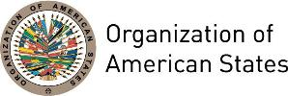
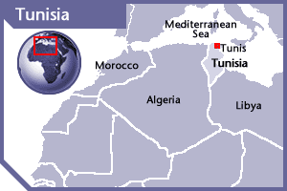
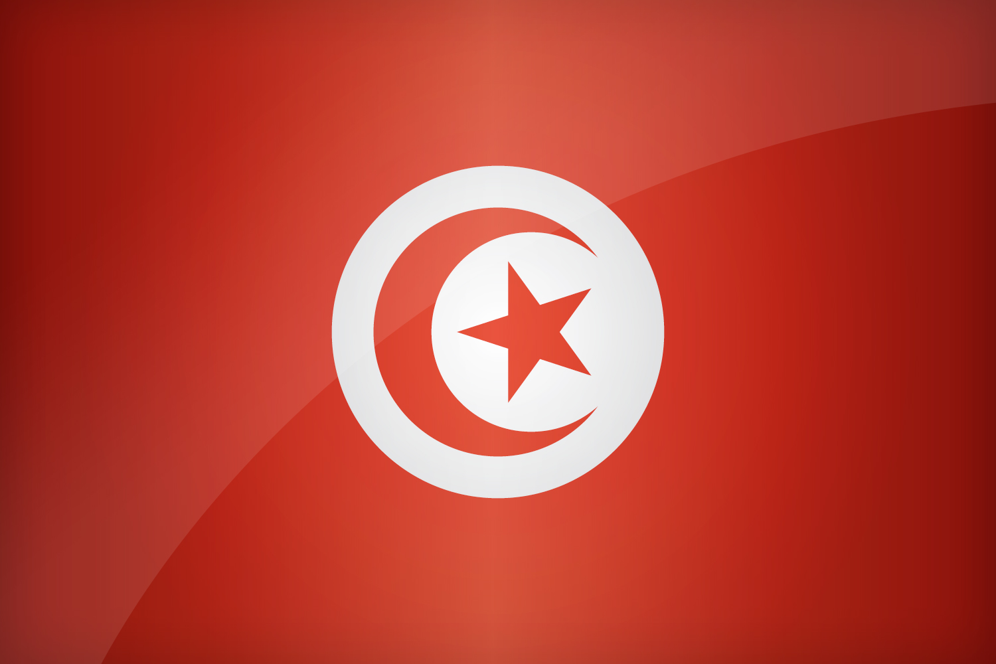

TUNISIA
PERMANENT OBSERVER

Date of Entry: April 14, 2009
National Day: March 20
Capital: Tunis
Type of Government: Republic
Head of State: President Beji Caid Essebsi (December 31, 2014)
Head of Government: Prime Minister Youssef Chahed (August 6, 2016)
Minister of Foreign Affairs: Khemaies Jhinaoui (January 6, 2016)
Permanent Observer: Ambassador Fayçal Gouia (May 18, 2015)

ECONOMIC INDICATORS | 2010 | 2011 | 2012 | 2013 | 2014 | 2015 | 2016
Population (in millions) | 10.44 | 10.55 | 10.67 | 10.78 | 10.89 | 11.1 | 11.4
GDP (US$ in billions) | 44.05 | 45.81 | 45.04 | 46.26 | 47.6 | 43.157 | 42.063
GDP per capita (US$) | 4,140.15 | 4,256.91 | 4,137.45 | 4,199.48 | 4,271.69 | 3,828.1 | 3,688.65
Source: www.tradingeconomics.com | The World Bank Group

FOREIGN RELATIONS POLICIES:
- Tunisia’s foreign policy is based on international law to enhance conditions of understanding, tolerance and solidarity between States and peoples, confer more justice, democracy and balance on international relations, and promote security, stability, well-being and progress for the benefit of humanity.
- These principles could be summarized as follows:
  - Adhering to international legality as well as to respect of its requirements and decisions;
  - Adhering to peace through dialogue, negotiation and peaceful settlement of disputes and conflicts;
  - Developing international relations based on mutual respect and non-interference in internal affairs of other States;
  - Supporting just causes; and
  - Contributing to all efforts and actions in favor of peace, security and stability, human rights promotion and fulfilment of well-being and progress for the benefit of humanity in its entirety.
- There are three primary objectives of Tunisia’s foreign policy:
  - To develop and diversify relations and enhance cooperation in fields of common interest, specifically reinvigorating the structures of the Arab Maghreb Union (Algeria, Morocco, Mauritania, Libya and Tunisia), promoting Arab solidarity and cooperation with Islamic countries, partnerships with the European Union, Africa, the Americas and Asia.
  - Promoting a favorable climate for peace, security and stability, by means of cooperation to fight against international extremism and terrorism taking into account different political, economic, social and cultural causes, settling problems of justice for the Palestinian people and Middle East conflict in a fair manner, reforming the United Nations, consolidating preventive diplomacy and containing the proliferation of weapons of mass destruction.
  - Balancing economic gaps between industrialized, developing and less developed countries by implementing practical solutions to foreign indebtedness, taking advantage of technological change and science to bridge the digital gap, intensifying horizontal cooperation and international solidarity in the fight against poverty, illiteracy and diseases; and enhancing international cooperation to address ecological degradation and the environment.

INVOLVEMENT WITH THE AMERICAS:
- Tunisia has diplomatic relations with the all the OAS Member States and maintains embassies in Argentina, Brazil, Canada, and the United States of America.

SOURCES:
PORTAIL DU GOUVERNEMENT TUNISIEN  http://www.tunisie.gov.tn/index.php?option=com_frontpage&Itemid=61  PRESIDENCY OF THE GOVERNMENT OF TUNISIA  http://www.pm.gov.tn/pm/content/index.php?lang=en  MINISTÈRE DES AFFAIRES ÉTRANGÈRES  http://www.diplomatie.gov.tn/ | MINISTÈRE DU DÉVELOPPEMENT ET DE LA COOPÉRATION INTERNATIONALE  http://www.mdci.gov.tn/  WORLD BANK – TRADING ECONOMICS  www.tradingeconomics.com

This page was last updated on July 6, 2017.

