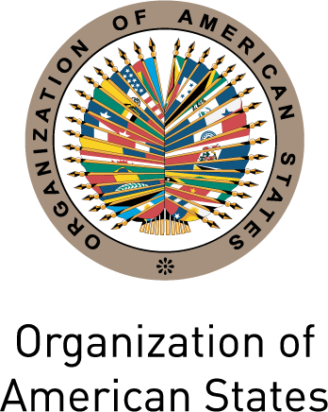
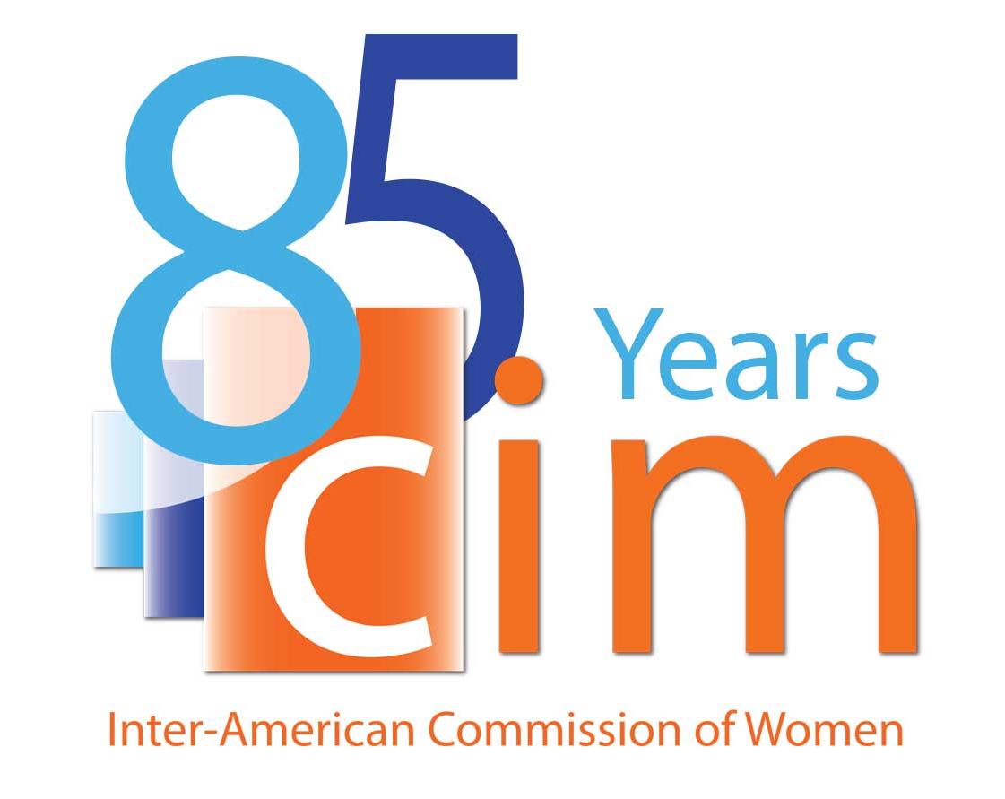

INTER-AMERICAN COMMISSION OF WOMEN

EXECUTIVE COMMITTEE 2013-2015 OEA/Ser.L/II.5.32
FIRST REGULAR SESSION CIM/CD/doc.8/13 Rev.1
Washington, D.C. February 28th 2013
February 28th to March 1st 2013 Original: Spanish

AGREEMENTS ADOPTED DURING THE FIRST REGULAR SESSION OF THE CIM EXECUTIVE COMMITTEE 2013-2015

Agreement 1

In the context of the Report on the Activities of the President and Executive Secretariat of the CIM, contained in document CIM/CD/doc.4/13, as well as the importance of the humans rights and gender equity and equality approach to the work of the OAS, to request the Secretary General of the OAS to elevate this issue for the consideration of the Permanent Council of the OAS with the aim of mainstreaming a gender approach throughout the work of the Organization.

Agreement 2

In light of the draft “Work Plan of the CIM Presidency 2013-2015,” contained in document CIM/CD/doc.7/13 and in preparation for the celebration of the 20th anniversary of the adoption of the Inter-American Convention on the Prevention, Punishment and Eradication of Violence against Women (Belém do Pará Convention) and the 10th anniversary of the creation of its Follow-up Mechanism (MESECVI) during 2014, to request:
- That the Executive Secretariat of the CIM and the Technical Secretariat of the MESECVI prepare a hemispheric and sub-regional overview of 20 years of the Belém do Pará Convention, focused on the significance and influence of the Convention on legislation and public policy for prevention and care, as well as the issue of trafficking, to be presented and considered during the Second Regular Session of the CIM Executive Committee 2013-2015, to be held during the last trimester of 2013.
- That the Executive Committee, the CIM Delegates and the Executive Secretariat of the CIM, throughout 2014, organize National and Sub-regional Forums and Meetings on the implementation of the Belém do Pará Convention, using the document prepared by the Executive Secretariat as a basis, within available human and financial resources;
- That the Executive Committee and the Executive Secretariat of the CIM prepare a proposal for a Hemispheric Forum “Overview of the Belém do Pará Convention: 20 years of prevention, punishment and eradication of violence against women,” including a draft agenda and a plan for mobilizing the resources necessary for the organization of the Forum; and
- That the Permanent Council of the OAS incorporate the celebration of the 20th anniversary of the Belem do Para Convention and the 10th anniversary of the MESECVI in the work and final conclusions of the 43rd Regular Session of the OAS General Assembly.

Agreement 3

On the basis of the draft Strategy for strengthening relations between the CIM and civil society, contained in document CIM/CD.doc.6/13, to request that the Executive Secretariat of the CIM;
- Incorporate the comments made by the Delegates during this session and circulate a revised draft strategy for comments by the Delegates;
- On the basis of the comments received, prepare a revised draft of the Strategy, to be considered during the Second Regular Session of the CIM Executive Committee 2013-2015, including:
  - A list of the organizations registered with the OAS that work on gender, women’s rights and human rights; and
  - An analysis of their participation in the ongoing activities of the OAS.

Agreement 4

In light of the preliminary findings of the study on women and drugs in the Americas: to request:
- That the Executive Secretariat of the CIM requests information and, in the event that it is available, statistical data, from the Delegates on the specific situation in their countries;
- That the Executive Secretariat of the CIM completes the study using the information provided by the Delegates and circulates it widely throughout the region in order to increase the visibility of the gender dimensions of this issue in the Americas; and
- That the President of the CIM participates in the forty-third session of the OAS General Assembly, to be held in La Antigua, Guatemala, from June 3rd to 6th 2013, in order to ensure that the work and final conclusions of the Assembly take into account these gender dimensions.

Agreement 5

In follow-up to resolution CIM/RES. 260 (XXXVI-O/12), adopted by the Thirty-Sixth Assembly of Delegates of the CIM, to request that the Executive Secretariat of the CIM finalize the proposal “Capacity-development for the integration on a rights and gender equality approach in integrated disaster risk management in the Americas,” contained in document CIM/CD/doc.33/12 and circulated it to the Executive Committee with a resource mobilization plan, in order that the Committee might support these efforts.

Agreement 6

In preparation for the Twelfth Regional Conference on Women in Latin America and the Caribbean, to be held in Santo Domingo from October 14th to 18th 2013, to request:
- That the Executive Secretariat of the CIM continues to disseminate to the Delegates information on the gender dimensions of and the participation of women and girls in information and communication technologies in the Americas; and
- That the President of the CIM participates in this conference, on behalf of the CIM, in order to consolidate collaboration between the CIM and ECLAC.

Agreement 7

In follow-up to resolution CIM/RES. 264 (XXXVI-O/12, adopted by the Thirty-Sixth Assembly of Delegates of the CIM and to the Report on the Activities of the President and Executive Secretariat of the CIM, contained in document CIM/CD/doc.4/13, to request:
- That the CIM Executive Committee support the celebration of the 85th anniversary of the CIM; and
- That the Executive Secretariat of the CIM organize, in the context of the Second Regular Session of the CIM Executive Committee 2013-2015, and event to highlight the progress of the CIM in promoting and protecting women’s rights and identify the main challenges to their full citizenship, for which the Executive Committee offers its support in the identification of possible panelists and the mobilization of resources; and
- That the Executive Committee and the Executive Secretariat of the CIM strengthen the collaboration between the CIM and the CITEL in order to ensure that a gender perspective is incorporated into to work of the OAS on ICTs.

