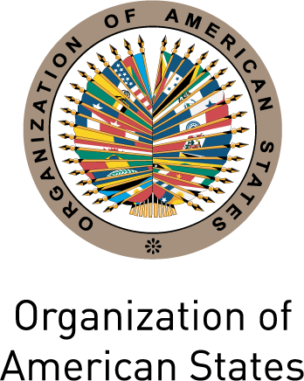
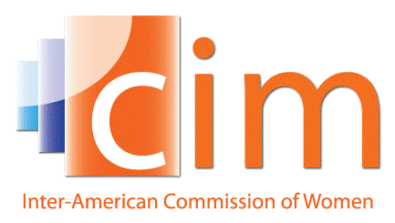

INTER-AMERICAN COMMISSION OF WOMEN

EXECUTIVE COMMITTEE 2013-2015 OEA/Ser.L/II.5.32
FIFTH REGULAR SESSION CIM/CD/doc.23/15 Rev.2
Washington, DC May 5th 2015
May 7th and 8th 2015 Original: Spanish

ORGANIZATION OF WORK

(Draft)

Day 1 – Padilha Vidal Room, GSB Building

9:00-9:15 Inauguration:
      - Jean Michel Arrighi, Secretary of the OAS’ Secretariat for Legal Affairs, in representation of the Secretary General
      - Alejandra Mora Mora, President and Principal Delegate of Costa Rica to the CIM

9:15-9:30 Adoption of the agenda
(Item 1 of the Agenda, CIM/CD/doc.22/15)
Adoption of the organization of work
(Item 2 of the Agenda, CIM/CD/doc.23 /15)

9:30-10:30 Report of the President and the Executive Secretary of the CIM and Budget execution through April 30th 2015
(Item 3 of the Agenda CIM/CD/doc.24/15)

10:30-11:00 Break

11:00-12:00 Report of the Technical Secretariat of the MESECVI and budget execution through April 30th 2015
(Item 4 of the Agenda, CIM/CD/doc.25/15)

12:00-13:00 Violence against women in the realm of politics
(Item 7 of the Agenda)

13:00-14:00 Lunch

14:00-15:00 Preparations for the XXXVII Assembly of Delegates of the CIM
(Item 5 of the Agenda, CIM/CD/doc.26/15, CIM/CD/doc.27/15)

15:00-16:00 Draft Triennial Program of Work of the CIM 2016-2018
(Item 6 of the Agenda, CIM/CD/doc.28/15)

16:00-16:30 Other matters
(Item 10 of the Agenda)
- Dialogue on the full and equal access of women and men to high-level posts in all strategic categories of the OAS
- Other matters

16:30-17:30 Adoption of agreements
(Item 9 of the Agenda)

Day 2 – Gabriela Mistral Room, GBS Building

10:00-13:00 Round-table debate
“Tools for monitoring women’s rights and evaluating the impact of gender
policies: A working agenda”

Moderator: Alejandra Mora Mora, President and Principal Delegate of Costa Rica to the CIM

Panelists:
- Rosa Celorio, Inter-American Commission of Human Rights
      - Monteserrat Bustelo, Gender and Diversity Division, IDB
      - Pamela Villalobos, Gender Affairs Division, ECLAC
      - Flavia Piovesan, Pontifical Catholic University of Sao Paolo
      - Hilary Anderson, Senior Specialist of the CIM
      - Luz Patricia Mejía, Technical Secretary of the MESECVI

Plenary debate

