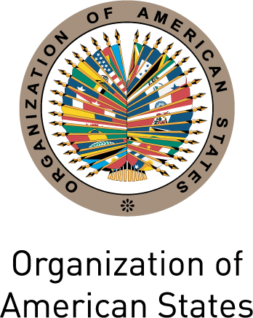
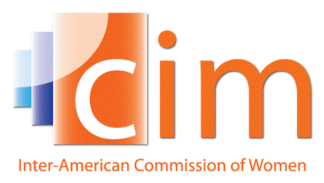

INTER-AMERICAN COMMISSION OF WOMEN

EXECUTIVE COMMITTEE 2013-2015 OEA/Ser.L/II.5.32
FIFTH REGULAR SESSION CIM/CD/doc.27/15
Washington, DC April 9th 2015
May 7th and 8th 2015 Original: Spanish

ORGANIZATION OF WORK OF THE THIRTY-SEVENTH ASSEMBLY OF DELEGATES OF THE CIM

(Draft)

DAY 1:

8:00-9:00 Registration of Participants

8:00-9:00 Informal session of the Heads of Delegation (Art.26)

9:00-9:30 First Plenary Session

- Election of authorities of the Assembly (Item 1 of the Draft Agenda) (Art.32) and Order of Precedence (Art.7)
- Adoption of the Draft Agenda (Art.23) and Organization of Work (Art.20) (Item 2 of the Draft Agenda)
- Installation of the General Committee and the Committee on Credentials (Art.32)

9:30-10:30 Inaugural Session (Art.25 y 31)

- President of the Inter-American Commission of Women,, Alejandra Mora Mora (Costa Rica)
- Secretary General of the OAS
- Authorities of Peru (to be confirmed)

10:30-11:00 Official photograph

11:00-11:30 Break

11:30-17:00 Second Plenary Session
11:30 Meeting of the Committee on Credentials

11:30 First Session of the General Committee (Declaration of Lima and Resolutions)
11:30-12:30 Panel on the thematic axis of the Assembly:
Autonomy and exercise of women’s economic rights

Moderator: Minister of Women and Vulnerable Populations of Peru (TBC)

- Beijing +20, women’s economic empowerment and the post-2015 development agenda
Elizabeth Villagómez, Regional Advisor for Economic Empowerment, UN Women
- Progress on women’s economic autonomy
Director of the Gender Affairs Division, Economic Commission for Latin America and the Caribbean (ECLAC)
- Evidence of best practices for economic empowerment
Andrew Morrison, Chief of the Gender and Diversity Division (GDI)
Inter-American Development Bank (IADB)
- Results of the application of the Integrated System of Indicators on Women’s Human Rights (SISDEHM)
Hilary Anderson, Senior Specialist of the CIM

12:30 – 13:00 Plenary debate

13:00 – 14:00 Lunch
2:00 Second Session of the General Committee (Declaration of Lima and Resolutions)
14:00-14:30 Results of the Dialogue between the Principal Delegates of the Caribbean Sub-region: Participation in the CIM and the MESECVI

14:30-17:30 Exchange among Principal Delegates on: good practices, strategies and national experiences; and informing on reports prepared on the Integrated System of Indicators on Women’s Human Rights.

DAY 2:

9:00 – 10:30 Tercera Sesión Plenaria
9:00 Second Session of the General Committee (Declaration of Lima and Resolutions)
- Report of the Committee on Credentials (Art.32 y Art.41)
- Presentation of the Report of the President, the Executive Committee and the Executive Secretariat (Art.24 inc. a)

- Consideration of the Triennial Program of Work of the CIM 2016-2018 (Art. 24 d.)

10:30 – 12:30 Fourth Plenary Session

- Report of the General Committee
- Election of authorities of the CIM: (Art. 24 y Art. 69)
- Election of the President
- Election of the Vice-Presidents
- Election of the Members of the Executive Committee
- Adoption of the Lima Declaration
- Adoption of the Draft resolutions (Art. 24)
- Other matters

12:30 – 13:00 Closing session (Art. 25)
- Speech by the President of the CIM 2013-2015, Alejandra Mora Mora (Costa Rica)
- Speech by the President Elect of the CIM 2016-2018
input.doc

The pertinent articles of the Rules of Procedure for the CIM Assembly of Delegates are cited

